CASTLEN ELEMENTARY SCHOOL
First Grade School Supply List
2020-2021
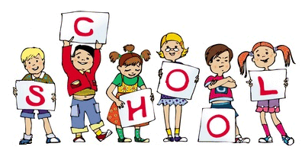
Central Office is requesting that parents provide a face mask for their child to have with them at school each day. Cloth is preferred due to durability.
1-pair of scissors (blunt tip)
2-24 count of crayons
3-glue sticks
2-packs of pencils
1-pack of washable markers
2- 1 inch white binders with clear sleeve on front
1-plastic school supply box
1-pack of watercolor paint
1-clear front zipper pouch (for binder)
1-8 count Avery two pocket plastic dividers (for binder)
3-plastic folders with brads and prongs (green, blue, and orange)
4-wide ruled notebooks

WISH LIST
Liquid soap
Hand sanitizer
Paper towels
Tissues
Baby wipes
Ziplock bags (1 quart and 1 gallon)
Lysol wipes

