2019 Occupational Therapy Toy List

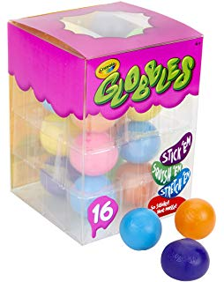
Crayola Globbles 16 Count, Squish & Fidget Toys, Stocking Stuffers, Gift for Kids, Age 4, 5, 6, 7, 8-$16.38

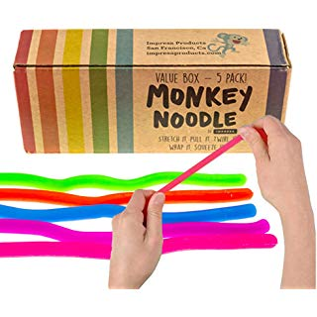
Impresa Products 5-Pack of Stretchy String Fidget / Sensory Toys (BPA/Phthalate/Latex free-$9.99

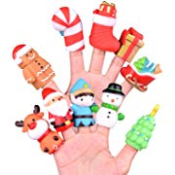
10 Pcs Christmas Finger Puppets, Best Choice for Christmas Stocking Stuffers, Party Favors, Pinata Fillers and Goodie Bag Fillers $9.95

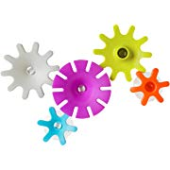
Boon Cogs Water Gears Bath Toys Set, Pack of 5 $ 7.49

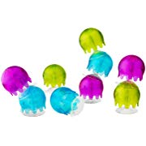
Boon Jellies Suction Cup Bath Toys – $10.49
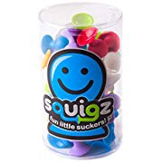
Fat Brain Toys Squigz Starter Set, 24 Piece -$24.99

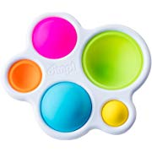
Fat Brain Toys Dimpl Baby Toys & Gifts for Ages 1 to 2, Multi -$12.95
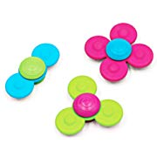
Whirley Squigz-$21.95

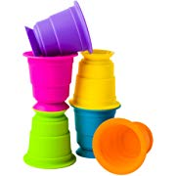
Fat Brain Toys FA183-1 Suction Kupz Baby Toys & Gifts for Ages 1 to 2, Multicolor -$14.95
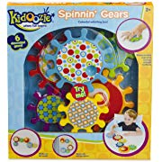

Kidoozie Spinnin' Gears -$21.80

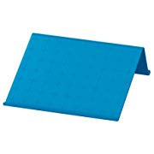
Ikea ISBERGET Comfortable and Adjustable Tablet Stand, Blue-$ 6.89

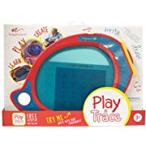
Boogie Board Play and Trace LCD Writing Tablet Clear See-Through Writing Surface for Kids to Write, Trace, and Draw eWriter Ages 3+ -$29.45

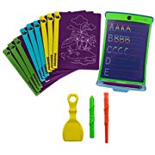
Boogie Board Magic Sketch Color LCD Writing Tablet + 4 Different Stylus and 9 Double-Sided Stencils for Drawing, Writing, and Tracing eWriter Ages 4+ $29.99

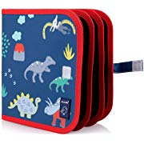
Jaq Jaq Bird Children's Mess-Free Chalk Coloring Book (Dinosaur) $ 9.95

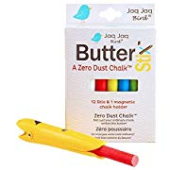
Premium 12-Count Colored Dustless Chalks by Jaq Jaq Bird - Non-Toxic, Truly Dust Free Chalk for Art, Decorating - Includes Fun Magnetic Chalk Holder w/Kid-Friendly Grip, Easy to Clean -$13.00

- 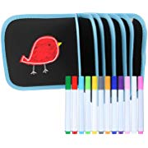
OCIOLI Portable Erasable Drawing Pad Toys for Kids, Double-Sided Reuse PVC Writing Board, with 12 Colored Erasable Pens,14Page (Bird)$10.99

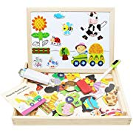
- Lewo Wooden Kids Educational Toys Magnetic Easel Double Side Dry Erase Board Puzzles Games for Boys Girls-$13.99

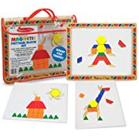
Melissa & Doug Magnetic Pattern Blocks Set (Developmental Toys, Sturdy Wooden Play Board, Carrying Case, 120 Pieces, Great Gift for Girls and Boys - Best for 3, 4, 5, and 6 Year Olds) $15.29

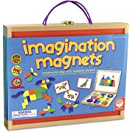
Imagination Magnets-$29.99

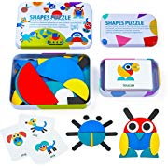
LiKee Wooden Pattern Blocks Animals Jigsaw Puzzle Sorting and Stacking Games Montessori Educational Toys for Toddlers Kids Boys Girls Age 3+ Years Old (36 Shape Pieces& 60 Design Cards in Iron Box) -$13.99
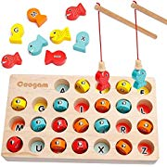

Coogam Wooden Magnetic Fishing Game, Fine Motor Skill Toy ABC Alphabet Color Sorting Puzzle, Montessori Letters Cognition Preschool Gift for 2 3 4 Years Old Toddler Kid Early Coogam Wooden Magnetic Fishing Game, Fine Motor Skill Toy ABC Alphabet Color Sorting Puzzle, Montessori Letters Cognition Preschool Gift for 2 3 4 Years Old Toddler Kid Early Learning with 2 Poles-$24.99

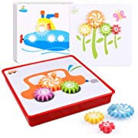
D-FantiX Spinning Gear Puzzle Board Set with 12 Pictures, Peg Puzzles Cog Gear Toys for Toddlers Kids Educational Preschool Learning Toys -$16.99

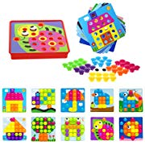
Soyee Button Art Early Learning Toys Color Matching Mosaic Pegboard Set for 3+ Year Old Boys & Girls Brain Training Games for Kids $ 14.99

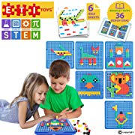
ETI Toys, STEM Learning, 505 Piece Mosaic Puzzle. Build Cat, House, Alligator, and More. 100 Percent Non-Toxic, Fun, Creative Skills Development. Gift, Toy for 3, 4, 5 Year Old Boys and Girls. $29.99

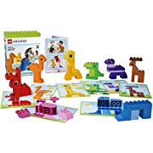
Animal Bingo Game for Shape and Color Recognition by LEGO Education DUPLO $34.99

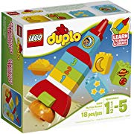
LEGO DUPLO My First Rocket 10815, Preschool, Pre-Kindergarten Large Building Block Toys for Toddlers $39.85

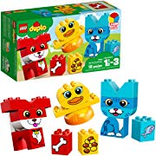
LEGO DUPLO My First Puzzle Pets 10858 Building Blocks (18 Pieces) $9.99

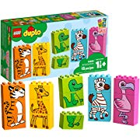
LEGO DUPLO My First Fun Puzzle 10885 Building Blocks, 2019 (15 Pieces) $19.99

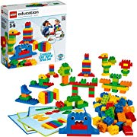
Creative LEGO DUPLO Brick Set by LEGO Education $63.65

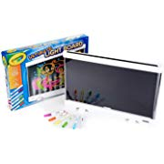
Crayola Ultimate Light Board Drawing Tablet, Gift for Kids Age 6+ $ 24.95

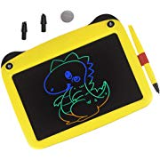
mom&myaboys Upgraded Colorful Screen 9 Inch Electronic Writing Board Doodle Board-Best Gifts for Kids (Yellow) $19.99

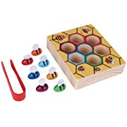
- Bee Games Toys,Bee Hive Games Wooden Bee Catching Practices Toy Early Childhood Education Intelligence Bee Games Toys for Kids Above 3 Years Old $9.38

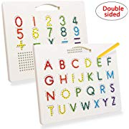
Apfity Alphabet Magnetic Board, Double Sided Magnetic Alphabet Letter and Number Tracing Board for Kids Toddlers, Colorful Magnetic Drawing Board STEM for Alphabet Learner and Writing, Uppercase $21.99

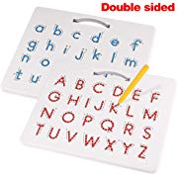
Apfity Magnetic Drawing Board, Magnetic Alphabet Letter Tracing Board- Educational ABC Letters Read Write Learn Preschool Gift for Boys and Girls $24.99
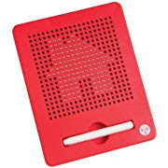
Kid O Free Play Magnatab $18.20

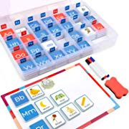

Gamenote Magnetic Objects and Letters Sorting Tiles with Magnet Board - Foam Tile for Beginning Sounds Phonics Learning (104pcs in Storage Case) $19.99

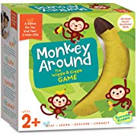
- Peaceable Kingdom Monkey Around - The Wiggle & Giggle Game of Movement for 2-Year-Olds $18.99

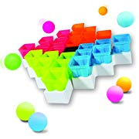
- Franklin Sports Battle Buckets Pong Game - Fast Paced Four Player Ping Pong Game - Fun for Kids and Families - It’s a Game of Skill, Strategy, Change and Its Addictive! 34.99

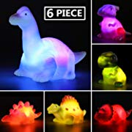
MAPIXO 6 Packs Light-Up Floating Dinosaur Bath Toys Set, for Baby Toddler Nephew in Birthday Christmas Easter , Great Water Bathtub Shower Pool Bath Toy for Children Preschool $12.98

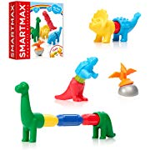
SmartMax My First Dinosaurs STEM Magnetic Discovery Building Set with Soft Animals for Ages 1-5 -$21.99

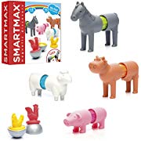
SmartMax My First Farm Animals STEM Magnetic Discovery Building Set with Soft Animals for Ages 1-5 $21.99

GlowCity LED Ring-Toss Game - Glow-in-The-Dark Dazzling Color Fun for Kids and Adults – Light Up Your Beach, Lawn and Backyard Parties $39.95

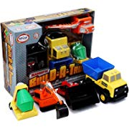
Popular Playthings Build A Truck: Construction Standard $32.99

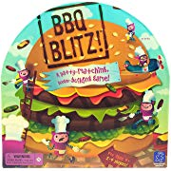
Educational Insights BBQ Blitz! $22.10

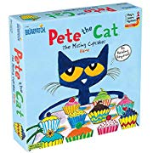
Pete The Cat The Missing Cupcakes Game Based On The Popular Book Series $14.80

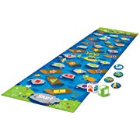
Learning Resources Crocodile Hop Floor Game, Early Learning Skills, Individual Or Group Play, Ages 3+-$26.49

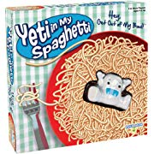
PlayMonster Yeti in My Spaghetti $6.29

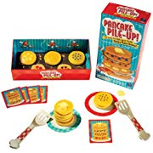
Educational Insights Pancake Pile-Up! Relay Game $14.99

