$4000 Scholarship
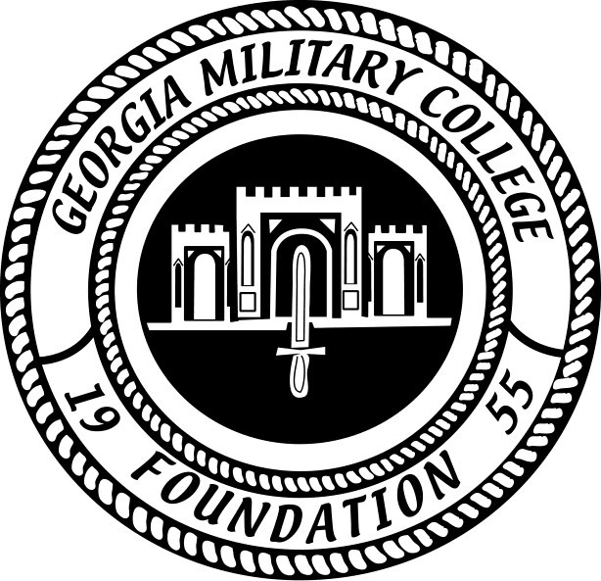
Scholarship will be awarded to a student attending the Warner Robins Campus of Georgia Military College.
Recipient Criteria:
- A member of Robins Financial Credit Union
- A GMC-Warner Robins student
- Demonstrate financial need
- Must maintain a full course load (minimum of 12 hours)
- Must maintain a GPA of 2.0 or higher
To complete an application and for more information, please contact Ms. Elizabeth Self, Financial Aid Advisor/Scholarship Coordinator at eself@gmc.edu or (478) 225-0180.

Application must be received by Friday, July 31, 2020.
Scholarship will be awarded over four quarters at $1000 a quarter starting Fall 1 2020.

