MOTION GRAPHS
Draw and label a graph the represents an object’s speed:
- NO MOTION: If an object is not moving, a horizontal line is shown on a distance-time graph.
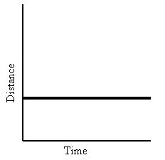
Time is increasing to the right, but its distance does not change; therefore, It is not moving. We say it is at rest.
- CONSTANT SPEED:
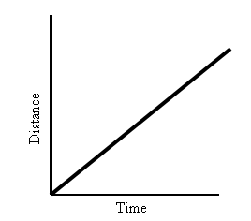
Time and distance increase as an object speeds up.
- DECREASING SPEED:
Time increases, but distance decreases as an object slows down.
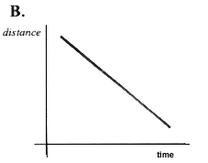
Draw and label a graph the represents an object’s acceleration:
- ZERO ACCELERATION:
A straight horizontal line on an acceleration graph means that speed is constant. It is not changing over time.
A straight line does not mean that the object is not moving! (ex. A car using cruise control)
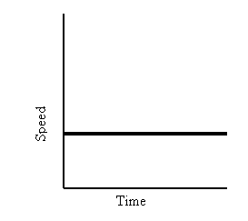
- POSITIVE ACCELERATION:
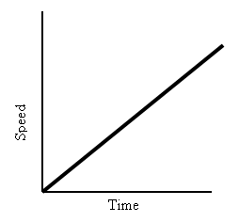
This graph shows increasing speed.
The moving object is accelerating.
- NEGATIVE ACCELERATION:
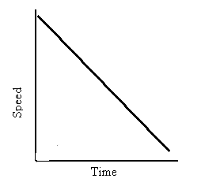
This graph shows decreasing speed.
The moving object is decelerating.

