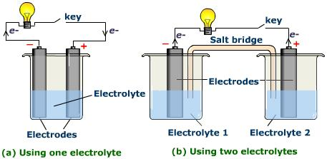

**How lightning is formed:** **1) CHARGE BUILD UP**- collisions between particles in storm clouds separate charges. Negatively charged particles collect at bottom of cloud. **2) CHARGED BUILD** **UP** – the negatively charged bottom part of the cloud induces a positive charge in the surface of the ground or surround objects. **3) STATIC CHARGE:** the charge jumps through the air to the ground or nearby object. Energy released by the discharge causes thunder and lightning.

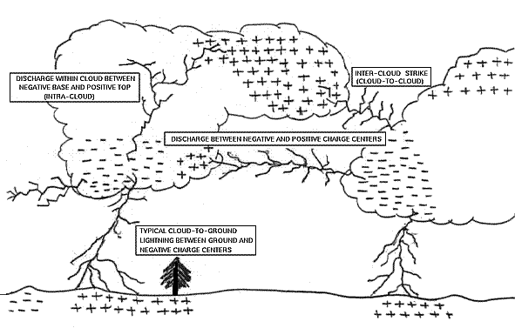

KNOW

|  |  |
| --- | --- |
| **Vocabulary term** | **Draw a picture** |
| **Batteries** – connected electric cells that convert chemical energy to electrical energy; source of power |  |
| **Resistor** – an object added to a circuit that restricts the flow of electrical energy; inhibits the low of electric current by producing a voltage drop when current passes through it. |  |
| **Load** – a device connected to an electrical circuit that operates using the electricity and converting it to heat, sound, light, etc. Examples – light bulb, radio, motor, hair dryer |  |
| **Switch** – a device that is used to control the flow of electrical current through a circuit. It is either **open** by separating the conductors stopping the flow or **closed** by bringing together 2 conductors allowing the electrical flow. |  |
| **Open** – circuit is broken, **load is off**- in other words, your radio WON’T play.  **Closed** – circuit is connected, **load is on**- in other words, your radio WILL play. |  |

* Electric charge is a property of matter.
* Static charges are caused by the movement of electrons.
* Technology uses static electricity.
* Charges can move from one place to another.
* Static charges have potential energy.
* Materials affect charge movement.
* Electric current is a flow of charge.
* Electric current can flow continuously .
* Charge movement is affected by electric potential and is measured in volts.
* A conductor has low resistance.
* An insulator has high resistance.
* Electric cells supply electric current.
* Electric current is measured ampres (amps).
* Ohm’s law state that current equals voltage divided by resistance.
* Electromechanical cells produce electric current through chemical reactions.

**Electric current is a flow of charge**. A **SERIES CIRCUIT** provides only one possible path for the flow of electric current. With a series circuit, one switch will turn off an entire series of lights – or whatever the electricity is going. Many labs use series circuits. Series circuits help deliver the charges of multiple batteries to one source evenly.

A **PARALLEL CIRCUIT** offers more than one path for the flow of electric current. Most households are wired with parallel circuits so if you turn off a light, your refrigerator doesn’t turn off too.

