Alabama Thespian Festival
Director’s Handbook
2019 Edition
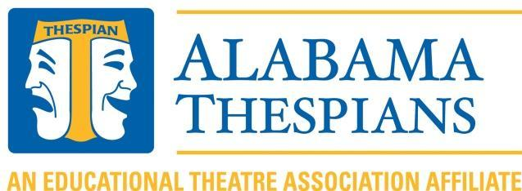
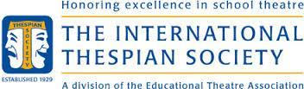
2019 Alabama Thespian Festival

Welcome to the Alabama State Thespian Festival! The Alabama Thespian Festival features numerous productions presented by schools throughout the state. In addition, there are a variety of workshops led by theatre professionals from around the country. Participants can also perform or view individual performance and tech events, interview for scholarships, talk to college representatives from around the country, shop with commercial vendors selling theatre merchandise, and hang out with hundreds of other Alabama Thespians. This handbook contains useful information to help you register, plan, and learn more about the 2019 Alabama Thespian Festival. For additional information, visit: www.alabamathespians.org

REGISTRATION:
Invitations containing a link to online registration for the 2019 Festival will be emailed in September to all active thespian troupes. If you do not receive an invitation, you can also access registration from a link found on the Alabama Thespian website (www.alabamathespians.org). This will be the only method of registration.

Festival Registration Fees:
 | Early Bird Registration | Registration
Time Frame | September 3rd – November 16th | November 17th – December 10th
Thespians (Active Troupe) | $55 | $65
Students (Inactive Troupe) | $65 | $75
Chaperones | $0 | $0
Troupe Director | $0 | $0
This fee includes all workshops, performances, events, programs, t-shirt, etc.

Additional fees are required to register for:
- Chapter Select Showcase – $25 per school
- Tech Challenge – $10 per school
- Improv Face Off – $10 per school
- Junior College Auditions – $10 per student
- Senior Scholarship Auditions – $10 per student
- Optional T-shirts for chaperones – $10 each

IMPORTANT NOTES:
- There is no cap on the number of students and/or adults a troupe can bring.
- Each school is required to bring one judge for their troupe’s adjudication responsibilities. The one judge may be the troupe’s director.
- Chaperones cannot bring unregistered children or adults with them.
- Chaperones are recommended at a 1 to 10 ratio – 1 chaperone for every 10 Thespians
- Troupe directors and chaperones can attend all conference events but should also consider themselves supervisors of students throughout the conference.
- No infants/small children can be present at any conference space/function, as dictated by the stipulations of our liability insurance.
- There are no day passes and no a-la-carte registration options.
- Students are expected to attend the planned conference events. Directors are responsible for monitoring the participation of each student in the planned conference events. Students found loitering in the hallways will be directed to find a workshop or performance to attend. It is the Troupe Director’s responsibility to ensure their students are taking advantage of all the festival has to offer.
- Emergency information needed for 911 calls has been added to the Agreement Form. Every student will be required to carry this information in his/her neck wallet at all times should 911 dispatchers need to be contacted.
Registration opens September 3, 2018 and closes on December 10, 2018
Alphabetical Listing of Important Items
AWARDS and GRANTS:
Pay attention to the due dates for each of these applications!
- Alabama Thespians Hall of Fame- This award annually recognizes an individual who has dedicated himself/herself to the cause of theatre education. This individual must have contributed to fine arts, either in the community or in a school, for at least 15 years. Due: January 10, 2019

- Administrator’s Award- EdTA Alabama Chapter presents this award to an outstanding school administrator who has demonstrated exemplary support for educational theatre. Administrators from all schools or school districts affiliated with Alabama Thespians are eligible for the Administrator’s Award. Troupe directors may submit nominations for individuals or administrative teams serving at the department, building, or district level by filling out an application that is then reviewed by the awards coordinator of EdTA Alabama Chapter. Previous award recipients may not apply. Due: January 10, 2019

- Troupe Director of the Year- EdTA Alabama Chapter presents this award annually to an Outstanding Theatre Educator in our state. This award recognizes an individual who has dedicated himself or herself to the cause of theatre education and the promotion of the fine arts in his or her community. Any student wishing to nominate their director for consideration will be required to fill out an application and include a letter of recommendation. The student who nominates the Outstanding Theatre Educator will help present the award at conference. Due: January 10, 2019

- Send a Troupe Grant- Each year the EdTA Alabama Chapter sponsors a grant to provide financial assistance to a troupe that would otherwise not be able to attend festival. Any troupe is eligible for this grant with the only restriction being that you may not apply if you have received the grant in a prior year. Due: December 10th, 2018

- Jenny B. Alford Registration Grant- EdTA Alabama Chapter awards this scholarship annually to a deserving thespian who has been nominated by one of his/her peers or by a troupe director. This scholarship covers the cost of Festival Registration for that student. Due: December 10th, 2018

To nominate a person or a troupe for any of these awards, applications will be on the website; www.alabamathespians.org or click on the link.

Event Opportunities:
OPENING CEREMONY
We are inviting troupes to participate in our Opening Ceremony! More information coming soon!

CHAPTER SELECT SHOWCASE: (Deadline to Register: December 10th, 2018)
At Festival, short plays, one-acts, or cuttings will be presented on Saturday in the Vestavia Hills Auditorium. Each selection will have forty-five minutes to perform, ten minutes to set, and five minutes to strike. There will be a high school division and a middle school division. The winning show(s) will be announced during closing ceremony. One high school show will be chosen to represent Alabama at the International Thespian Festival in Lincoln, Nebraska. A middle school will also be selected as an overall “Best in Show” for their division.
If a troupe would like to perform in the Chapter Select Showcase, follow the guidelines below:
- A troupe must be registered for the entire Festival weekend. Making arrangements to participate in the Chapter Select Showcase does not register you for the Festival.
- Select the Chapter Select Showcase option via online registration and submit the corresponding information form.
- Visit the website for more information www.alabamathespians.org

RESTRICTIONS:
- Troupes who participated in the Trumbauer One Act or Studio Theatre categories CAN participate at festival, however a new performance piece must be used.
- The winning Chapter Select Troupe may not participate in the following year’s Chapter Select Showcase. The EdTA Alabama Chapter Board reserves the right to waive this rule due to extenuating circumstances.
FEE: $25
Click here to register.
COLLEGE/SCHOLARSHIP AUDITIONS:
The Alabama Thespian Festival offers students an outstanding opportunity to pave the road to their future. At Festival, you will have time to meet with colleges and universities, learn more about their programs, and even possibly earn scholarships towards your college tuition. Seniors, click here for application. Juniors, click here.
FEE: $10
General Audition Guidelines:
College Auditions: Deadline to Register: December 10th, 2018
- ONLY high school Juniors may audition for college representatives.
- Students should select one of the following areas in which to audition: Musical Theatre, Acting, Technical Theatre, Theatre Education.
- Students should be registered using the correct form on the website. The Troupe Director will also need to include them on their online registration.
- Students should be prepared for this possibility by bringing their audition portfolio. Additional audition selections may be needed as well for acting and musical theatre callbacks.
Acting Audition Guidelines:
- Two contrasting monologues (not to exceed 90 seconds total)

Musical Theatre Audition Guidelines:
- Two contrasting songs (not to exceed 90 seconds total)
- Bring a track- no live accompanist or acapella will be allowed. You may use an iphone, we will have a amplification device.

Technical Theatre Audition Guidelines:

- Portfolio containing examples of creative and/or technical work
- Presentation of your portfolio

Theatre Education Audition Guidelines

- Please bring a performance piece, lesson plan, video of teaching, and a portfolio.
- A concise and organized explanation of materials presented.

Scholarship Interviews: Deadline to Register: December 10th, 2018
Each year EdTA Alabama Chapter awards scholarships to deserving high school seniors who plan on continuing their theatre education at the collegiate level. These are separate from the college auditions and are for high school seniors ONLY. The areas of available scholarships are: Musical Theatre, Acting, Technical Theatre, and Theatre Education. In order to be considered for one of these scholarships, the participant MUST be registered for festival and a Scholarship Audition Session.
In addition:
- Students must be seniors and active members of their high school Thespian troupe.
- Students must be recommended by their Thespian troupe sponsor.
- Students should be planning to major in theatre.
- A student should submit a scholarship interview form and a troupe involvement resume prior to festival. The link to this form is on the website.
- Each student must have a 3.0 GPA or better (or an 80 numerical average or better).

Scholarship recipients will be determined as follows:
- Interview teams will read all Troupe Involvement Resumes for all Thespian Scholarship candidates.
- Interview teams will interview all Thespian Scholarship candidates.
- Interview teams will sit in on college scholarship auditions (tech and performance).
- Scholarship recipients will be selected by the interview team using the following criteria:
  - Troupe Involvement: 20%
  - Interview: 30%
  - Performance/Portfolio: 50%

Visit the EdTA web site for helpful advice on preparing for your live audition (www.edta.org).

IMPROV FACE OFF: The Improv Face Off uses teams of five players who have been working solidly on the games that will be scored by the Improv Face Off moderators. This event will take place during an evening session the opening night of festival.
Two games will be utilized for this event:
First Line, Last Line - Each team will pull two pieces of paper with random lines written on them. The first line pulled must be the beginning line of the sketch. The second line pulled must be the last line of their sketch. It is up to the team to fill in the middle part of the scene.
Three Suggestions - Each team will pull one piece of paper from each pile of Location, Object, and Profession. These three suggestions will be the basis of their sketch.
Participants must learn the games that will be adjudicated at the event prior to arriving at Conference. Teams are expected to practice these games and learn their rules to the best of their abilities.
For this event, five players are on a team that represents their school. The team with the highest cumulative score will be announced at the end of the event and will be determined the champions of Improv Face Off. The Moderators may award individual students special recognition if they feel a student has performed exceptionally well.
At the event, each team is given a choice of which game they would like to use. After the suggestions have been given, each team will have 3 minutes (No more!) to prepare a sketch. Each team will perform in front of the audience and be adjudicated by the moderators. Each sketch should last no longer than 3-5 minutes. It is very important that each sketch have a CLEAR beginning, middle, and definite end so use your time wisely! Also, the more characters each player has at their disposal prior to arriving, the faster they can put together a sketch. It’s much easier to be able to plop a familiar character into a situation rather than create one from scratch in such a short period of time.
Points are awarded based on :
1. Each group’s ability to play together as a cohesive unit. The games in this event are to be played by all members of the team. Group participation and each individual’s ability to participate in a way that helps build something unique and as a team is essential. This most definitely includes being able to give and take focus in a way that is polite and helps to share the stage without railroading one another.
2. A group’s ability to follow the rules set forth by the Improv Coordinator. This is especially important, as many games are taught by different names or with slightly different rules. If any of the teams have clarification questions about how to play the games, they need to contact the Improv coordinator for clarification so as not to rehearse the game differently from other students.
3. Ability to play each game within the allotted time limit.
4. Playing at the top of their intelligence, i.e., no blue or shock value humor, please… & thank you! Any material that is deemed inappropriate will result in the disqualification of the team.
5. The scoring rubric used by the moderators can be found in the registration form for Improv Face Off.
Registering for Improv Face Off
Teams will be registered on a first come, first served basis. The final Improv Face Off School List will be released once the Conference schedule is finalized in February. Remember that to participate fully in Improv Face Off each team needs to view the Improv examples posted online to learn the rules of the games used for the Improv Face Off event and to practice them with their home team. To register, click here.
Fee: $10 per school
INDIVIDUAL EVENTS: (Deadline to Register: December 10, 2019)
Commonly called IE's, these events give theatre students from around the state opportunities to perform in solo, duet, or group dramatic or musical scenes. Technical IE's allow tech students the opportunity to show what they know and display the work they've done. The website has more information about securing performance rights; things to consider when choosing, preparing, and performing the IE; and the rubrics for performance and technical IE’s.

REGISTRATION:
- All forms must be received by the registration deadline. Additions to IEs will not be honored after registration is closed.
- Changes (non-additions) to IE’s can be made free of charge until the registration deadline. No changes can be made after December 10, 2018.
- Only TWO individual events are allowed per thespian and are covered as part of registration.
- NO additional events will be allowed at festival. There is a 2 event maximum for all participants. NO EXCEPTION.
- Schools are limited to 6 entries per Individual Event. Students CANNOT compete multiple times in the same event.
- Missing a scheduled IE time due to the student viewing a mainstage or chapter select show will result in an IE disqualification.

PERMISSION TO PERFORM

Securing Performance Rights for Individual Events Materials
EdTA has negotiated agreements regarding performance rights for chapter conferences and the Thespian Festival National Individual Events program with several play publishers. The details of those agreements, which vary among publishers, are summarized below.
The first step in determining the performance rights status of a scene or monologue is to identify the publisher of the acting edition. To find the publisher of a particular play, go to the Findaplay website (www.findaplay.com). A title search on the play will return the name of the publisher. Then check the summaries below for information on that publisher’s posture on performance rights for IE pieces.
Play Publishers
Broadway Play Publishing, Inc.
http://www.broadwayplaypubl.com/
All properties are available with no royalty charge.
Dramatic Publishing Co.
http://www.dramaticpublishing.com/
There is no charge for use in the International Thespian Festival NIES.
Dramatists Play Service
http://www.dramatists.com/
All Dramatists Play Service properties are pre-approved for the International Thespian Festival, with no written permission required, for no royalty unless the student is selected for the NIES Showcase. The only exception is plays by Samuel Beckett, which are not available.
Samuel French, Inc.
www.samuelfrench.com/
Samuel French’s Red Light and Green Light lists of titles, prepared for the Kennedy Center’s American College Theatre Festival Irene Ryan Acting Scholarship Auditions, provide guidance on the availability of scripts for NIES. Those lists may be accessed with the following links:
Samuel French Green Light List
http://kcactf.org/KCACTF.ORG_NATIONAL/French_Green_Light_List.html
Samuel French Red Light List
http://kcactf.org/KCACTF.ORG_NATIONAL/French_Red_Light_List.html
If your monologue or scene is from a play that’s on the Green Light list, it is preapproved for use in Individual Events performances. You have permission to use it with no licensing fee. There is no need to contact Samuel French, and no written permission is required. If you are selected for the NIES Showcase at the International Thespian Festival, a licensing fee of $15.00 (in the case of Neil Simon properties, $75.00) will be charged for that performance. This payment must be made to Samuel French at the Thespian Festival prior to appearing on the stage.
If your monologue or scene is from a play that’s on the Red Light list, it may not be performed in the IE program. Do not contact Samuel French to request permission to use material that’s on the Red Light list. That particular piece is unavailable for monologue or scene cuttings. You will need to choose another piece.
If you've checked both the Red Light and Green Light lists carefully and your Samuel French title isn’t on either list, the title you are looking to use must be cleared for cutting use. E-mail Samuel French at amateur@samuelfrench.com requesting permission to use the material for your chapter conference or International Thespian Festival IE performance. Samuel French will respond to you as swiftly as possible and let you know if this piece is approved for your use. Please note that Samuel French cannot guarantee approval.
Playscripts, Inc.
http://www.playscripts.com/rights
Royalties are waived for the performance of excerpts lasting less than ten minutes at adjudicated school theatrical festivals or auditions, unless otherwise noted in the script. These particular performances, and only these, are automatically authorized by the playwright when you purchase books from Playscripts. (Note: Any other cuttings must receive prior approval from Playscripts.)
Smith and Kraus
www.smithkraus.com
Most Smith and Kraus collections and monologue books include a blanket permission statement for audition use. These collections in some cases provide a loophole if you’re desperate to perform a piece listed on Sam French’s “Red Light List” of plays. Remember, however, the particular piece you’re interested in performing must be found in one of these collections that include blanket permission.
Theatrefolk
www.theatrefolk.com
Monologues and scenes/excerpts lasting ten minutes or less taken from plays published by Theatrefolk may be performed in any Thespian Society Individual Event program without royalty.
YOUTHPLAYS
www.youthplays.com
Royalties are waived for monologues and scenes/excerpts lasting less than 10 minutes for Thespian IEs. Participants need only purchase through our website a single printable perusal copy of the play from which the monologue or scene comes and then email info@youthplays.com with their name(s), school and event information to receive a statement of permission. Please email us with any questions about the usage of materials.
Securing performance rights FOR SONGS
Performances of songs from shows in IE programs are considered a fair use under the educational purpose rule. The student performer is not required to secure the rights to the work as long as the performance environment is one in which the student is being evaluated/judged. The same rule applies to the NIES showcase. All NIES performances are adjudicated and critiqued, and thus qualify for this licensing exemption. The song must be from a published musical that has been produced.
RULES
Please read the Judge's Rubric for each event that you have entered. The information on each rubric is specific to that category.

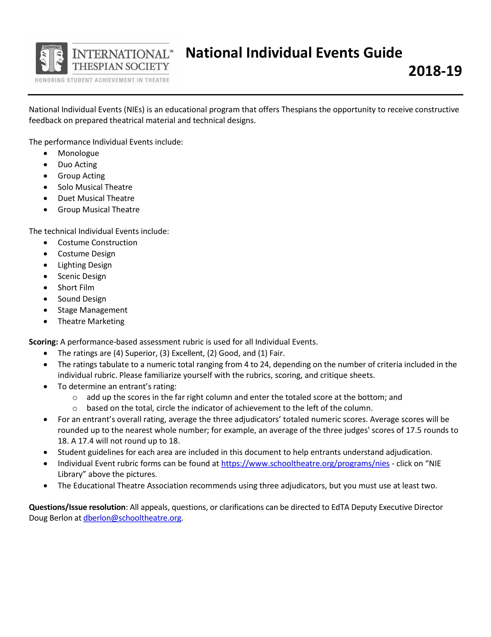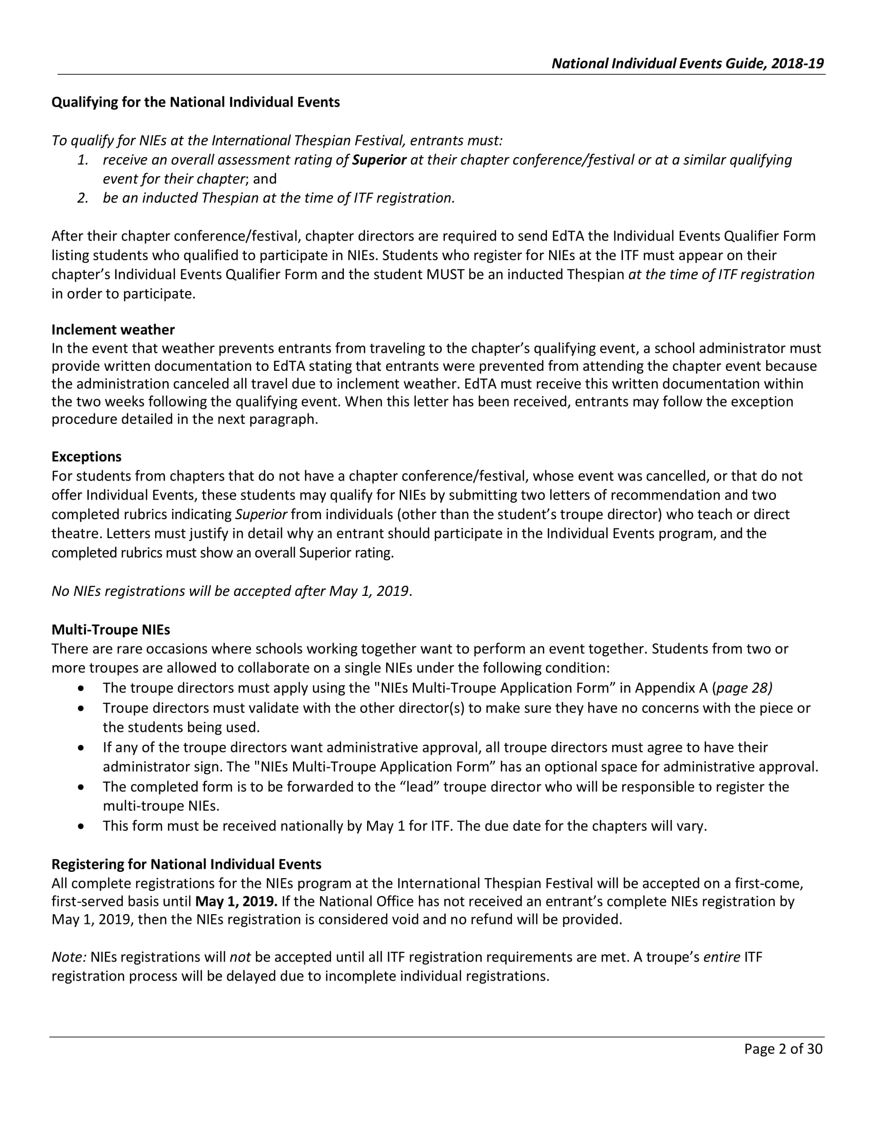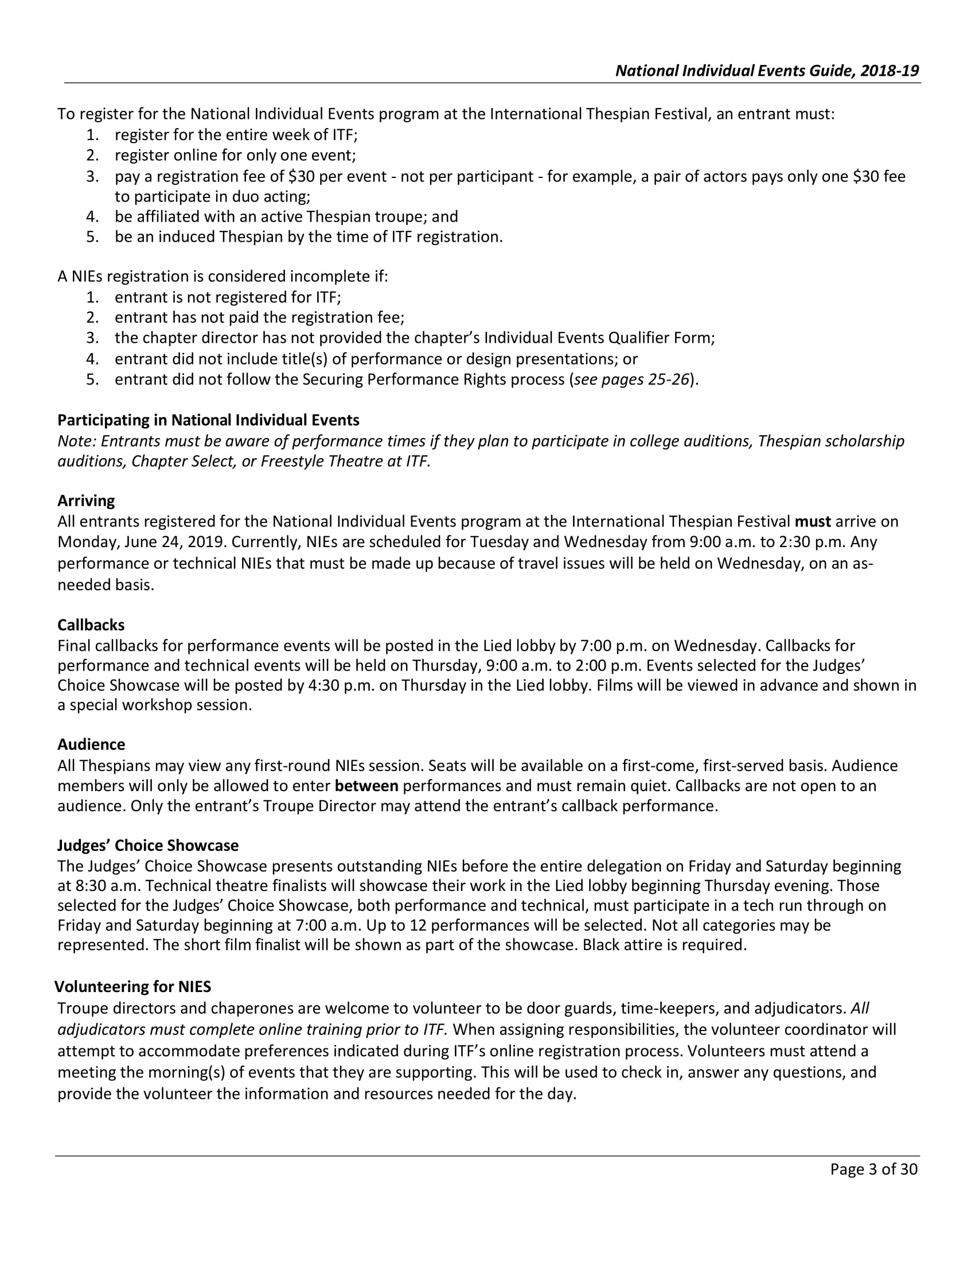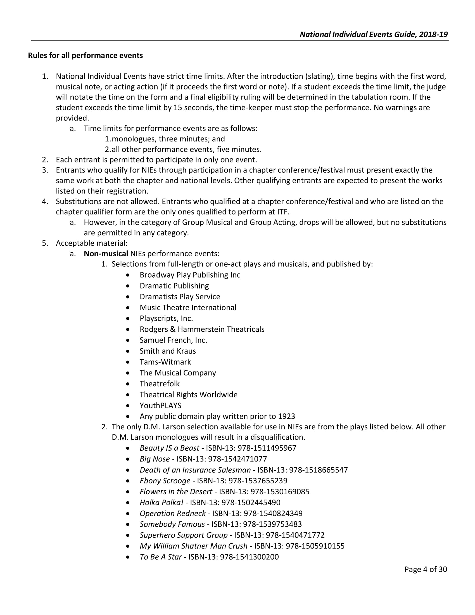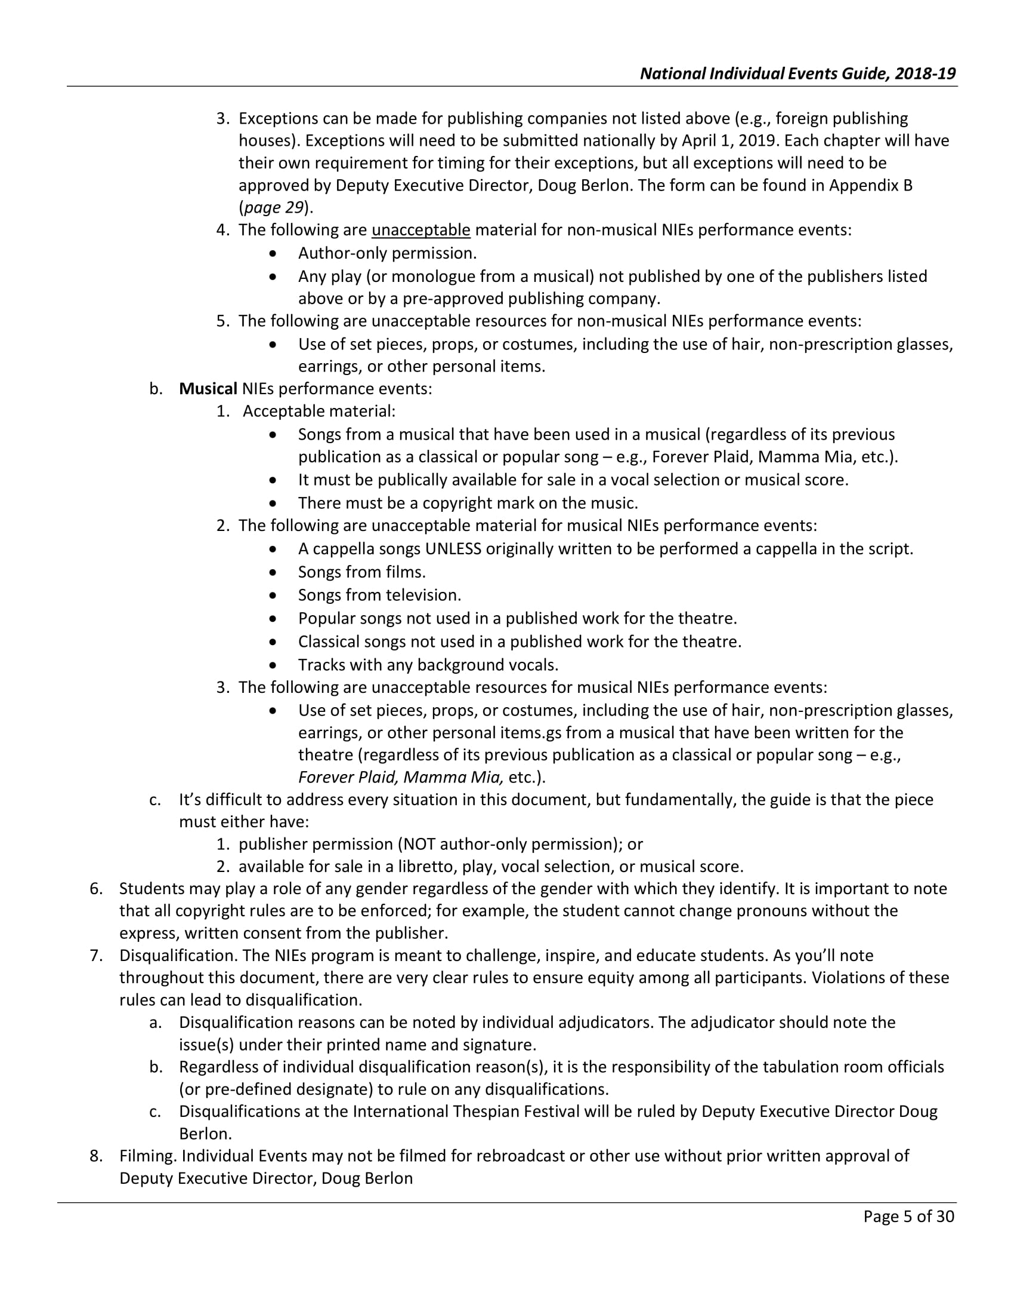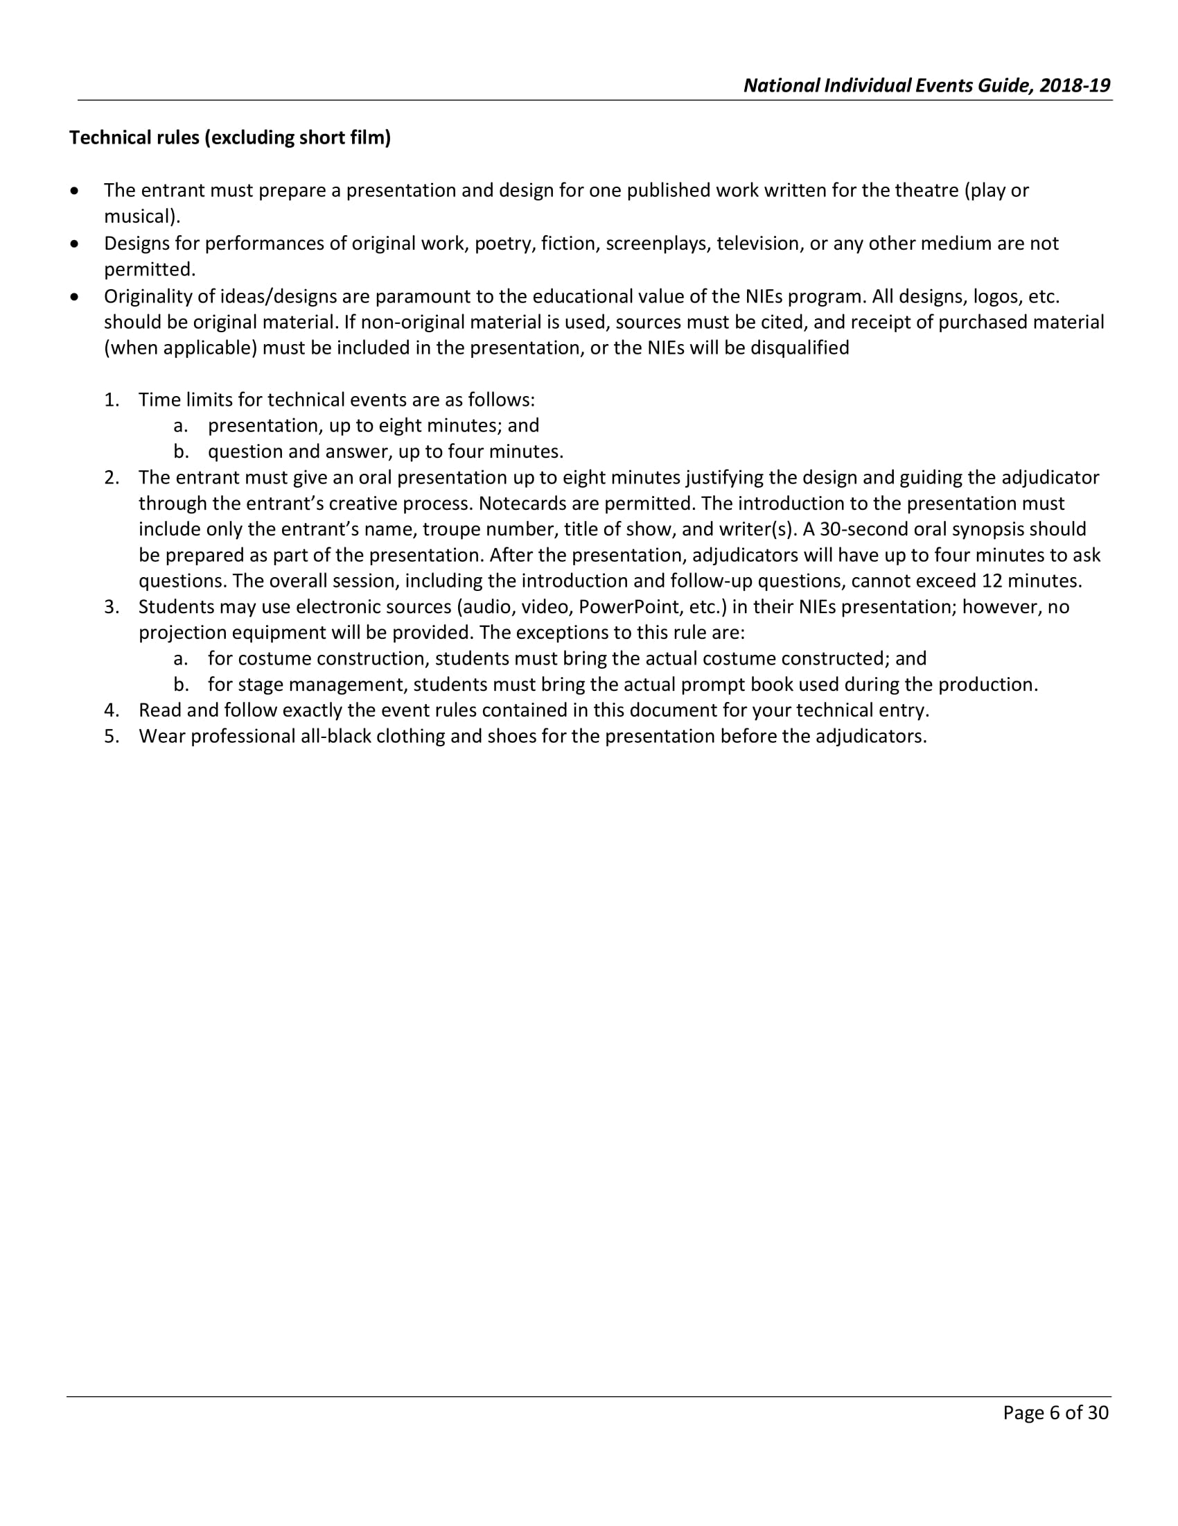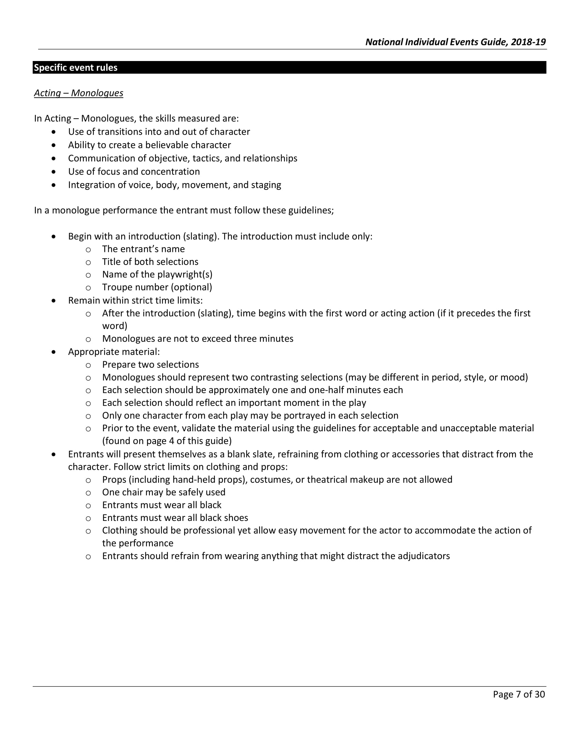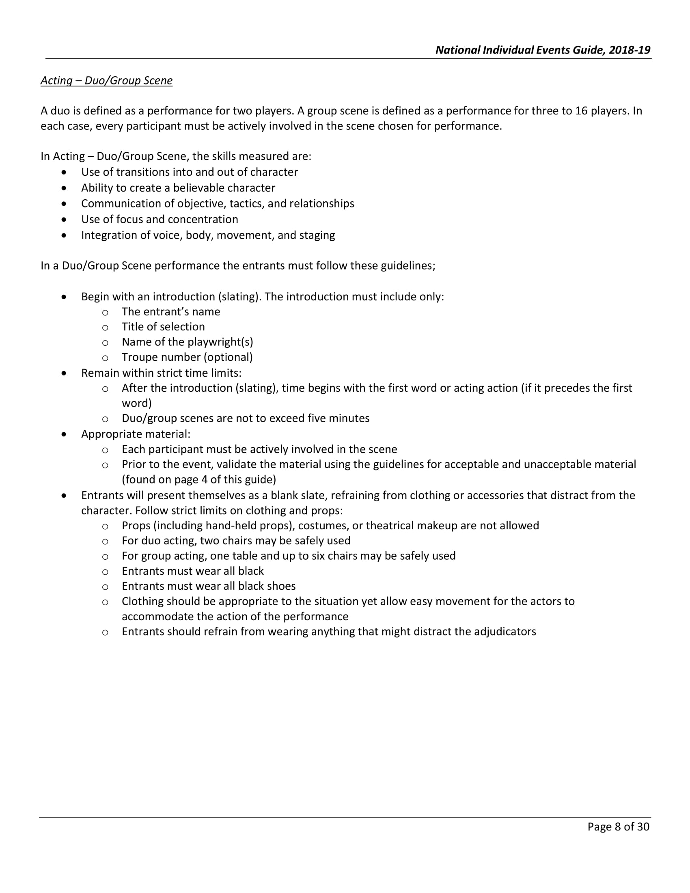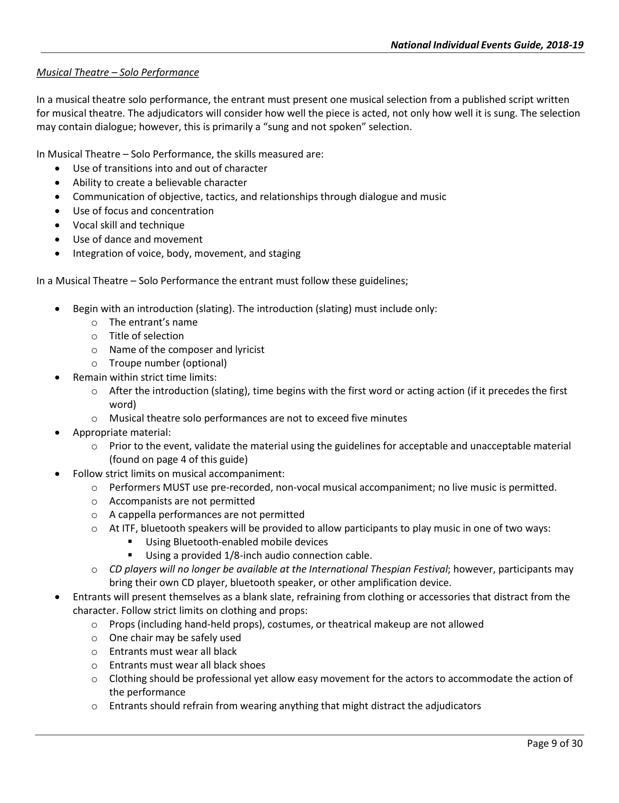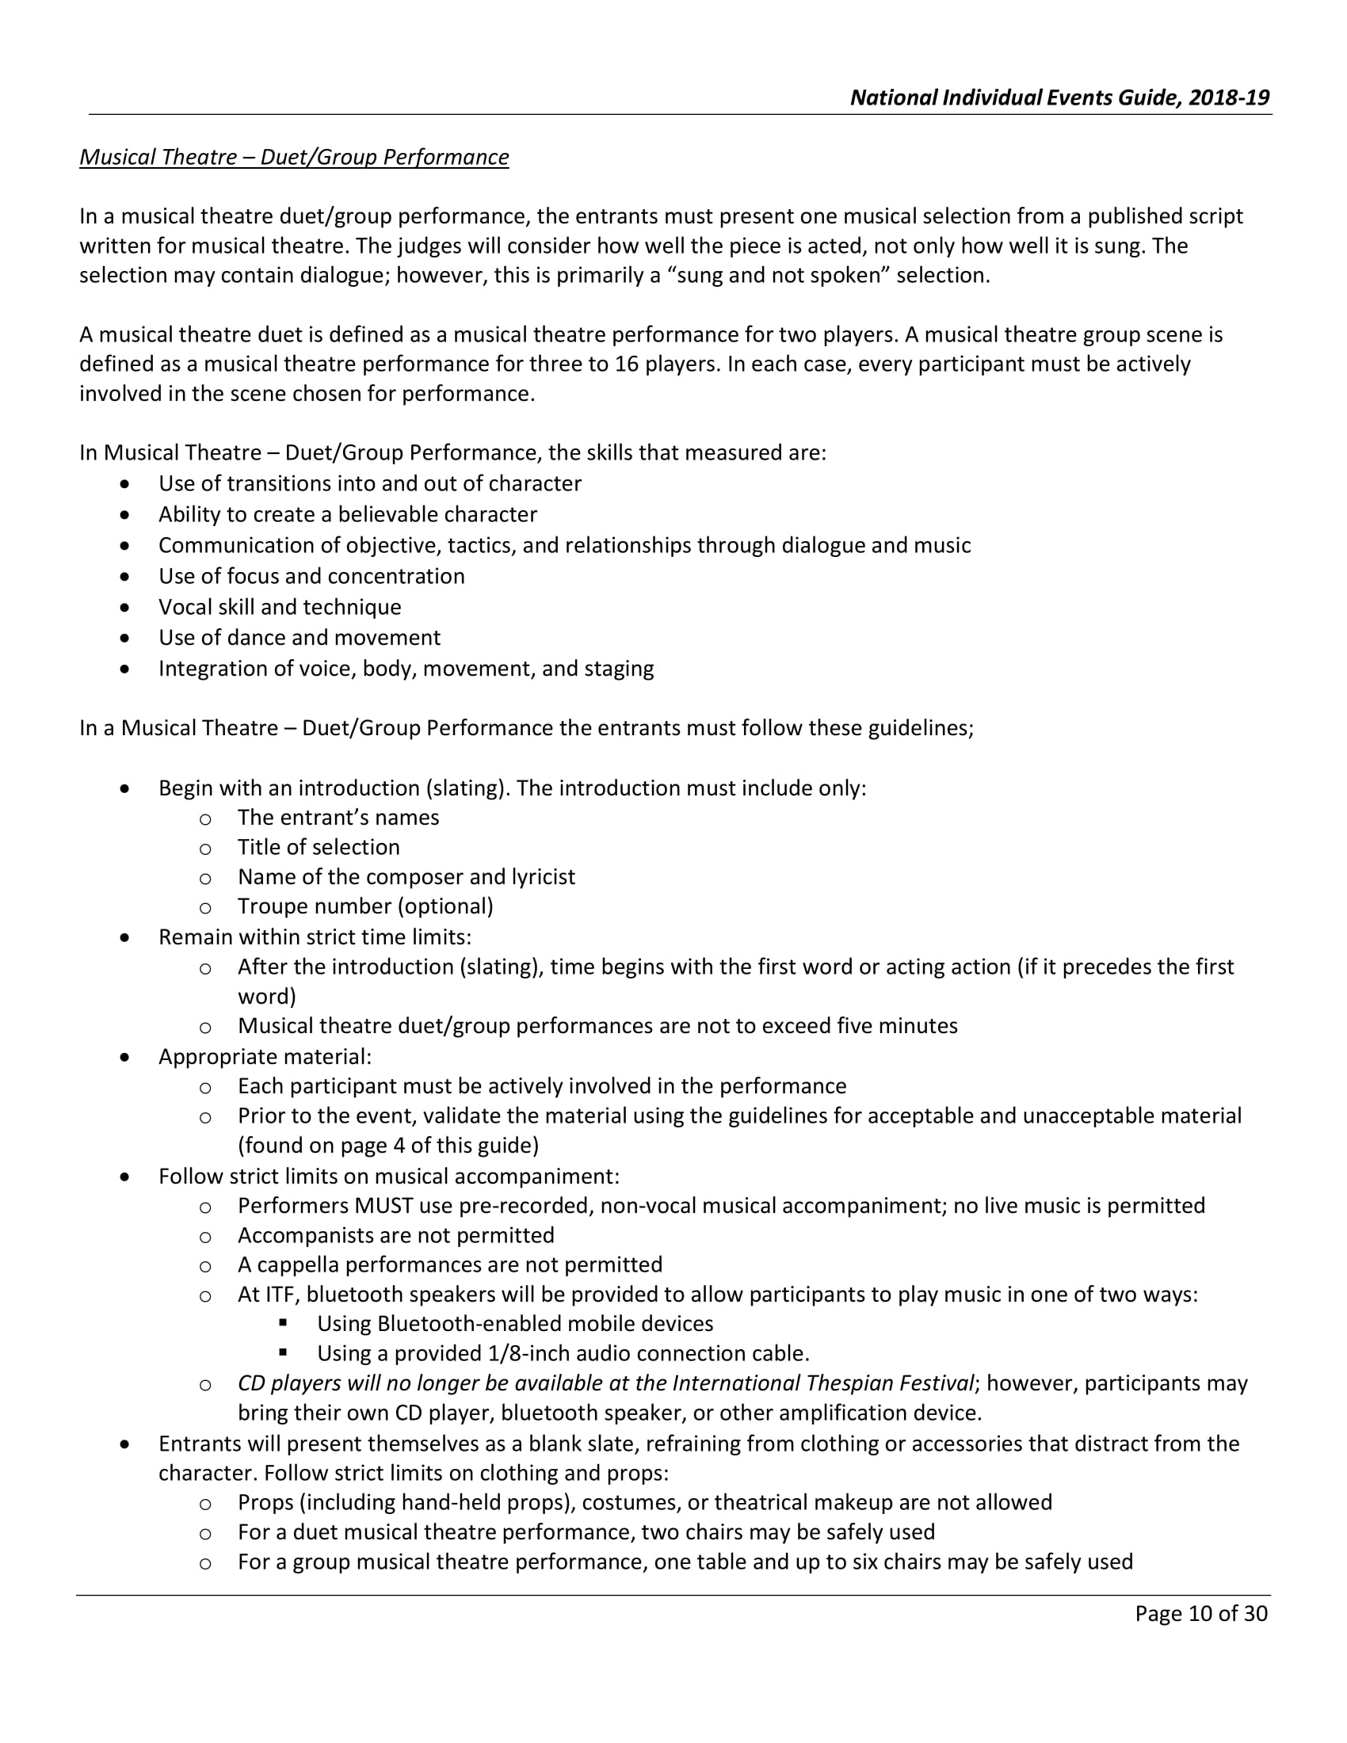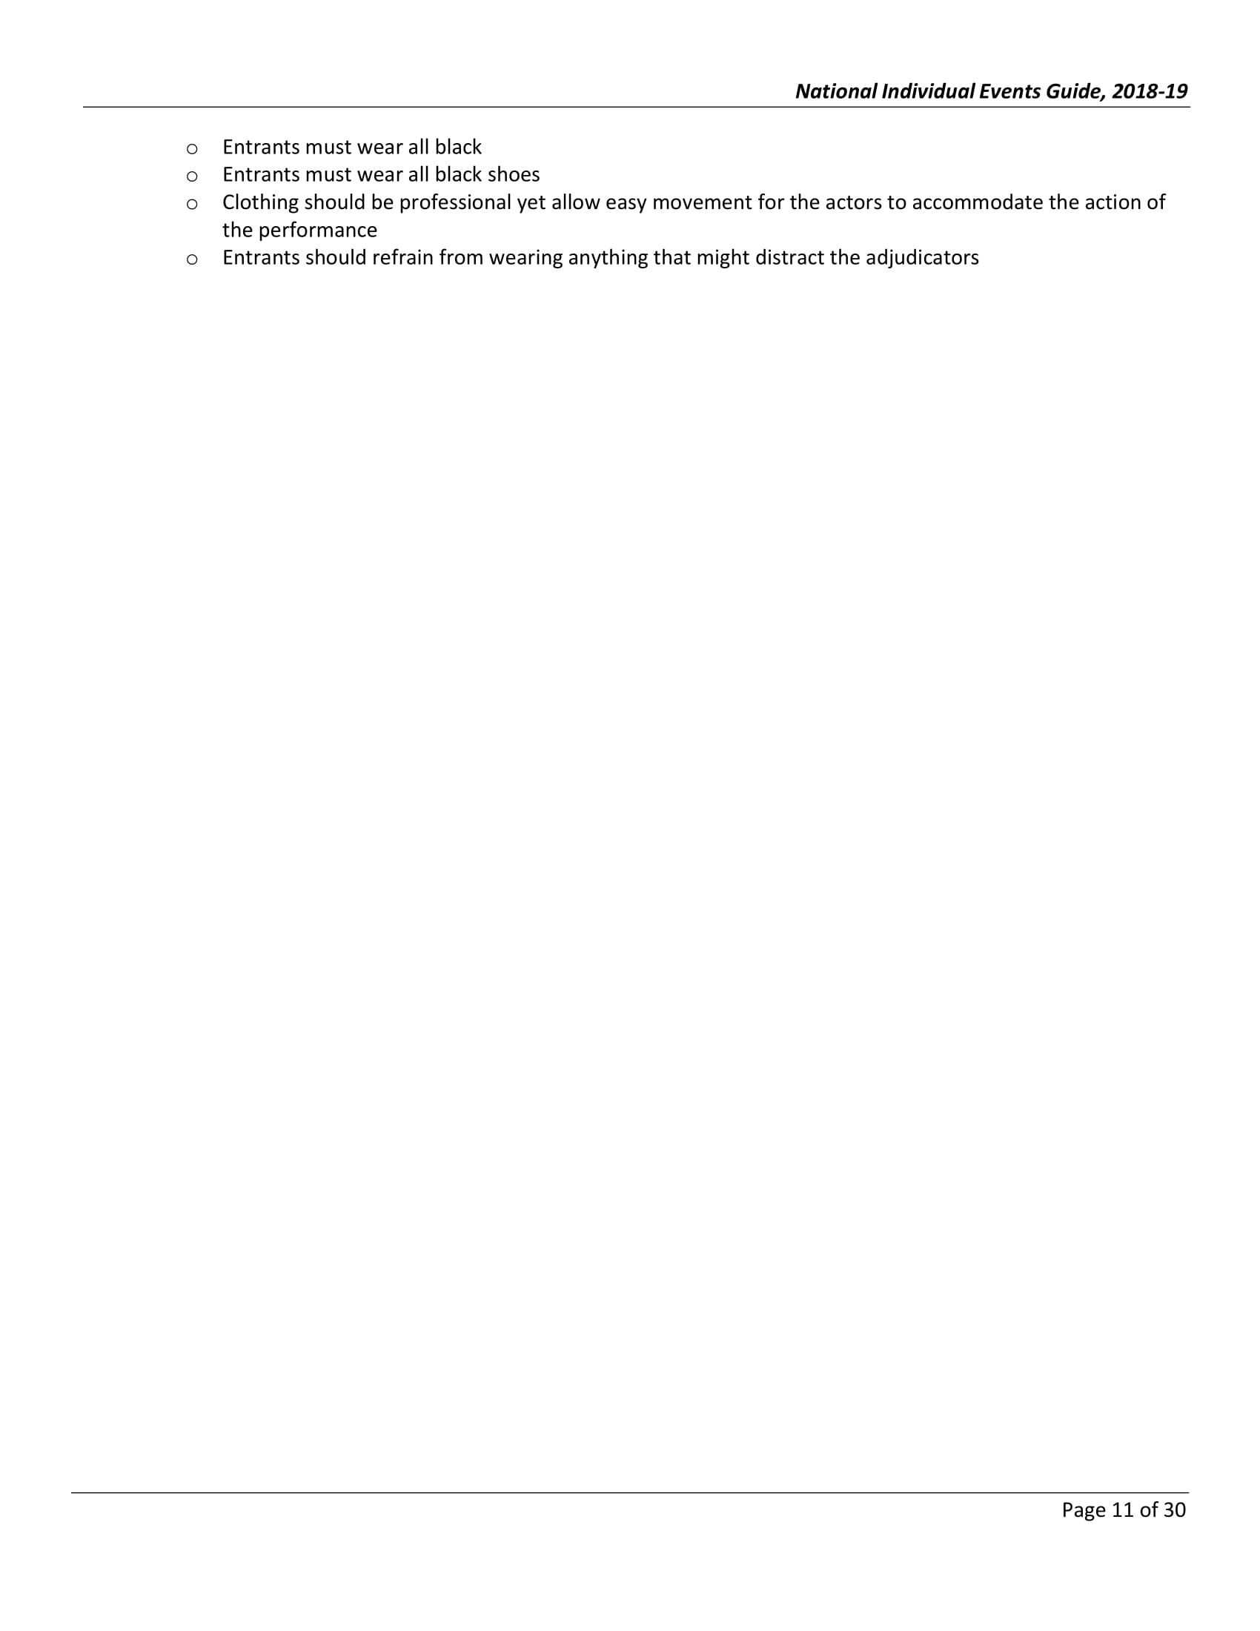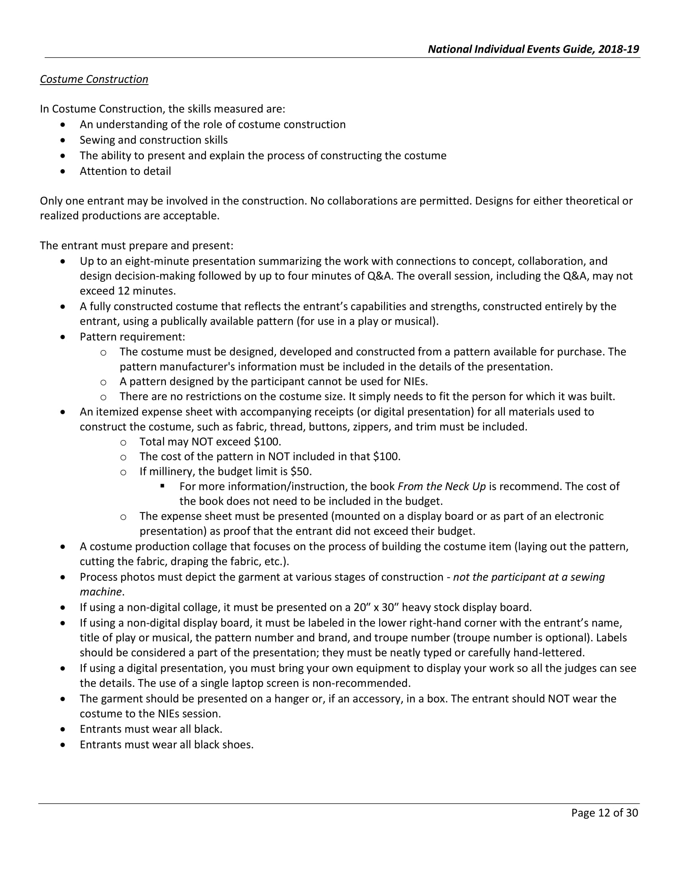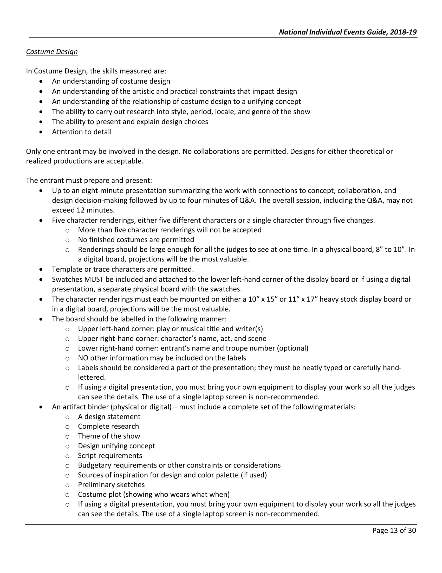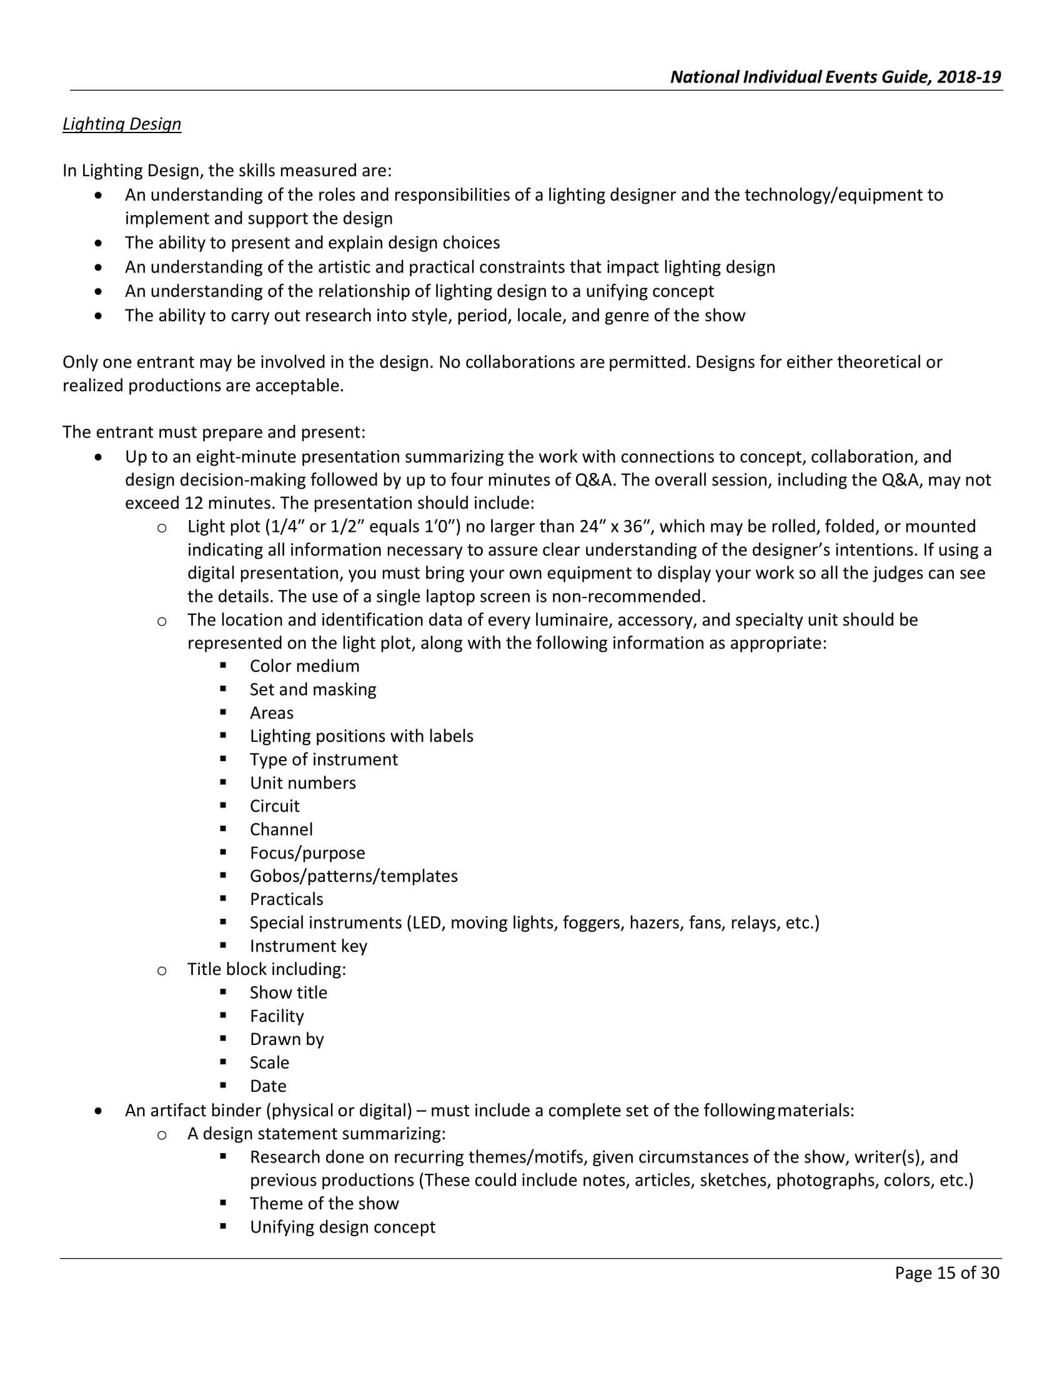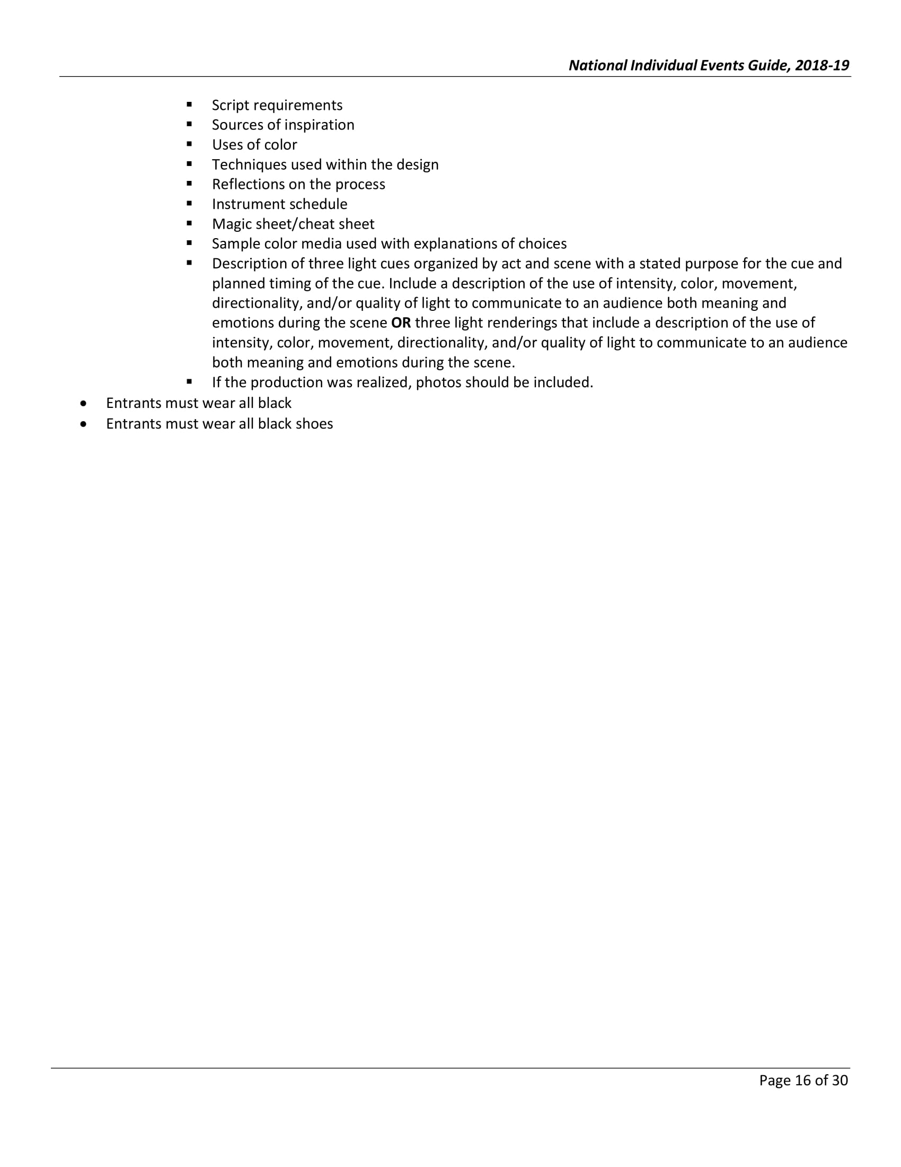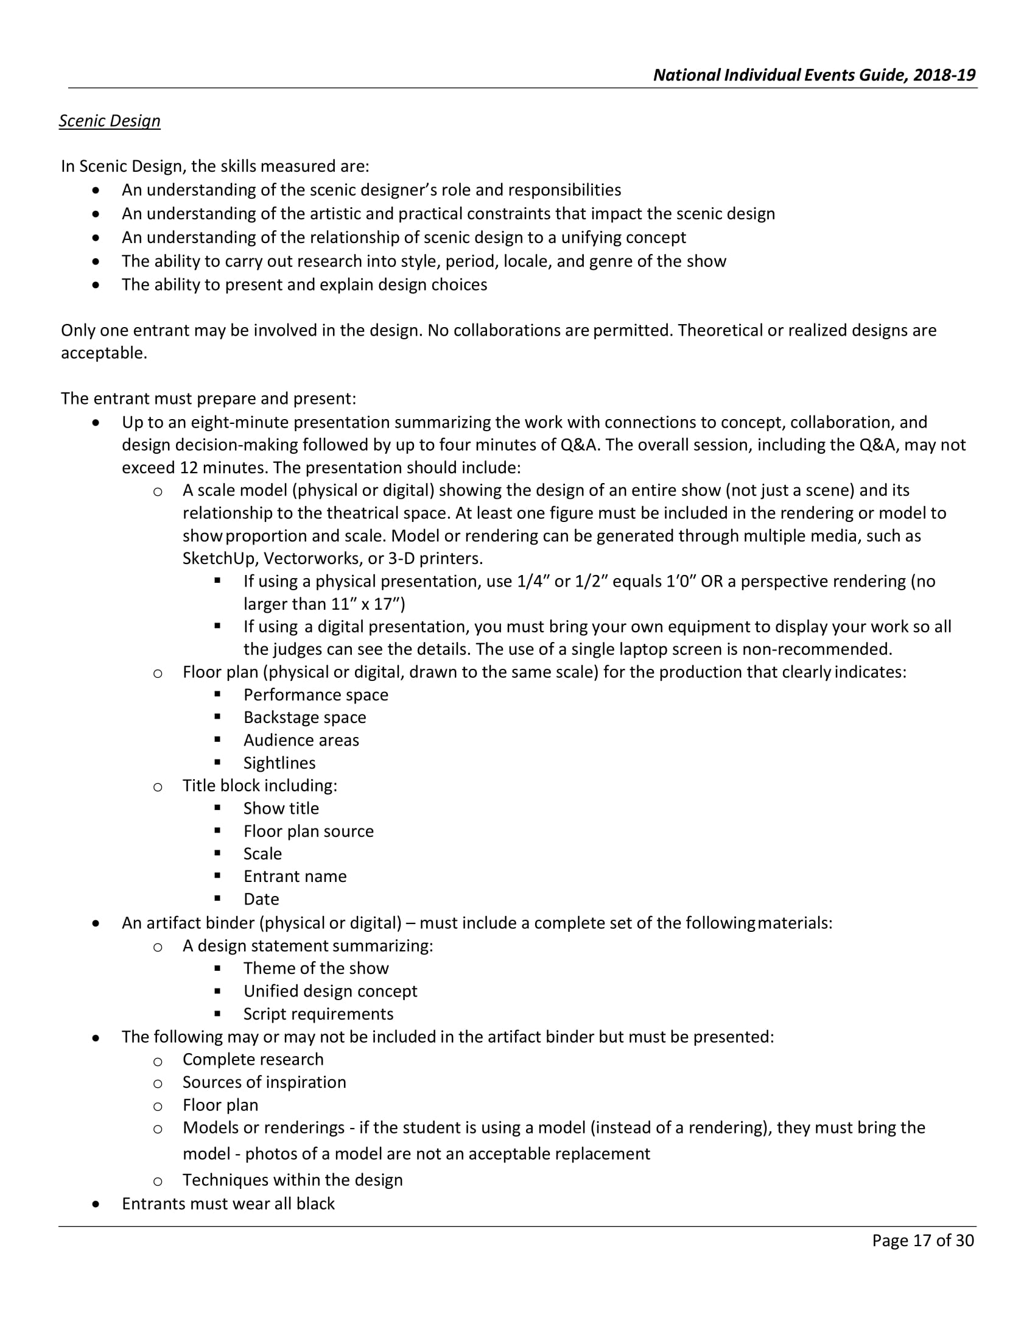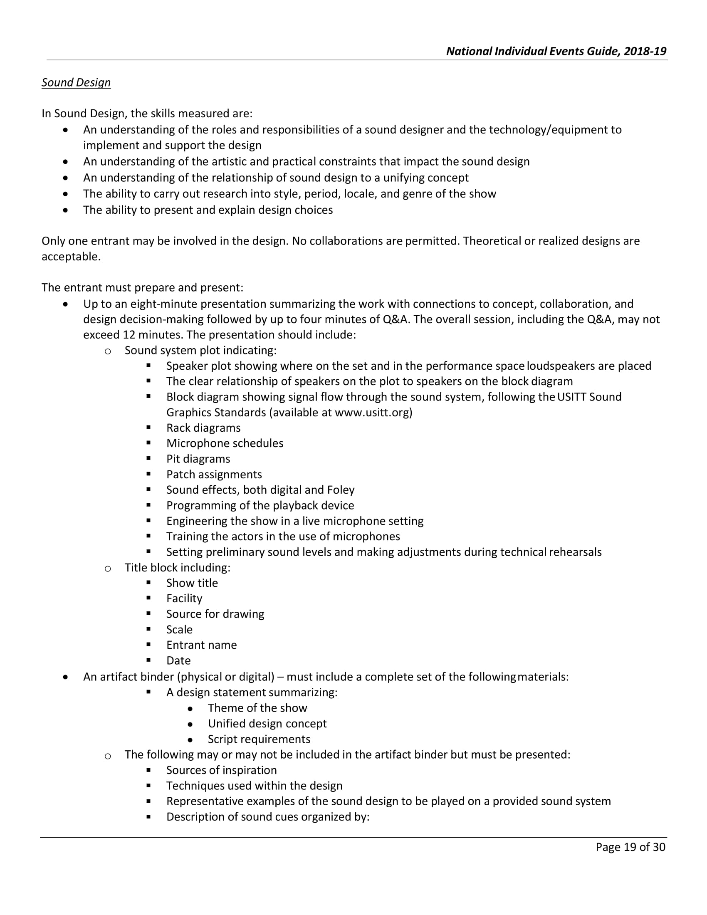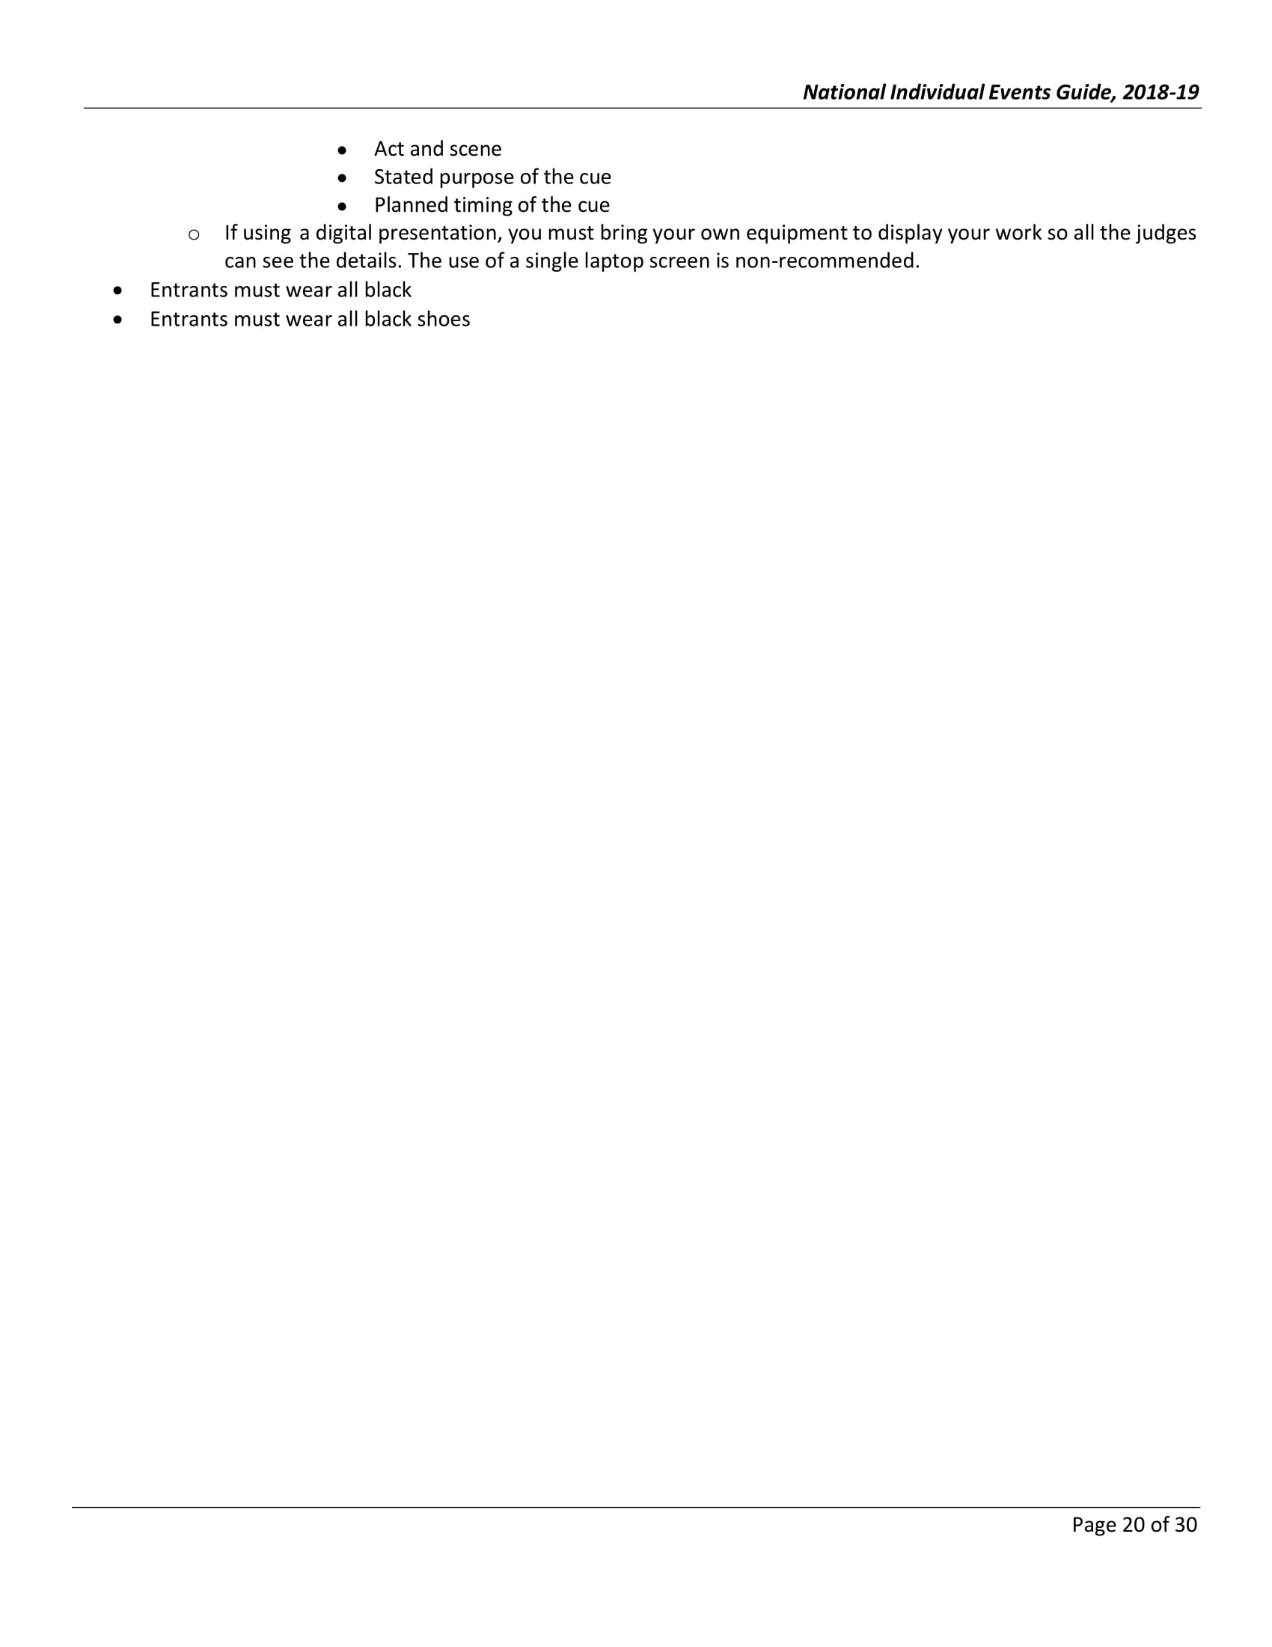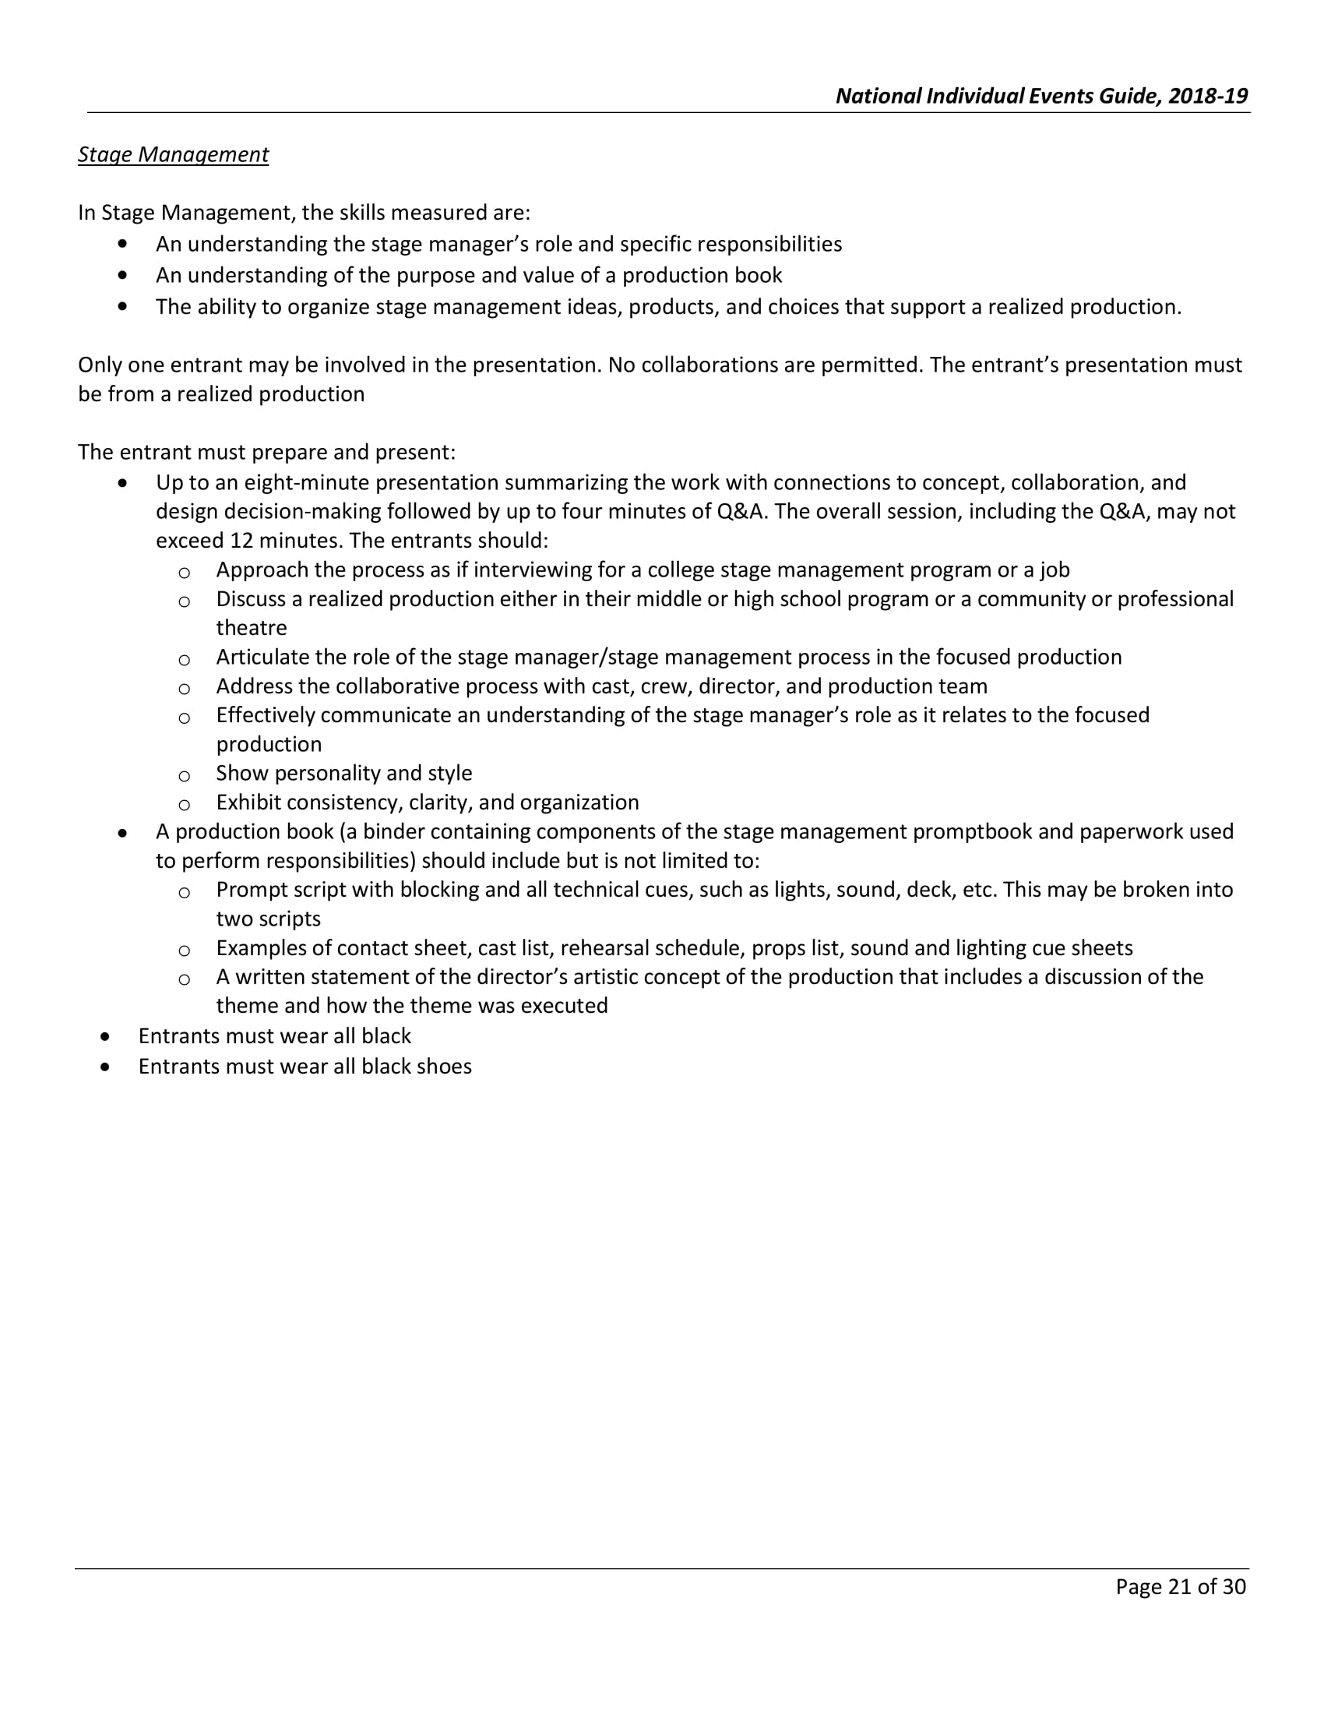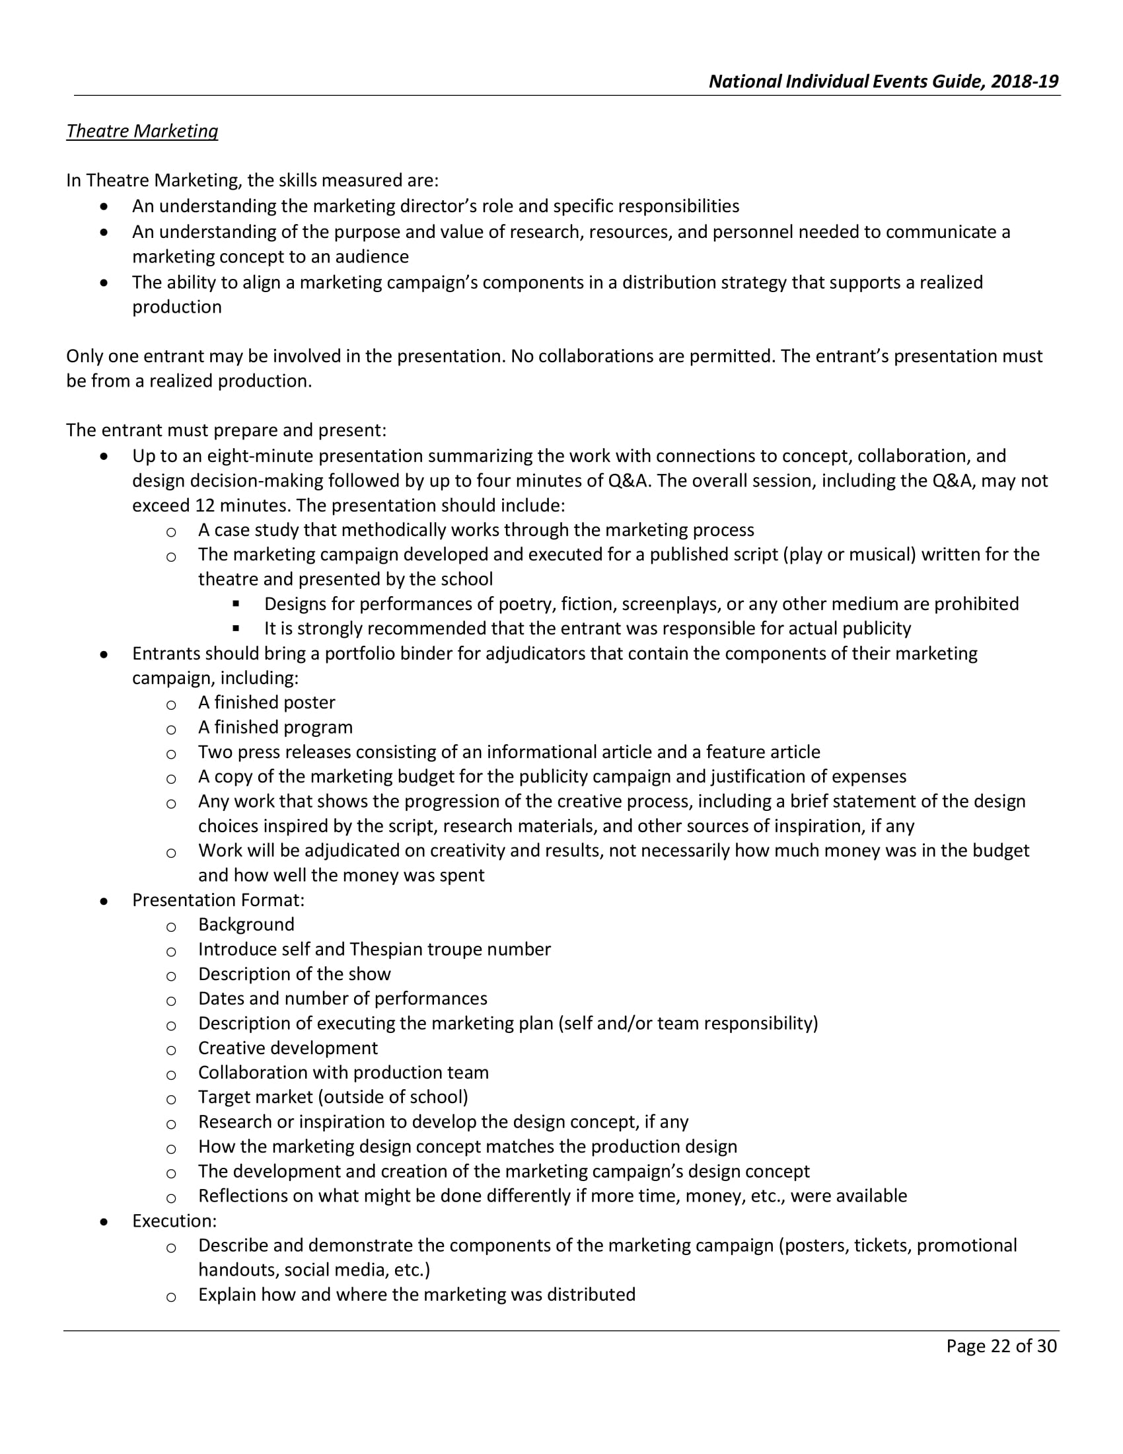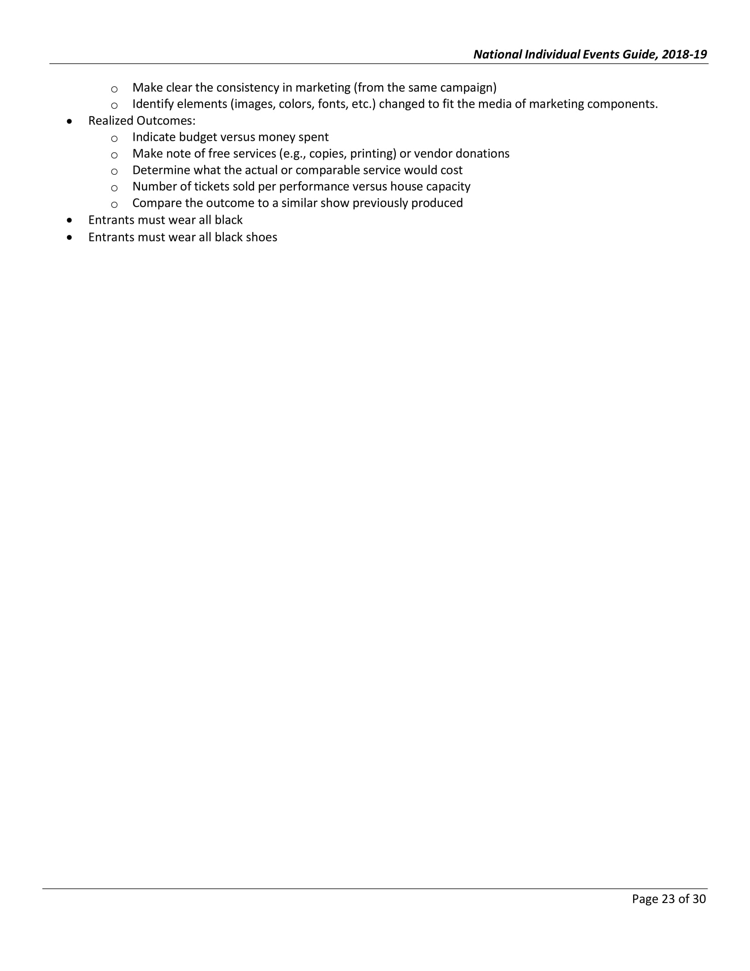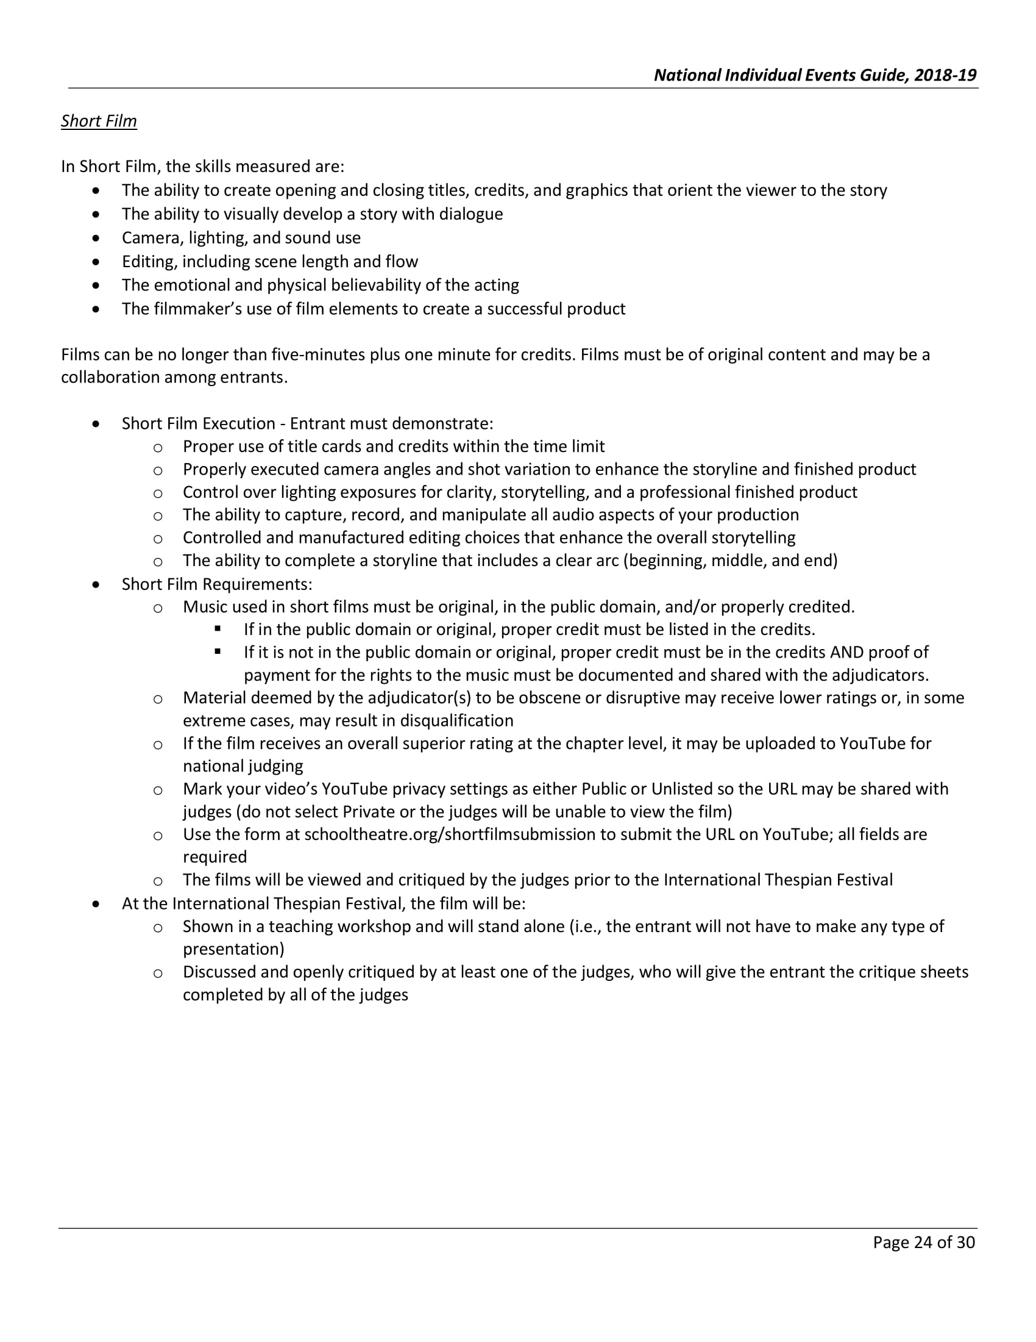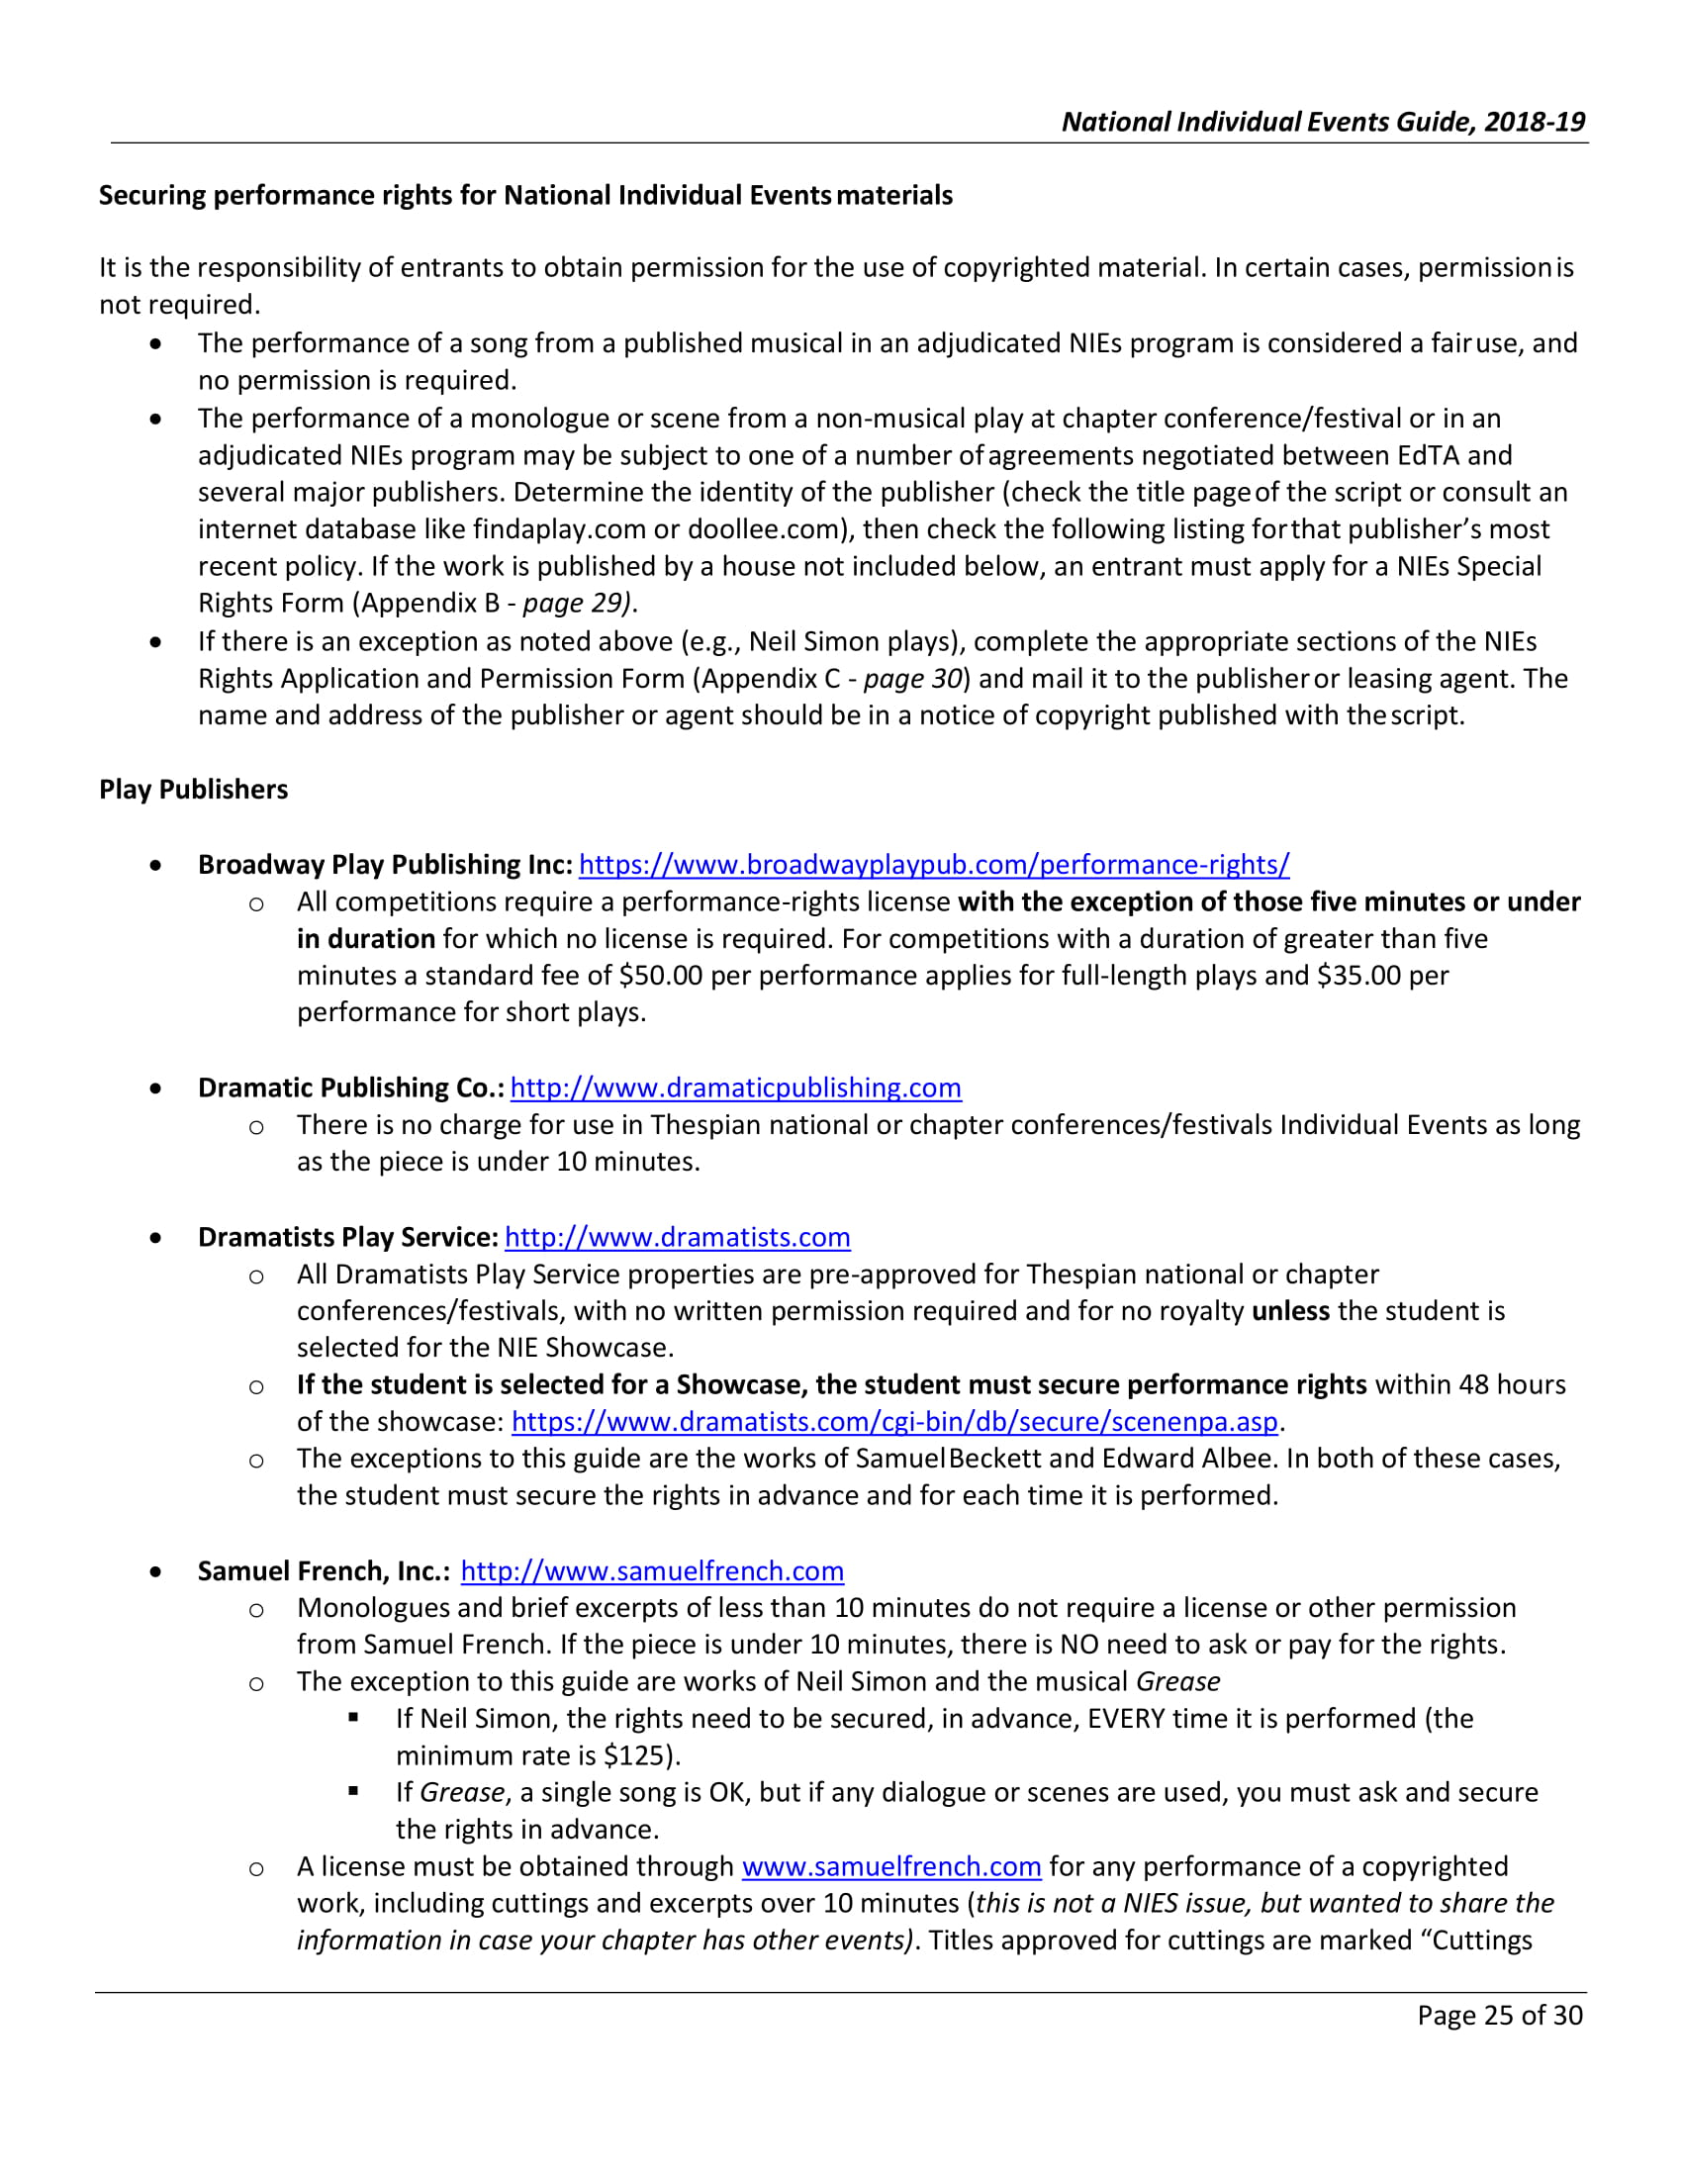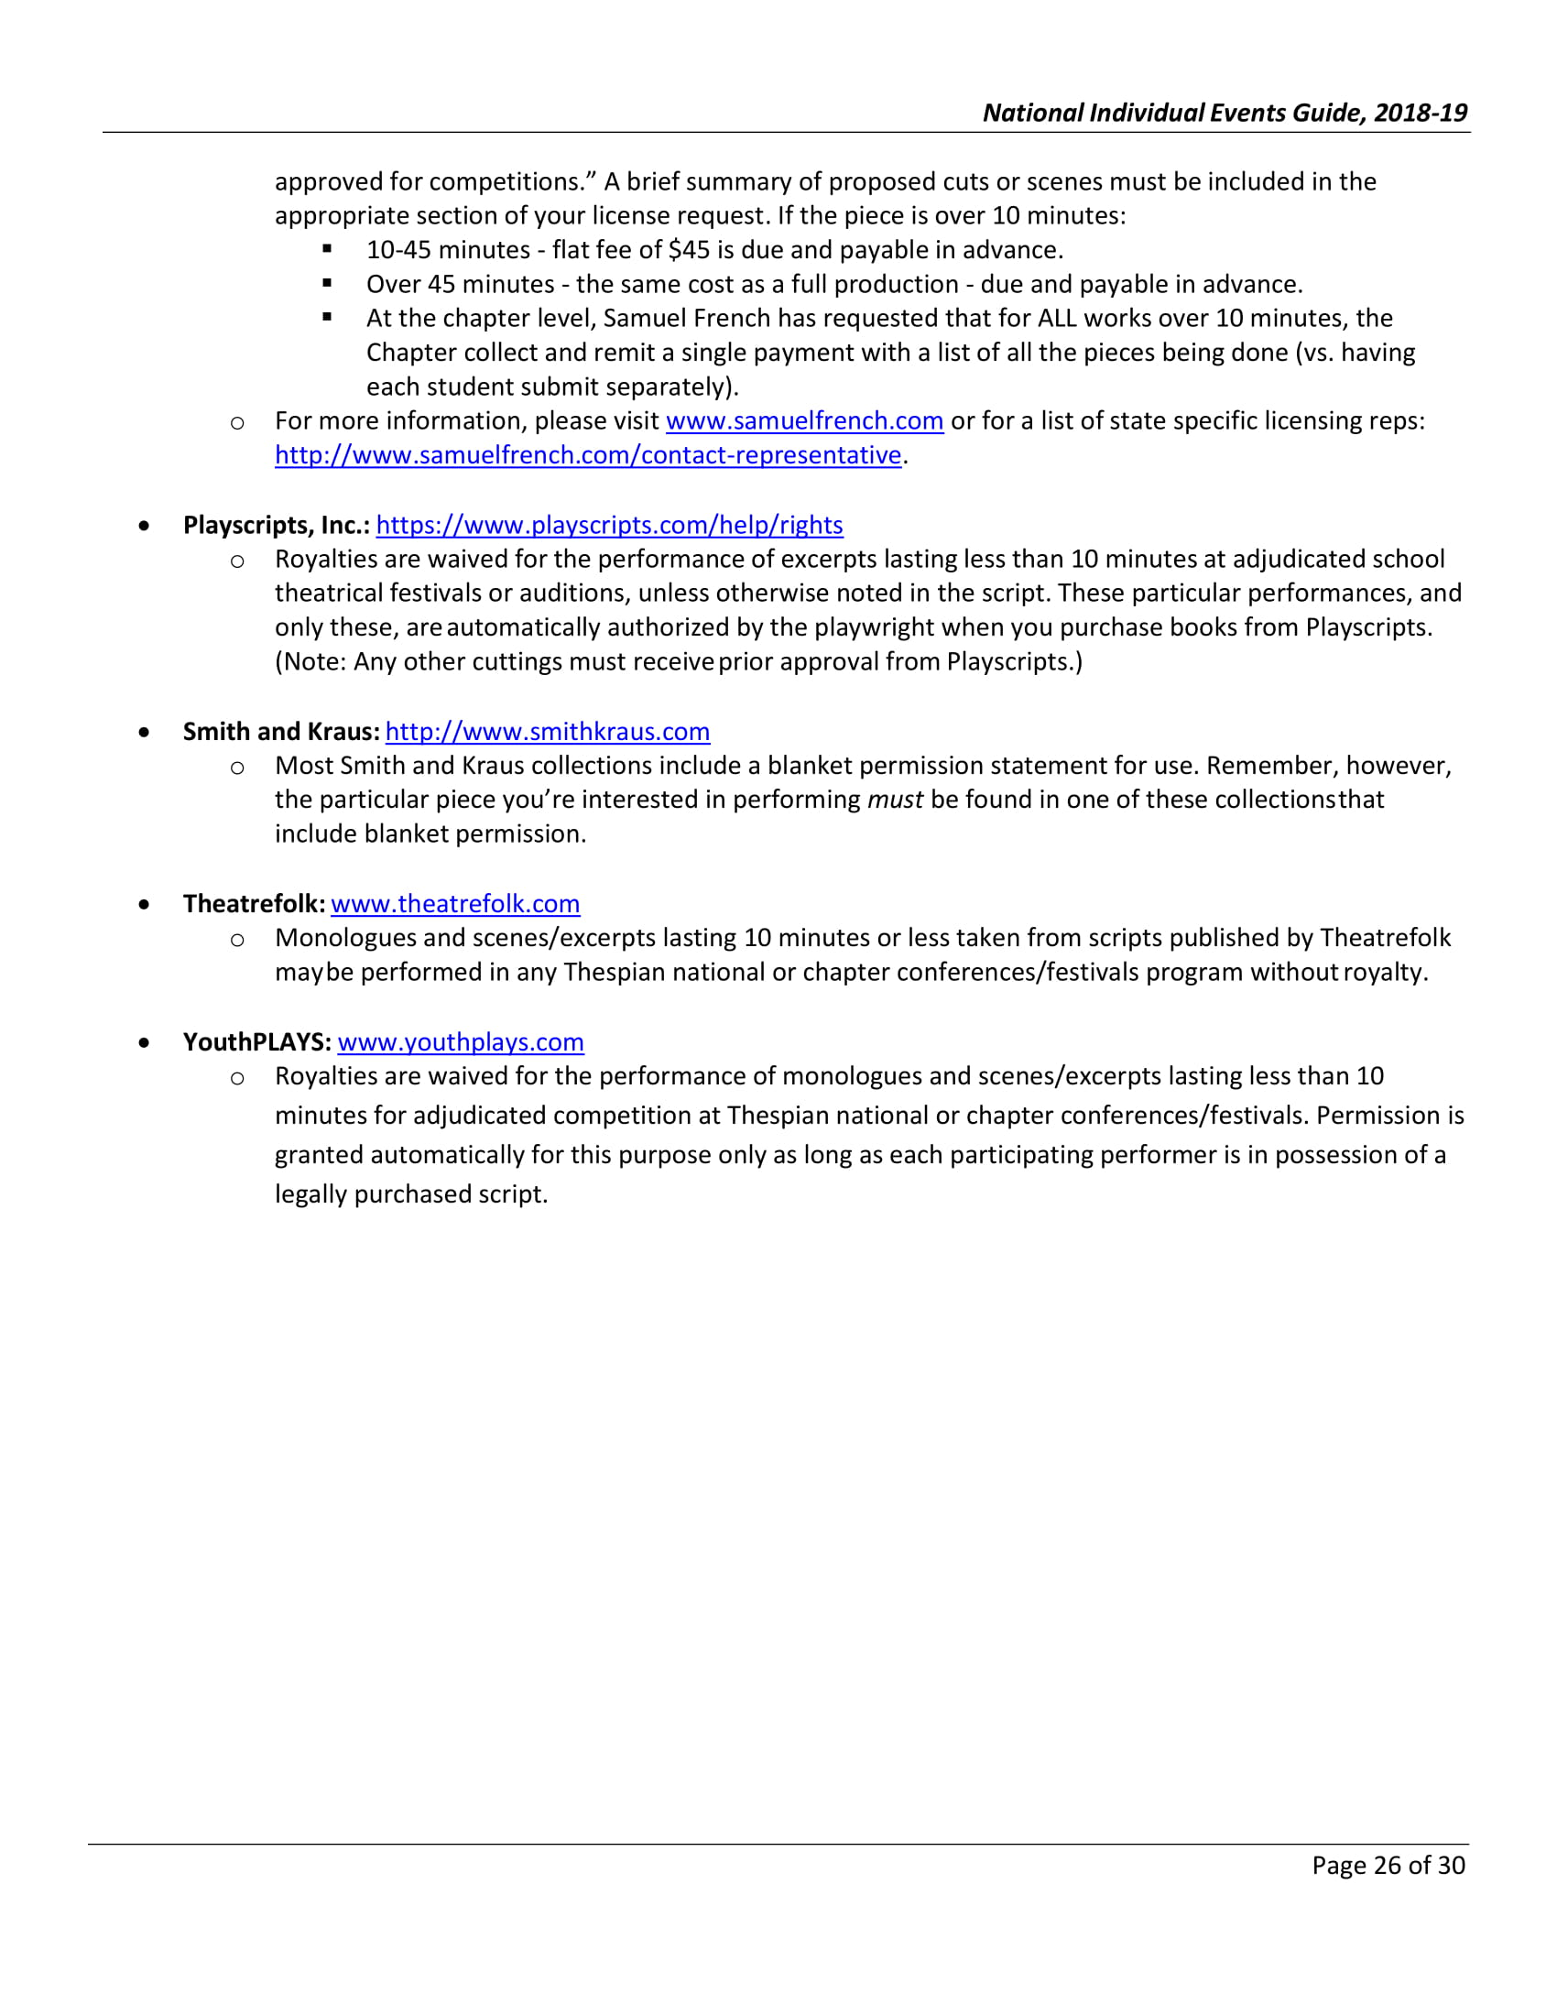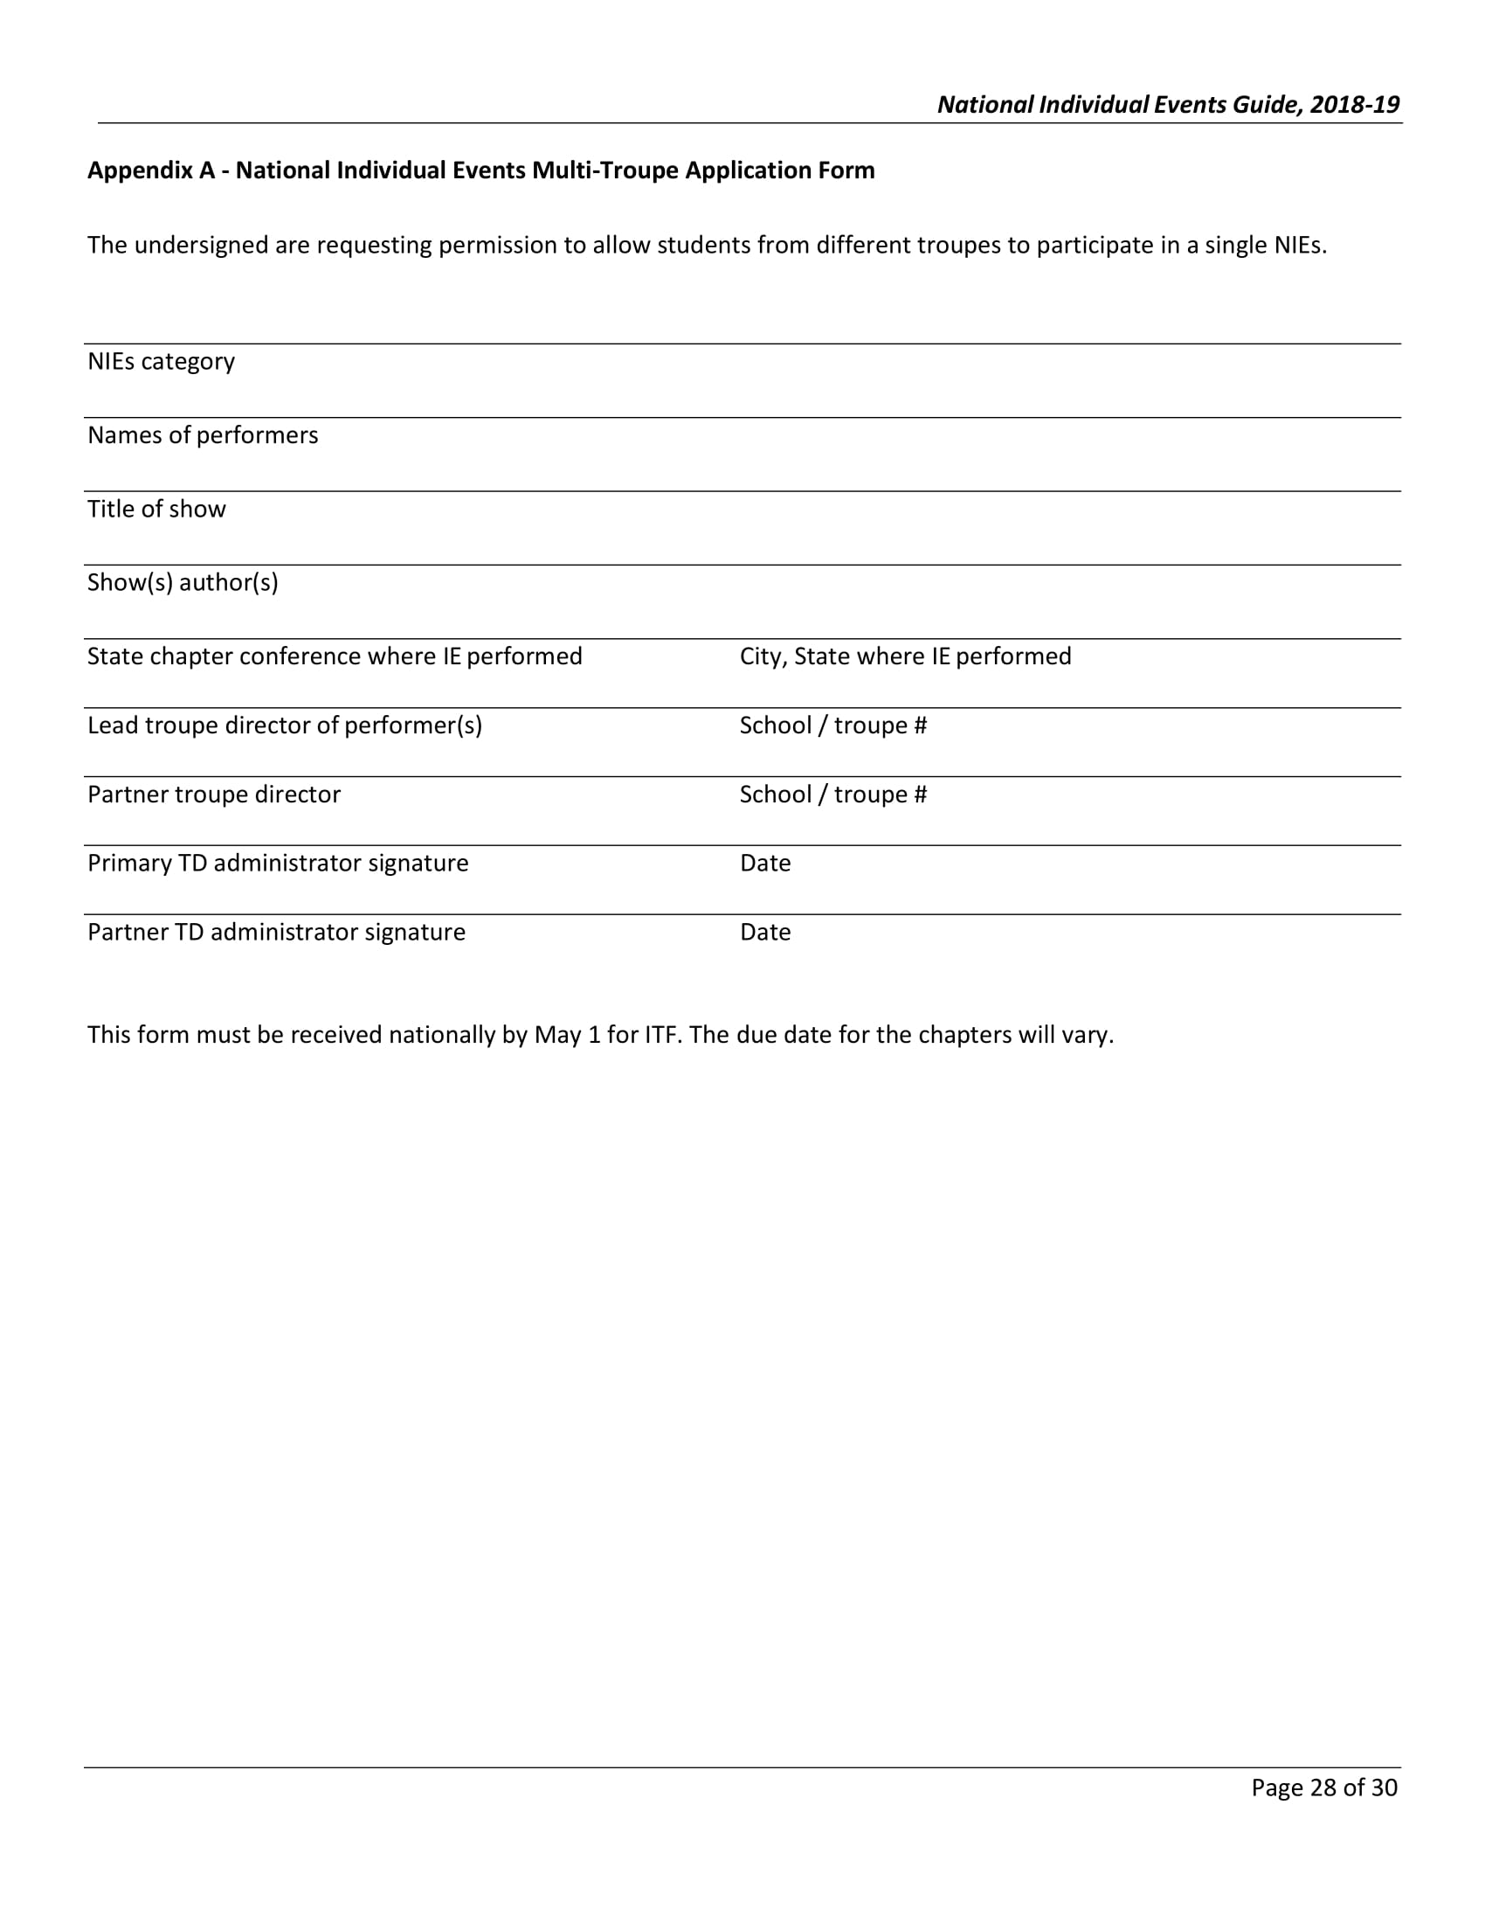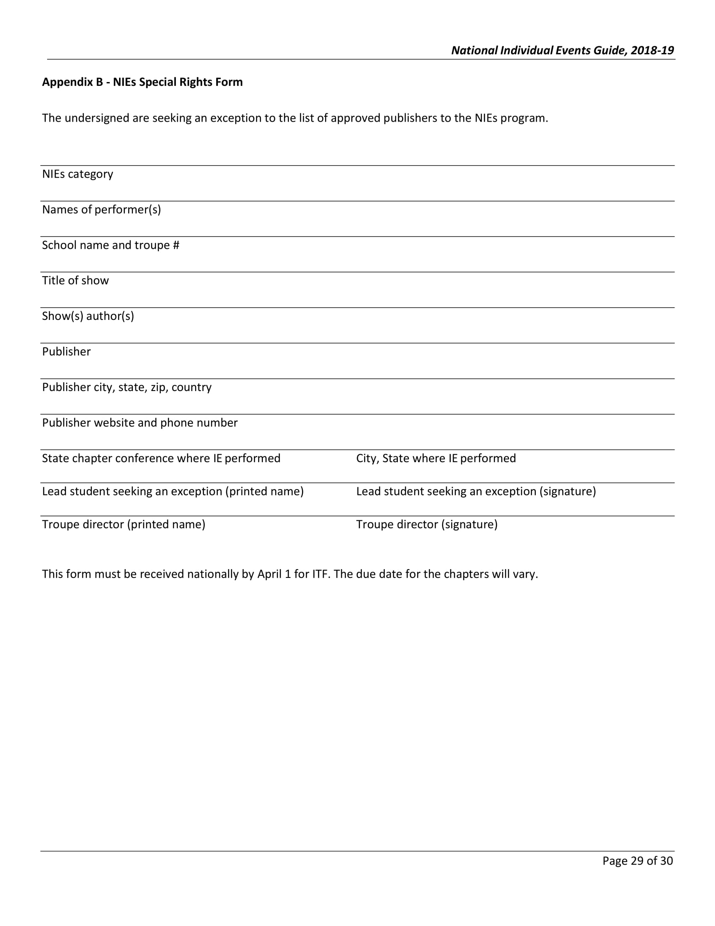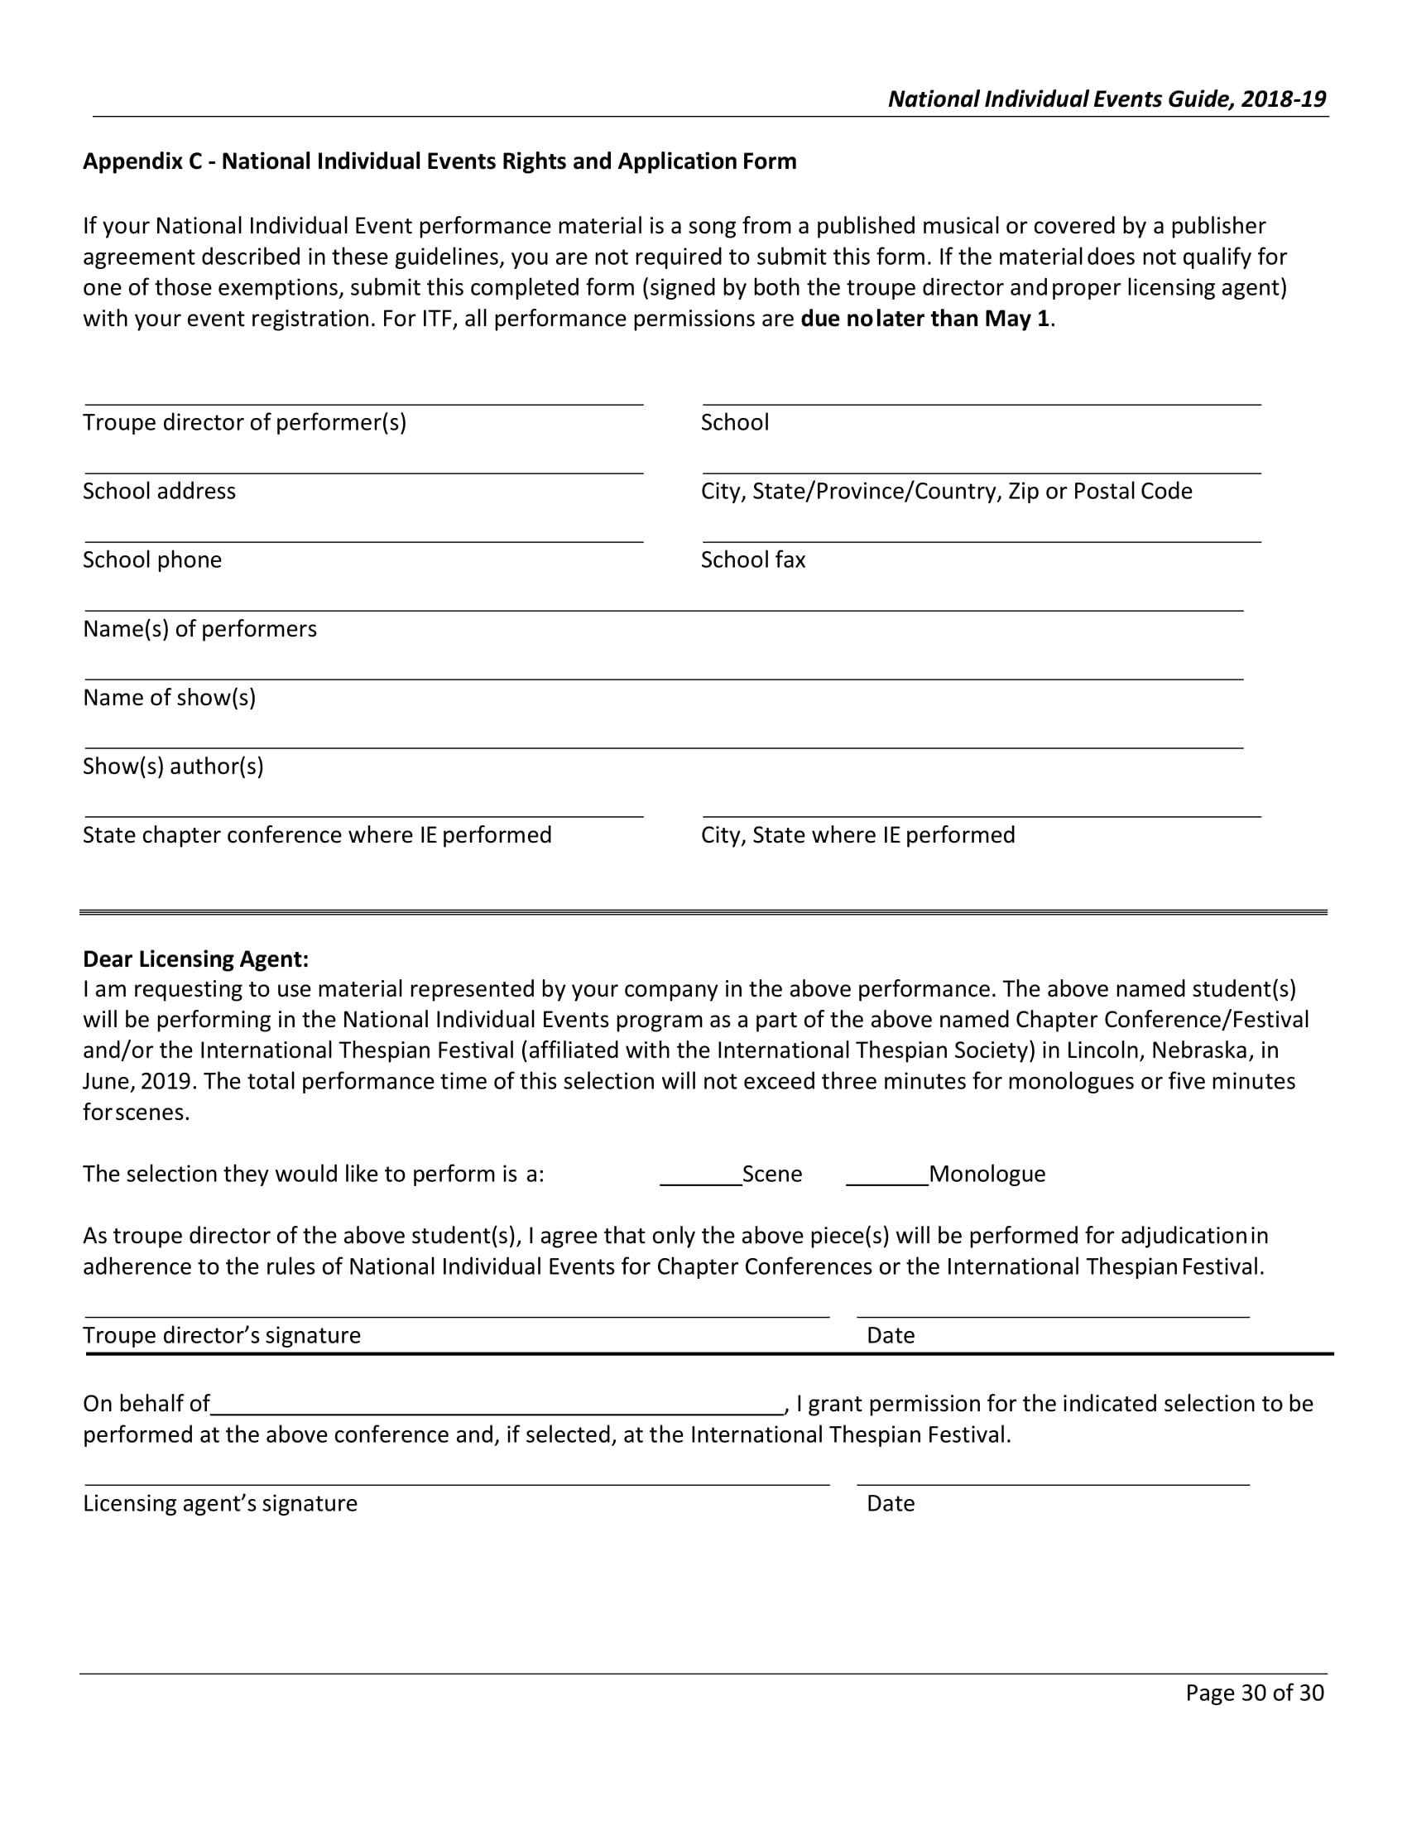

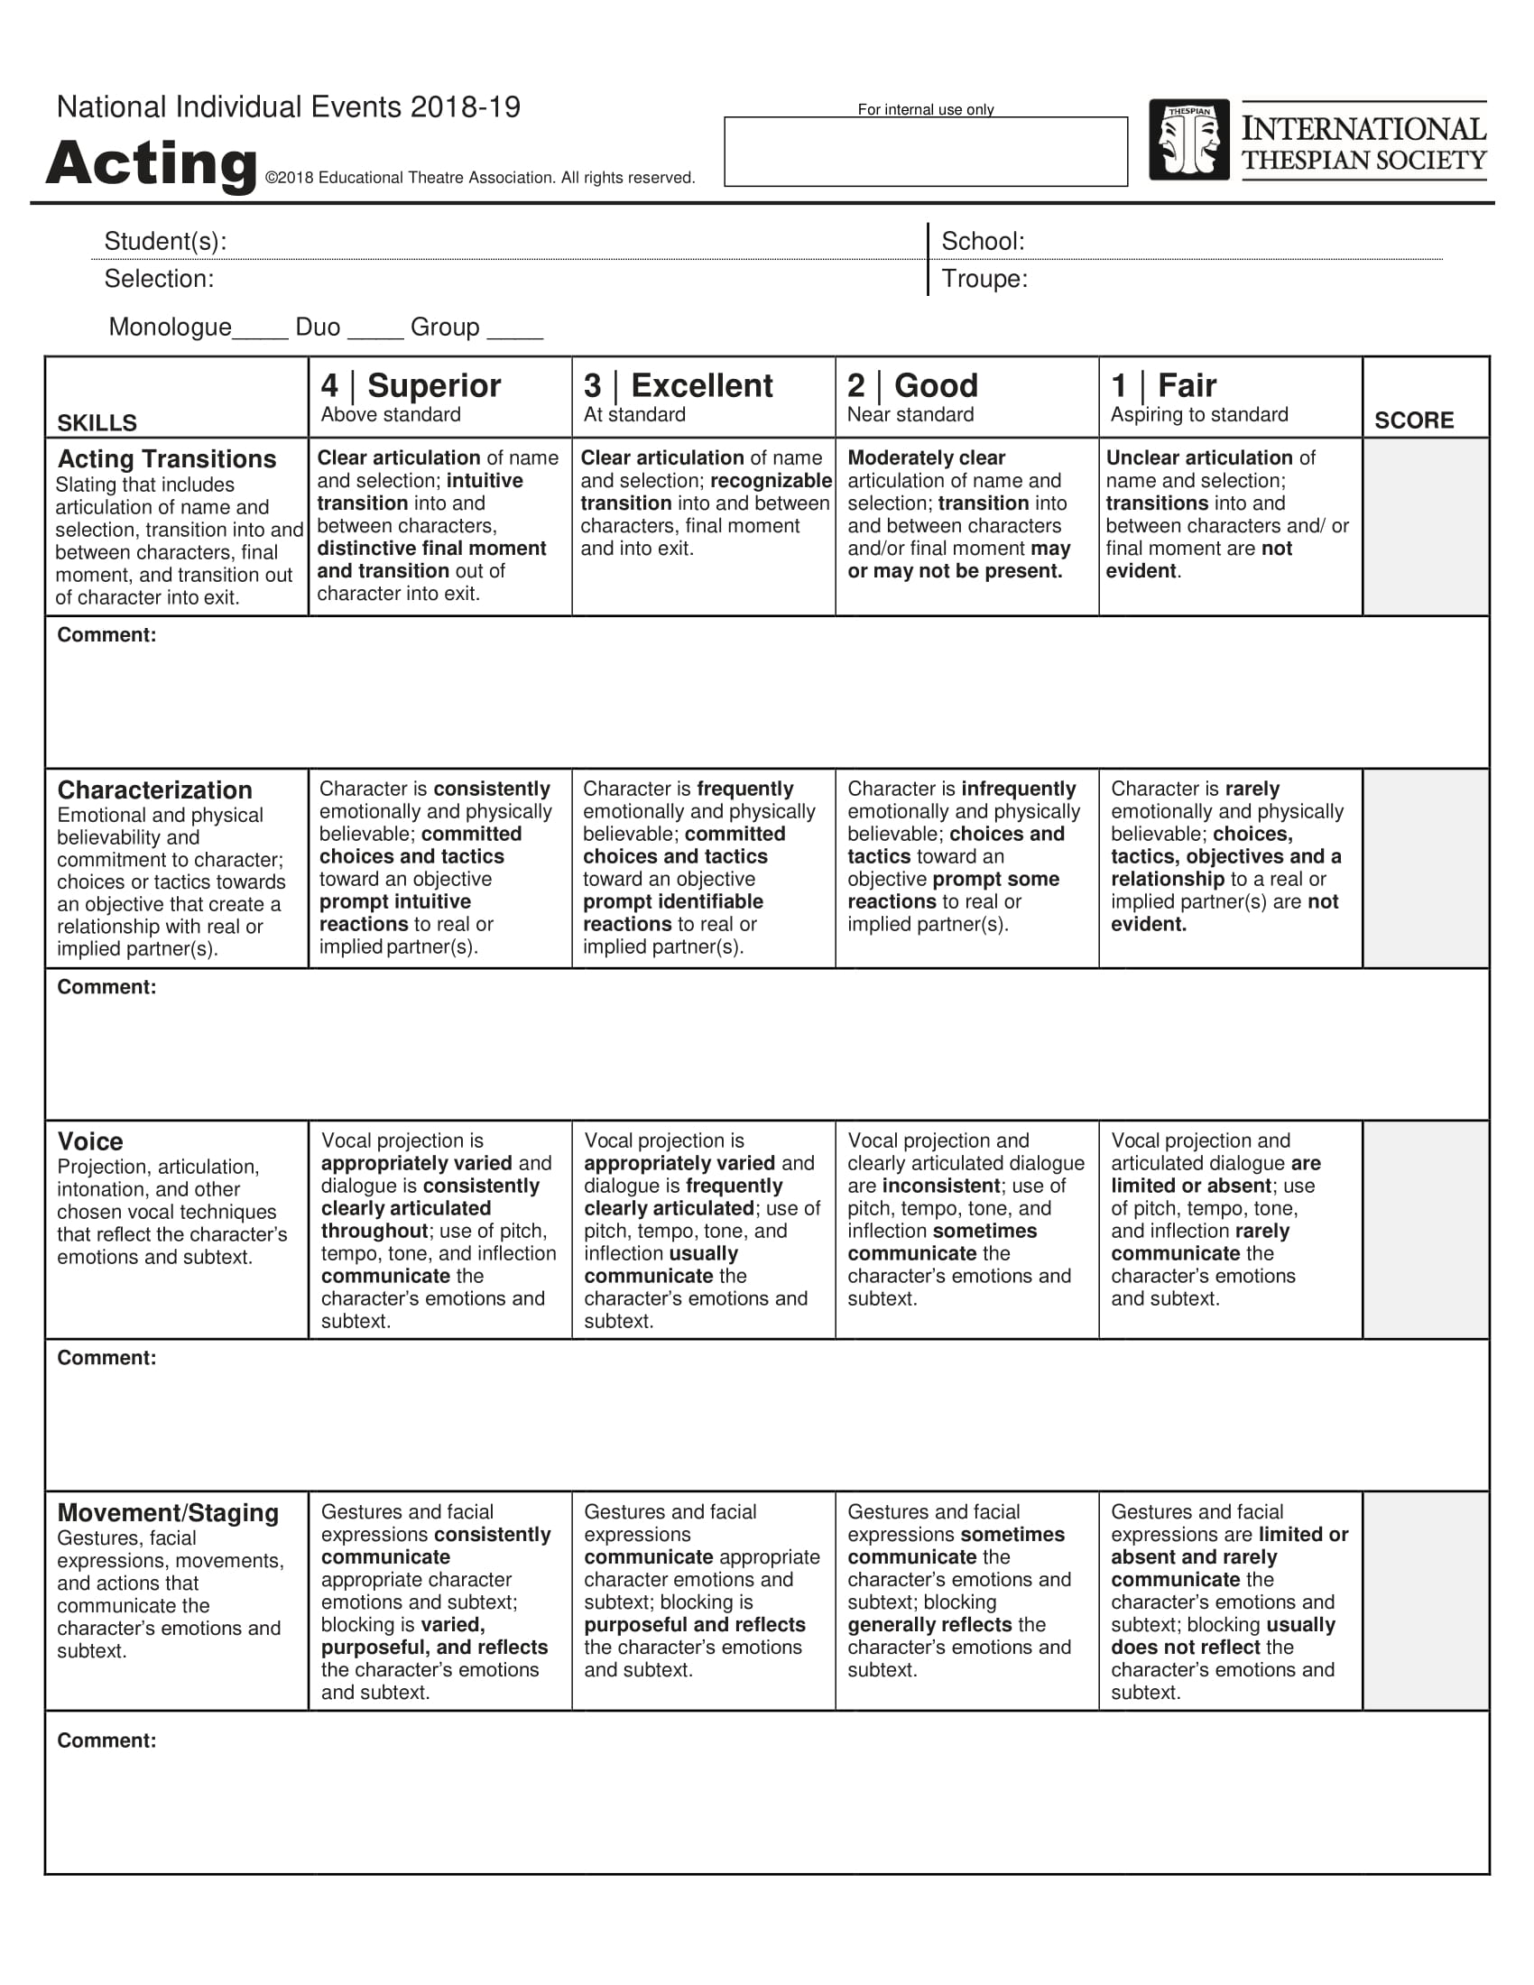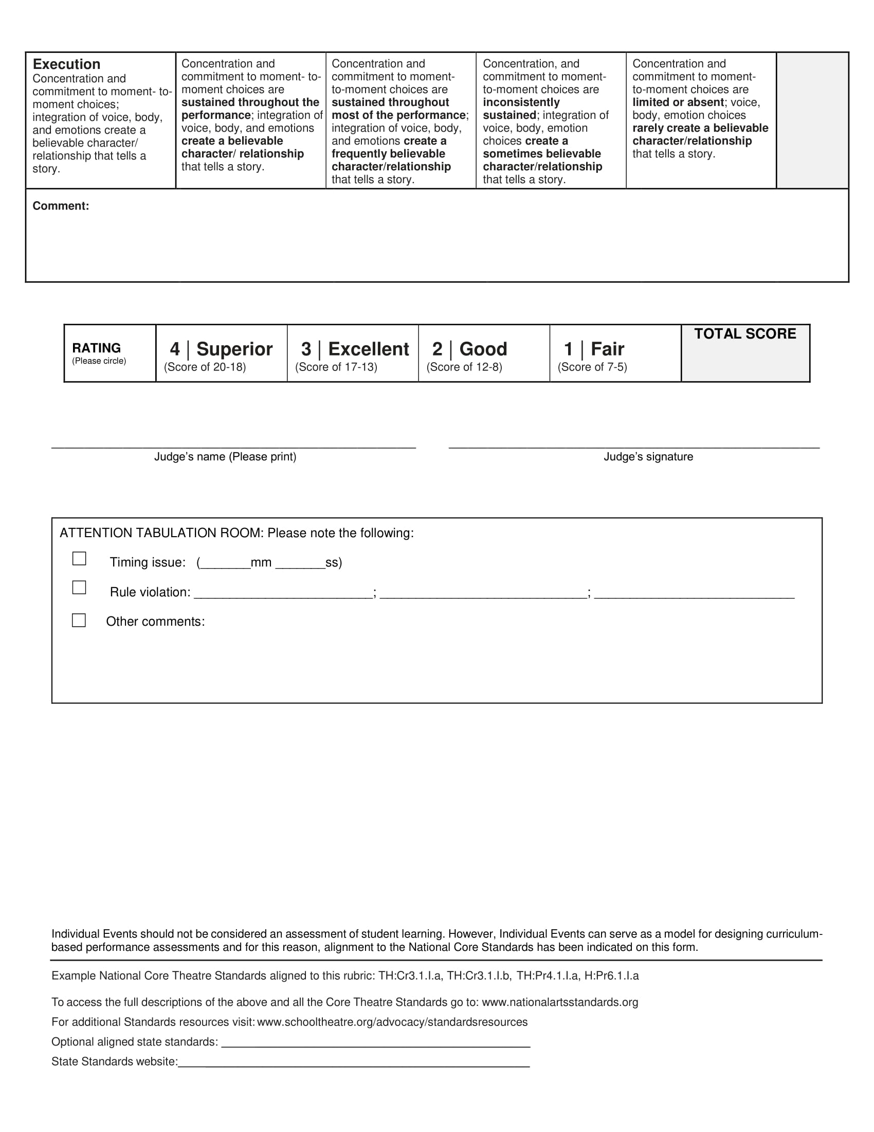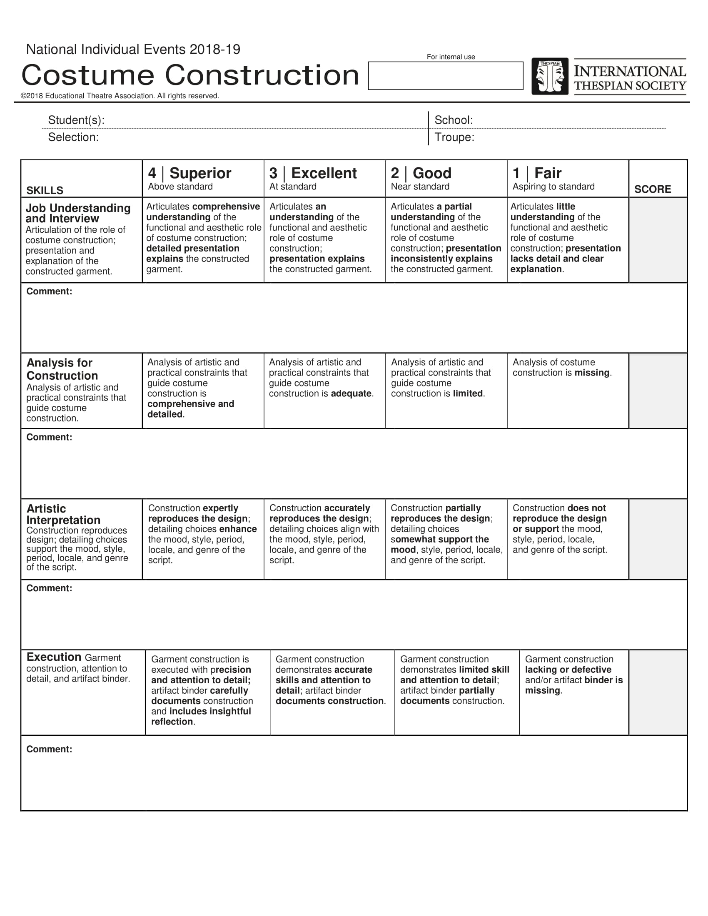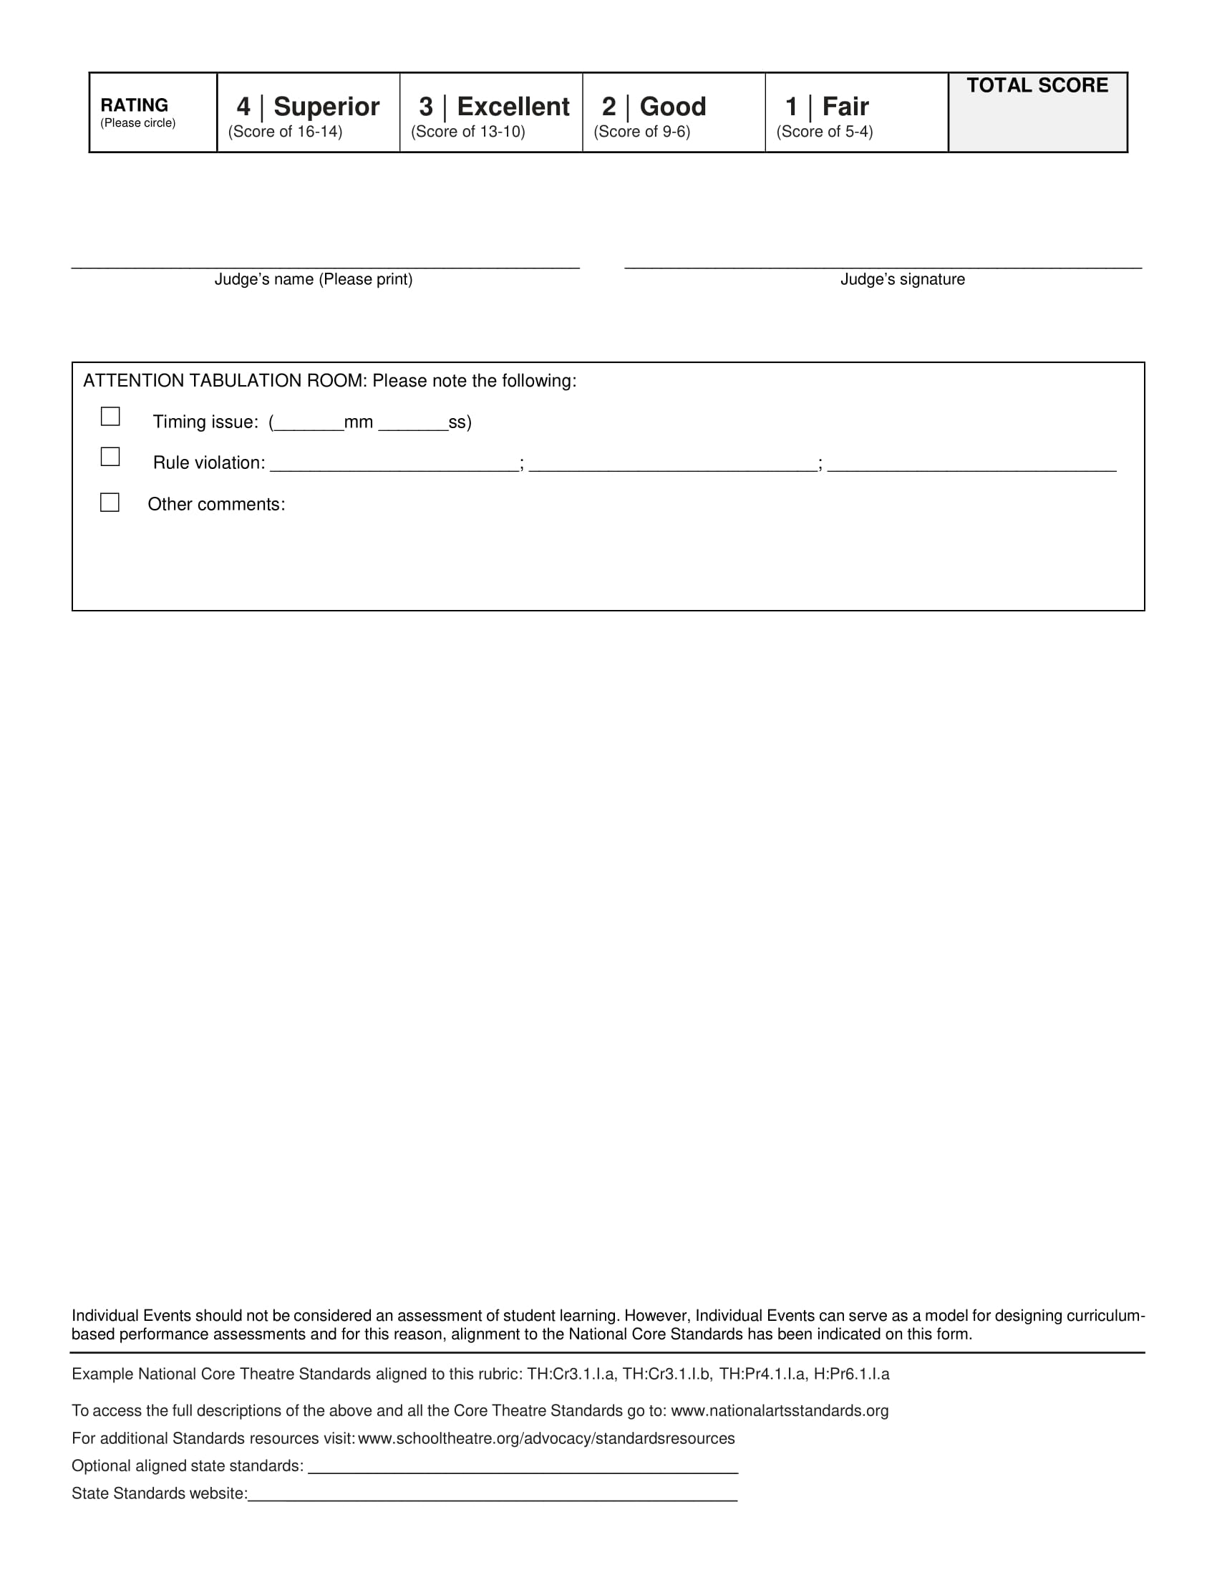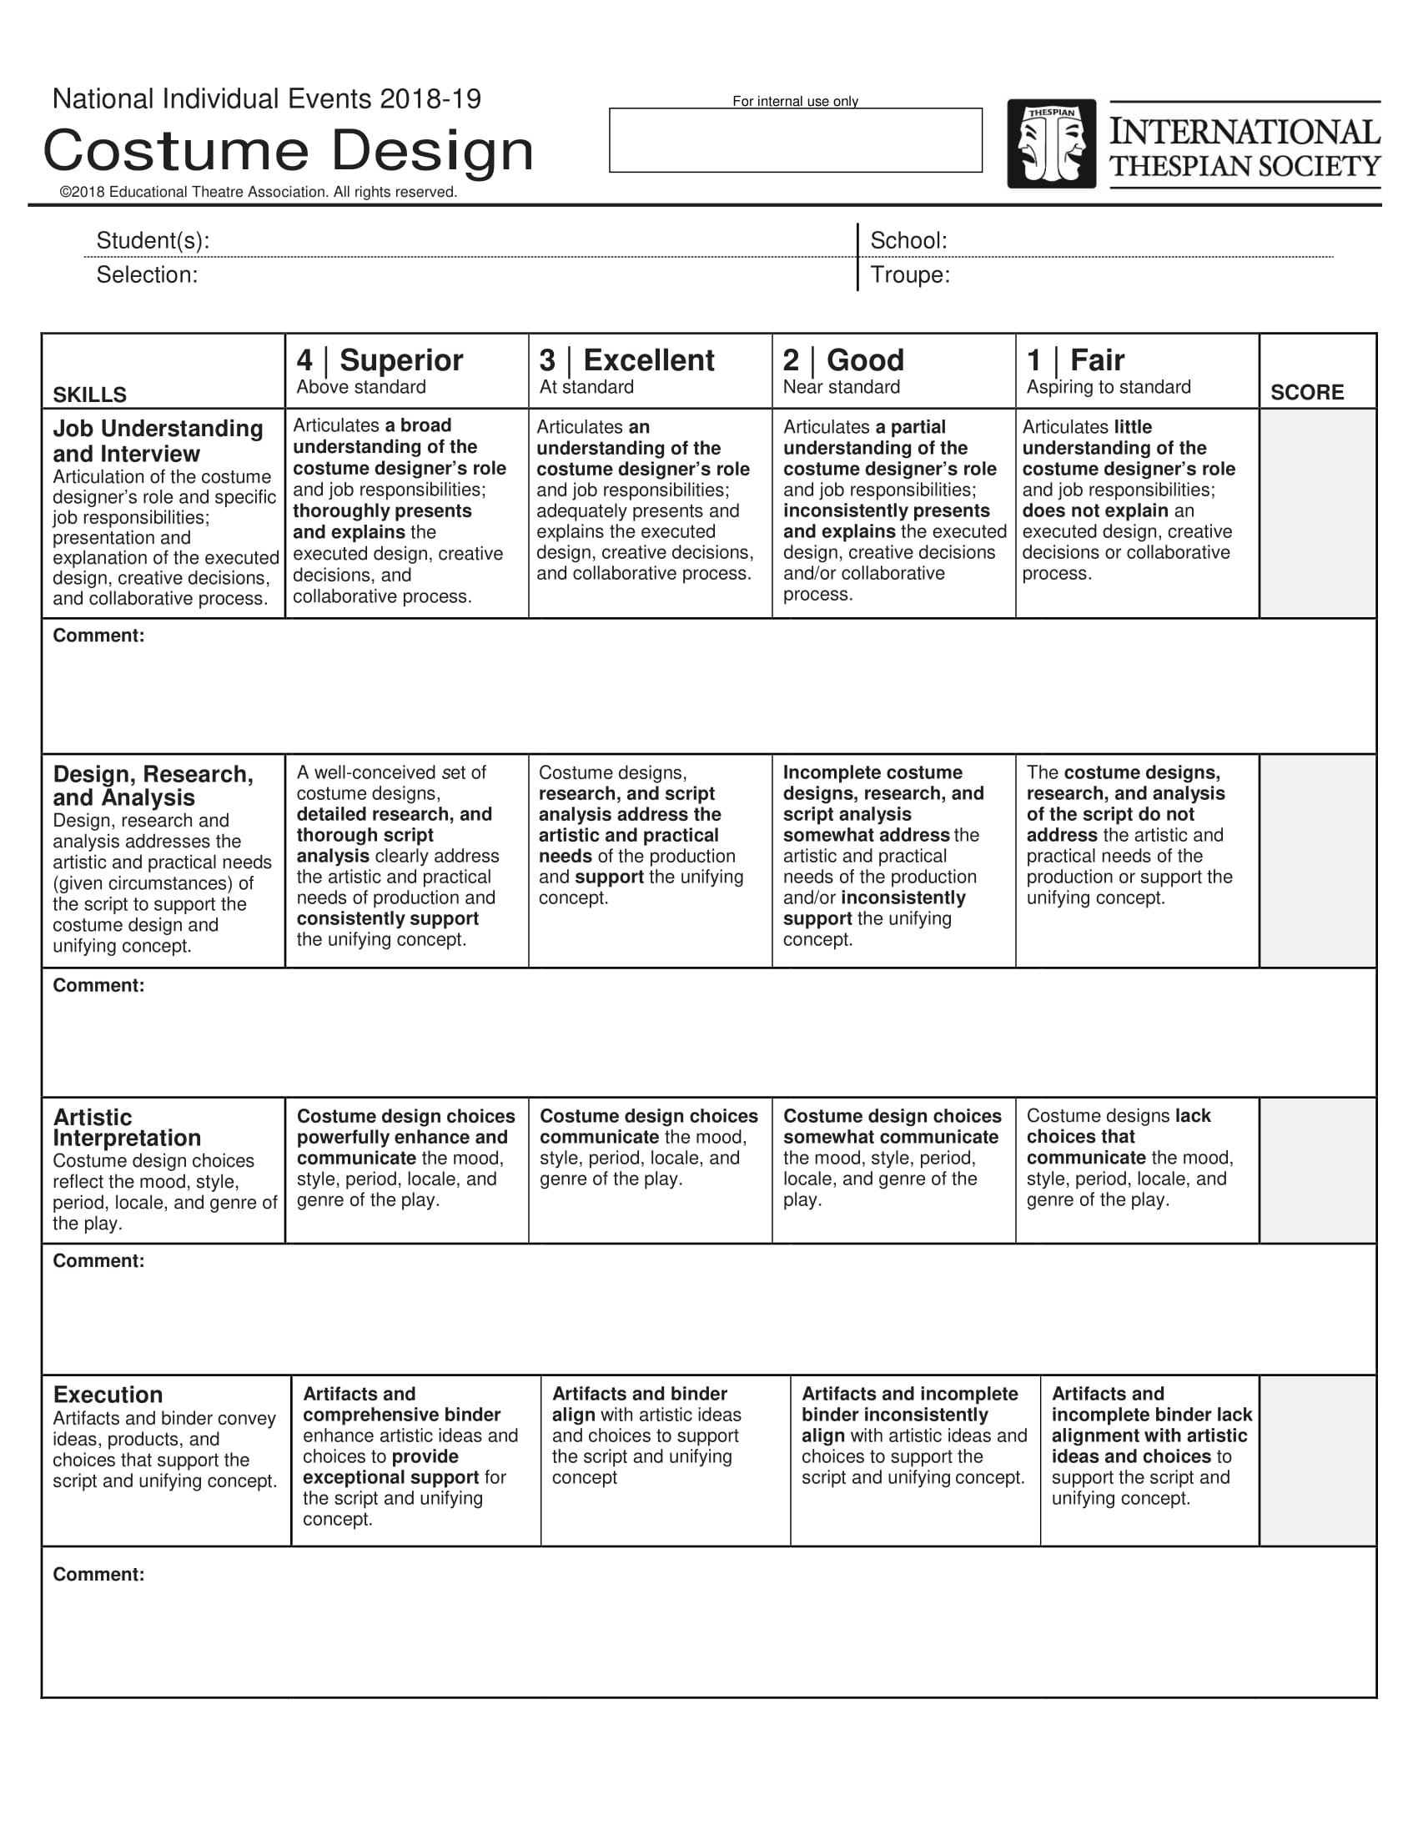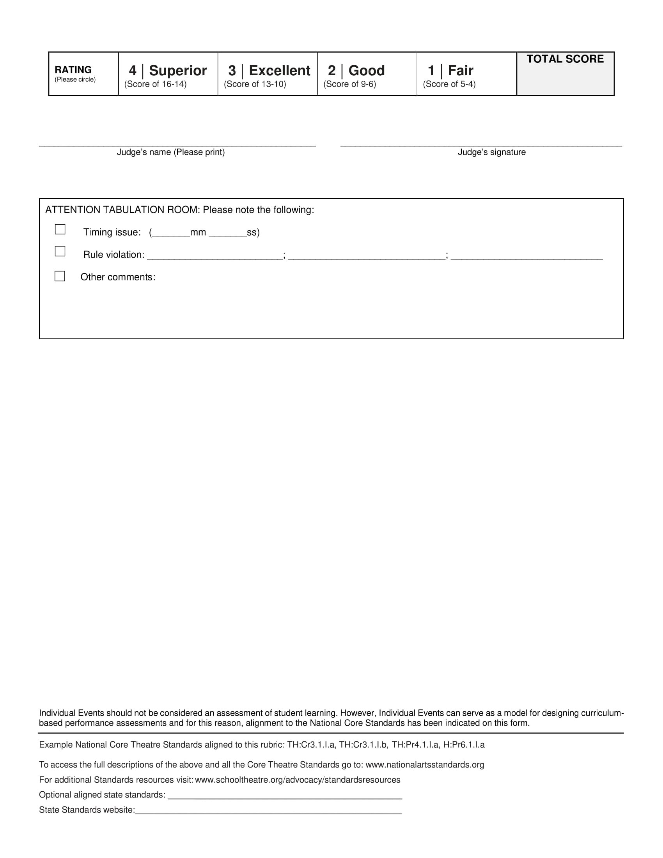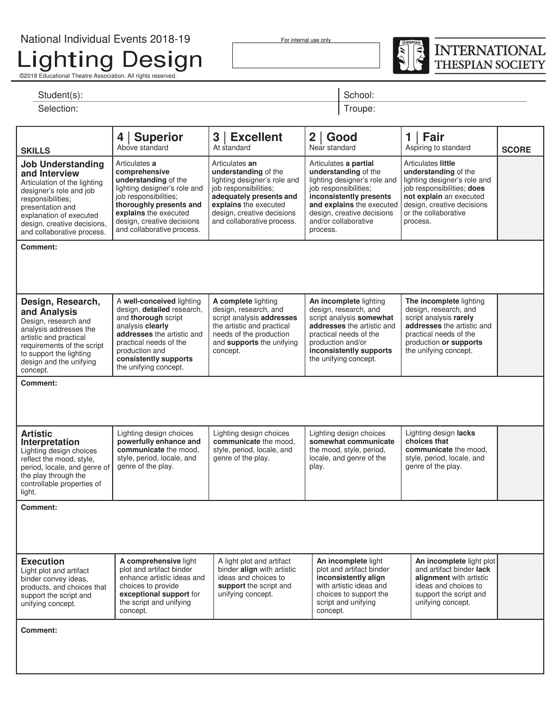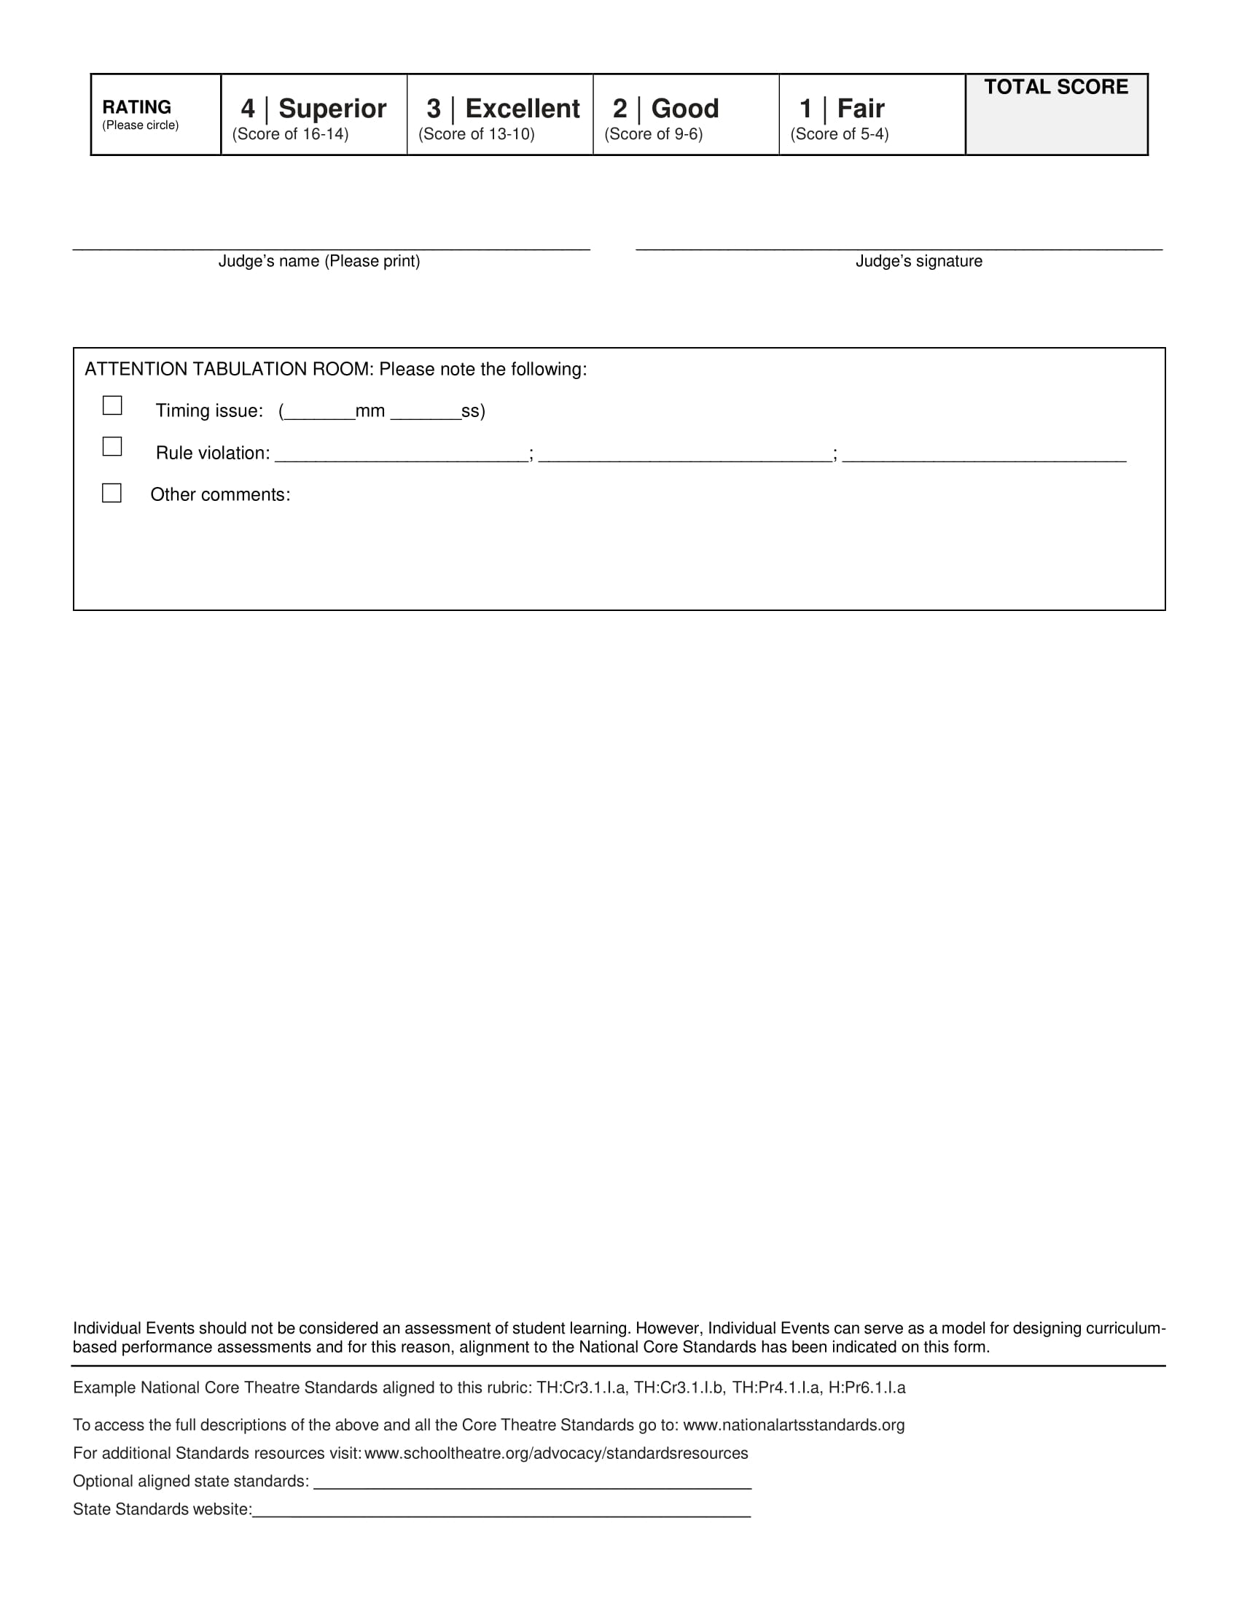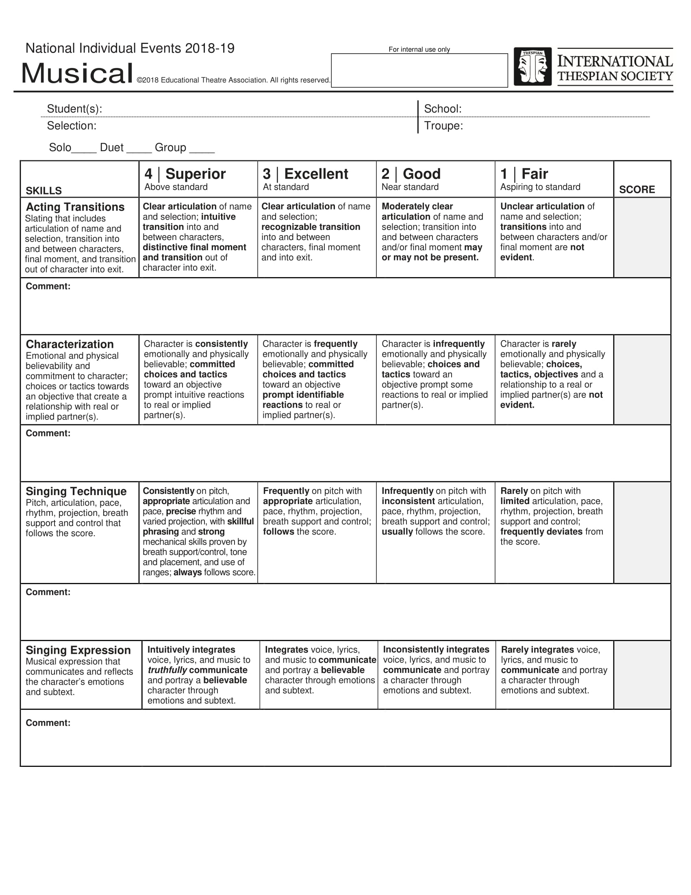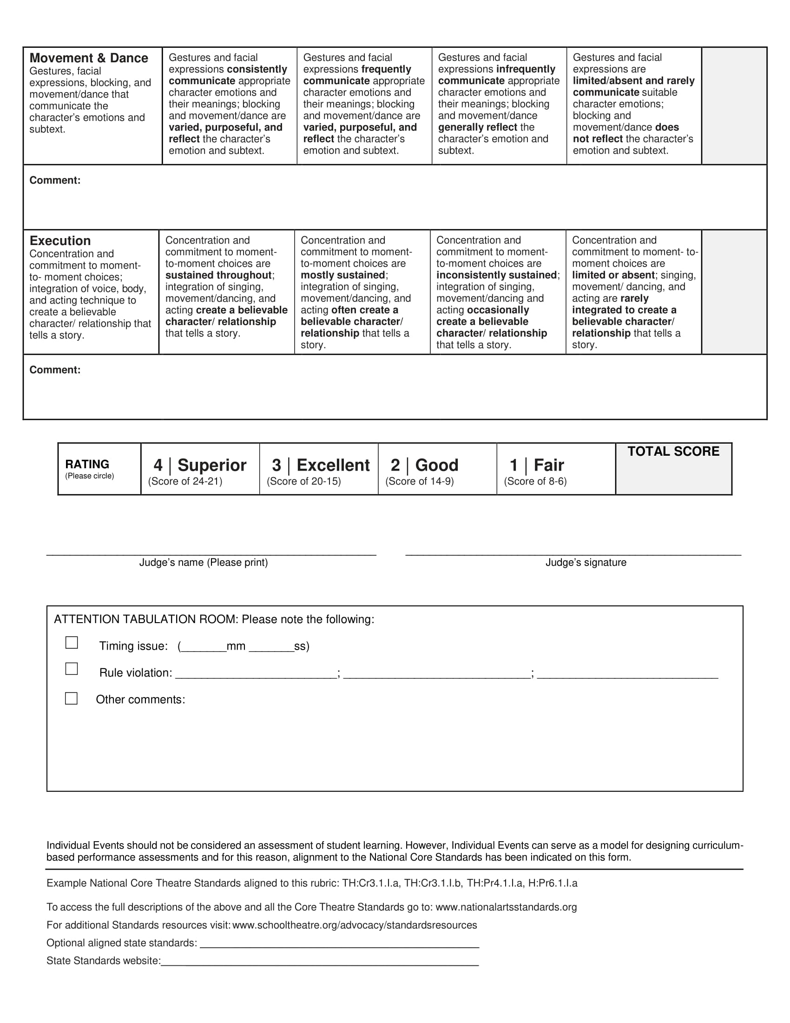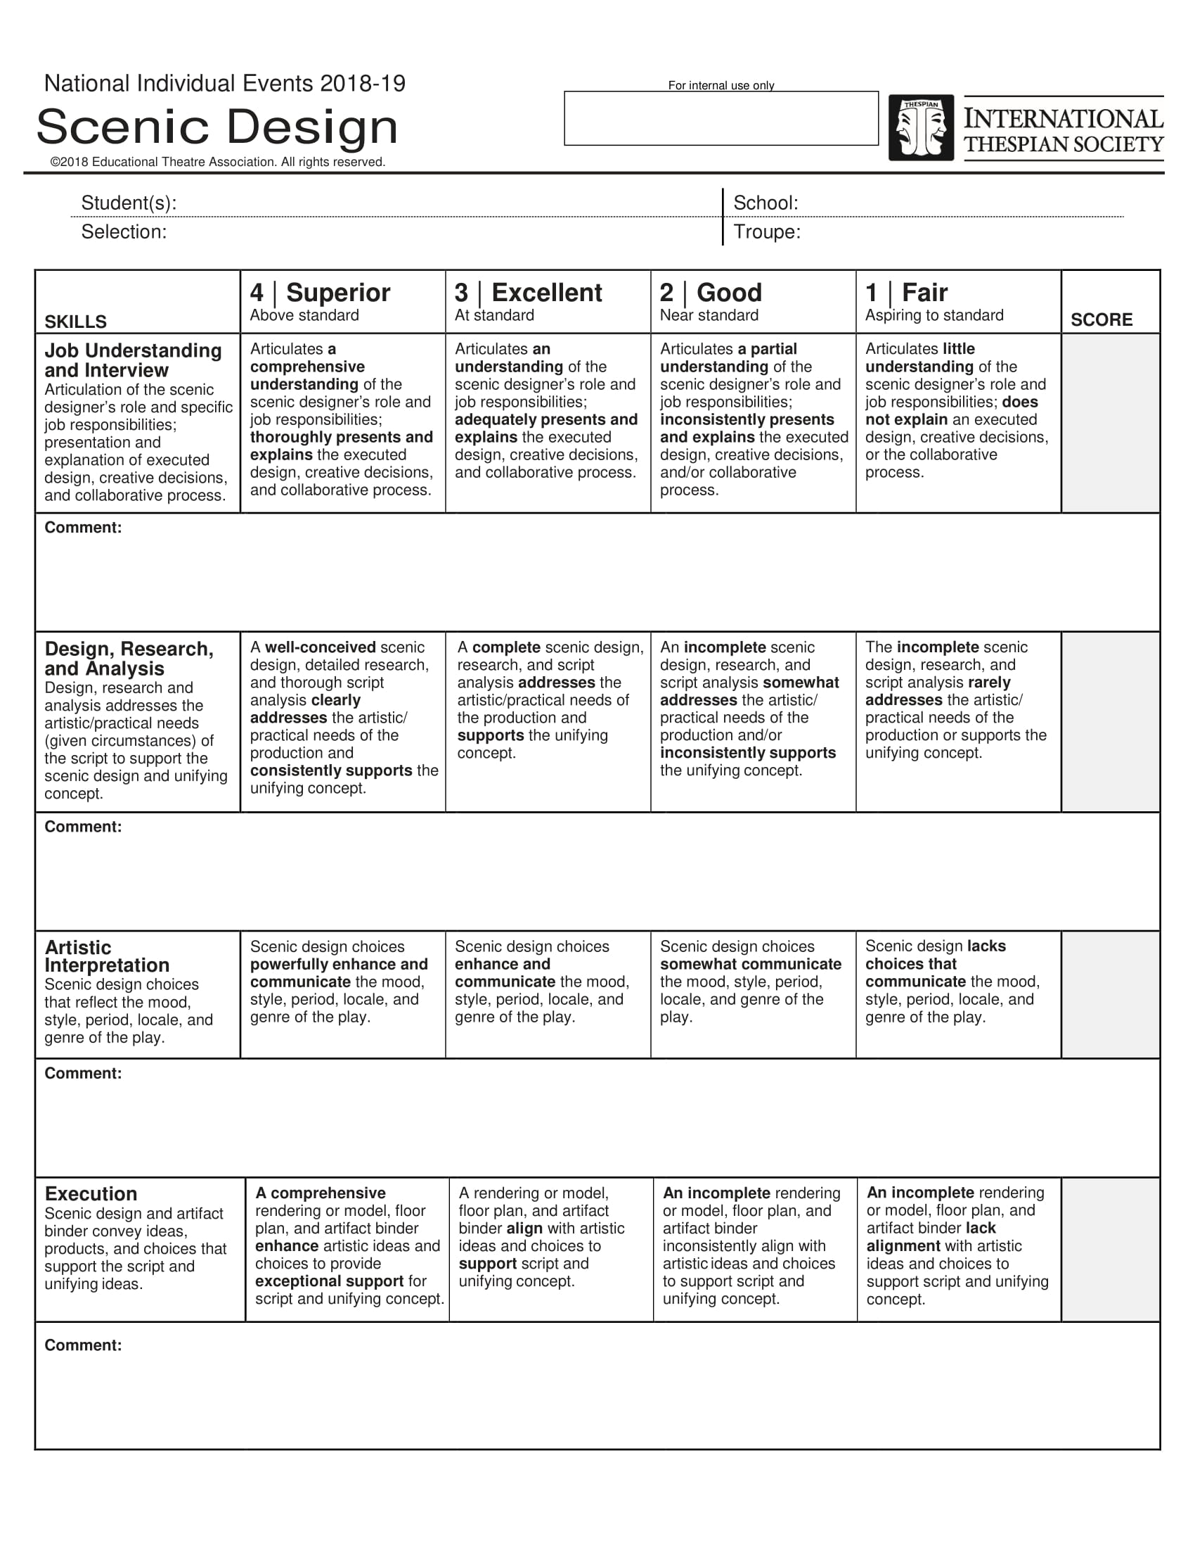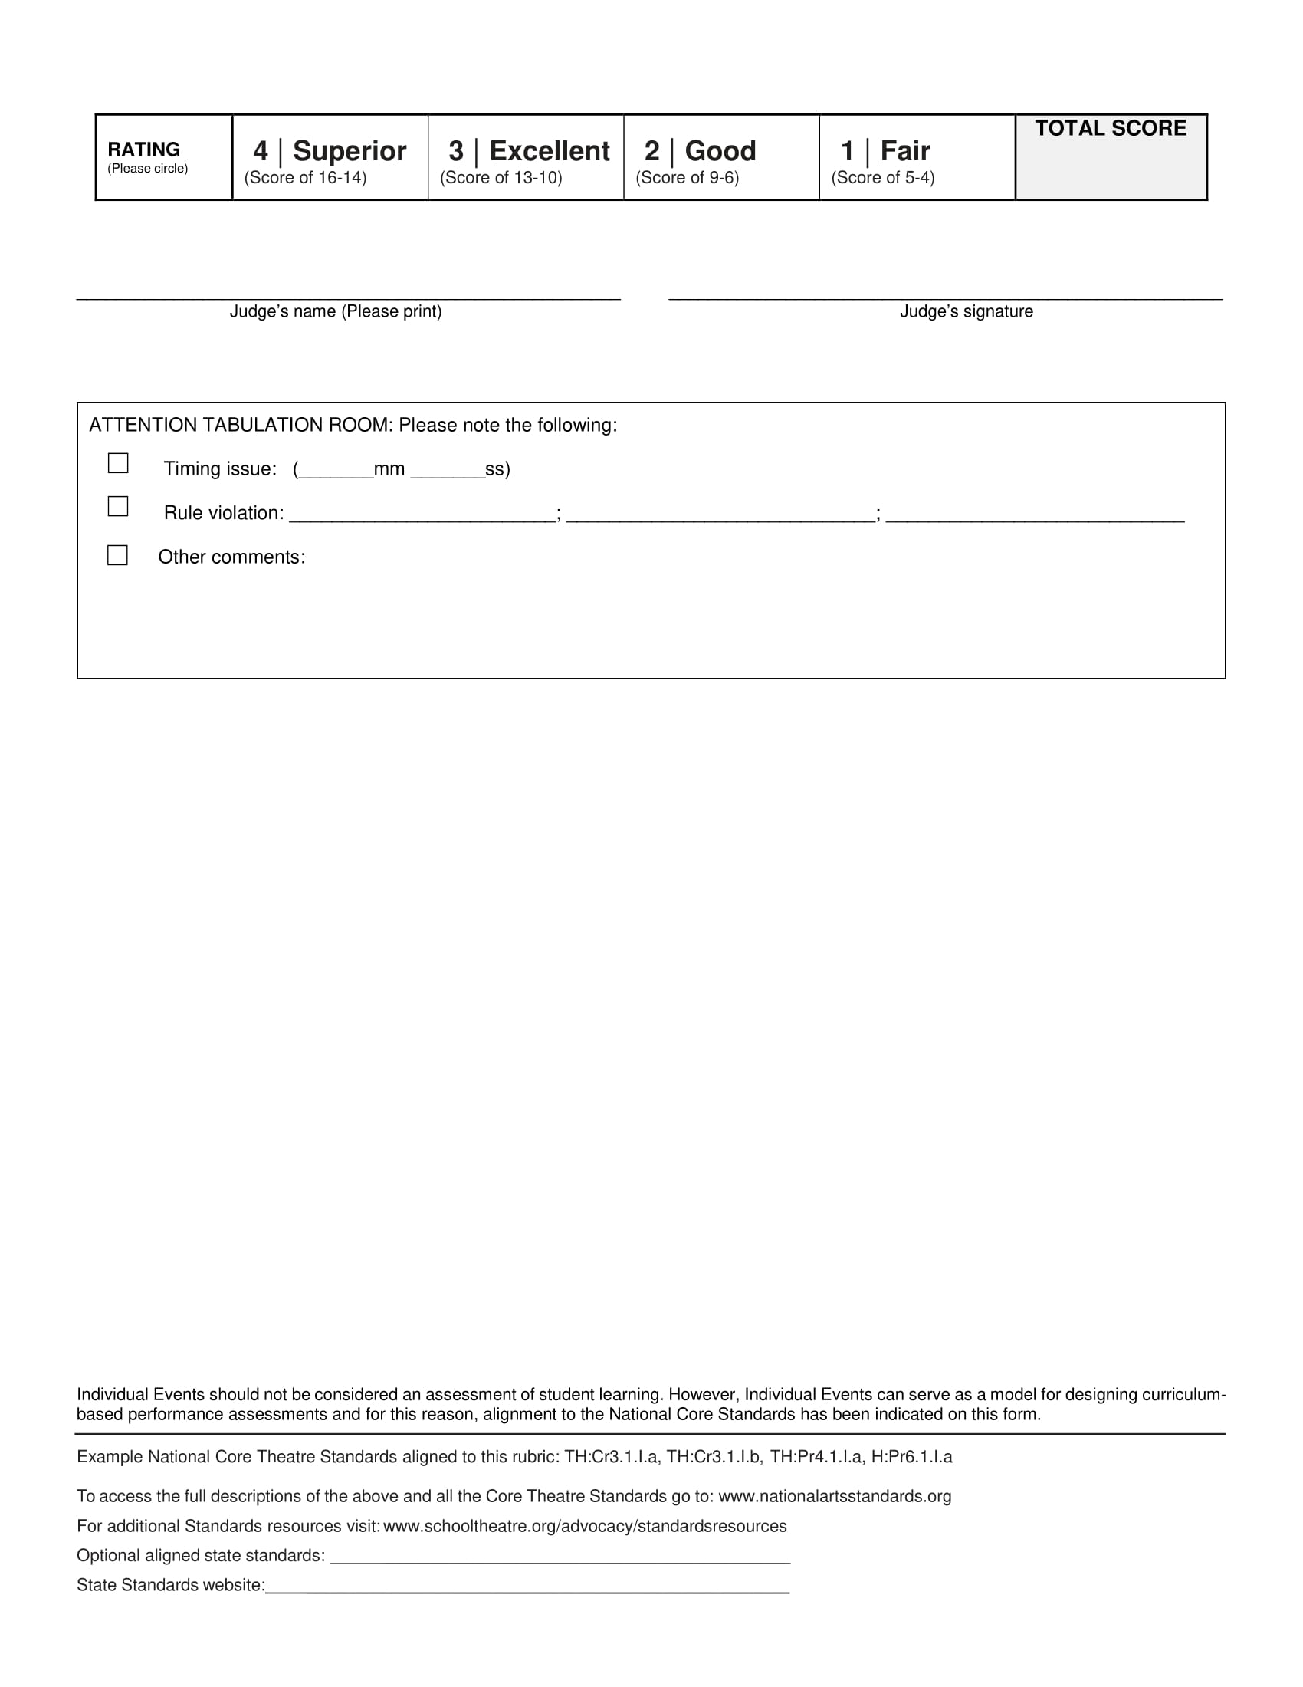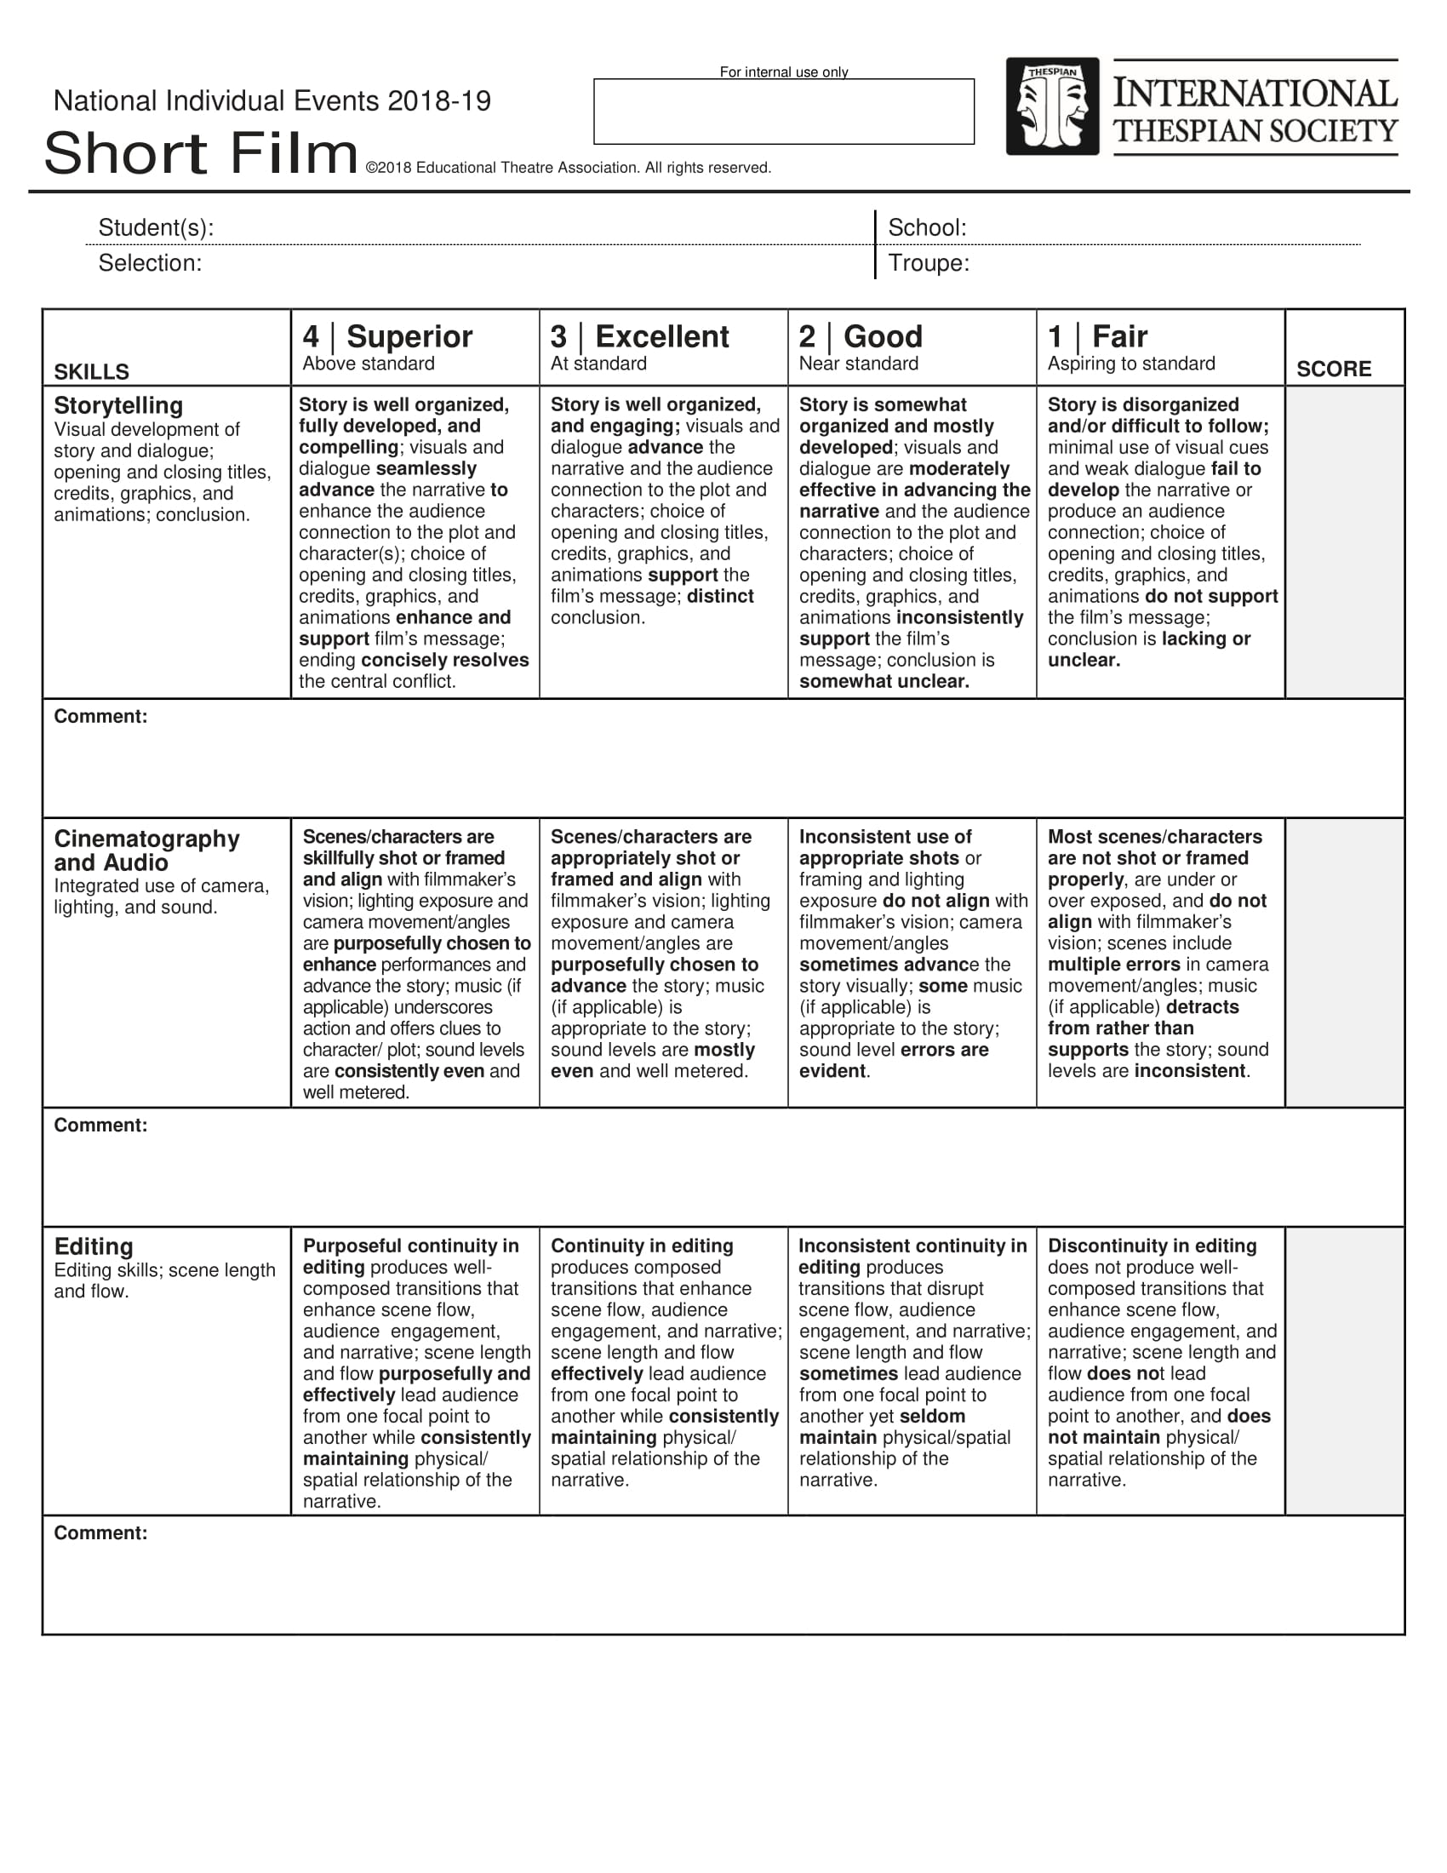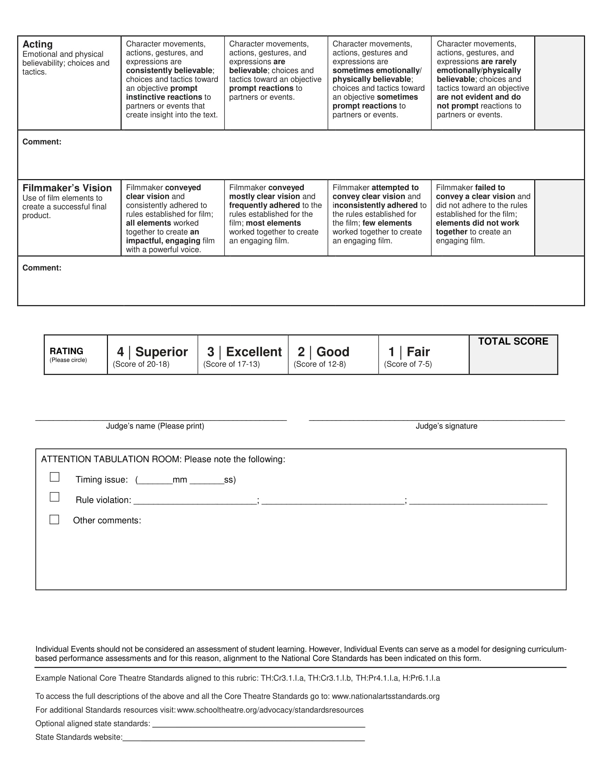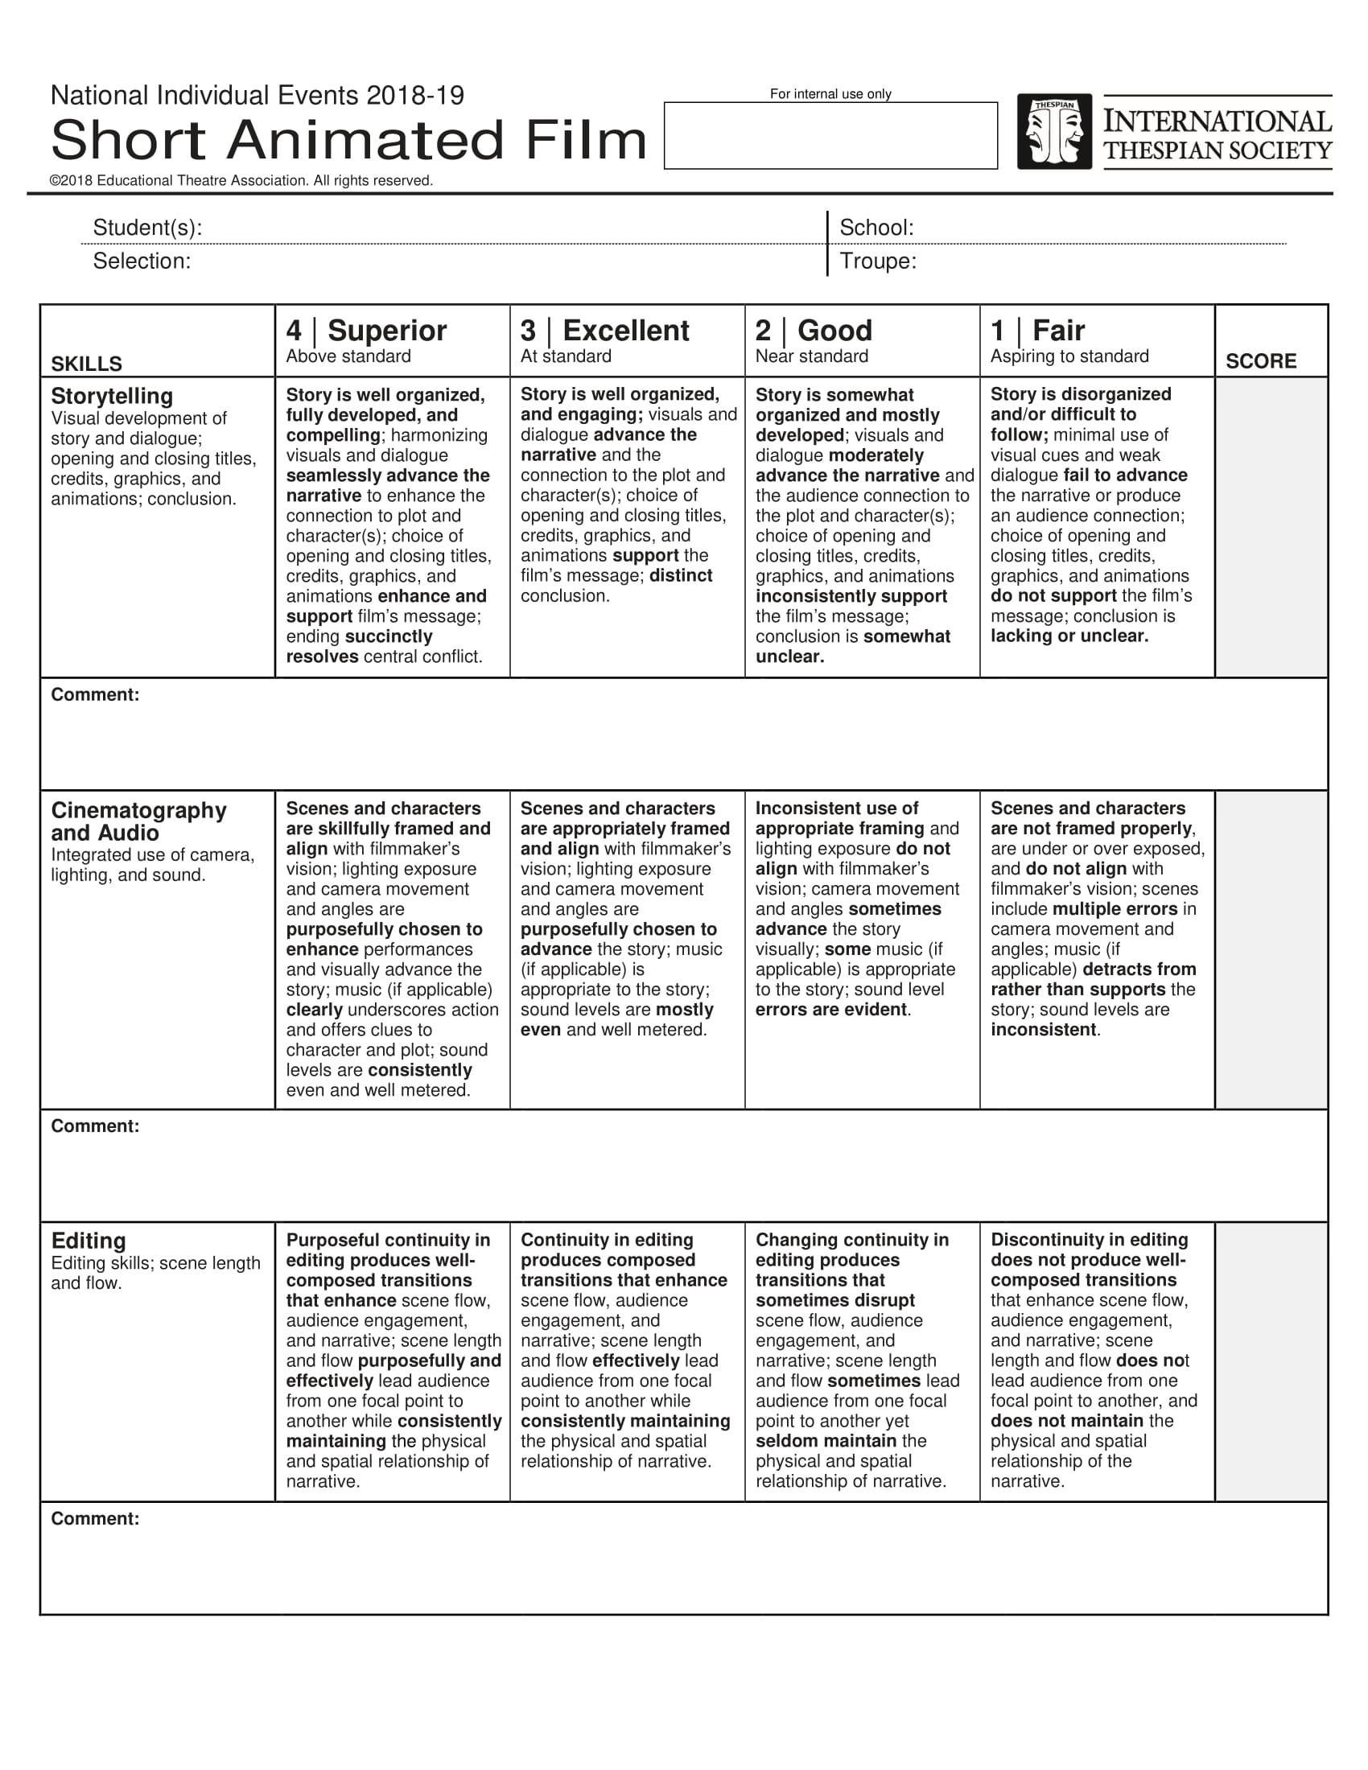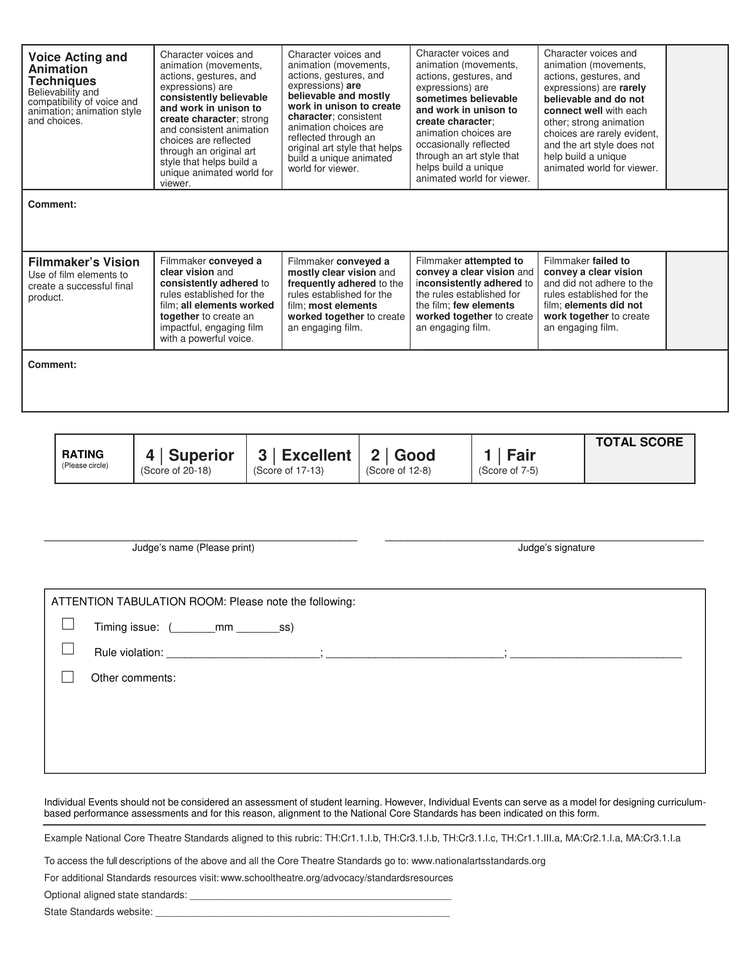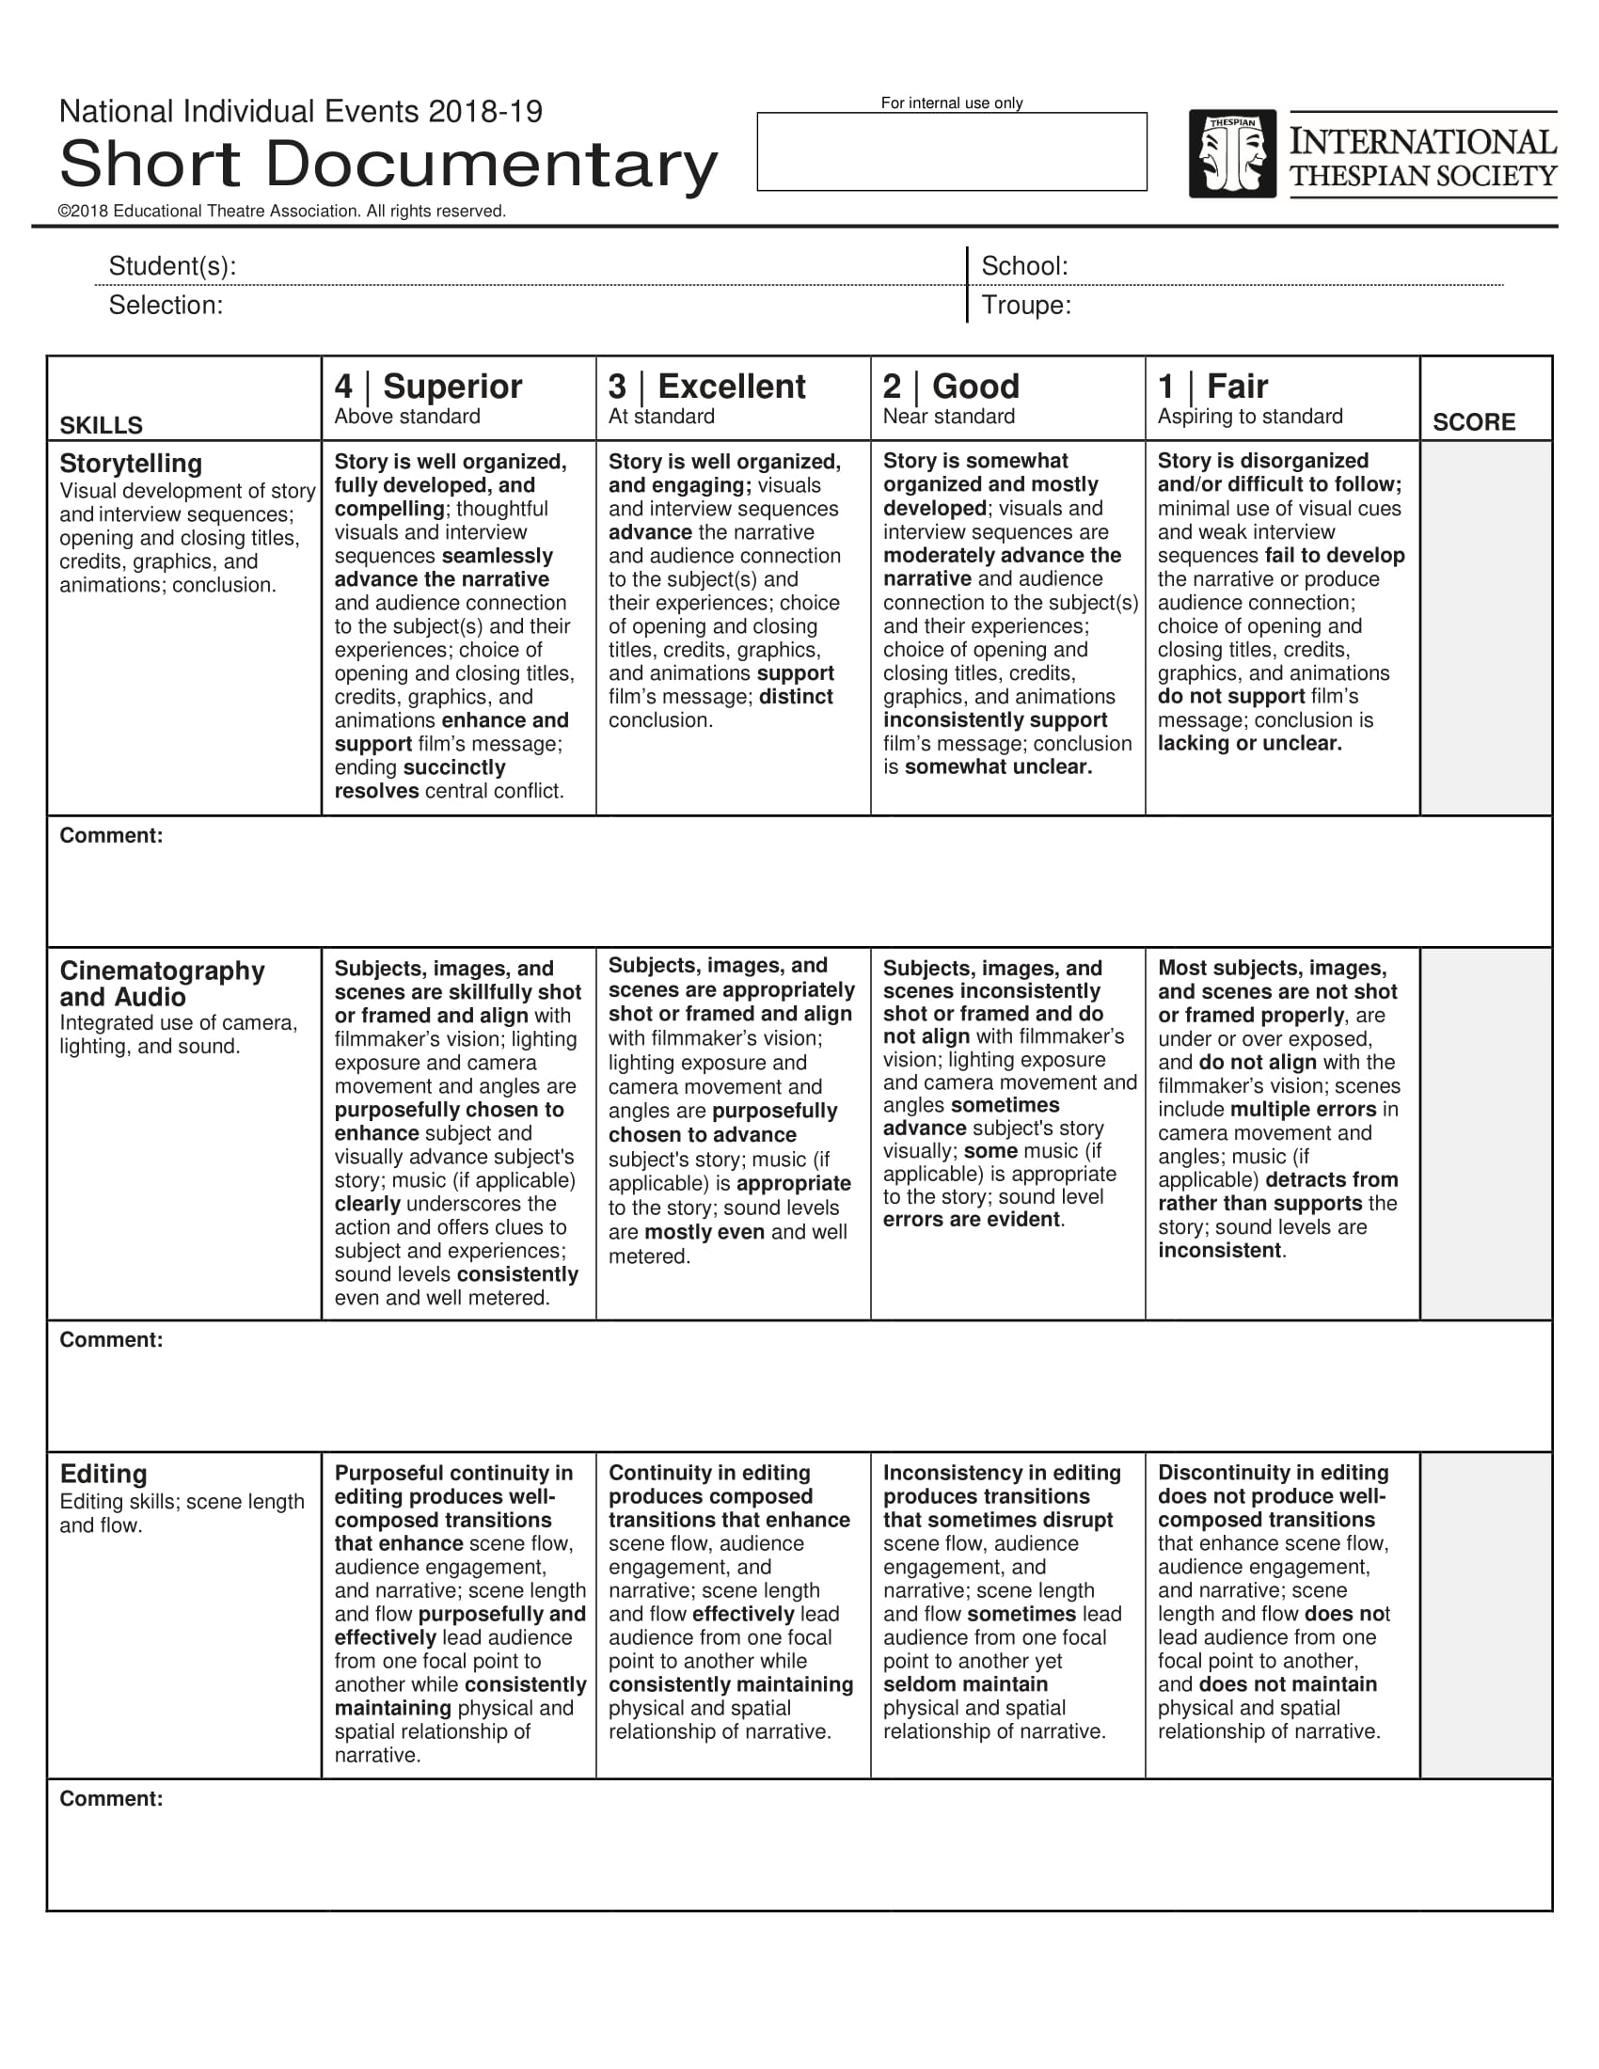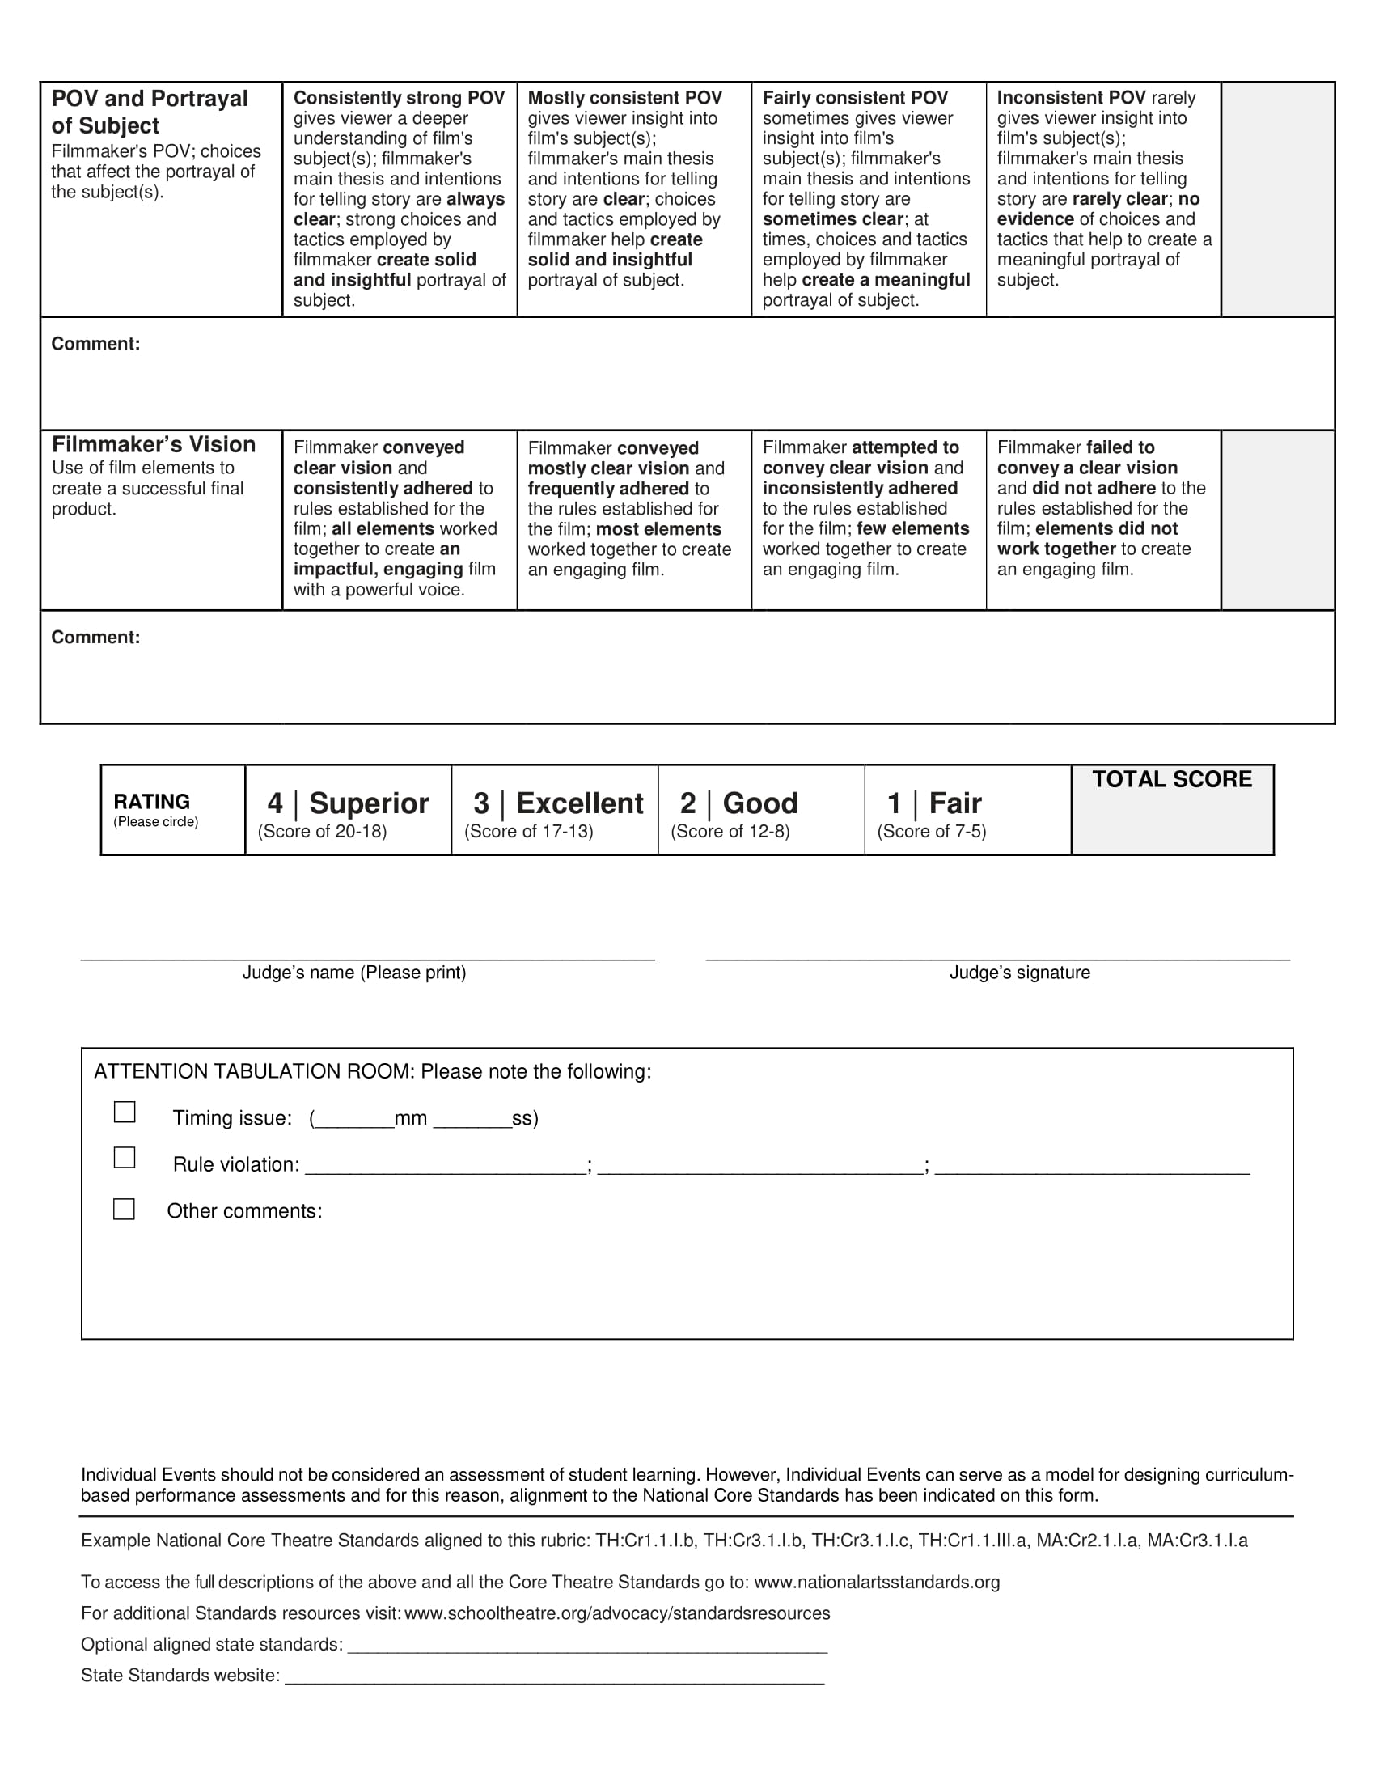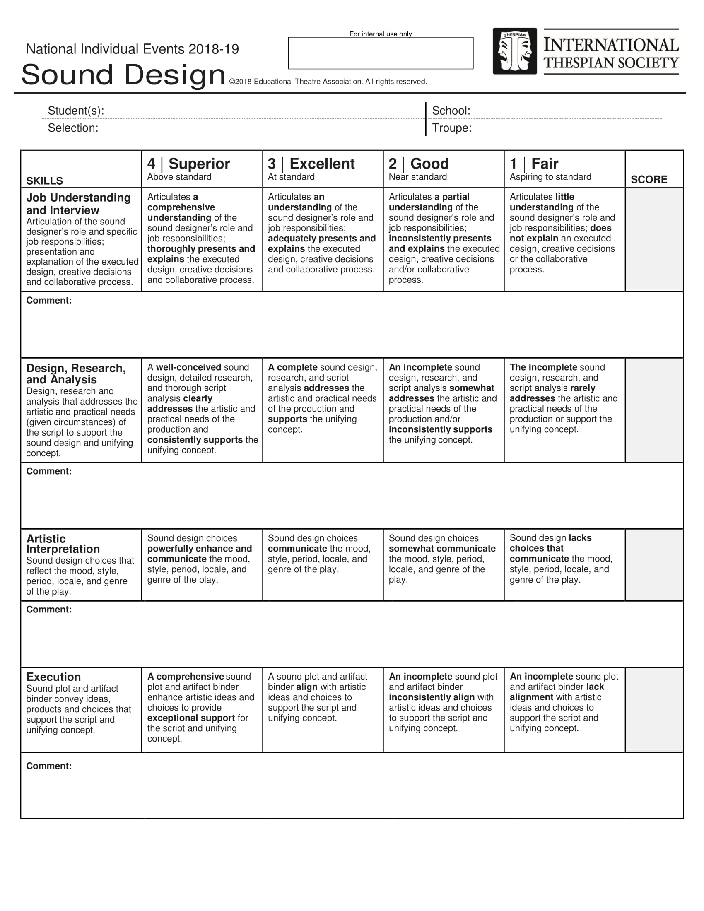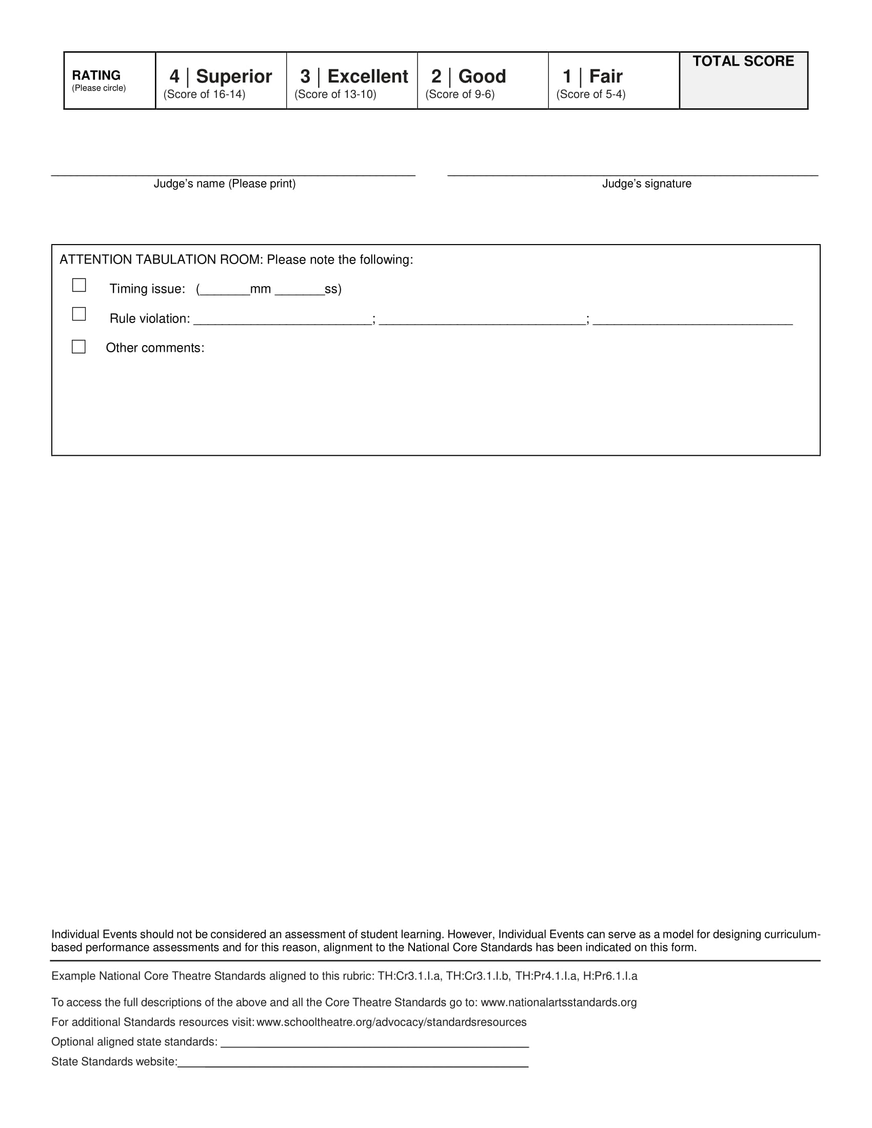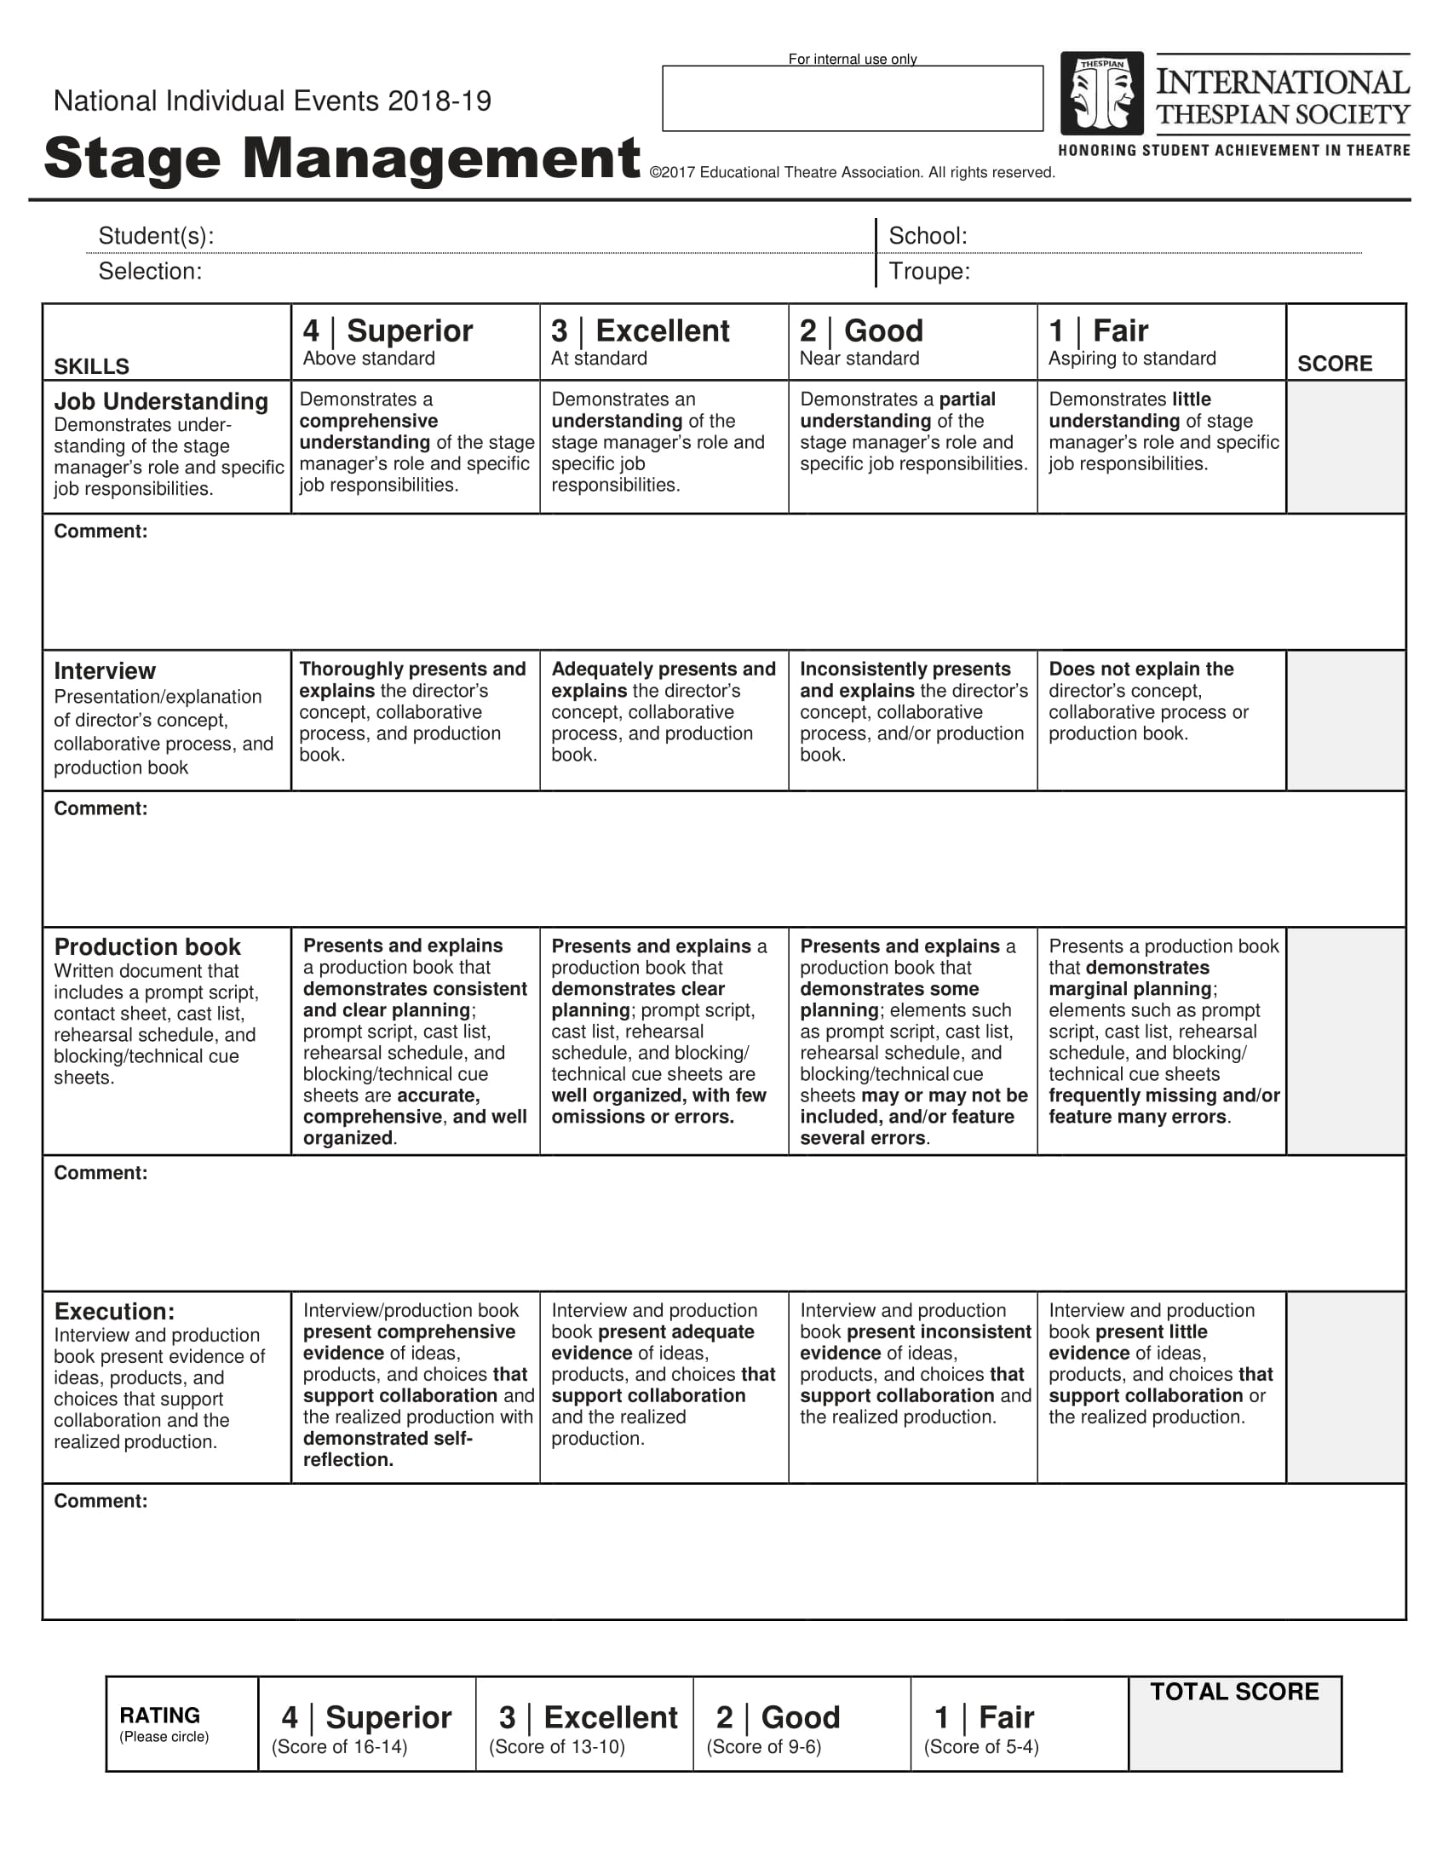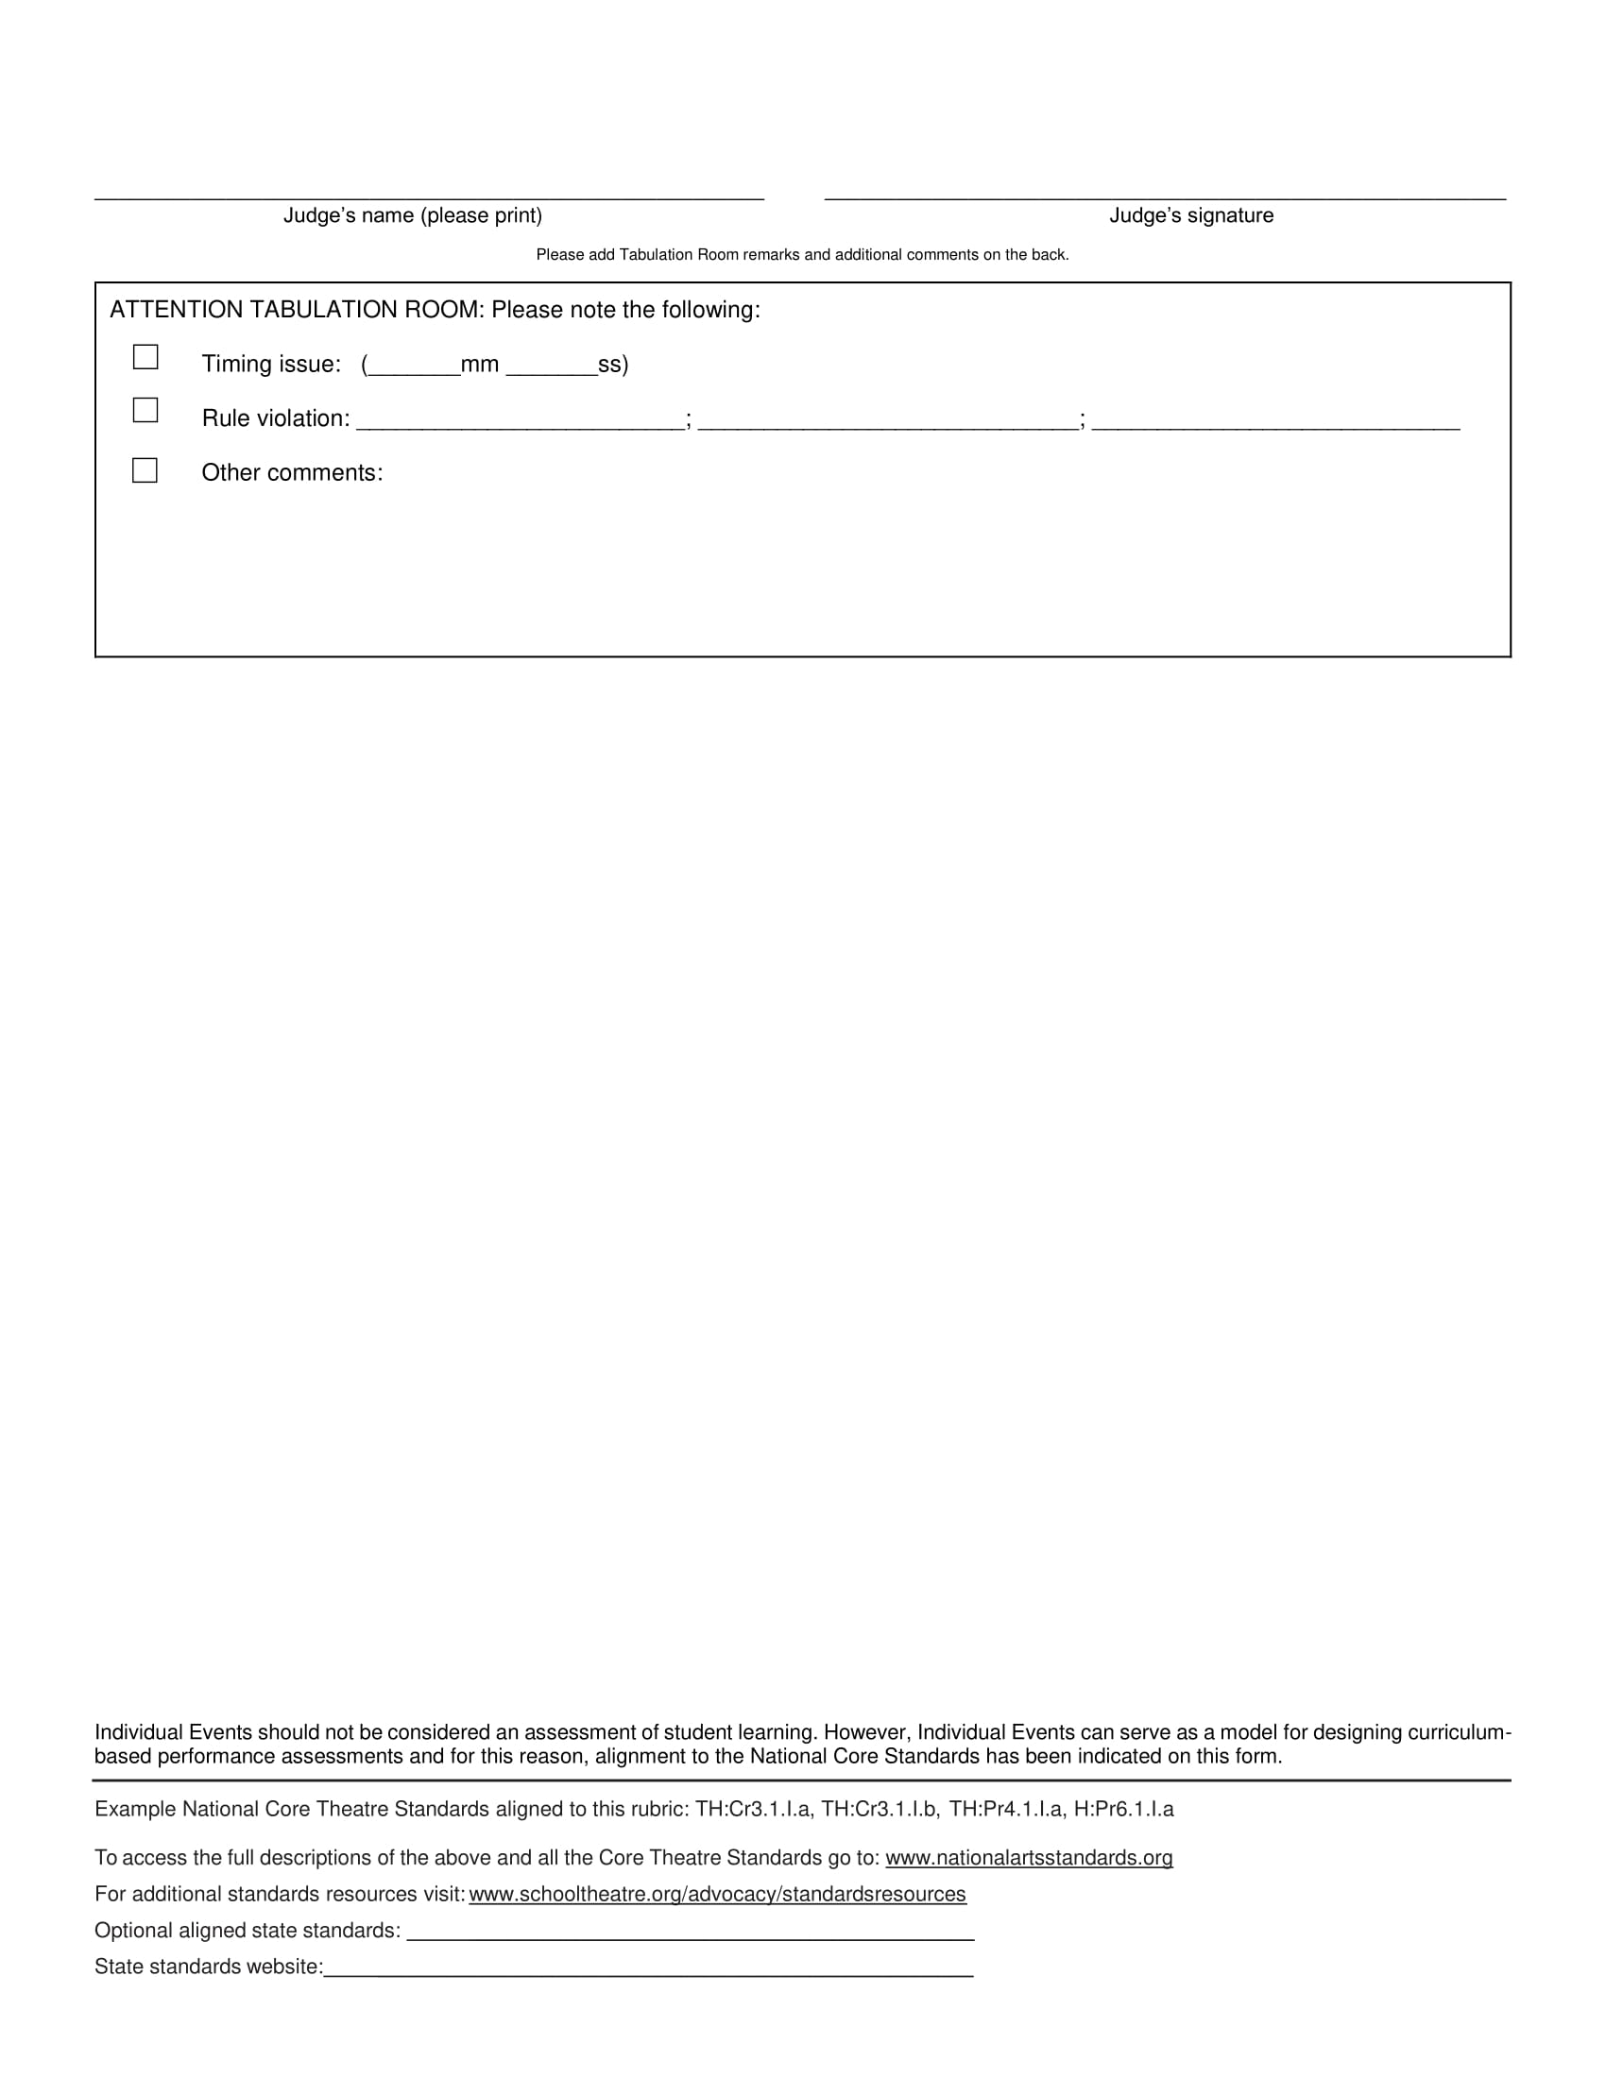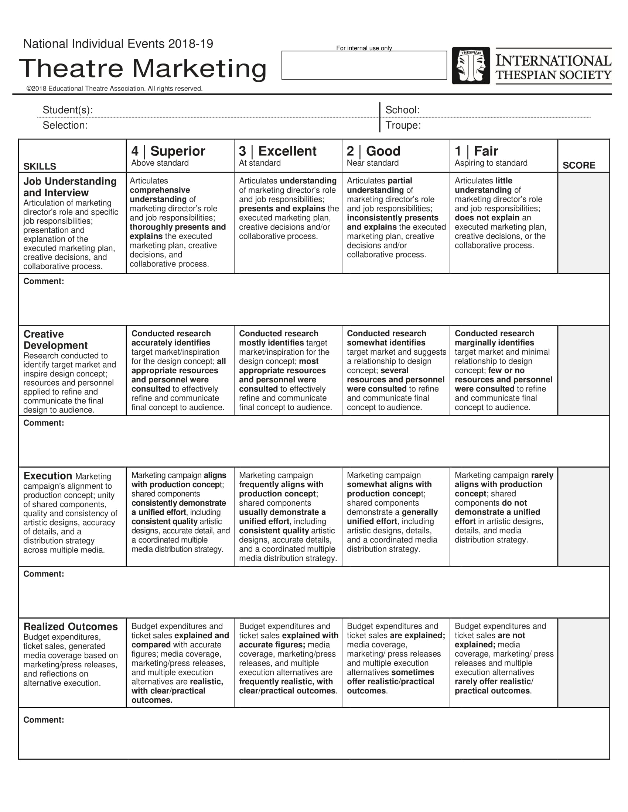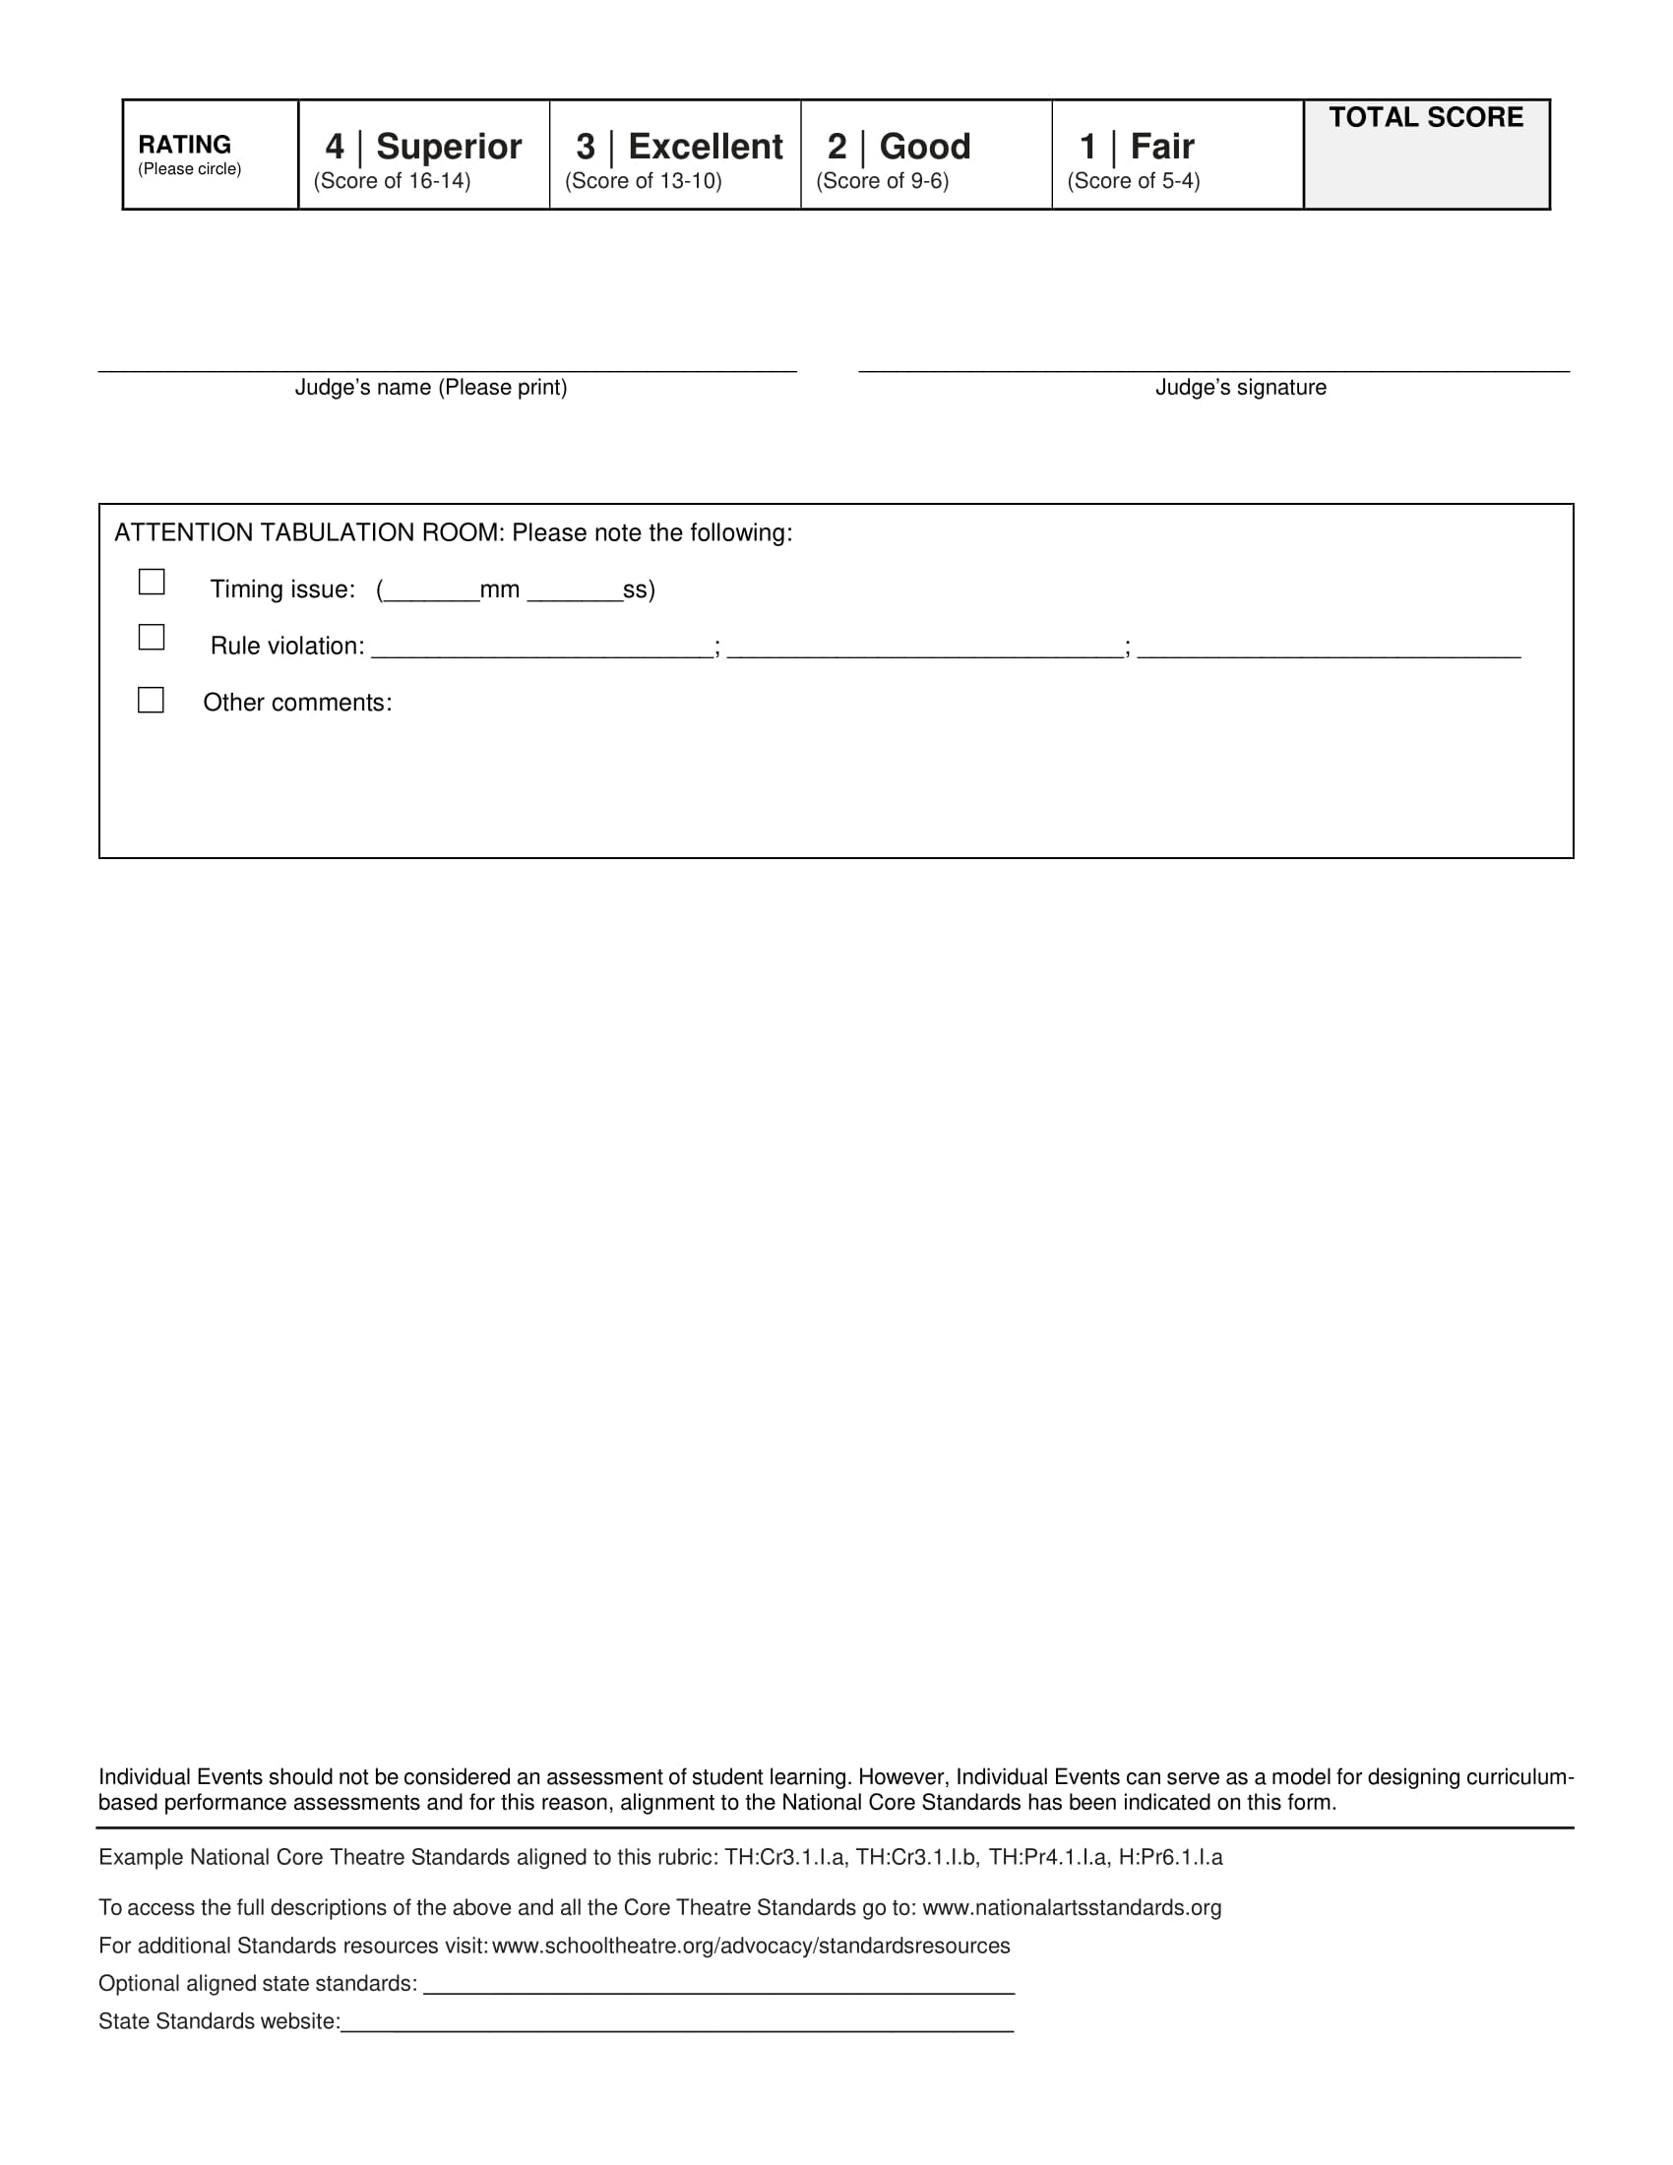

Dance IE’s

Dance Events Criteria
Appearance: personal appearance, all dancers in black, grooming, hair, makeup, etc.
Stage Presence: personality and character, expression, and stage presentation.
Routine: interpretation, style, choice of music, and overall impression.
Technique and Execution: quality, dance technique, timing and difficulty,
Theatrically Based: dance performance must be from a Broadway (Musical Theatre) Show

Solo Dance Male & Female Divisions
1. The performance features one dancer in a piece from Broadway musical/theatre.
2. Performer must supply his/her accompaniment music and speaker.
3. Performer must supply his/her proper footwear and resin, if needed. (Dance flooring may not be available.)
4. Performance cannot exceed five minutes.
5. Introduction must include the student’s name, troupe number, title of the selection. Intro is NOT included in time.
6. Any style of music is acceptable as long as it is within the time limit and is from a Broadway (Musical Theatre) Performance.
7. Dancers should wear all black. Props and Costumes are not allowed. Street or corrective makeup is allowed.

Duet Dance
1. The performance features two dancers in a piece from Broadway musical/theatre.
2. Performer must supply his/her accompaniment music and speaker.
3. Performers must supply his/her proper footwear and resin, if needed. (Dance flooring may not be available.)
4. Performance cannot exceed five minutes.
5. Introduction must include the student’s name, troupe number, title of the selection. Intro is NOT included in time.
6. Any style of music is acceptable as long as it is within the time limit and is from a Broadway (Musical Theatre) Performance.
7. Each participant must be actively involved in the performance.
8. Dancers should wear all black. Props and Costumes are not allowed. Street or corrective makeup is allowed.

Group Dance
1. The performance features at least three dancers and not more than 16 in a piece from Broadway musical/theatre.
2. Performer must supply his/her accompaniment music and speaker.
3. Performers must supply his/her proper footwear and resin, if needed. (Dance flooring may not be available.)
4. Performance cannot exceed five minutes.
5. Introduction must include the student’s name, troupe number, title of the selection. Intro is NOT included in time.
6. Any style of music is acceptable as long as it is within the time limit and is from a Broadway (Musical Theatre) Performance.
7. Each participant must be actively involved in the performance.
8. Dancers should wear all black. Props and Costumes are not allowed. Street or corrective makeup is allowed.

NOT ADHERING TO ALL RULES WILL RESULT IN DISQUALIFICATION.

INTRODUCTION:
Each act must be introduced (time begins after the introduction). The introduction must include the student’s name, troupe number, title of selection(s), and the name of the playwright, composer, or lyricist.

DRESS:
All IE participants should wear all black clothing including shoes. The shirt should be free of logo and writing. No costumes, stage makeup, or props are allowed.

TECHNICAL PROVISIONS:
The IE rooms do not allow any special lighting. Music must be already cued. A speaker with bluetooth connectivity will be provided.

ARRIVAL AND PERFORMANCE:
The IE schedule will be emailed to directors and posted on the Festival 2019 Mobile Link prior to the festival. An IE Act must arrive 15 minutes prior to appointed performance time.

ADJUDICATION:
An overall Superior Rating for any IE is one that has received a total score between 18-20 for acting/short film categories, 21-24 for musical categories, and 14-16 for technical categories from the adjudicators. All acts receiving an overall Superior Rating are eligible to enter the act in the IE events at the next International Thespian Festival (provided the act meets all international requirements including proof of permission to perform from the publishers of the piece). Not every event offered at the State Festival will qualify for the International Festival. Please check the website to see which ones are qualified to move onto ITF.

MAIN STAGE PERFORMANCE OPPORTUNITIES:
Alabama Thespians is looking for high caliber one act and full-length productions to showcase at Festival. If you would like to share your show with other Alabama Thespians, then we encourage you to apply for one of our main stage slots. Click here for more information and to apply. (Registration deadline, December 10, 2018)

Alabama Thespians will have two performance slots available this year for Main Stage. This is an exciting opportunity for the selected schools and for the state thespian membership. We would like you to consider bringing your show to the State Thespian Festival! For questions, contact Mari Adams at madams@jp2falcons.org

Please review the information provided here to decide whether or not your show would work in the performance spaces.

ALEdTA recognizes and appreciates all of the effort and dedication required to bring a main stage to festival. We would like to honor this commitment by offering troupes performing main stage productions at festival the following:

1. Troupe Director Fee will be waived with no volunteer slots required.
2. A $350 grant will be awarded to offset travel costs.

Requirements
A completed application must be submitted online by the deadline (December 9).
Proof of Performance Rights must be submitted at the registration table on day 1 of Festival.
Registration
Schools who are selected for a main stage performance must register all performing and tech students and adults for conference (all students who are active in the production - front and backstage). No student will be allowed to perform at the conference that is not registered for the conference. The only exception to this will be student musicians performing in orchestras for musicals.

Restrictions
Our main goal is to provide festival attendees with as many performance opportunities and experiences as possible while at festival. It is for this reason we ask that schools not submit a show for main stage in two consecutive years. Any school who presented in the year prior will not be considered for main stage performance. (In the unlikely event that we do not receive enough submissions for mainstage, Alabama Thespians reserves the right to allow a school who presented in the previous year to submit an application for performance.)

TECH CHALLENGE: (Deadline: December 10, 2018)
The goal of this event is to provide an opportunity for theatre students to exhibit their abilities in the technical production environment. Production skills and collaboration are required to efficiently accomplish each task. There may be additional discretionary points awarded (or subtracted) by the judges for creativity, ingenuity, teamwork, etc. Click here to register.

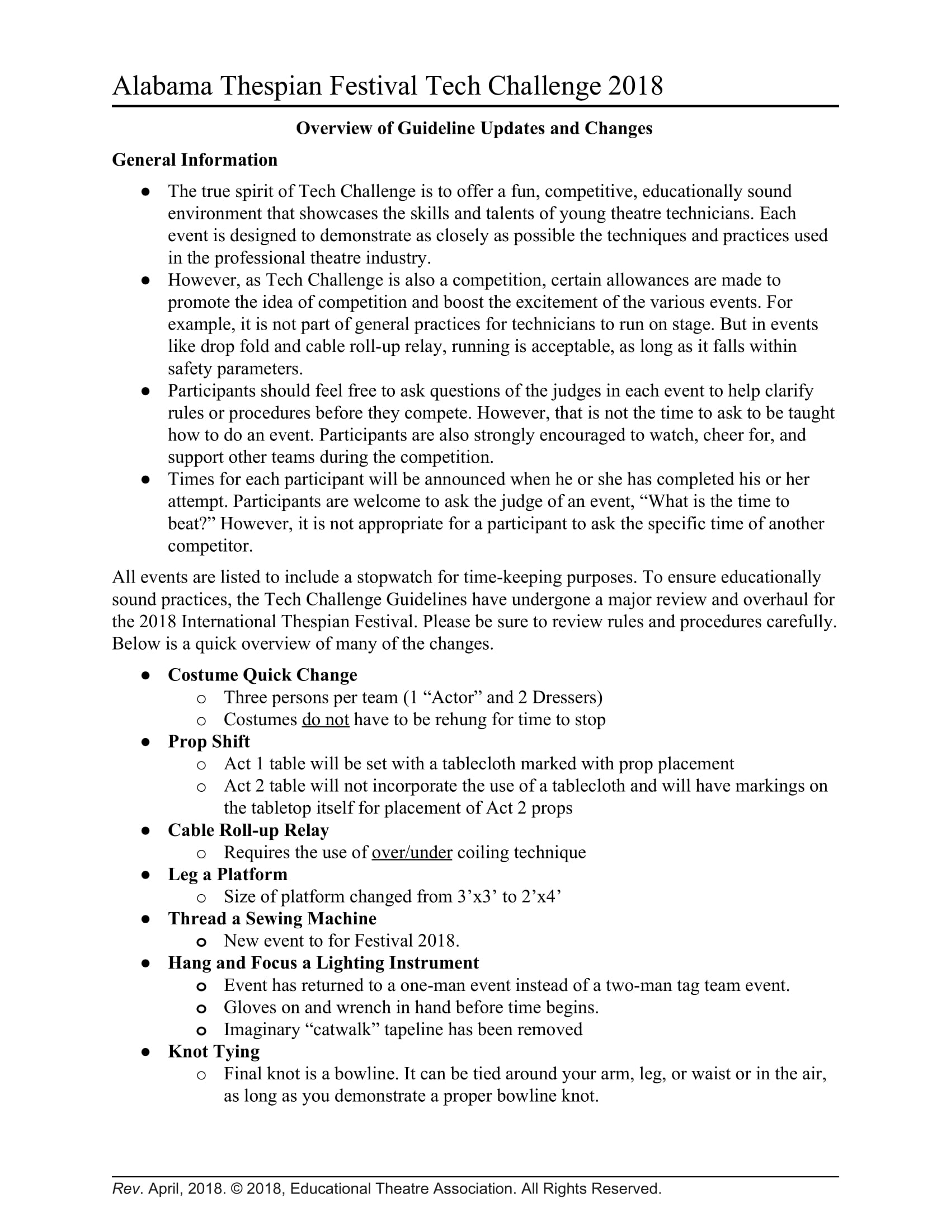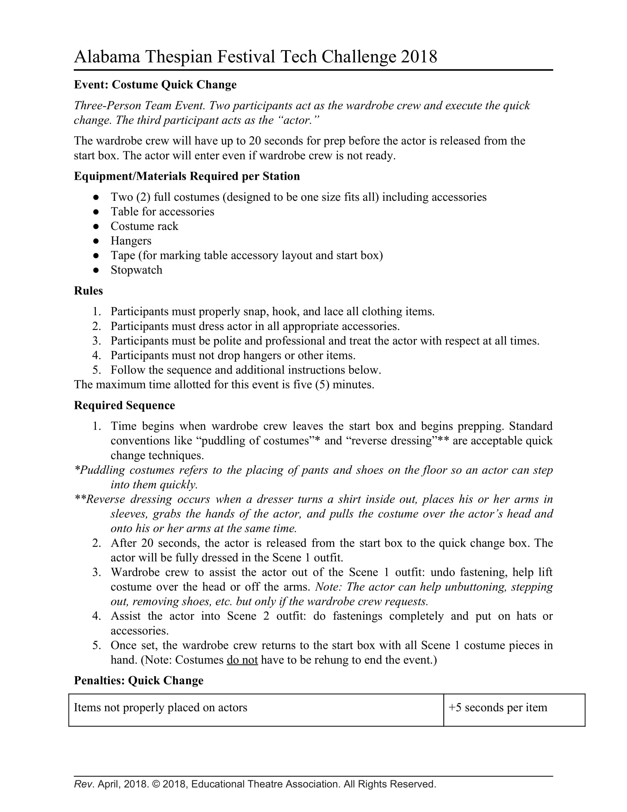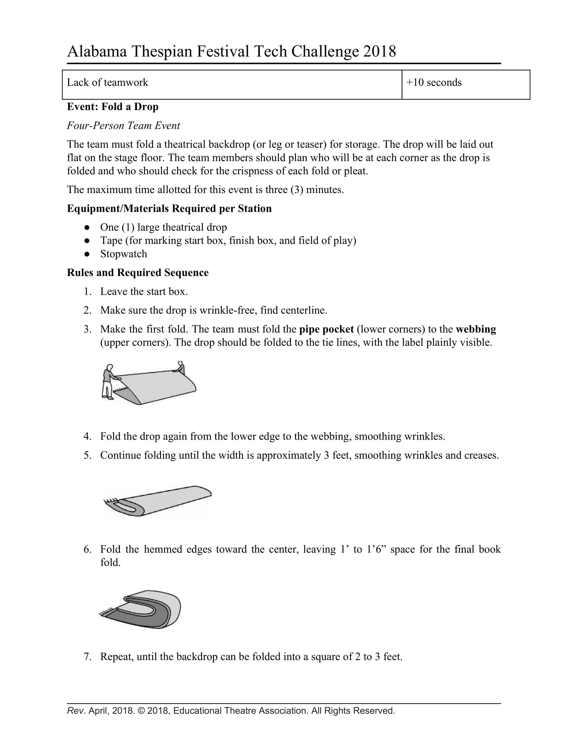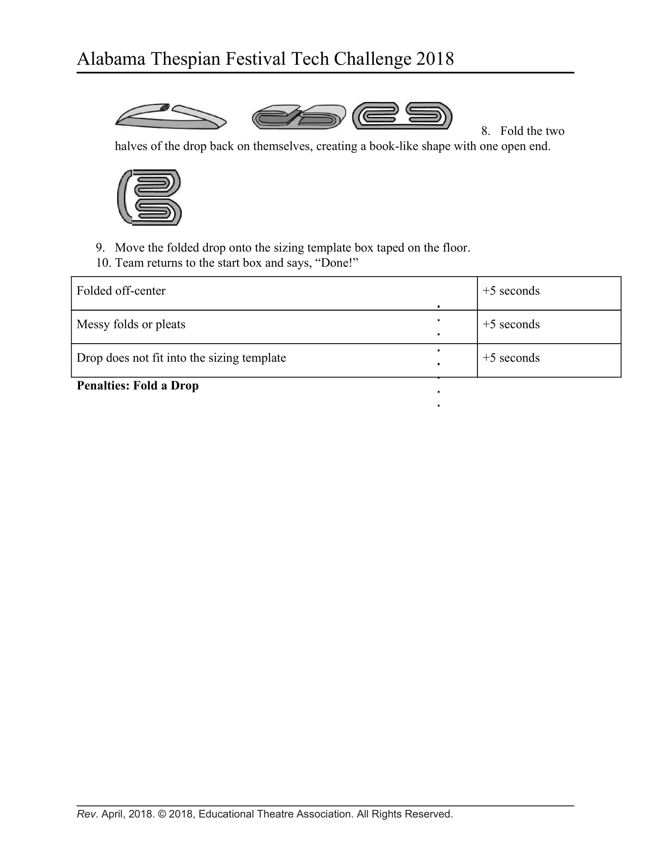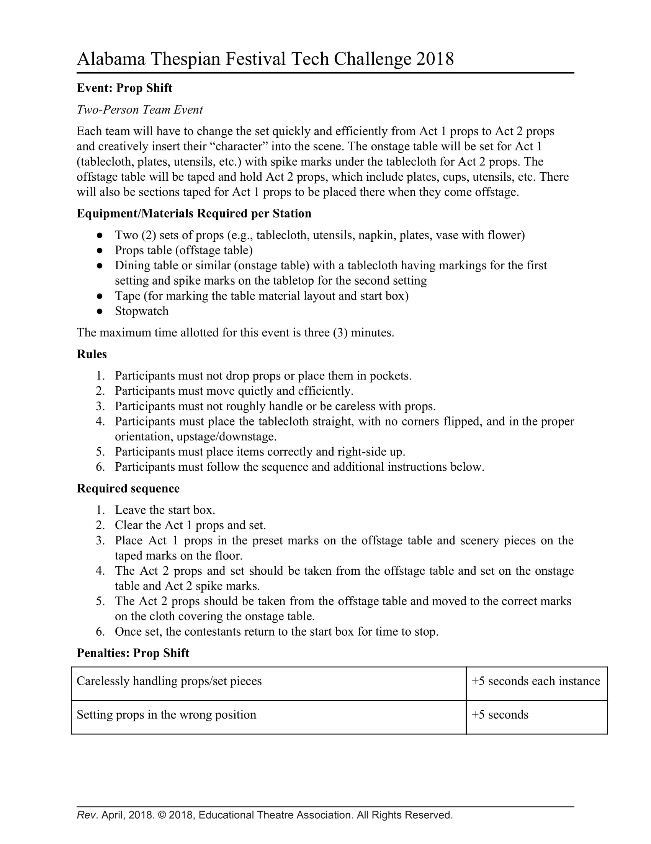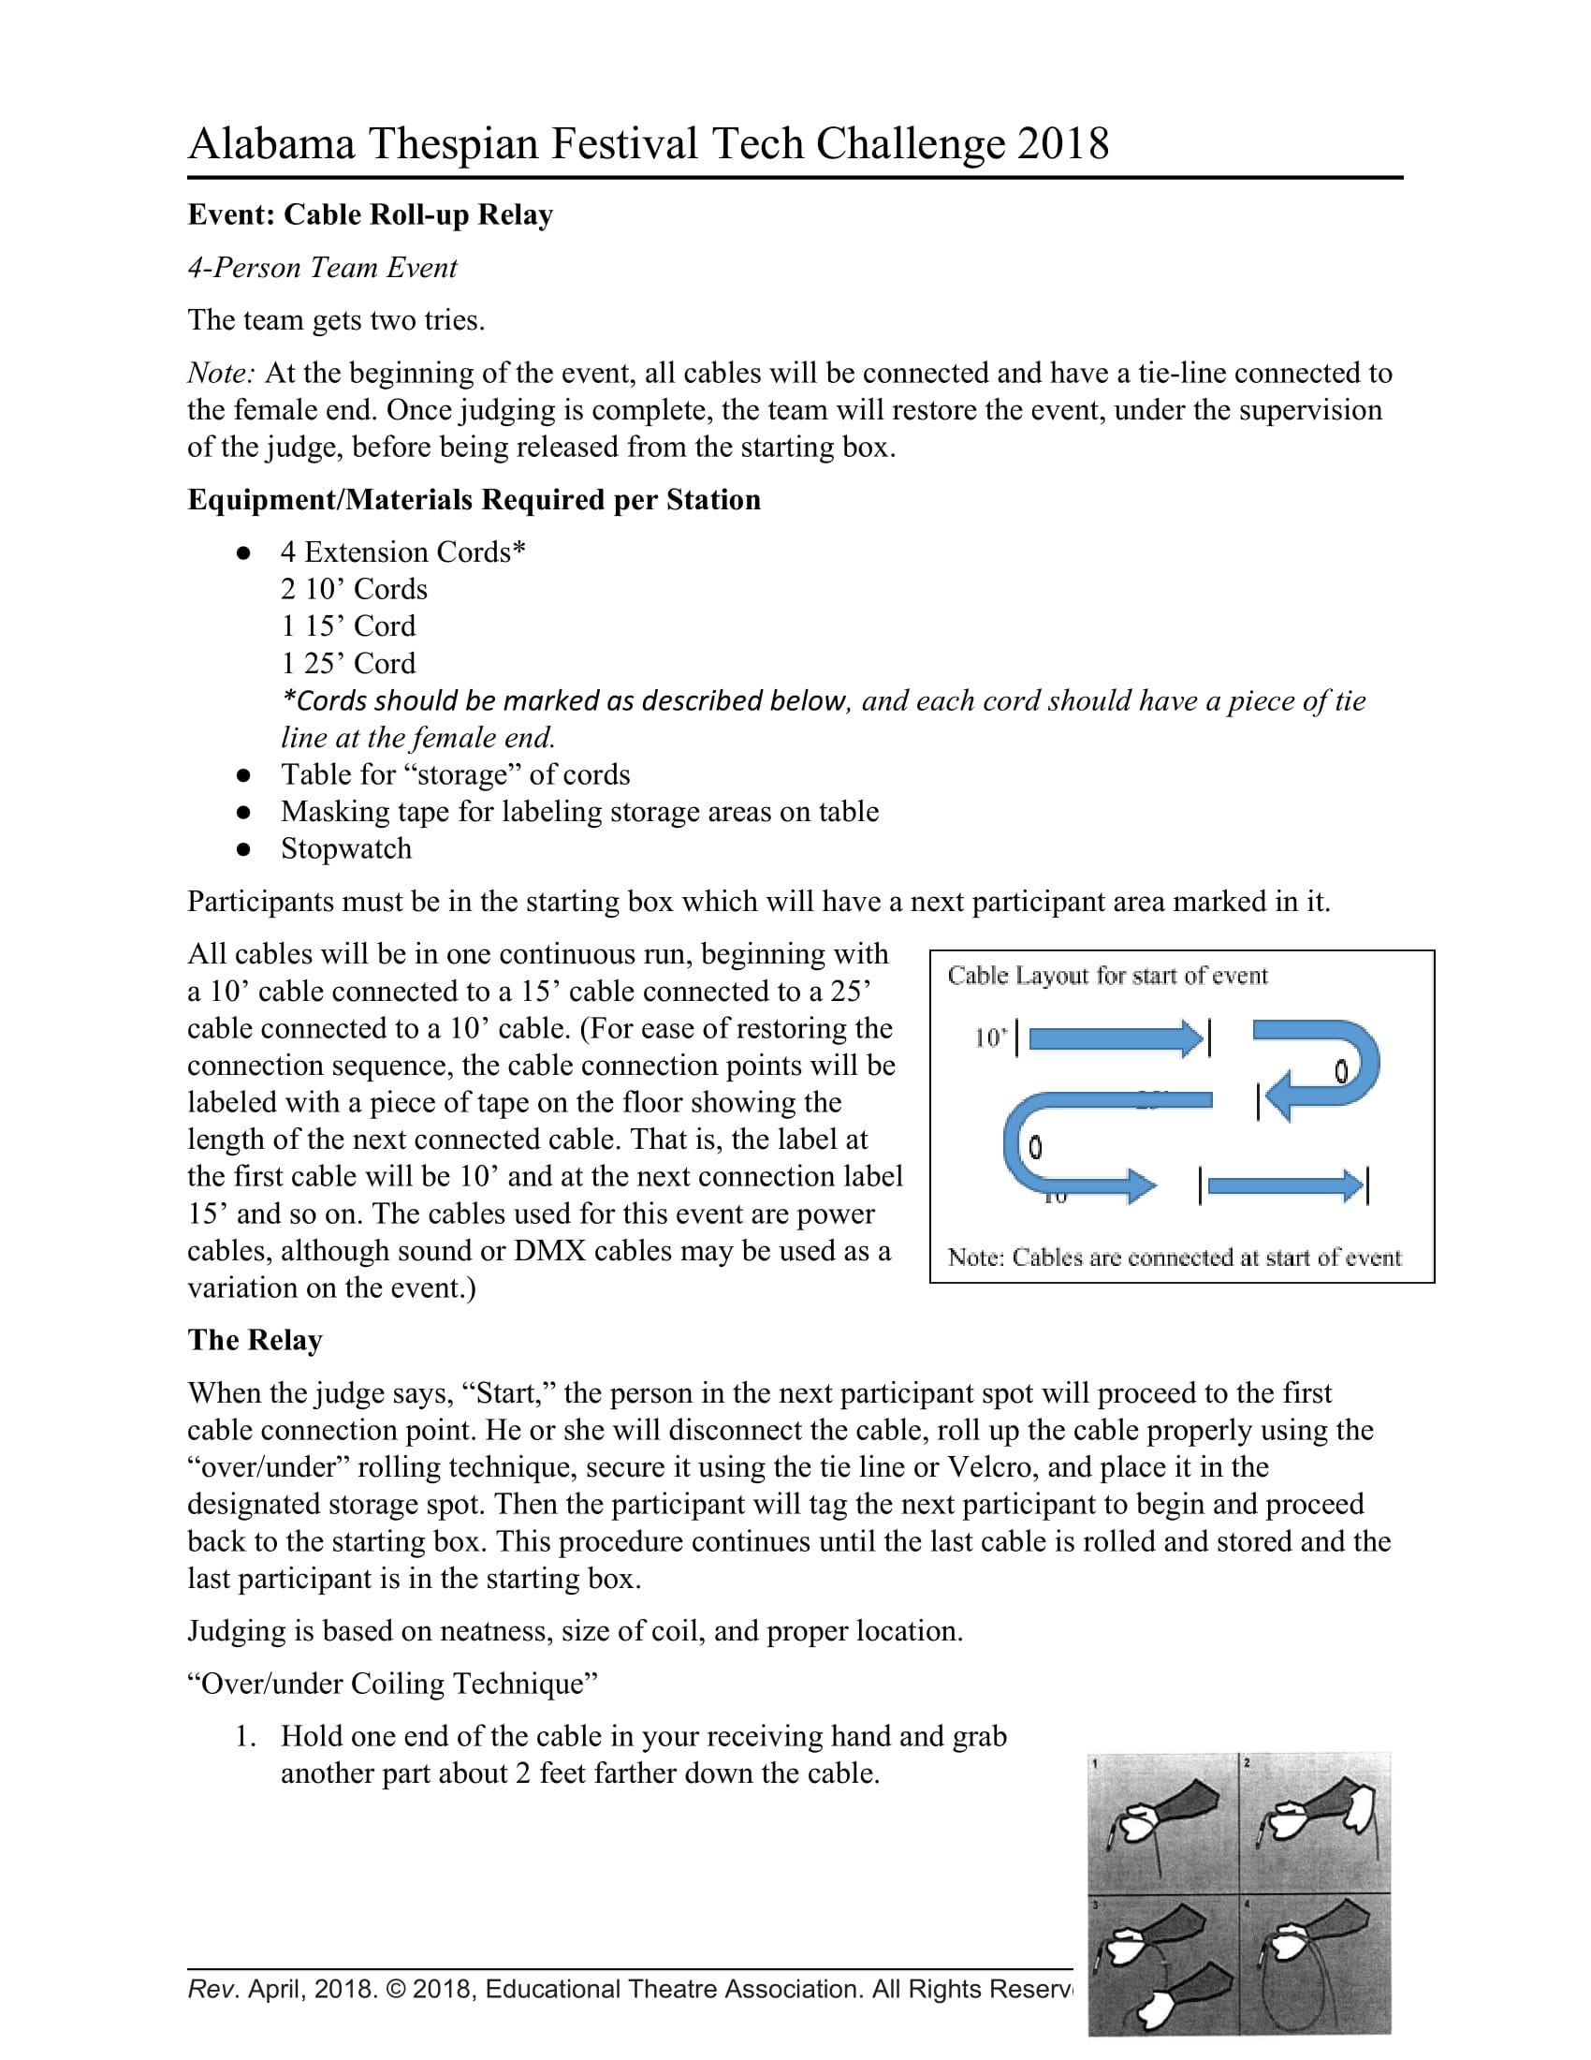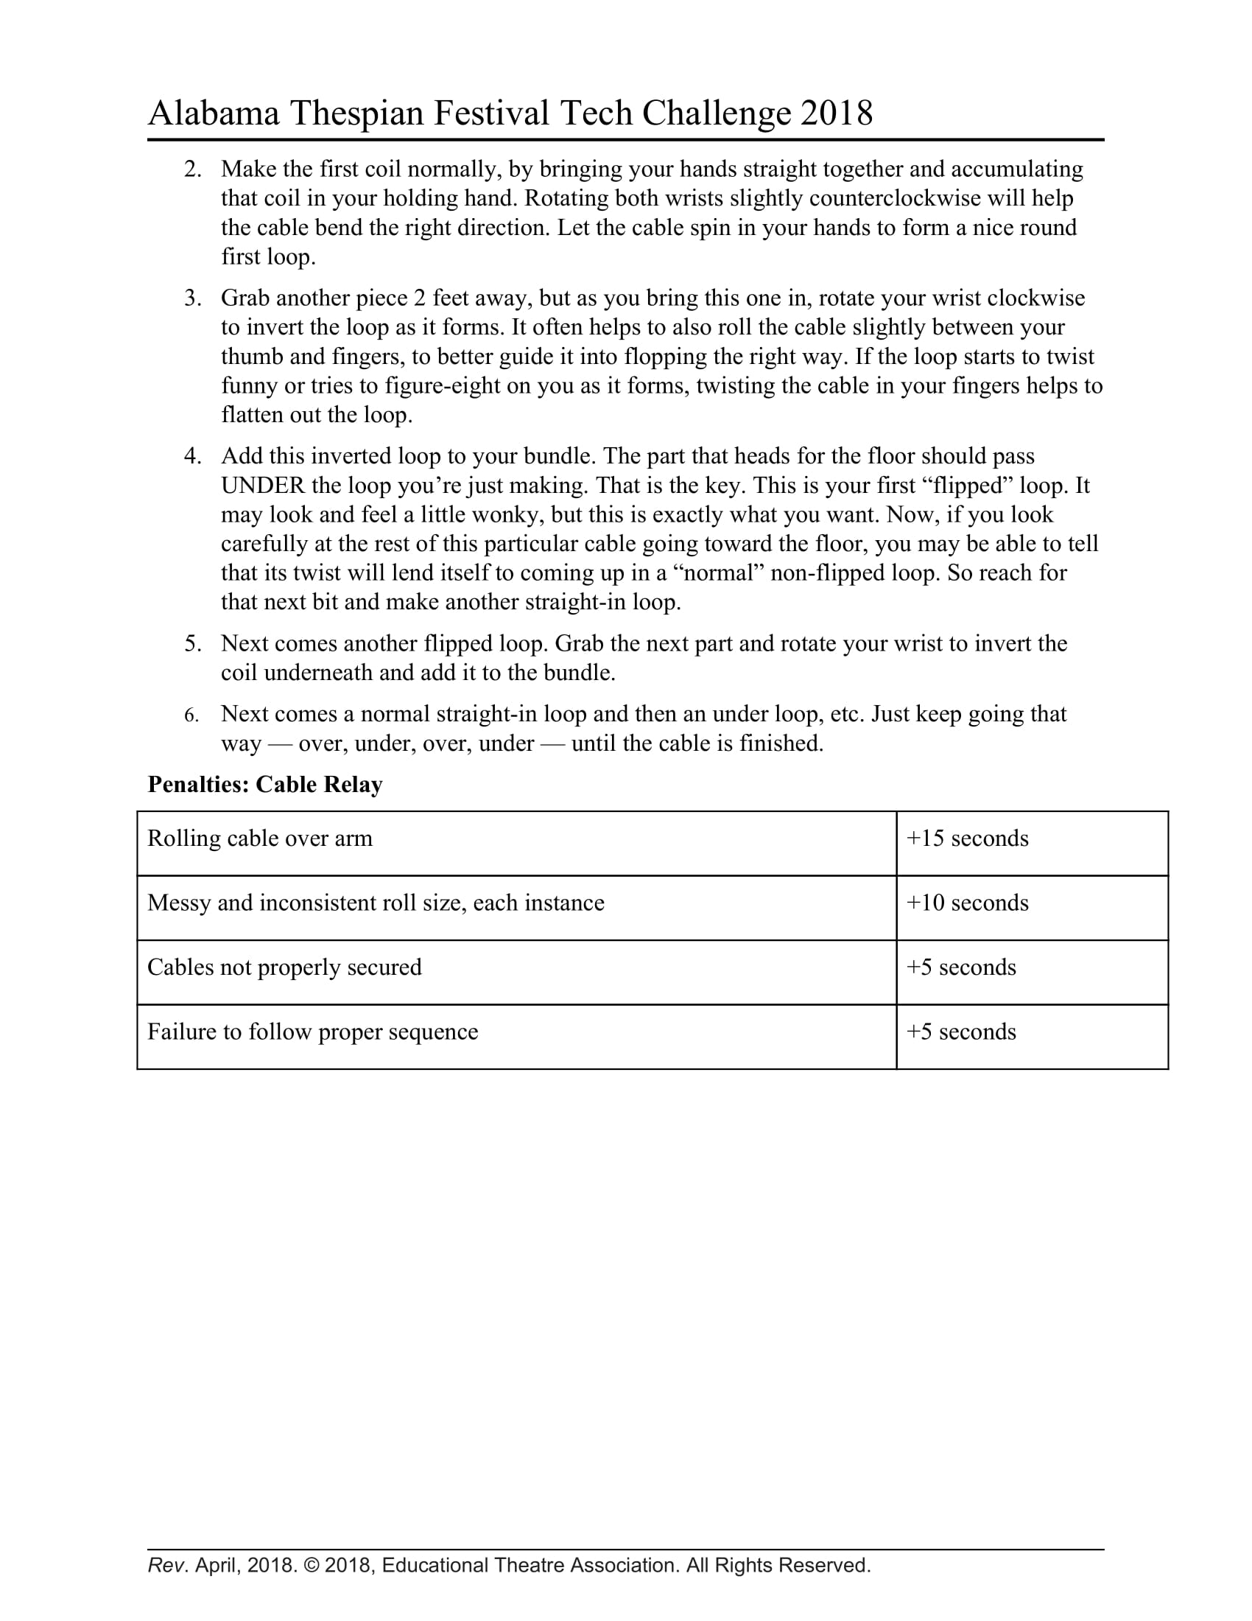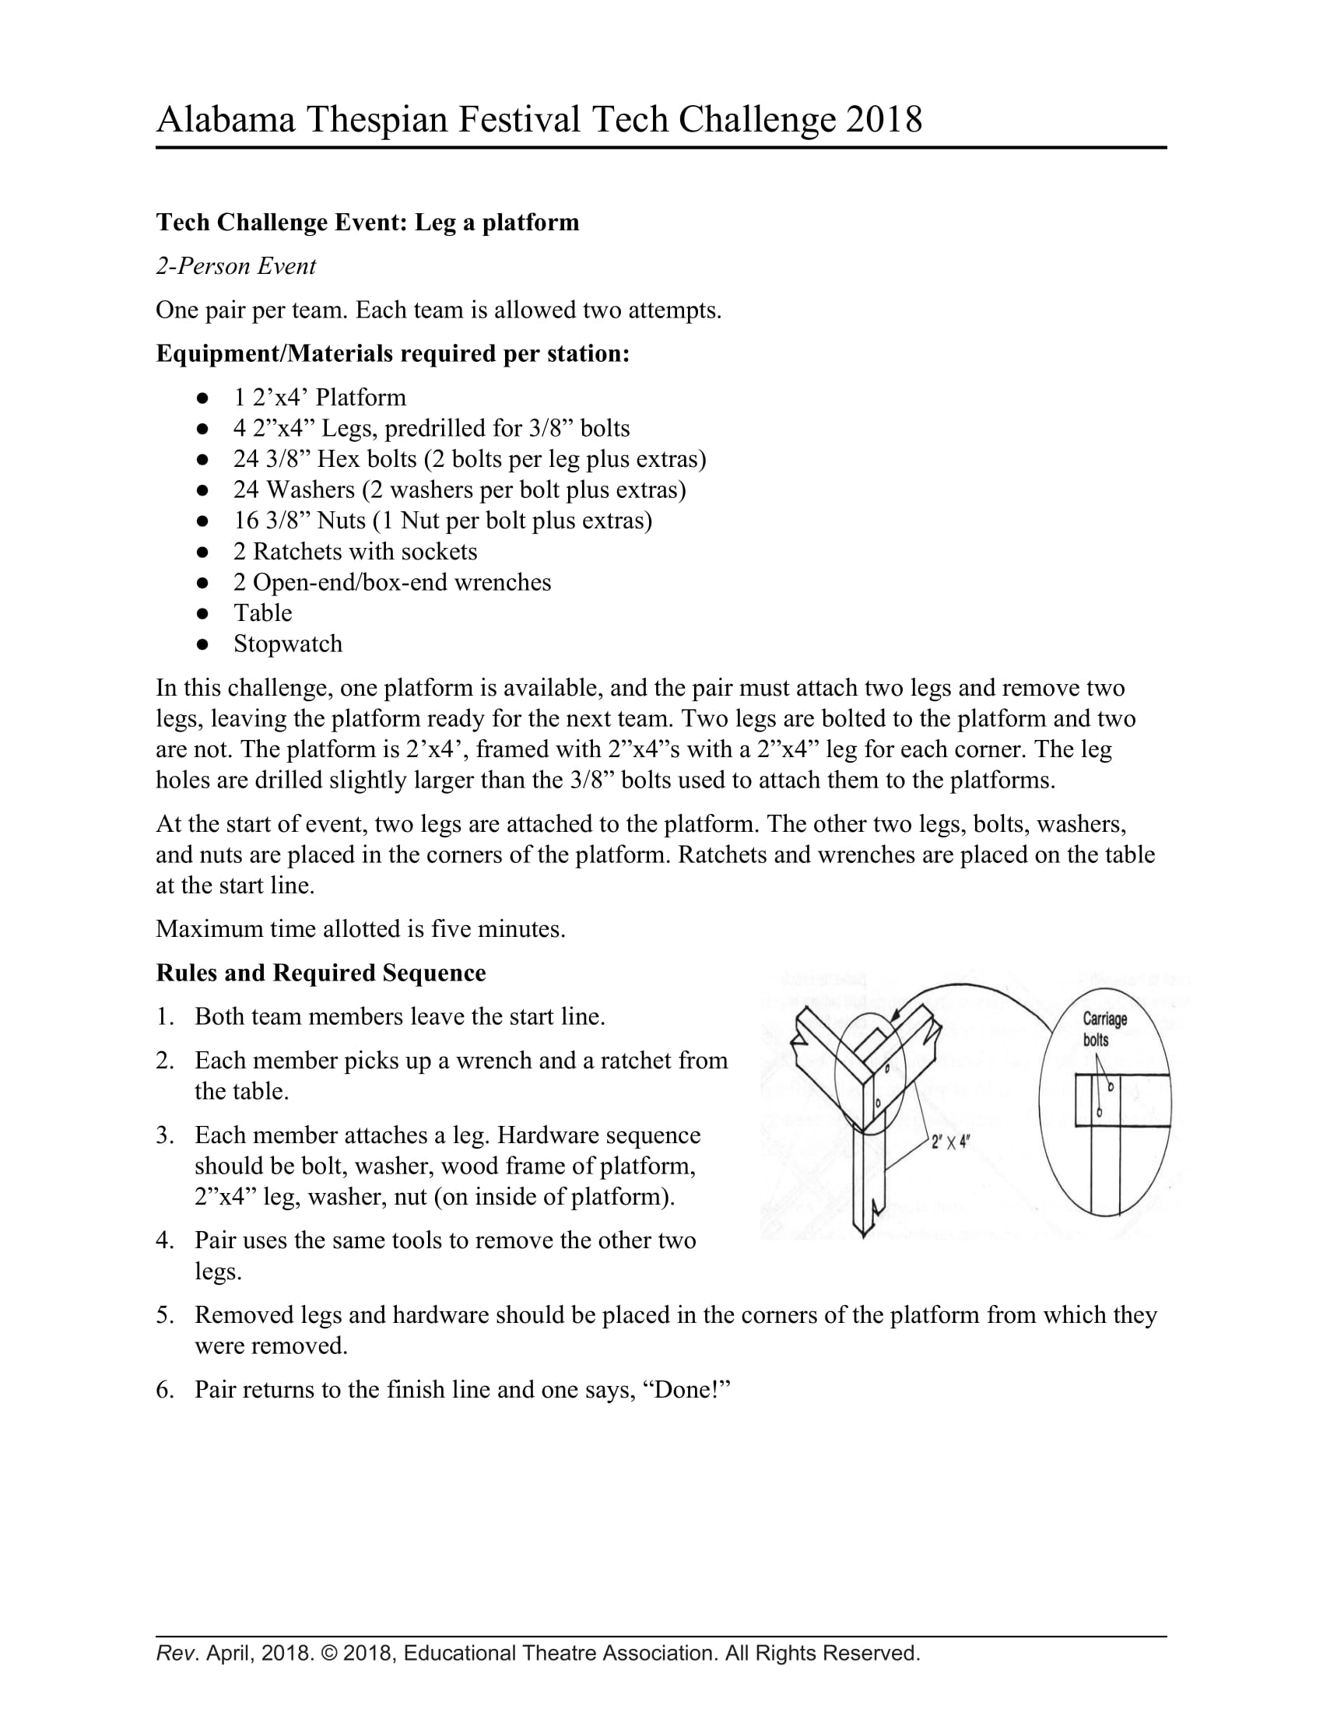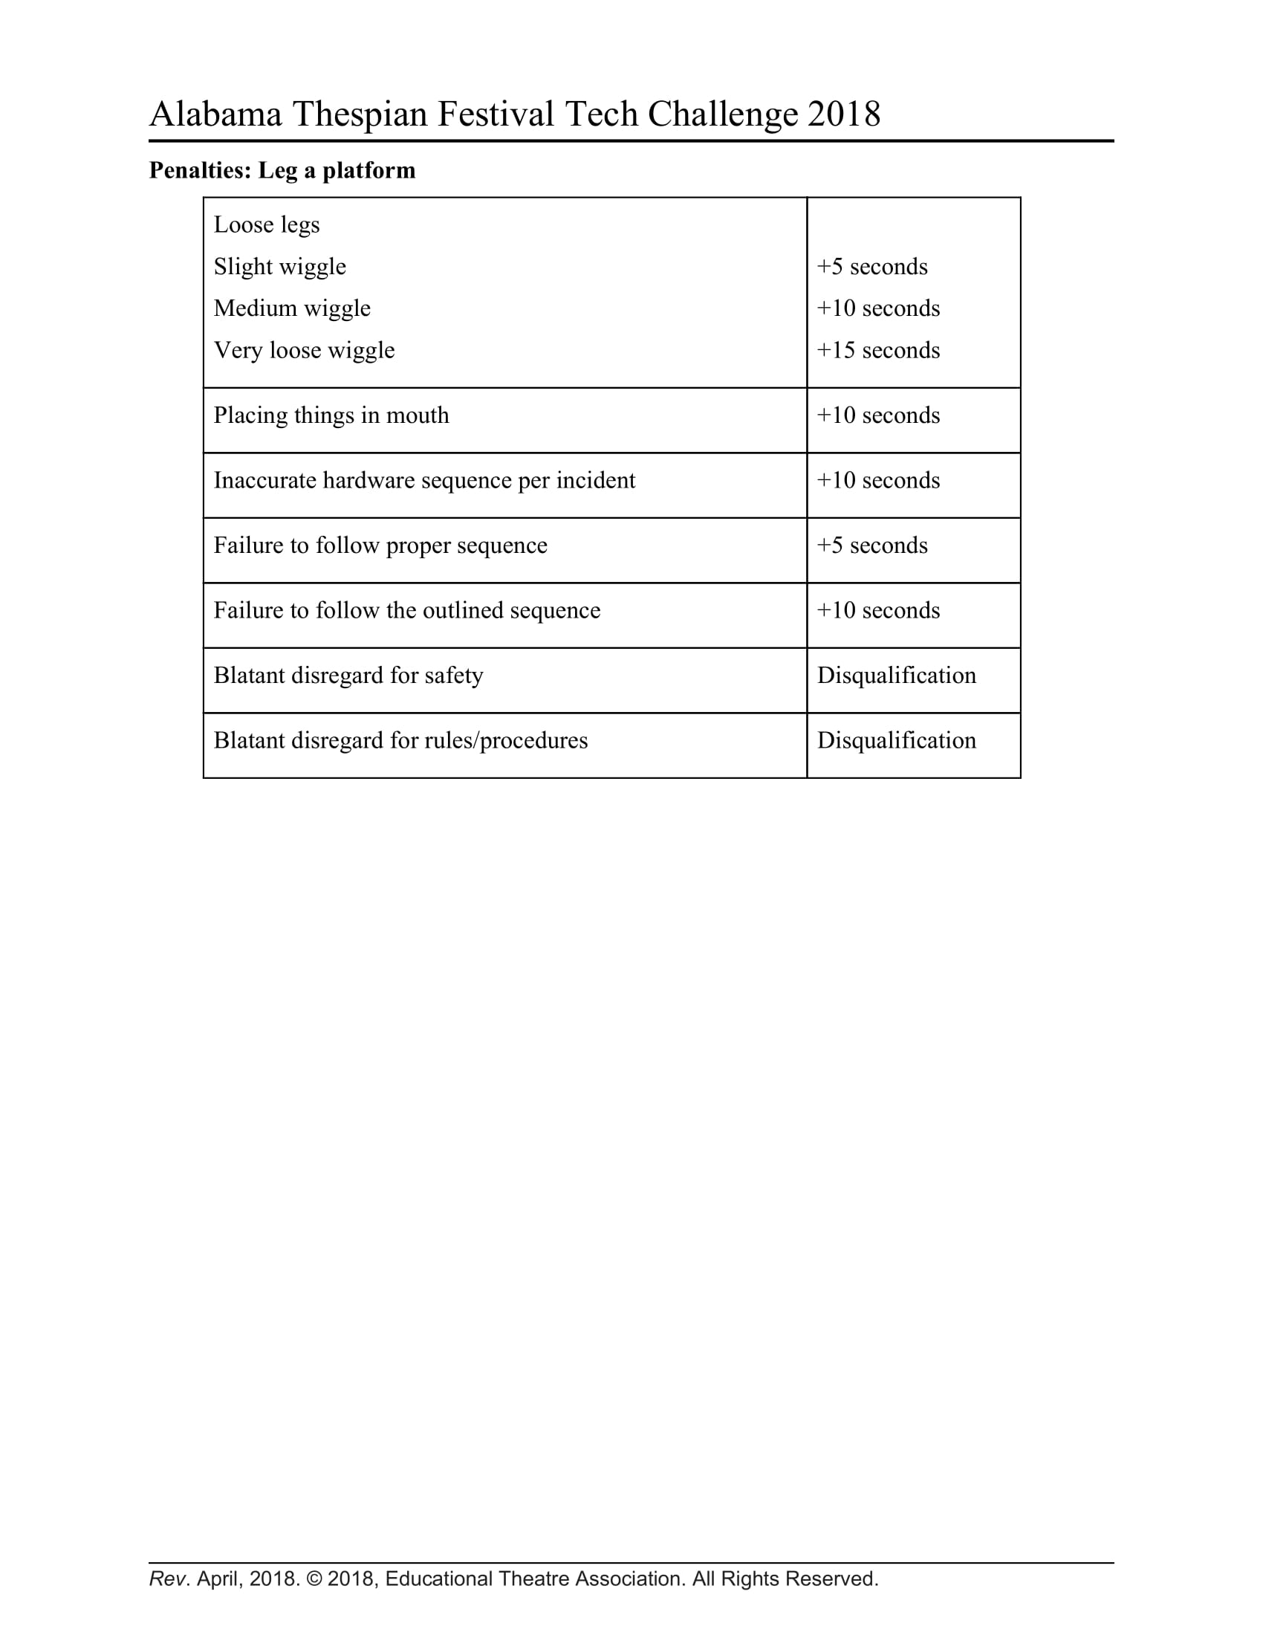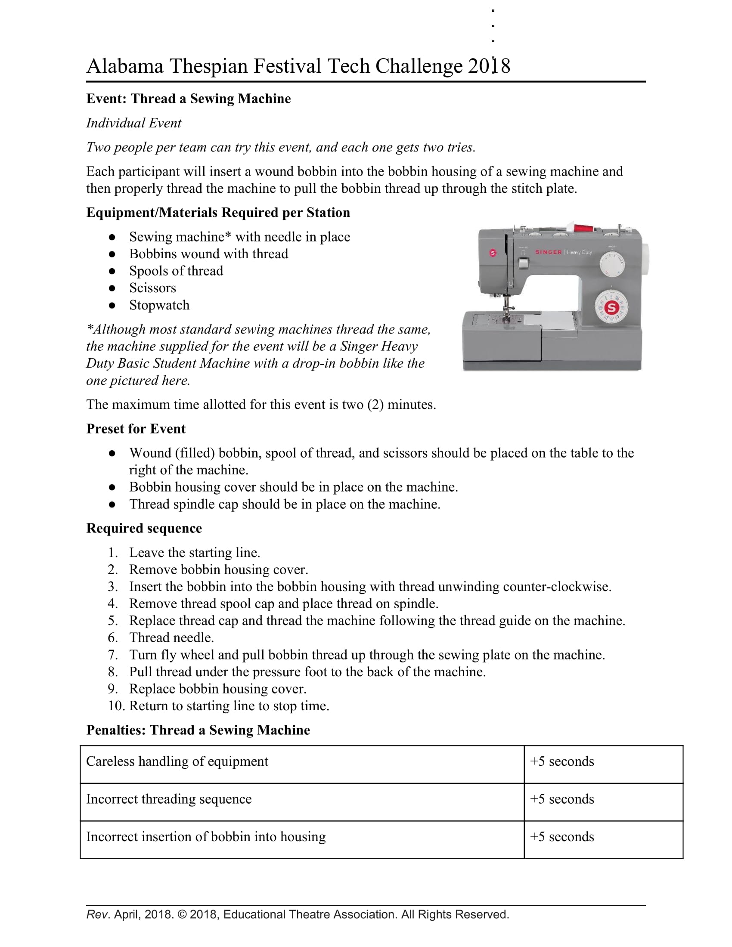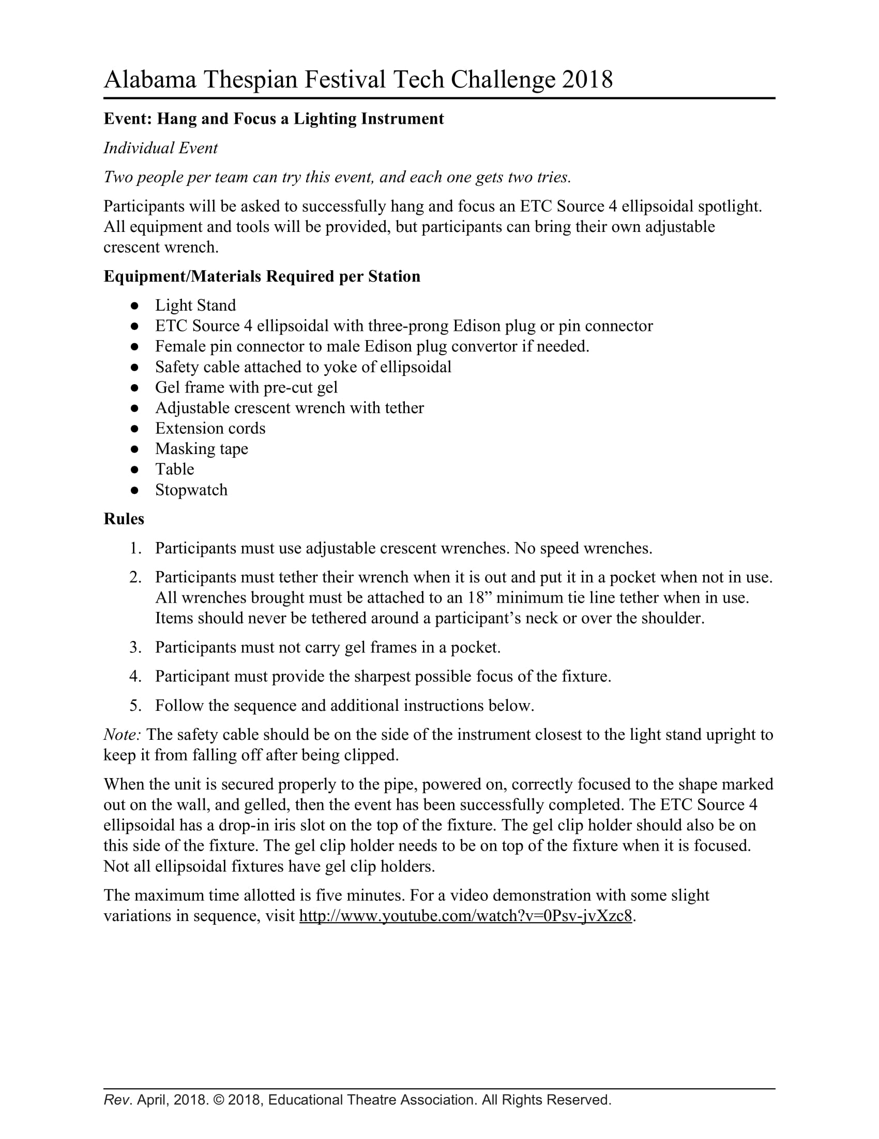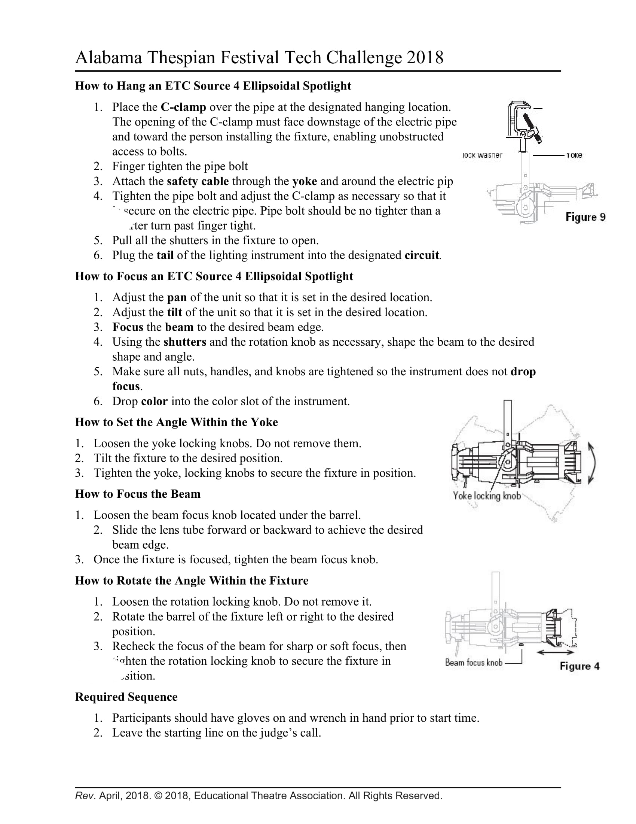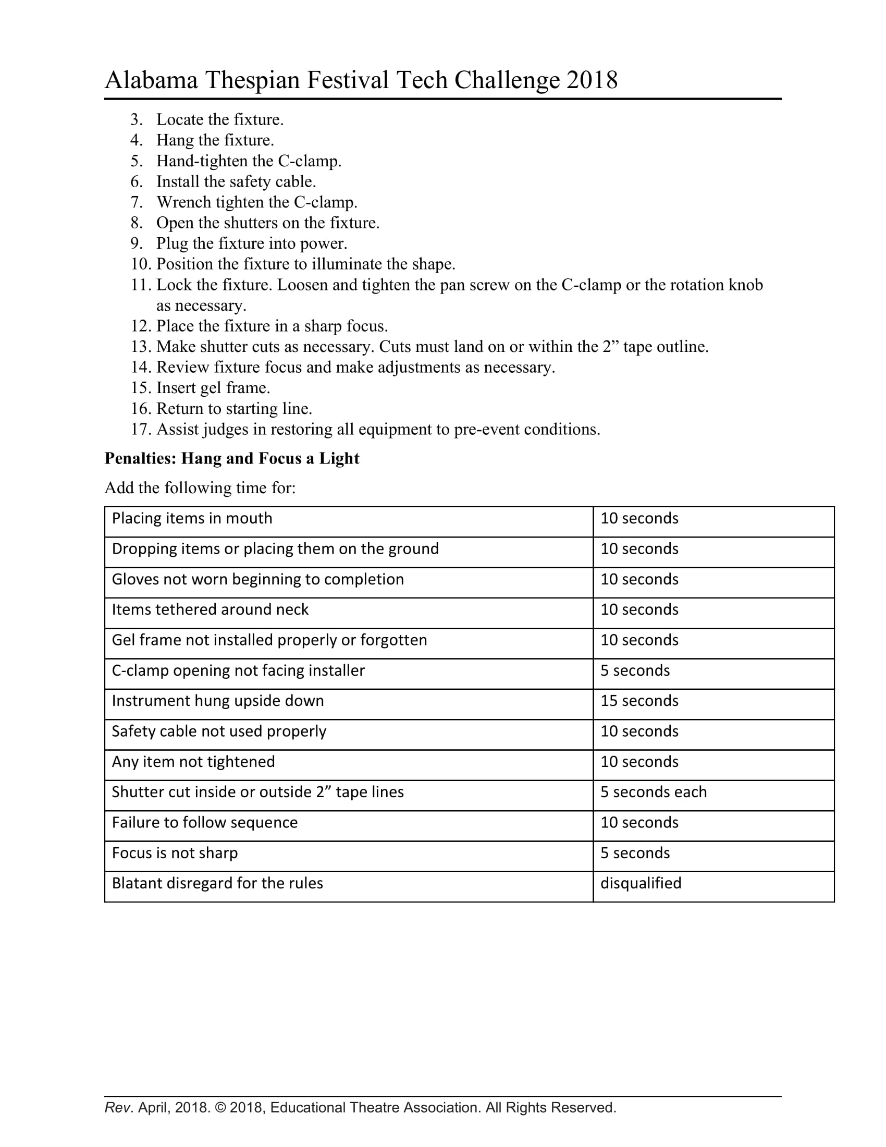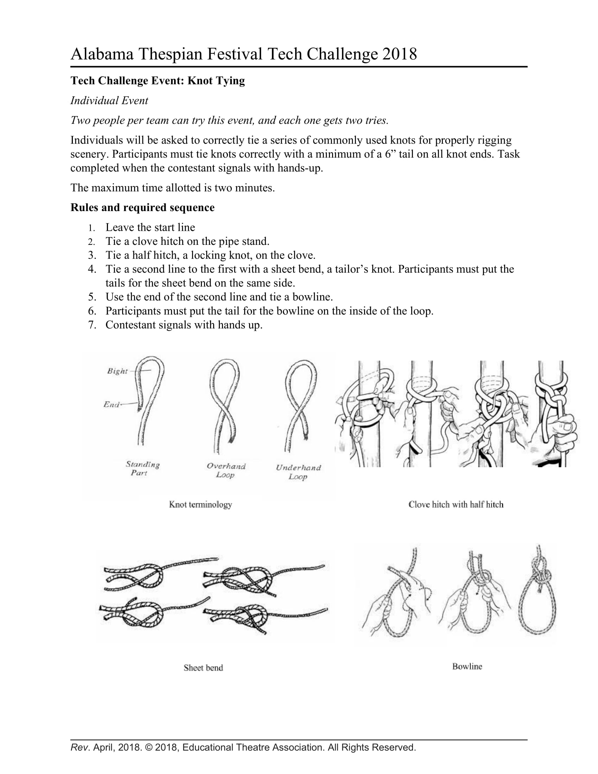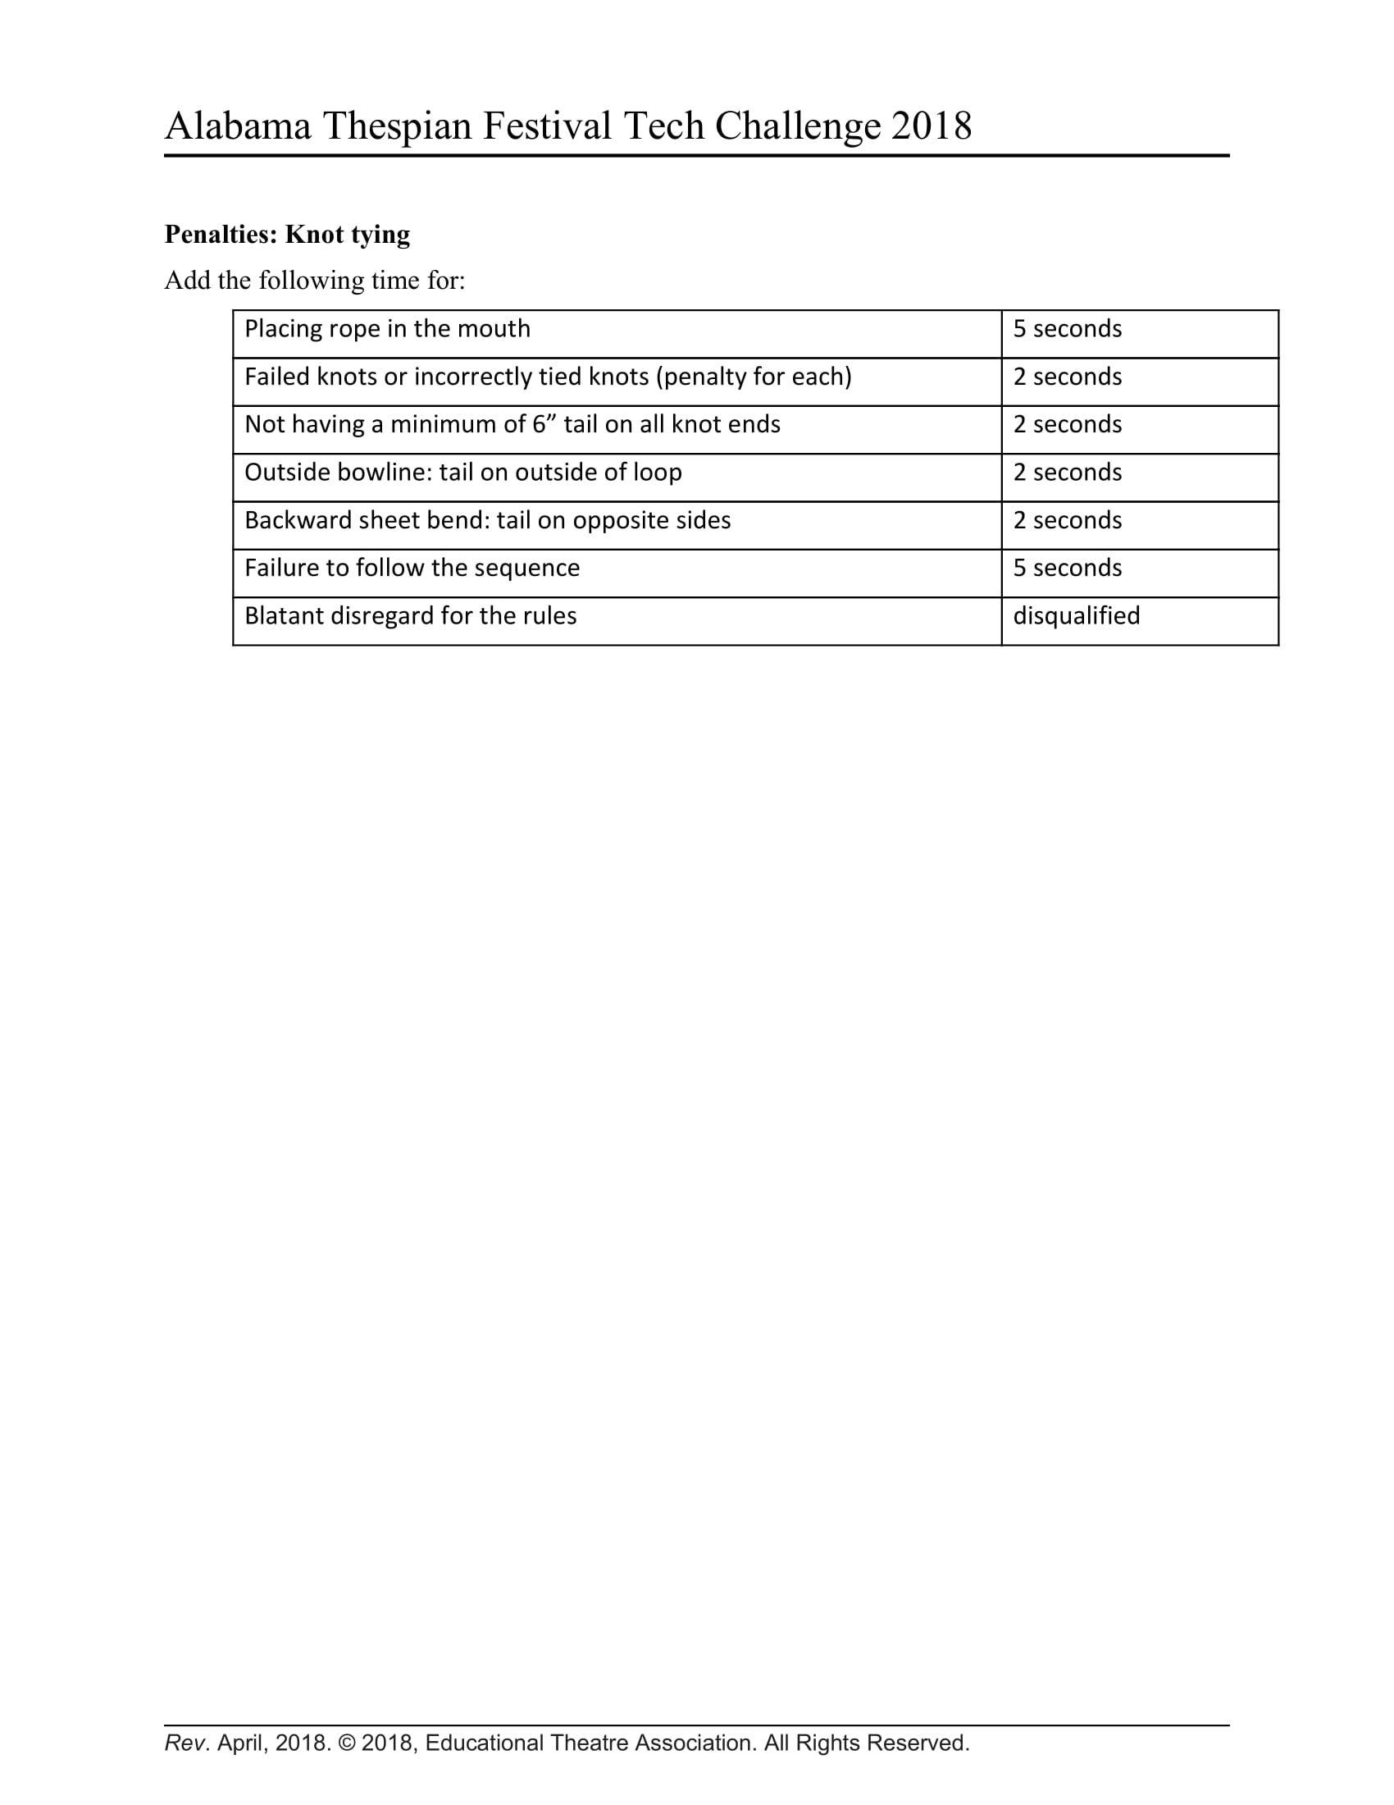

WORKSHOPS AND VENDORS:
During the festival, students have the opportunity to participate in dynamic and exciting workshops led by theatre professionals in all areas of the theatre arts, including many types of dancing, movement, vocal, accents, the audition process, improvisation, makeup, costuming, stage management, set design and construction, lighting and sound, team building, and theatre games, just to name a few. The workshop schedule will be posted on the website as soon as possible before conference so that you and your troupe members can plan their conference workshop experience in advance.

***If you or someone you know is interested in leading a workshop session OR being a vendor at the festival, please visit our website for the information and proposal packet at www.alabamathespians.org.

STATE THESPIAN OFFICERS:
An STO is a State Thespian Officer. These are exemplary high school theatre thespians. The STO’s job is to plan, manage, and host the next year’s Conference. Also, the STO’s serve as a constant communication link between the students of Alabama Thespians and the Adult Executive Board; therefore, it is their job to serve as an advocate for the students. STO’s serve as the ambassadors of theatre arts education for the state of Alabama in a very active role.
Who can be an STO?
- Any Freshman, Sophomore or Junior who is an inducted Thespian and in good standing with his/her troupe and school is eligible to run.
- The student must have a desire to be a strong leader and be prepared to work for the good of Alabama Thespians and theatre in schools in the state of Alabama.
- The student must also have attended one festival prior to running for office.

If you are interested in becoming an STO, visit our website to download the information and application packet.
www.alabamathespians.org

STATE THESPIAN OFFICER ONLINE APPLICATIONS DUE: December 10, 2019

COMMUNICATION:
This year Festival will be utilizing the app “Guidebook.” This app will allow participants to access their personal festival agenda, maps of the campus, Guest Artist information, and more! In addition, it will allow festival staff to send out push notifications with important information during the festival.
Prior to festival, any changes to dates/events/ schedules and any emergency information prior to and while at conference will be emailed to registered troupe directors, posted on our website (www.alabamathespians.org), and posted on our Facebook page (Alabama Thespians).

LODGING:
There will be a list of discounted festival area hotels on the website by Dec. 10. Each school is responsible for making its own lodging reservations.
www.alabamathespians.org
NEW TROUPE DIRECTORS:
If you are a new troupe director, we can pair you with a mentor director. We want to help make this year as easy as possible. Contact our Chapter Director, Jamie Stephenson (althespianfestival@gmail.com) for more information about mentoring, chartering a troupe, re-chartering a troupe, or any other troupe needs you may have.

PARKING/UNLOADING:
UPDATE INFORMATION Buses can drop off and park in front of the school in the second tier parking lot. Parent cars are allowed to park in the front and side parking lots.

RATINGS:
Alabama Thespians exhaust every effort to ensure that festival participants are exposed to a wide variety of genres and experiences. However, we recognize that everyone has different personal perspectives and we host a range of maturities during the festival. If you feel your troupe has specific show needs, let us know by emailing Mari Adams at madams@jp2falcons.org, Performance Coordinator.

VENUES:
Vestavia Hills High School
2235 Lime Rock Road
Vestavia Hills, Alabama 35216

Vestavia Theatre
Seating Capacity - 1100
Wing Space - stage left is 10ft wide and 20 ft tall, stage right has 3 ft and 8ft tall.
Performance Space - 51'x30'

Set Design:
Traveler: yes
Cyclorama on the last line set
Grand Curtain yes
Dressing Room Availability: 2 dressing rooms
Green room: no
All scenery must remain on your truck until your load in time and must be removed from the theatre immediately following your performance.
Scenery cannot be screwed into the stage floor and no painting is allowed.

Lighting:
General front lighting. Gels are not provided. The instruments cannot be moved from their hung position. Schools performing should bring colored gels if needed for their production and all supplies needed to place those gels. General “wash” lighting is provided for simple area lighting; you will not have the luxury of adding numerous lighting cues or specials. Schools should be able to identify a few specials, but your instrument choices and hang locations are limited. Lighting Plot, special instrument schedule and cues should be clearly listed and organized.

Sound:
Multi-channel sound board are provided for sound effects and sound cues. The festival does not provide wireless microphones; this is the presenting school’s responsibility.

Technical Support:
One technical support staff member from Vestavia will be provided.
Cargo bay for at 20ft and 10ft and rear door at 15ft by 6

SCHEDULE:
NOTE: The following is a draft conference schedule intended for your planning purposes. Actual times throughout the day may vary from the final schedule which will be posted on our website as soon as it is finalized.
Friday:

1:00 - 2:00 PM Registration (Lobby)

2:00 - 2:30 PM Opening Ceremony (Vestavia Hills Theatre)

2:00 PM Judges Meeting (Library)

2:45 - 10:00 PM Sr. Individual Events

3:00 - 8:00 PM Workshops

4:30 - 9:00 PM Dinner - Eat at your leisure.

6:30 - 8:30 PM Mainstage
- Load in 5 PM
- Perform 6:30 PM
- Load out 8:30 PM

9:00 - 10:00 PM (after evening performance) Improv Face-Off

9:30 - PM Tech Walk Thru for Chapter Select Directors

Saturday:

9:00 - 11:00 AM Mainstage Performance
- Load in 7:30 AM
- Perform 9:00 AM
- Load out 11:00 AM

12:00 - 5:00 PM Chapter Selects

- Sr. Chapter Select
  - Load in 11:50
  - Perform 12 PM
  - Load out 12:45 PM

- Jr. Chapter Select
  - Load in 12:50 PM
  - Perform 1:00 PM
  - Load out 1:45 PM

- Sr. Chapter Select
  - Load in 1:50 PM
  - Perform 2:00 PM
  - Load Out 2:45 PM

- Sr. Chapter Select
  - Load in 2:50 PM
  - Perform 3:00 PM
  - Load Out 3:45 PM

- Sr. Chapter Select
  - Load in 3:55 PM
  - Perform 4:00 PM
  - Load Out 4:45 PM

9:00 - 11:00 AM Scholarship Auditions

11:00 AM Troupe Director’s Lunch Meeting

9:00 am - 7:00 PM Workshops

11:00 AM Lunch - Eat at your leisure

12:00 - 4:30 PM Jr. Individual Events

4:00 PM Dinner - Eat at your leisure.

5:00 - 7:00 PM TECH CHALLENGE (Large Gym)

7:00 IE Showcase and Award Ceremony

Important Dates and Deadlines

September 3, 2018 Registration OPEN
Awards Nominations OPEN
Grant Submissions OPEN
Chapter Select, Improv Face Off,
Mainstage, and Tech Challenge OPEN

November 9, 2018 Grant Submissions CLOSED
Chapter Select Registration CLOSED
College/Scholarship Auditions CLOSED

November 16, 2018 Early Bird Registration CLOSED
Mainstage Registration CLOSED

November 17, 2018 Late Registration OPEN

December 10, 2018 Late Registration CLOSED
Improv Face Off Registration CLOSED
Individual Events CLOSED
Tech Challenge Registration CLOSED
2018-2019 STO Applications DUE

February 15-16, 2019 Alabama State Thespian Festival
Vestavia Hills High School
2018-2019 STO Board Announced

September 1, 2019 Main Stage 2019 Applications OPEN

May 31, 2018 STO Leadership Camp Registration DUE

June/July 2018 Leadership Camp
2018-2019 STO Board

I have a question… Who do I ask??
Area | Job Title | Name | Email
Administrative | Festival Director | Mari Adams | madams@jp2falcons.org
 | Chapter Director | Jamie Stephenson | stephensonjl@vestavia.k12.al.us
 | Host School Liaison | Jamie Stephenson | stephensonjl@vestavia.k12.al.us
 | Treasurer | Clint Merritt | m.clinton.merritt@gmail.com
 | Secretary | Jeff Glass | jeff.glass@elmoreco.com
 | State Thespian Officer Adviser | Megan Garner | mgarner@jefcoed.com
 | Junior Thespians | Dianne Rowe | drowe@hoover.k12.al.us
Guest Services | Registration | Jeff Glass | jeff.glass@elmoreco.com
 | Hospitality | Jamie Stephenson | stephensonjl@vestavia.k12.al.us
 | College Rep Liaison | Katie Dalrymple
 | Volunteer Coordinator | Gail Allen | gailspeaks@comcast.net
 | Guest Relations | Mari Adams | madams@jp2falcons.org
Events | Main Stage Performances | Mari Adams | madams@jp2falcons.org
 | Tech Challenge | John Jackson | jjackson@florencek12.org
 | Improv Face-Off | Mari Adams | madams@jp2falcons.org
 | IE Showcase | Jennifer Kilpatrick
 | Scholarships/College Auditions | Katie Dalrymple
Workshops | Guest Artists | Mari Adams | madams@jp2falcons.org
 |  | Jamie Stephenson | stephensonjl@vestavia.k12.al.us
Individual Events | High School | Jeff Glass | jeff.glass@elmoreco.com
 | Middle School | Diane Rowe | drowe@hoover.k12.al.us

General Festival Checklist:

THESPIAN | TROUPE DIRECTOR
- Download the mobile link for festival and create your digital festival agenda.  - CD, portfolio; anything you require to complete your IE  - Black attire for participation in your IE  - Gloves and tools not provided by festival if participating in the Tech Challenge  - Money for meals  - School appropriate attire that is comfortable and easy to move in  - Extra money for: STO Swag, Silent Auction Items, Snacks, Breakfast, and VENDORS! | - Download the mobile link for festival and create your digital festival agenda.  - Completed participant health forms (2 copies of each form) and signed code of conduct  - Check or school credit card to cover registration fees if they were not prepaid.  - Coordinate a judge to bring for your school’s adjudication responsibility  - Make sure you have received an email stating your volunteer time slot and position. If you have not received this by the week prior to festival, email althespianfestival@gmail.com  - A completed Purchase Order (PO) to reimburse yourself for any items you might buy at the silent auction (we sell lots of plays at low cost) and there will be GREAT thespian items this year.

Alabama State Thespians Can...

The goal of this weekend is for thespians and their sponsors to meet as many thespians from all over the state of Alabama; work together; exchange ideas; renew friendships; and celebrate our Love of Theatre. Observing the following rules will make the festival a pleasurable experience for all.

I realize that being able to go to the Thespian State Festival is a privilege.

I realize that I am representing not only my parents, teacher, school and my troupe, but also my school district.

I will be a positive part of the festival. I will complement rather than criticize other students. If I have a problem I will speak to other adults with respect.

I will pick up trash, even if I didn’t leave it on the ground. I will not leave my food or drink anywhere other than a trash can.

I will be attentive, cooperative and maintain proper theatre etiquette at all Thespian events. I realize that appropriate theatre response is applause, not yelling or verbal responses. An example would be when someone is doing a fabulous performance and you yell during their best note of the song. I will leave my feet on the floor and not on the back of seats.

I will attend all workshops and performances, including auditions. I will support all performers, not just the students from my troupe. I will not be just sitting around talking when there are festival activities happening on campus.

I realize that when I am late for a starting time, I must wait in the lobby quietly until an usher lets me enter. I also realize that if I must leave during a performance, due to illness, that I must wait until a convenient time to exit.

I will not leave campus at any time during the festival activities, without the approval of sponsor.

I will treat my sponsor with respect and obey the instructions of other chaperones and sponsors. I will respect all hotel and campus security and obey curfews.

I will not damage or take any hotel or school property.

I will treat all workshop leaders with respect and courtesy. I realize they may remove me from the workshop if I am disruptive. A disruption is talking while they are talking, being on your phone or being disrespectful to other students.

I will leave any drugs, alcohol or tobacco at home… Thespians are here to connect to the moment which can’t happen when you put poisons into your body.

I will respect my fellow Thespians verbally and physically by listening and appreciating their thoughts and requests.

I realize that if I cannot follow the established code of conduct, I will be sent home without a refund of fees, and will be excluded from the next year’s festival.

Student Signature: _________________________________________
Parent/Guardian Signature: __________________________________
Troupe Director Signature: __________________________________

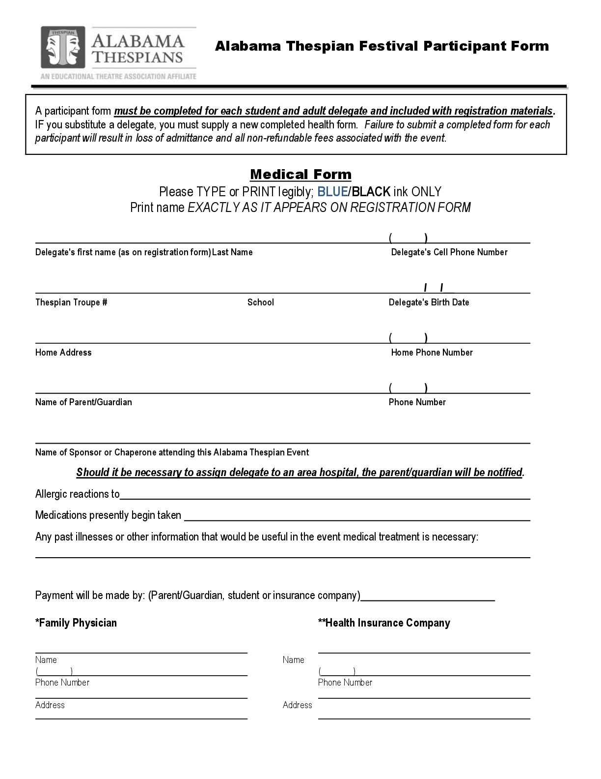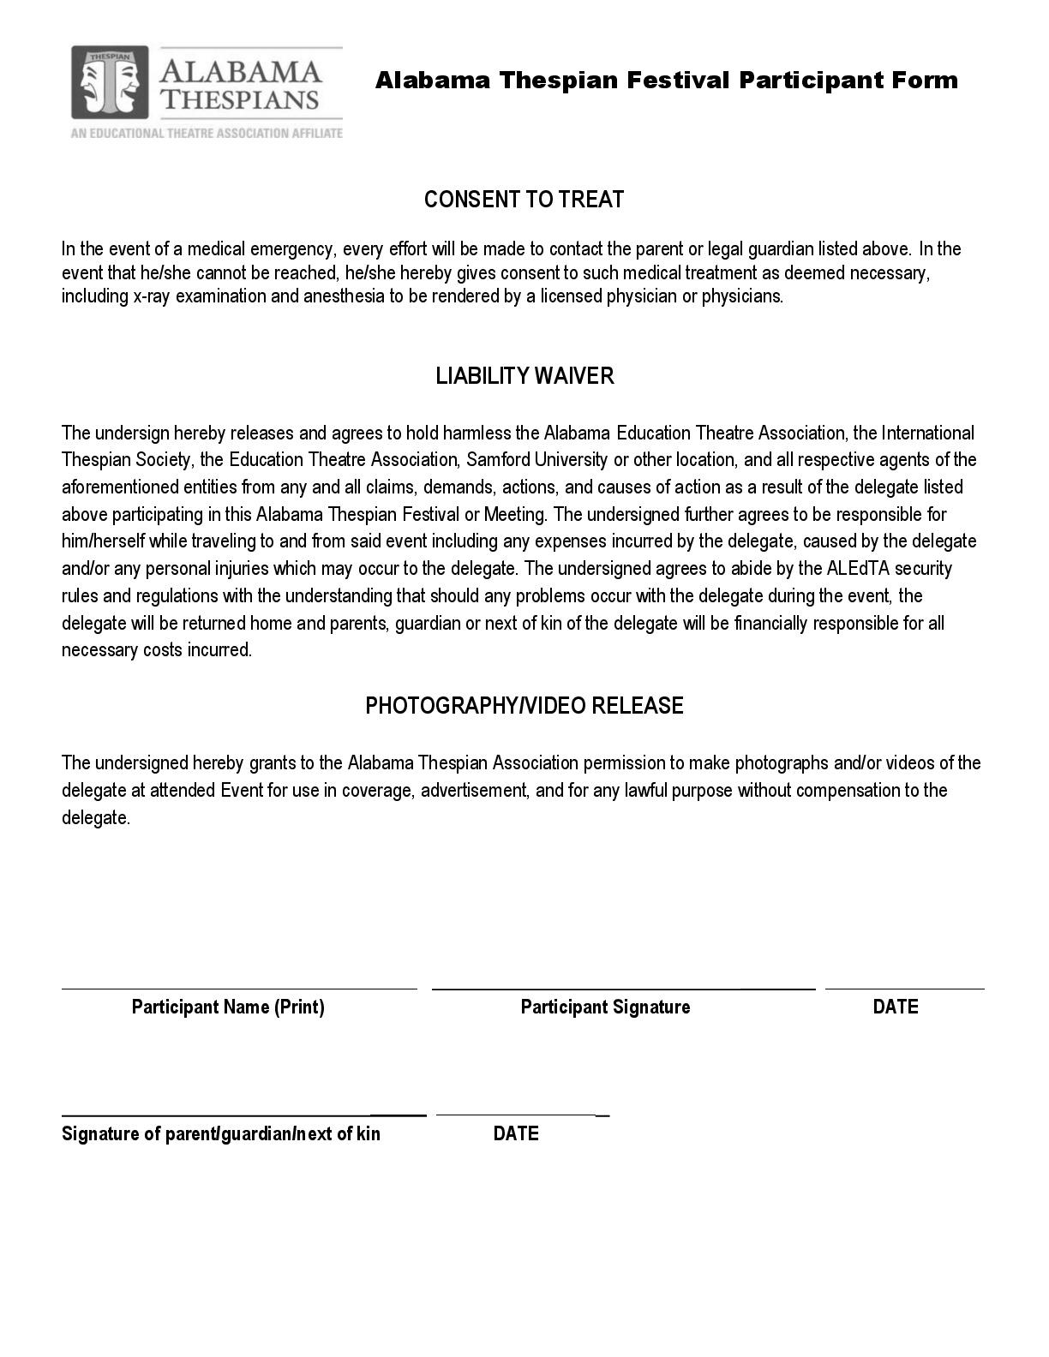

Helpful Links

Website: http://www.alabamathespians.org
Participant Agreement form: https://drive.google.com/file/d/0B1UmxviNNO0kZkhZbmZMNlJCUlE/view?usp=sharing

Alabama Thespians Hall of Fame https://goo.gl/forms/Yr6TIgyyTVG1kxE22

Administrator’s Award https://goo.gl/forms/54FYHs3XmsRmGvyu1

Troupe Director of the Year https://goo.gl/forms/SeQsL269ya0ujR8f1

Send a Troupe Grant https://goo.gl/forms/yppxDpmUsfM1YDZP2

Jenny B. Alford Registration Gran https://goo.gl/forms/QqBzqPwAHlTnx3oU2

Chapter Select http://goo.gl/forms/GNpLN6DakFLxaC4U2
College Auditions Senior https://goo.gl/forms/dxEBHwpbfaE3E8i52
College Auditions Junior https://goo.gl/forms/7lc3JpBgfpU0lIPz1
Improv Face Off https://goo.gl/forms/CGxrHuTmUqCf9YJq2
Mainstage https://docs.google.com/forms/d/e/1FAIpQLSeKsslIkQk_oibcPjYsJxg4YDvvHenqVtwTMX2Bv1895exQ0A/viewform

Tech Challenge https://goo.gl/forms/NZYvZrvYFgNlqRP93

ATF Tech Challenge Guidebook https://docs.google.com/document/d/1k9xHbvCVPXXCYxMpqmANzKb8G71BZo8csKKmkFuY6Io/edit?usp=sharing

