Engineering Design Project
Due 4/17/2020

Learning Goal: Students will choose a project and create a design for their choice.

Design Project:
- Choose any building project that interests you. EX: Deck, House, Sky Scrapper, Catapults, Rockets, etc.
- Draw out a design of your build using a ruler.
- Use proper Ratios. ie. 1in(on paper)=1 foot(in the build) or 1 in=1yard.
- On Design drawing label both measurements and materials.
- Make the design as if you wanted a younger sibling to easily follow your instructions to build your project.
Videos:
Engineering Design
Design Sketching
Engineering Process

Ex:
- 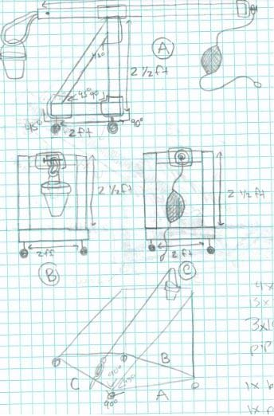
Materials:
-Wood 2x4’s
-Rope
-Bucket

