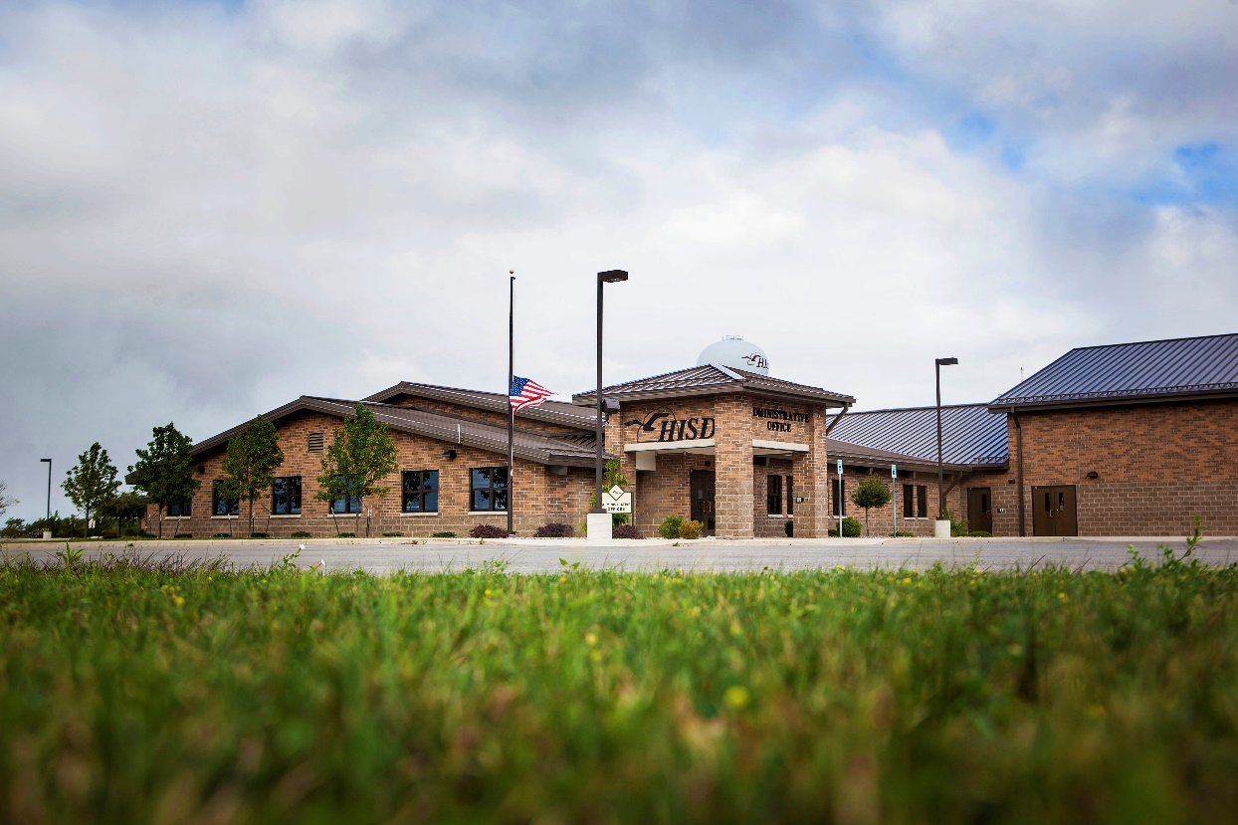



HISD Professional Development

0

Title

|  |  |
| --- | --- |
| **Date(s)** |  |
| **Time** | 8 a.m. to 3 p.m., meal included  3:30 – 7:00 p.m., light meal included  4:00 – 7:30 p.m. |
| **Location** | Huron Intermediate School District Administrative Offices  1299 S. Thomas Road, Bad Axe, MI 48413 |
| **Cost** | $10 per full day  $5 per half day |
| **Credit** | 6 State Continuing Education Clock Hours (SCECH) pending approval |
| **Stipend** | Stipends MAY be available if pre-approved by your superintendent or principal, please check with your district administrator. |
| **Presenter(s)** |  |
| **Audience** | Teachers, Paraprofessionals, Administrators, New Teachers |
| **Description** |  |
| **Registration** | Deadline to register is one week prior to each training.  Register online at [www.huronisd.org](http://www.huronisd.org), Professional Development link. |
| **Questions** | Contact Vicky Erdman at (989) 269-6406 with registration questions.  Contact presenter at [email@huronisd.org](mailto:email@huronisd.org) regarding content. |

*Federal funds not used for meal costs