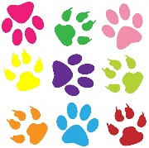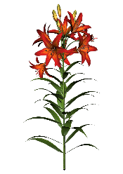
Plant and Animal Scavenger Hunt
Goal: Complete at least 8 of the items- I would love to see your photos (collage) or video of this!!
1. A ladybug
2. Any type of worm
3. Animal tracks
4. A bird
5. A hole in the ground (burrow)
6. A lizard
7. Sound of an animal
8. An animal
9. 3 different plants
10. 2 types of trees

