E

N

E

R

G

Y

C:\Users\dawn.bray\AppData\Local\Microsoft\Windows\Temporary Internet Files\Content.IE5\JZVDNC8J\MC900383376[1].wmf

**Technology i**mproves the ways we use energy. Energy conversion may produce unwanted forms of energy such as heat. That unwanted energy is “lost or wasted” energy. Technology decreases wasted energy. It improves our ability to use cleaner forms such as wind and solar. Energy cannot be created or destroyed but it can be conserved.

**Conduction**

**Convection**

**Radiation**

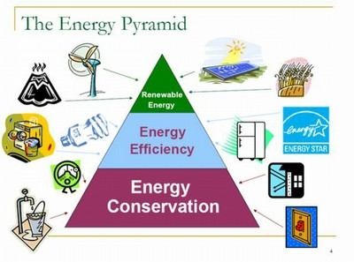

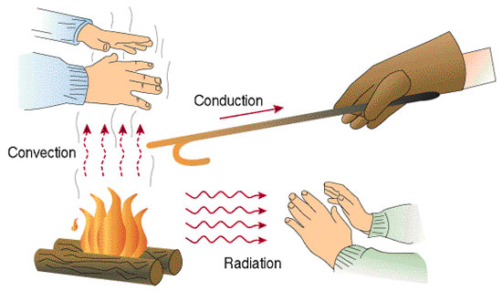

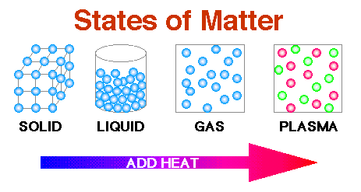

C:\Users\dawn.bray\AppData\Local\Microsoft\Windows\Temporary Internet Files\Content.IE5\KAVU31L1\MC900150809[1].wmf

C:\Users\dawn.bray\AppData\Local\Microsoft\Windows\Temporary Internet Files\Content.IE5\KAVU31L1\MC900241091[1].wmf

**The students will understand that…**

1. energy is not matter.

2. energy is never lost, it only changes form.

3. energy is the ability to do work.

4. the Sun is the ultimate source of energy on Earth. This energy is changed into many forms that all plants and animals use to do work.

5. without energy, forces cannot be generated to make things move or change.

6. energy is the source of all activity.

7. each form of energy possesses its own distinguishing characteristics.

8. energy exists in two primary forms: potential(stored) and kinetic (motion).

9. potential energy can be stored in foods. This food can be used for our bodies to do work.

10. energy not only appears in forms such as heat, light, electricity, mechanical, motion, and sound; but also chemical, thermal, nuclear, gravitational, and magnetic.

11. chemical energy is potential energy stored in compounds.

12. we get energy from the compounds that make up our food.

13. electrical energy is the energy carried by moving electrical charges.

14. energy can change from on form to another in the natural world.

15. energy is transferred from one object to another when work is done.

16. transformations of energy usually release some energy, typically, in the form of heat.

17. heat energy is the result of the disorderly motion of molecules.

18. temperature changes as heat is transferred from a hotter object to a colder object.

19. heat is thermal energy and travels in waves like other forms of energy.

20. heat always moves from hot to cold.

21. heat travels more rapidly through some materials than others.

22. heat transfer occurs via conduction, convection, or radiation.

23. as the energy of particles change, their movement changes and the phase in which matter is present changes.

24. the thermal energy of a substance is determined by the activity level of the atoms and molecules within.

25. temperature changes as heat is transferred from a hotter object to a cooler object.

26. the molecules and atoms of hot objects show rapid movement, while the molecules and atoms of cooler object show less movement.

27. conductors and insulators affect heat transfer.

28. heat transfer occurs by conduction, convection

or radiation.