CASTLEN ELEMENTARY SCHOOL
Fifth Grade School Supply List
2020-2021
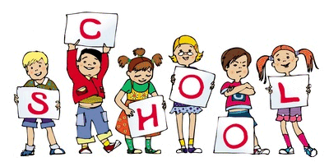
Central Office is requesting that parents provide a face mask for their child to have with them at school each day. Cloth is preferred due to durability.
Pencils-needed each day
Crayons-no more than 16 count
Dry erase markers-4
Highlighters-2
Post It notes
Index cards-2
Glue sticks-2
Wide ruled paper-4 packs
Composition notebooks-6
Pocket folders with tabs for holding paper-6
Dividers for all folders

Wish List
Kleenex
Hand Sanitizer
Hand soap
Paper towels
Ziploc bags-gallon and quart
Disinfectant spray and wipes

