PERIOD 6 GILDED AGE WEB QUEST
1. What led to a falling out of relations between President Johnson and General Grant in 1867?
(Use both links for 2 distinct reasons)
2. What tradition did Grant follow when running for President that would not be followed today?
3. How did Democrats try to hurt Grant’s image on the campaign trail? How did Republicans respond?
4. What did the close margin of the popular vote in 1868 indicate to Republican leaders?
5. Grant’s presidency was marked by poor judgement in appointing political officials and his lack of political
experience that led to several scandals. Identify the basic idea involved with each of the following:
a. Whiskey Ring
b. Crédit Mobilier

6. What did the rise of “Grantism” lead to in 1872? What did many people attribute the real cause of the
problems in government?
7. After the Civil War, an economic bubble centered around what industry burst and led to the Panic of
1873? Synthesis: How is the Panic of 1873 like economic events in the 1990s and 2008?
8. What is meant by the Gilded Age? Who is famously credited with coining the phrase in the 1870s?
9. Complete the following chart about Democrats and Republicans policy beliefs during the Gilded Age:
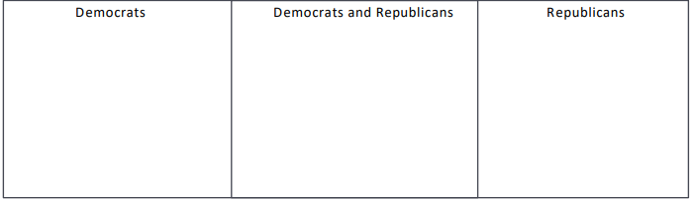

10. How did Tammany Hall change in 1817 that would impact its power for the rest of the century?
11. Who is Thomas Nast and why did he bring down William “Boss” Tweed of Tammany Hall? How did “Boss”
Tweed try to stop Nast? Who eventually came out on top of their battle?
12. Rutherford Hayes became President when the Compromise of 1877 was accepted by Democrats. How
did this Compromise impact the South? (Give at least 3 ways)
13. What did the Plessy v. Ferguson case legalize? What Amendment was challenged in the case? How did
the outcome impact voting in New Orleans? (Use the page and watch the short video)

