**Math Lessons** for the Week of April 14 **Ohio Standard 4.MD.2a**

Things keep changing. This week we have the option of online work or paper work. Hopefully, this helps!

If you have any problem with the work, you can ask me by emailing me. I will be glad to help!

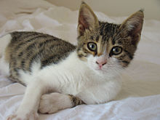

Please send all math solutions in **one** email to Mrs. Pinkerton at [diana.pinkerton@southern.k12.oh.us](mailto:diana.pinkerton@southern.k12.oh.us).

I cannot get any papers back at this time.

I am sending work for 5 days. We are considering Monday, April 13 a holiday. Hope you had a HAPPY EASTER!!!

**Tuesday, April 14**

Problem of the Day

Jett earned $5.45 helping his grandma in the garden. He already had $6.78 in his savings. How much money does he now have in all?

Write the answer in a sentence:

Read and Solve

**Lawn and Pet Services**

**Lawn**

**Front and back mow: $20.00 Flower bed cleanout: $10.00**

**Fertilize $20.00 Bush trim: $15.00**

**Pets**

**30 minute walk $10.00 per pet Feed and water twice a day $10.00**

**Litter box clean out $5.00 per box Pooper Scoop $5.00**

1. Mr. Smith was on vacation. He asked Aiden to take care of his dog for 5 days. Aiden had to walk it and feed & water it every day. How much money would Aiden make?

________________________________________________________

1. Maddy got paid to help her mother cleanout the flowerbed and fertilize it. Dominick got paid to lawn his neighbor’s yard 3 times. How much more

did Dominick make than Maddy?

1. Bella had clean out the litter box. She was paid $5.00. When she went to the store, she bought something that cost $4. 35. List three **different** groups of coins that Bella could have got in change. _______________________________________________________________________________________________________________________________________________________________________________________



**Wednesday, April 15**

PROBLEM OF THE DAY

Kyla found 3 quarters, 5 dimes, 1 nickel, and 3 pennies when she cleaned up her bedroom. How much money did Kyla find?______________

Also complete STUDY ISLAND. The lesson is called “Money”. If you are working online, remember your login information. User Name: [firstname.lastname@sles](mailto:firstname.lastname@sles) Password: lunch number.

**Thursday, April 16**

Problem of the Day

Hannah had $7.00. Her mother took her to Walmart. She bought a candy bar for $0.88 and a necklace for $5.24. How much change would Hannah get back?

******

JUST EMAIL THE ANSWERS TO THE RIDDLE BELOW. (Not all the answers.)

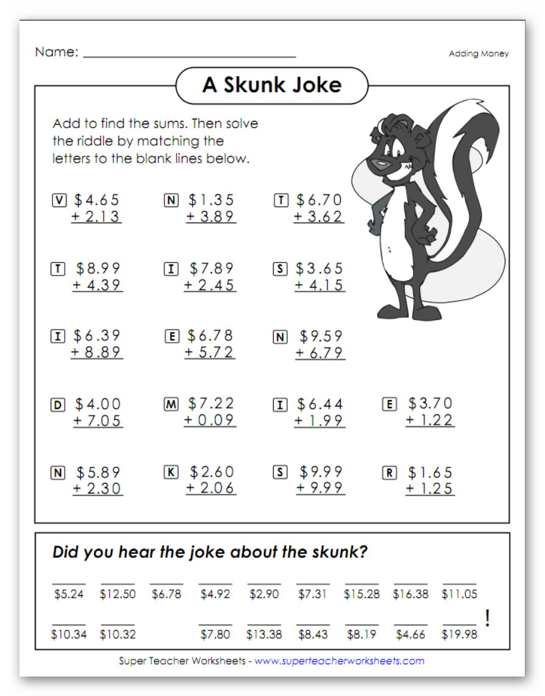

**Friday, April 17**

Problems of the Day

1. Mrs. Coleman was decorating her house. She had a budget of $100.00 for new lamps. When she got to the store, she found some she liked for $35.78 each. If she bought 2 lamps, how much money would she have left?



1. Mr. Reese bought Boo-Boo a toy for $4.89 and treats for $4.55. If he pays with $10, how much will his change be?
2. Mrs. Pierce bought her dog a new leash and a dog bed. Her total cost was $45.99. If the dog bed cost $39.79, how much was the leash?

**Complete the next page:**

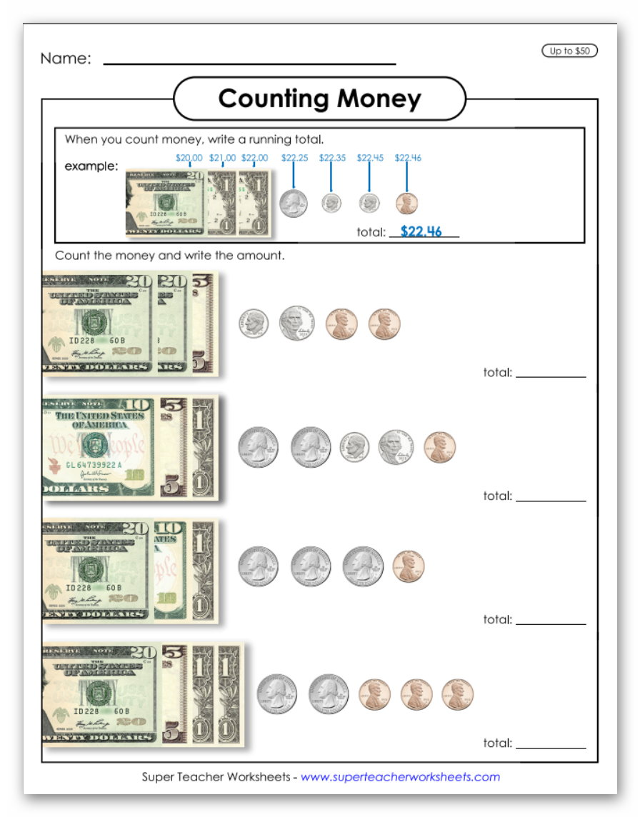

**Monday, April 20**

Problem of the Day

Jensen went to the store. He wanted a Pepsi that cost $1.29. He counted the change in his pocket. He had 3 quarters, 5 dimes, and 1 nickel. Does he have enough money to buy the Pepsi?

Write a sentence to explain your answer.

We have been covering Ohio Standard 4.MD.2a this week. If you want you can, find a lot more information about money from other countries online. It may be fun to think about….

***********

Please finish the worksheet on the next page. Thanks!

Just send the answer to the riddle. (Not all the answers.)

Hope you are staying healthy and happy!

