1.

1. The process where plant cells capture light energy and change it into sugar

9. List the 2 stages in photosynthesis

8. Draw ADP

7. ATP energy is released when _____________.

3. Which organelle inside a cell goes through photosynthesis?

2. The process where cells get energy from glucose

6. What is ATP made of?

(also draw it)

5. A compound used by cells to store and release energy

4. Which organelle inside a cell goes through cellular respiration?

1.

10. List the 3 **reactants**

(things going in)

for photosynthesis

18. List 4 things that go through anaerobic respiration

17. When something does not need or use oxygen

16. When something USES OXYGEN

12. What is the formula for sugar?

11. List the 2 **products**

(things coming out)

for photosynthesis

15. List the 3 products (going out) for cellular respiration

14. List the 2

reactants (going in)

for cellular respiration

13. List the

3 phases in cellular respiration

1.

19. List 4 things that are made from anaerobic respiration

27.

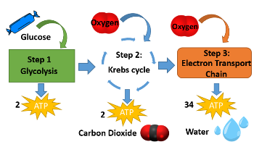

26. Cells constantly transfer energy.

List 3 types of energy.

25. All organisms require ______ and need ________ to perform life functions.

21. Which stages in cellular respiration are aerobic?

(use oxygen)

20. Which stages in cellular respiration are anaerobic?

(no oxygen)

24. What is produced in lactic acid fermentation?

22. What are the 2 different types of anaerobic respiration?

1.

1.

9.

8.

7.

3.

2.

6.

5.

4.

23. What is produced in alcoholic fermentation?