Good afternoon,

Your i-Ready account is now live for the 20-21 school year!

In order to guarantee you have the best possible experience with the program, we are sending along some resources to ensure you are up and running with the program and your students.

Getting Started with the Program
- The assessment will automatically start for students when they log in.
  - The test normally takes approximately 2 class periods.
  - Students have 21 days to complete the assessment before the assessment resets itself.
- Teachers receive rushing information on their students on the home page upon logging in (if a student spent less than and an average of 12 seconds per item on the assessment).

Instruction:
- After the assessment is finished, all students will receive a personalized lesson path based on their diagnostic results.

Assessing Virtually or in a Hybrid Plan
This is a year of teaching and learning that is sure to be unique. As teachers, students, and families navigate different learning contexts and constantly adapt to change, we are here to help

Testing at Home in 2020
Here is a link to our Teaching and Learning site which has a wealth of resources for all plans.

If students are being assessed virtually, we recommend the following video:

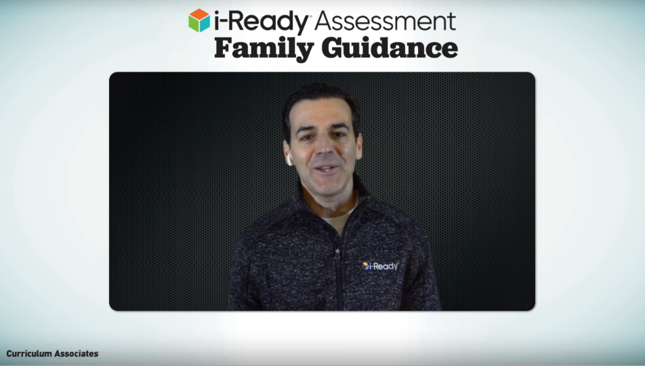

i-Ready Family Guidance

Here is also our Virtual Proctoring video
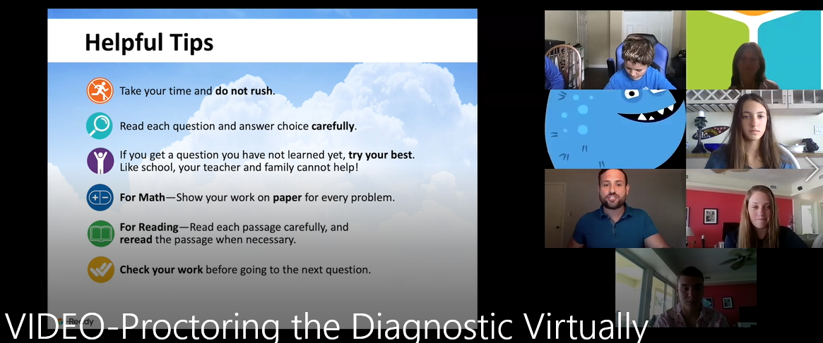
Additional Resources
- We have a great FAQ: How can I control student access to assessments? to help with the next steps and our new Hide Assessment feature for Teachers (available for Admins in September).
- Refer to this FAQ to help you better plan for using Personalized Instruction.
- Share this short how-to video that explains how to set up their profile, assign the lessons, and then manage lessons in response to student needs.
- Share the videos, resources, and helpful tips available on i-Ready.com/Families to stay connected and help families engage their children.

If issues occur
If any technical hiccups occur or you have technical questions, our Tier 1 tech team can be reached at:

i-readysupport@cainc.com or 1-800-225-0248 ext. 6

