### DCPS

2nd Grade Newsletter:

March 25th – 28th

**What are we learning?**

**We want to keep things as simple as possible for all students. We have created the 3 R’s. This is what your child with internet at home can do every day.**

**3 R’s: Read/Reflex/ReadingEggspress**

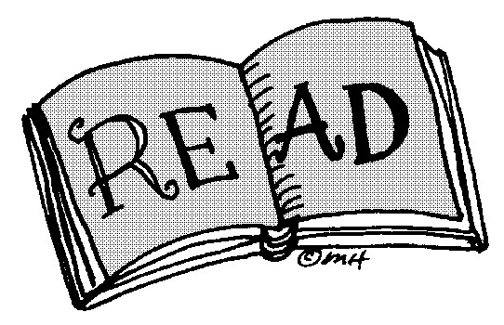**-** Your child should read for at least 30 minutes a day. They can read books online or books they have at home.

**Questions you can ask them for this week?**

|  |  |
| --- | --- |
| Fiction Book | Non-Fiction Book |
| What character did you like the most in your book? Why? | What did you learn while reading? |
| What is the main problem in the story? | Did you find any text features while reading? |

**- Get a green light!**

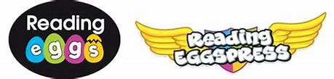

Log onto Reading eggs and click on the icon Reading Eggspress. It should look like the picture above. Your child can do My Lessons, English skill, visit the Library and so much more.

2nd Grade News

**Math Skills**

This week your teacher will post on their website:

* Word Problem of the day

**Writing**

Have your child start a Journal at home.

This week’s writing prompt it:

***The best thing about me is…***

**Website/Facebook:**

Please look at your teacher’s website for more links and information. We have also created a DCPS 2nd Grade Facebook group that you can follow for more ideas and websites.

**Remember me**

**Please contact your child’s teachers for any questions. We miss you all! Please be safe, wash your hands, and remember we can’t wait to see you soon.**

## Phonics