May 3, 2021
Dear Parent/Guardian,

Marion County is focused on supporting EACH student’s academic progress as we move TOGETHER toward the end of the 2020-21 school year. As a global health pandemic has impacted our communities for the past year, we are now focusing on recovery as a community. Every student’s experience through this pandemic has been unique, and it is our responsibility to ensure their needs are met and that children can continue to receive a high-quality education in our state. To ensure we have quality data on each student’s progress toward their grade-level expectations this year, Tennessee is moving forward with administering our annual state summative assessments(TCAP).

TCAP test results will be important to understanding each student’s individual needs and in combination with other information about your student, such as attendance and classwork, be used to determine which supports your child may need in the year ahead. Families, teachers, and students have stepped up in heroic ways throughout this pandemic, and our desire is to make sure TCAP tests do not add more stress or anxiety to an already challenging year.

This year, Marion County will have a more flexible testing window to allow for socially distanced testing and generous time allowances for student make-up exams. We want to ensure we are able to test students safely while adhering to health guidance.

Marion County will be testing students in grades 2nd for English Language Arts and Math. Third through fifth grade students will be tested in English Language Arts, Math, and Science. Sixth-eighth grade students will be tested in English Language Arts, Math, Science and Social Studies. Please see the test schedule below.

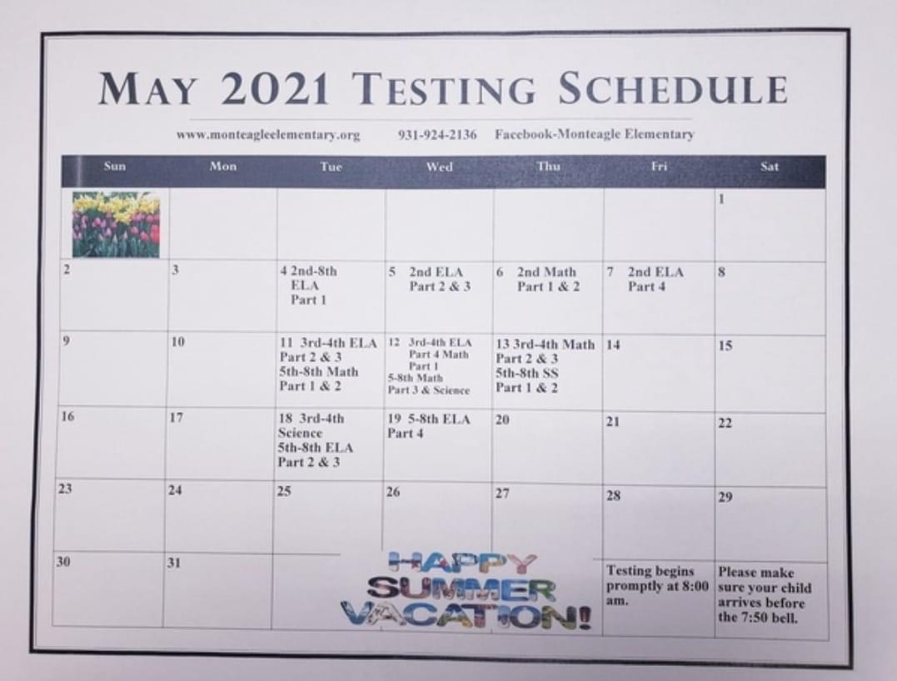
Attendance is important on all days, but please ensure your child gets a good night’s rest, is at school on time for a healthy breakfast or provided one at home, and ready to succeed.

Given the uncertainties and transitions you and your student(s) have faced due to COVI-19, this year’s TCAP tools will be an important tool for you to understand how and where you can support learning at home. Teachers will use the results to help identify and address any learning gaps and school/district leaders will use them to identify schools that could benefit from additional resources. For more information about TCAP, please visit https://www.tn.gov/education/assessment/tnready/tnready-parent-resources.html.

Thank you for all you do to partner with us in your child’s education, and please do not hesitate to reach out to us with any questions you may have.
Phone: (931) 924-2136 or kwoodlee@monteagleelementary.org

Sincerely,

Veronica Rogers-Horton
Principal

Kasey Woodlee
Building Testing Coordinator

