Save the Date!
VHSA Designer Bag
When: Saturday, April 13th
Doors open at 5:30pm
Bingo games begin at 7:00pm
Where: St. James Memorial Hall
6415 Atlantic Ave., Ventnor
Tickets are available for purchase online at www.eventbrite.com/e/vhsa-designer-bag-bingo-tickets-57345965326
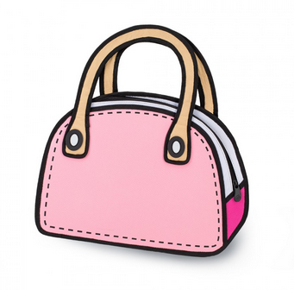
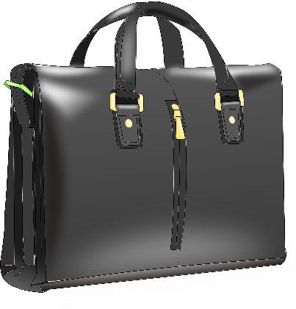
Tickets will be available for purchase at the door the night of the event. (while supplies last)

