MATH Assignments for the Week of May 4-8
Ohio Standard: 4.NBT.6 Illustrate and explain how to divide whole numbers using equations, rectangular arrays and area models.
Monday, May 4
Problem of the Day: Emmanuel bought 3 big bags of Skittles. Each bag had 129 Skittles in it. How many Skittles did Emmanuel have in all?_________________
Dividing (in math) means separating into equal groups. For the next few weeks, we will be practicing division. We will start with a basic fact review.
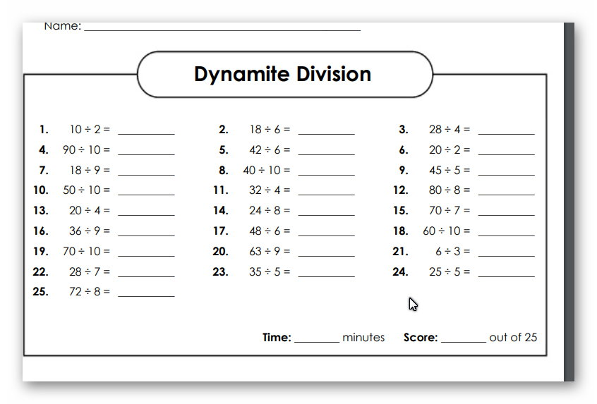

Tuesday, May 5
Problem of the Day Emma made 24 cookies. There are 4 people in Emma’s family. If Emma divides the cookies equally, how many would each person get?
They would get

If you have internet access, you can find fun division games online to sharpen your skills. One place to look would be MATHPLAYGROUND or www.multiplication.com (which has multiplication and division) .
If you don’t have internet, don’t give up. I have included flashcards to use for practice. Make it fun. Have a competition with a sisiter or brother or time yourself several times and try to keep getting a shorter time for fluency. (The flashcards follow the Shark riddle paper.)
Don’t give up on yourself. Practice is the key to success.

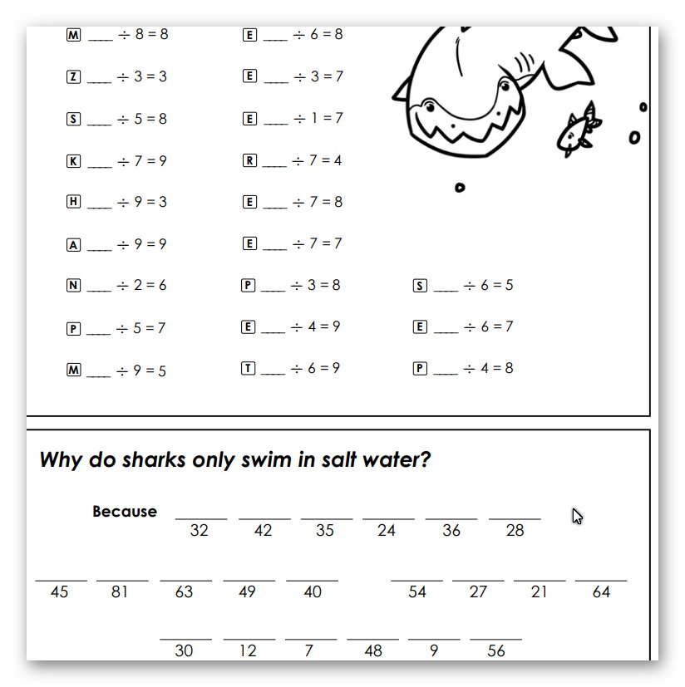

Wednesday, May 6
Complete Study Island lesson “Basic Division”
Thursday, May 7
Problems of the Day
A.
Mrs.Kellison decided to arrange her room differently. She made 4 long rows with tables. If she had 28 computers, how many computers would be in each row if she wanted to have the same number in each row?_____________________
B.
There were 48 children who signed up to play baseball. If there were 4teams, how many children were on each team?_______________________________
C.
Coach Randolph was organizing her equipment. If she has 36 scooters and she wants to make 4 equal groups, how many scooters will be in each group?______________________________
Lesson continued on the next page…….
is mental and physical.

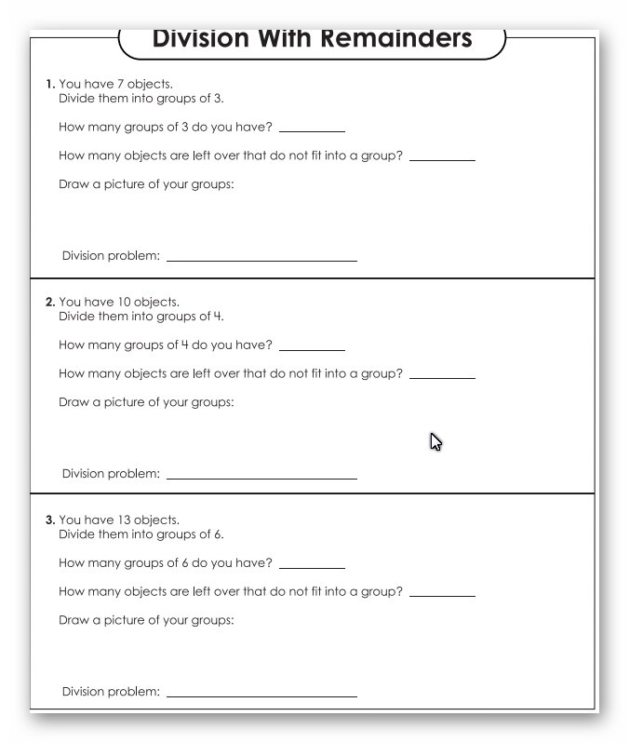

Friday, May 8
Understanding division with a remainder is the first step to long division. You have to really know your division facts, so please keep practicing them.
Use part of today for flashcards or online practice.

