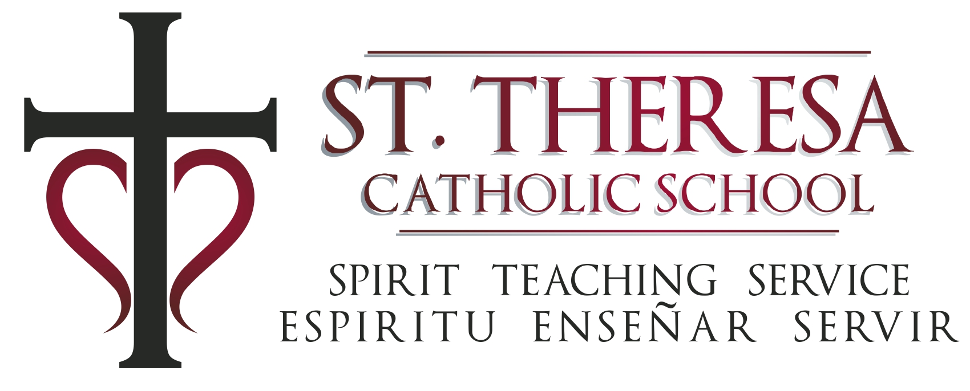

December 4, 2019

As required by Arkansas Act 676 to report vaccination information for the school population:

- St. Theresa School has 0 students who have been granted an exemption by the Department of Health to obtain one or more of the required vaccinations.
- The percentage of students in St. Theresa School with a vaccination exemption from the Department of Health is 0%.
- The number of students who have failed to provide proof of vaccination required by the Department of Health and have not obtained an exemption is 0.
- The percentage of students who have failed to provide proof of vaccinations required by the state and have not obtained an exemption is 0%.

Submitted by,

Kristy Dunn, principal
6311 Baseline Road
Little Rock, AR 72209
501.565.3855
kdunn@stslr.org
stslr.org

