WHY WOULD I NEED A COUNSELOR?
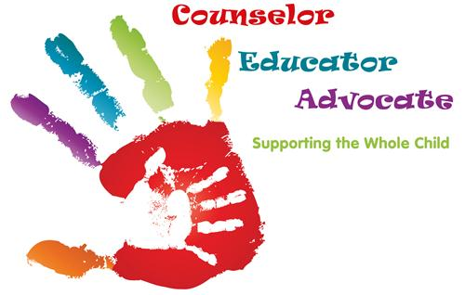
- Assist with personal/social concerns (friends, family, relationships, etc.)
- Assist with academic concerns
- Assist with career choices and interests
Services Offered?
- Individual counseling
- Individual student planning
- Referrals to outside agencies as needed
- Consultations
- Large group counseling
- Small group counseling
- Grief counseling
Benefits?
- Helps students feel connected to school
- Enhances students’ social-emotional development
- Develops students’ decision-making skills
- Encourages outreach to all parents/guardians
- Enhances students’ academic performance
- Interprets data for information on student progress
- Serves as a liaison for teachers, parents, and students
How Are Students Referred?
- Teachers/Administrators refer to counselor
- Parents are welcome to call or email anytime
- Outside agencies may refer as needed
Who?
- Malia Robinson- Counselor (205) 280-2750 mmrobinson@chilton.k12.al.us
- Greta McGowan- Counselor/Intervention ( 205)280-2750 gfmcgowan@chilton.k12.al.us

