Mrs. Patisaul’s Classes - Supply List

- 3-Ring Binder (single or multiple subjects)

- Loose-leaf Paper

- Pencils & Erasers ONLY

- 3-5 Colored Pencils

- Ruler

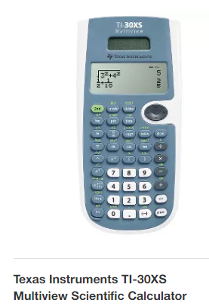
- Scientific Calculator TI-30 XS Multiview – ONLY as illustrated! Cost is approximately $17. (Available at Target, Walmart, any office supply store or Amazon). You may also purchase it through me at the beginning of the semester.
Please do NOT purchase a different model as it will NOT have ALL required features. Students will CONTINUE to use this calculator in Geometry as well.

