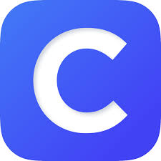
WMES Technology Resources
Technology access thru Clever
Students will use their school email and password to access Clever.
Learning.com provides digital curriculum and assessments that help students develop 21st century skills. | Study Island provides practice in math, ELA, science, and social studies.
MobyMax provides learning in more than 27 subject areas, including science, social studies, math, phonics, spelling, and more. | Exact Pathprovdes individual learning in math, reading, and language arts.
USA Test Prep provides digital test practice in reading and math.
Other Techology Resources for WMES Students
Epic!’s digital library includes many of the best kids books, popular ebooks, and videos.  Website: www.getepic.com/students  Login: teacher code or library code ccl0991  Accessible from 6am-4pm Mon. thru Fri. | Flocabulary provies students interactive resources to help sstudent practice skills across subject areas.  Website: www.flocabulary.com  Login: teacher code
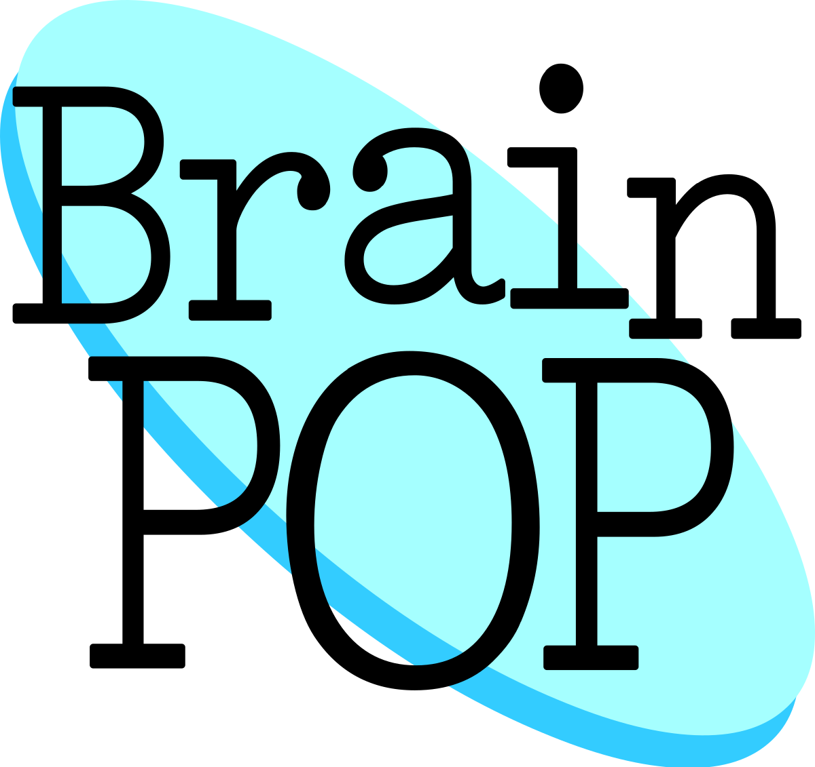  Brain Pop provides over 1,000 short animated movies for students in science, social studies, English, math, engineering and technology, health, and arts and music.  Login: teacher code or library code leash6136 | 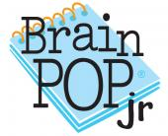  Brain Pop Jr. provides over 1,000 short animated movies for students in science,social studies, English, math, engineering and technology, health, and arts and music.  Login: teacher code or library code straw8993
Tumblebooks are animated, talking picture books which teach kids the joy of reading in a format they'll love.

Website: www.tumblebooklibrary.com
Login: username: wmsc password: read

Free Resources until April 20 provided by Scholastic
Students will log in using usermame: Learning20 password: Clifford
BooKFlix provides a fun way for early readers to engage with delightful stories and interesting nonfiction ebooks.  Website: https://digital.scholastic.com/site/launch/bkflix?ucn=642726498 | TrueFlix helps students build science and social studies knowledge in an engaging way.  Website:  https://digital.scholastic.com/site/launch/tfx?ucn=642726498
ScienceFlix gets students excited about all sciences with exciting articles, videos, and projects.  Website:  https://digital.scholastic.com/site/launch/sfx?ucn=642726498 | Watch & Learn Library builds learning excitement with real-world videos in English and Spanish.  Website:  https://digital.scholastic.com/site/launch/watchandlearn?ucn=642726498
Free Resources
Spelling City provides instructin in reading, vocabulary, and spelling.  Website: www.spellingcity.com  Code: VSCFree90 | Prodigy provides math practice.  Website; https://play.prodigygame.com  Login: teacher code
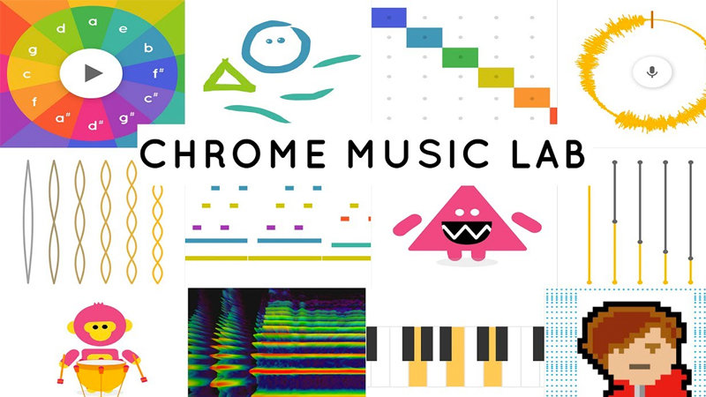  Chrome Music Lab is a website that makes learning music more accessible through fun, hands-on experiments.  Website: https://musiclab.chromeexperiments.com  No Login | GoNoodle® engages 14 million kids every month with movement and mindfulness videos created by child development experts. Available for free at school, home, and everywhere kids are!  Website: www.gonoodle.com No Login
Nitrotype helps tudents improve the foundational skill of typing by competing in fast-paced races against their friends.  Website: www.nitrotype.com No Login | Switcheroo Zoo watch, listen and play games to learn abll about amazing animals.  Website: www.switchzoo.com No login
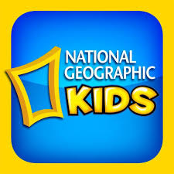  National Geographic Kids learn aboutgeography and fascinating animals!  Website: https://kids.nationalgeographic.com/  No Login | 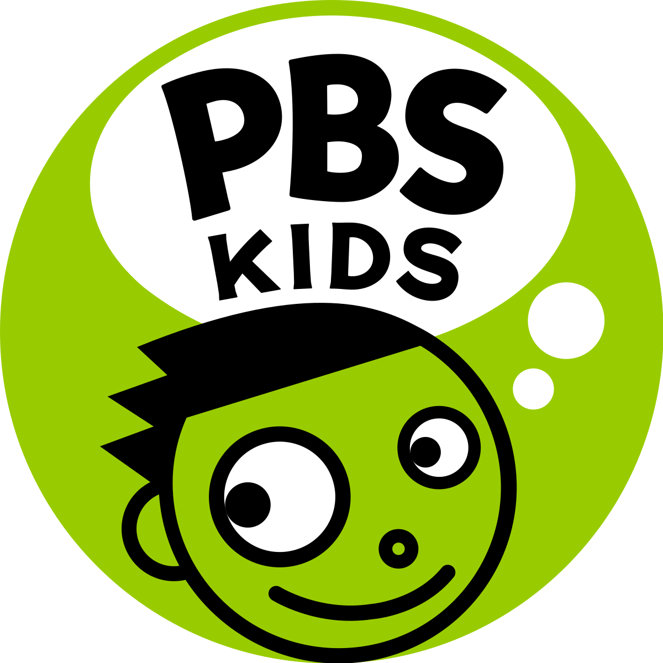  PBSKids provides learning with their favorite PBSKids.  Website:  www.pbskids.org No Login
Into the Book to play games that practice reading strategies.  Website: www.reading.ecb.org No Login | StarFall practice your practice skills with these read-along stories.  Website: www.starfall.com No Login
Suessville read, play games and hang out with Dr. Seuss and his friends.  Website: www.seussville.com No Login | 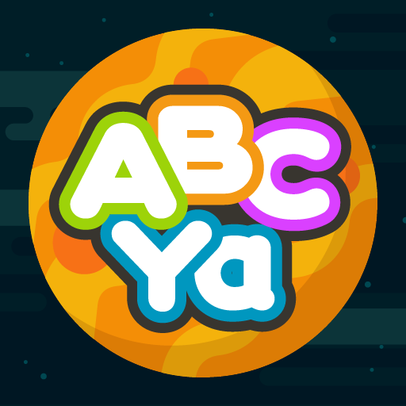  ABC YA practice math and reading skills all while playing fun games.  Website: www.abcya.com  No Login
Highlights Kids read, play games and conduct science experiments.  Website: www. Highlightskids.com No Login | 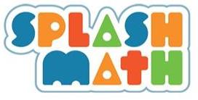  Splashmath provides math practice from Kindergarten thru 5th grade.  Website: www.splashlearn.com  Login: Parent sign up

