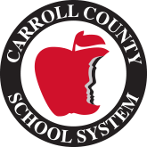
2021-2022 School Supplies List

2nd Grade

2 - 12 Count Box crayons
2 - Spiral Notebooks, wide ruled
1 - 1” white with clear view front pocket 3-Ring Binder
2 - Plastic Pocket Folder
1- 5 Tab Insertable Dividers
2 - Pack of Notebook Paper, Wide Ruled
2 - Pack of Standard #2 pencils, yellow
1 - Pair of blunt tipped student scissors
4 - Pink erasers
8 - Glue Sticks
1 – ear buds/head phones

Wish List-
-Liquid Hand Soap
-Hand Sanitizer
-Antibacterial Wipes
-Tissues
-Paper Towels
-Ziplock Bags (quart or gallon)

