**Nature of Science Student Notes**

**BIG IDEA: Science is a systematic and logical approach to discovering how things in the universe work.**

**ENDURING UNDERSTANDING: Students will understand that scientific inquiry provides them opportunities to make observations, pose questions, develop hypotheses, design and conduct investigations, and analyze data to draw conclusions.**

**Lab Safety**

I. Safety Rules (10 Commandments of Safety)

* 1. Know what equipment is being used and what it is used for.
  2. **Never** do anything, while in the lab or in the lab instructions, without your teacher’s permission first.
  3. **Never** eat or drink in the lab. Also never eat, drink, or sniff the lab chemicals.
  4. Know your safety and identify all possible dangers.
  5. No open shoes in the symbols lab. Pull long hair up when needed.
  6. Make sure your lab area is clean and uncluttered.
  7. Dispose of materials properly.
  8. In case of **any** accident, inform your teacher immediately.
  9. Know where the nurse and emergency equipment is located.
  10. Only 1 person per group, at a time, may go get supplies or use equipment.

II. Safety Symbols

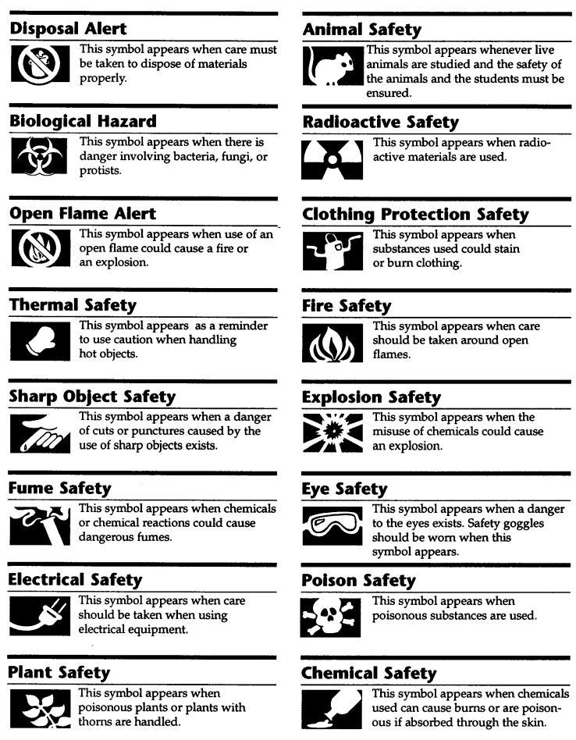

**Note Interaction:**

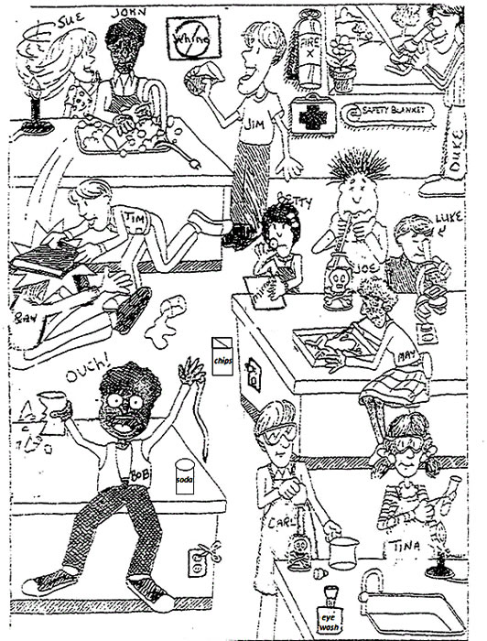

1. List 3 unsafe activities shown in the illustration and explain why each is unsafe.

2. List 3 correct lab procedures depicted in the illustration.

**Lab Equipment**

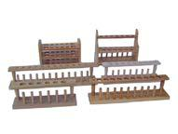

**____________________** – used to hold and dry test tubes.

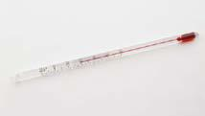

**_________________________** – used to measure how much heat energy is in an object.

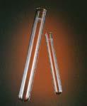

**___________________** – used to hold small amounts of pre-measured substances.

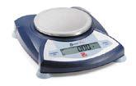

**____________________________** – used to determine a smaller, lighter object’s mass.

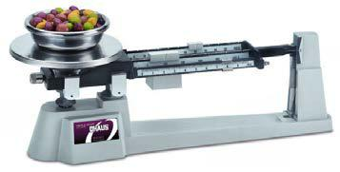 **___________________________ –** used to determine the mass of larger, heavier objects

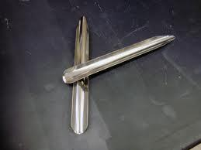

**_______________________** – used for transferring dry chemicals.

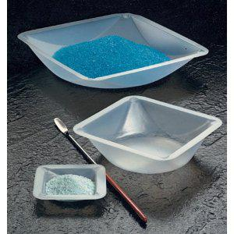

**___________________________** – used to weigh or transfer chemicals (usually dry).

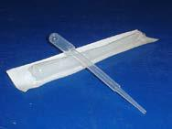

**____________________** – used to transfer liquid from one container to another. (Increments are verysmall – usually .25 mL per increment.)

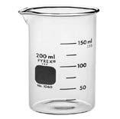

**___________________**– used to measure large volumes of liquid. (Increments are larger than agraduated cylinder – usually 25 -50 mL per increment.)

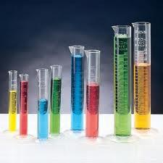

**__________________________ –** used to measure the volume of liquids. It is more*precise*than abeaker. (Increments are smaller than a beaker – usually 1 mL per increment.)

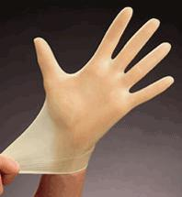

**____________________________** – used in laboratory anytime chemicals are to be used.

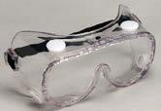

**_________________**– protects your eyes.

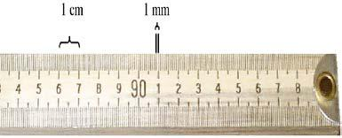

**____________________________-** measures length of objects.

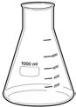

**_______________________________-** glassware with a wide base and with sides that taper upward to ashort vertical neck; allows contents to be *mixed by swirling*.

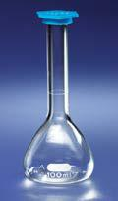**___________________** – used for making liquid solutions of*precise volumes.*

**Note Interactions:**

Identify which piece of lab equipment would be most useful for each of

the following tasks.

1. ____________________ Used to pick up or hold hot objects

2. _____________________Protects the eyes from flying objects or chemical splashes

3. _____________________A wide-mouthed container used to transport, heat or store substances

4. _____________________A small glass container used to view chemical reactions or to heat small amounts of a substance

5. _____________________A device to measure the mass of an object or substance.

6. _____________________Used to measure the volume of liquids very precisely

**Measurement**

1. **Scientific Measurement**
   1. Using one method of measurement common to all scientists helps in *communication* and *understanding* of scientists all around the world.
   2. You will need to make sure you use the *appropriate tool* for measurement based on the size or distance you are measuring.
   3. The **International System of Units:**
      1. Also known as the **SI System**.
      2. Based on *multiples of 10* for easy conversions.

|  |  |  |  |  |  |
| --- | --- | --- | --- | --- | --- |
| a. | **Kilo**- = thousand | | | (1000.) | (“Kilo” means “thousand”.) |
| b. | **Hecto**- = hundred | | | (100.) | (“Hecto” means “hundred”.) |
| c. | **Deca**- = ten | | | (10.) | (“Deca” means “ten”.) |
|  | **Base Unit** - Meter, Gram, liter | | | (1.) |  |
| d. |  |  |  | (.1) | (“Deci” means “tenth”.) |
|  | **Deci**- = one-tenth | |
| e. |  | **Centi**- = one-hundredth | | (.01) | (“Centi” means “hundredth”.) |
| f. | **Milli**- = one-thousandth | | | (.001) | (“ milli” means “thousandth”.) |

1. **Length:** the*distance*from one point to another.
   1. The base unit is the **meter (m)**.
   2. You use a ruler, meter stick, etc. to measure.
2. **Volume:** The*amount of space*an object takes up.
   1. The base unit for liquids is the **liter (L)**.
   2. You use a graduated cylinder or beaker to measure liquid volume.
      1. Make sure to use the most accurate sized tool to get the most precise measurement.
      2. In a graduated cylinder, there is a **meniscus** (curve at the top of the fluid).

i. Always measure at the *bottom of the meniscus*, not the top of the curve.

* + 1. Measure at *eye level* and on a solid surface.
  1. *Finding Volume of a Solid*: can be calculated by multiplying the length, the width and theheight. (length X width X height)
     1. Units of measure will be **cm3.**

4. *Finding Volume by Immersion/Displacement*: To get the volume of an irregular shaped object.(rock, paper clip, etc.)

a. First, measure the volume of water in graduated cylinder without the object. Then gently add the object and take the new measurement. Subtract the measurement without the object from the measurement with the object. (Final measurement – Initial measurement = Difference [The volume of object you measured.]) This will give you the volume of the irregular shaped object.

b. **1 mL = 1 cm3.**

F. **Mass**: The*amount of matter*an object contains.

* + 1. The material that all objects and substances are made up of; anything that has *mass* and *takes* *up space.*
    2. The base unit is the **gram (g)**.
    3. Mass is measured by an electronic *balance* or a triple-beam *balance*.
    4. For electronic balances, make sure they are “zeroed out” before weighing your material.

G. **Temperature:** the measure of the*intensity of hotness*of a body or environment; also the measure of the*average Kinetic Energy (movement) of the particles* in a sample of matter.

1. Measured in **degrees Celsius (oC)** or **Kelvin (K)**.

1. Converting degrees Fahrenheit (oF) to degrees Celsius (oC).
   * + - 1. Fahrenheit **→** Celsius: (0F – 32) X 5/9 = 0C
         2. Celsius → Fahrenheit: 0C X 9/5 + 32 = 0F
2. **Kelvin** (Physics related measurement) conversion:
   * + - 1. Celsius **→** Kelvin: 0C + 273 = 0K
         2. Kelvin **→** Celsius: 0K – 273 = 0C

2. A *thermometer* is the tool used for measuring temperature.

H**. Time**

1. Measure in **seconds (s)** with the use of a timer or stopwatch.

I. **Area:** the measure of the*size of a surface*or a region.

1. Measure in **square units (cm2** **or m2).**

2. Can be calculated by multiplying the length of an object by its width. (Length X Width)

**Note Interaction:**

Complete the online Measurement Practice.

<http://www.sheppardsoftware.com/mathgames/menus/measurement.htm>

Measure the object using the ruler shown. Round to the nearest centimeter.

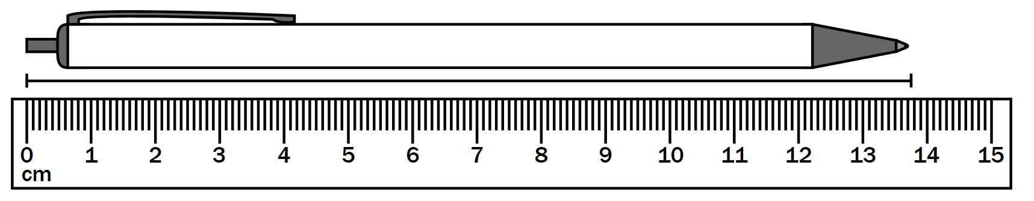

**Dimensional Analysis**

1. **Dimensional analysis** - a fancy name for a method of calculating that:

A. uses *numbers in the form of fractions*.

B. enables us to *convert from one type of unit measurement to another*.

II. What is a **Unit**?

A. A **unit** is something that gives definition to a numerical value, quantity, or measurement. (Let us consider “1 mile”. The unit involved here is the “mile”. Without the unit, you would not know what is being referred to.) Different measurements often times have multiple possible units associated with them.

B. For example:

1. Length - meters, centimeters, feet, inches, miles, kilometers

2. Mass - kilograms, grams, pounds

3. Time - hours, minutes, seconds, days, months

4. Volume - cups, teaspoons, liters, milliliters, gallons, quarts

5. Currency - dollars, cents, dimes

1. Turning Numbers (or quantities) *into Fractions*:

A. If a quantity does not appear as a fraction, it is possible to put it in a fraction form. Doing this sometimes makes solving **dimensional analysis** problems easier. Remember that numbers and **units** that appear *above* the fraction line are in the “**numerator**” and numbers and units that appear *below* the fraction line are in the “**denominator**”. Here are some examples:

B. Example 1: 2 eggs. This quantity is not in the form of a fraction. To put it in a fraction form we put the number and unit that is given in the numerator, and simply put “1” in the denominator.

2 eggs = 2 eggs

1

The numbers on both sides of the equal sign mean the same thing. We have not changed the value or the unit involved.

C. Example 2: 60 seconds/minute**.** This quantity does not look like a fraction, but it actually is a fraction. This quantity reads “60 seconds perminute”. The word “**per**” refers to the “fraction line” mentioned above. Again, notice that we have not changed the value or meaning of the *quantity.*

60 seconds/minute = 60 seconds

1 minute

D. The quantity given tells us there are 60 seconds. This goes in the numerator. We are not specifically given the number of minutes. In this case we can assume it is 1. This value then goes in the denominator.

1. Canceling Units:

A. If a unit appears in the numerator and the same unit appears in the denominator, it can be **cancelled** or removed. This unit can be in the numerator and denominator of the same fraction or in two different fractions being *multiplied* together.

B. Sometimes in order to change the quantity we are “**given**,” we must “**invert**” the other quantity (or quantities) we intend on using to convert from one set of units to the other. The quantity (or quantities) that is given is the quantity (or quantities) *specifically identified* in a problem. It is what we *start out* *with* and need to **convert** (or change) into what is being *asked for*. In order to convert from one quantity to another, we must use other sets of known quantities called **constants**. Your text will identify constants that you may use for problem solving.

C. What do we mean by “**invert”**? First, it is important to know that the quantities you are given are not to be inverted. Only the constants you are using to perform dimensional analysis can be inverted. To invert a constant simply flip it over or around.

D. For example:

**Constant Inverted**

7 days 1 week

-------- = ---------

1 week 7 days

OR another way to think of it:

*Given* unit X *Wanted unit* = *Wanted* unit

*Given* unit

*~~Given~~* ~~unit~~ X *Wanted unit* = *Wanted* unit

*~~Given~~* ~~unit~~

The given units cancel out and leave you with the desired unit.

**Note Interaction:**

Using the provided conversion factors/relationships (if necessary), complete all of the follow problems. Show your work!

**Conversion Factors/ Relationships**

1 mile = 1.61 kilometer

1 gallon = 3.78 liters

2,000 pounds = 1 ton

2.20 pounds = 1 kilogram

1. Convert 9.85 L to gallons.
2. How many miles are in 25 km?
3. If a person has a mass of 60 kilograms, what is his mass in tons?

**Interpreting Tables and Graphs**

I. Tables and graphs are visual representations.

II. Data tables and graphs are useful tools for both recording and communicating scientific data.

III. **Data Tables**

A. You can use a **data table** to organize and record the measurements that you make. Some examples of information that might be recorded in data tables are frequencies, times, and amounts.

B. Normally, independent variables go in the left- hand columns and

dependent variables on the right.

IV. **Line Graphs**

A. You can use a **line graph** to show a relationship between variables.

B. Line graphs are particularly useful for showing changes in variables over time.

V**. Circle Graphs**

A. You can use a **circle graph**, sometimes called a **pie chart,** to represent data as parts of a circle.

B. Circle graphs are used only when the data can be expressed as percentages of a whole. The entire circle shown in a circle graph is equal to 100 percent of the data.

VI. **Bar Graphs**

A. A **bar graph** is a type of graph in which the lengths of the bars are used to represent and compare data. A numerical scale is used to determine the lengths of the bars.

B. Many times the bar will represent an average.

C. Bar graphs contain categories.

**Note Interactions:**

The following table is a record of the performance of a baseball team for the first seven weeks of the season.

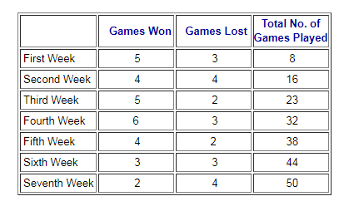

1. How many games did the team win during the first seven weeks? Explain your answer.
2. What percent of the games did the team win? Explain your answer.
3. According to the chart, which week was the worst for the team? Explain your answer.

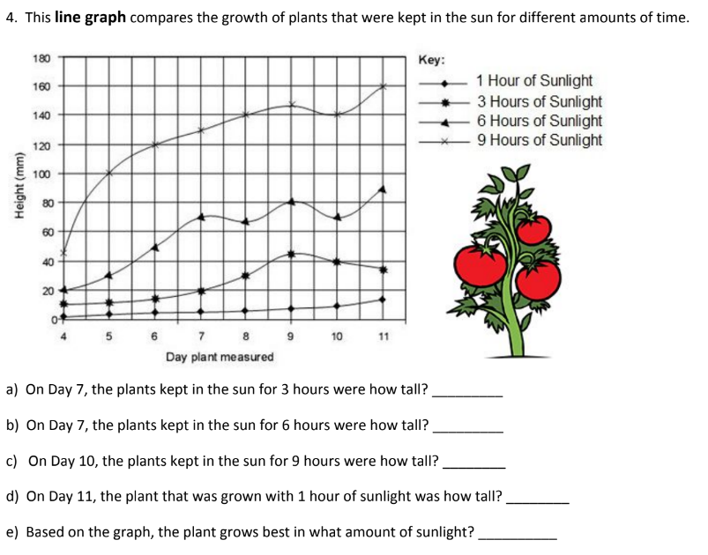



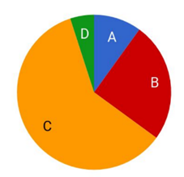

Mr. M’s class grades were graphed as a **pie chart.** Based on this graph:

a. The largest percentage of students received what grade? _____

b. Estimate what percentage of the class received a B. ______

c. Estimate what percentage of the class received an A. _______

d. Based on the graph, do you think Mr. M’s class is difficult? Why or why not?

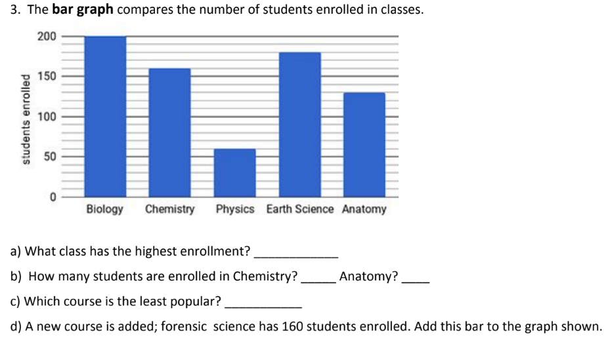

**Scientific Method**

## The Scientific Method

## This is a *series of steps* followed to *solve problems*. The steps are not always the same for each question you are researching.

* 1. **State your Problem/Question**

1. Develop a **question or problem** that *can be solved through experimentation*.

2. Make sure it is something that interests you.

C. **Make Observations/Do Research**

1. Make **observations** – the act of *seeing* an object or an event and *noting* the physical characteristics or points in the event. Observation is an extension of our *senses*; when we observe, we *record what is seen, smelled, tasted, heard, and touched.*

1. **Qualitative observations** - These *describe* an object’s characteristics, properties, or attributes. (For example, in the state, “The apple is red,” red is a qualitative observation of the apple’s appearance.)

b. **Quantitative observations** – These involve a *quantity or an amount*. (In the statement,

“The apple weighs 125 grams,” 125 grams is a quantitative observation of the apple’s appearance.)

c. **Inferences** – *conclusions based on observations*. Inferences go beyond what we

can directly sense.

i. You make an inference when you use clues from a story to figure out something the author *doesn’t* tell you.

ii. Be sure to look at all the evidence available and combine it with what you already know.

d.  **Predictions-** using observations, inferences, and/or trends in data to predict what will happen in the *future*.

(Example: If, on a sunny day, you observe a massive line of dark clouds quickly advancing, what prediction can you make?)

2. Do research - Good quality research helps in developing an excellent hypothesis.

D. **Formulate a Hypothesis**

1. A **hypothesis** is a *prediction or possible answer* to the problem or question.
2. It is a relationship between the **Independent** **variable** and **Dependent variables**.
   1. **Independent Variable (manipulated variable)** – the factor that is *intentionally varied* by the experimenter.
   2. ***Dependent Variable* (responding variable)** – the factor that *may change* as a result of changes made in the independent variable (the outcome).
   3. The hypothesis needs to be in an “If…then” statement.

i. The “If” part of the statement *is your question.*

ii. The “then” part of your statement *is your prediction about the outcome of your experiment.*

(For example, If the basketball is dropped, then it should bounce.)

E. **Designing an** **Experiment**

A. An **experiment** is a scientific procedure to test a hypothesis.

B. All experiments consist of a **control group, an experimental group,** and **constants.**

1. A **control group** is used for comparison. This group does not get any manipulations by the experimenter.

2. The **experimental group** is the group being tested. The experimental group gets the independent variable**.**

3. To get the intended results of an experiment, some factors must remain the same always in both the control group and the experimental group. These factors are called **constants.**

4. A good experiment is always repeated at least three times. This is called **trials.** The more experiments completed by the experimenter the stronger the principle is for the hypothesis.

F. **Analyzing Data**

A. **Data** shows *relationships* between the independent and dependent variable in the experiment.

B. Graphing data can *help* *explain/communicate* the relationships between the tested variables.

G. **Drawing a Conclusion**

A. A **conclusion** is a summary of what happened in the experiment.

B. The conclusionshould answer the question posed in step one. The conclusion is based solely on the results obtained from the experiment.

C. Think about the following questions when writing your conclusion:

1. Was your hypothesis correct?

2. If your hypothesis wasn't correct, what can you conclude from that?

3. Do you need to run your experiment again, changing a variable?

4. Is your data clearly defined so everyone can understand the results and follow your reasoning?

D. Remember, even a failed experiment can yield a valuable lesson.

**Note Interactions:**

1. Read the following examples and then decide if each statement is Qualitative (QL) or Quantitative (QNT).

1. _________The candy was sour.
2. _________The bug was 5 cm long.
3. _________The flower is red.
4. _________The mass of the beaker was 122 g.

2. Refer to the scenario below and list any observations made by the individual. Once you have listed the observations you should try to come up with an inference (or inferences) based on those observations.

Timothy noticed that after Mr. Smith gave Jessica her quiz she said, “I cannot believe this” and a few tears rolled down her face.

|  |  |
| --- | --- |
| **Observations** | **Inferences** |
|  |  |

3. Read “The Experiment” and then identify the components of the scientific method by completing the graphic organizer provided. Give your reason for choosing the example from the story.

