Unit 2: Atomic Structure
Student Notes
- Atoms
  - Parts
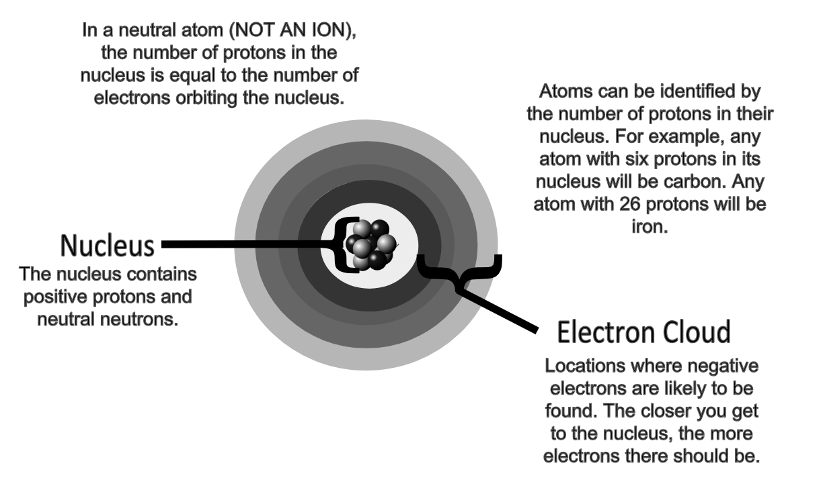
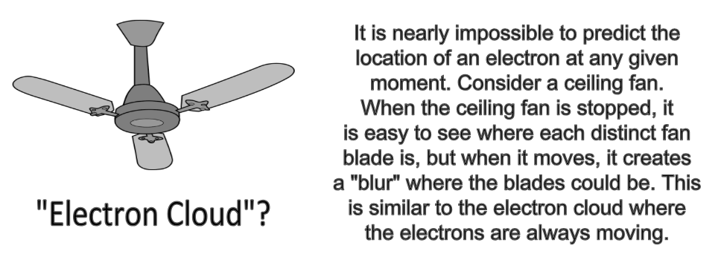

  - Charges
    - Protons are Positive (P⁺)
    - Neutrons are neutral (n)
    - Electrons are negative (e⁻)
    - Atoms are electrically neutral because they have the same number of protons (positive charges) as electrons (negative charges)

  - Size (Just How Small is an Atom Video)
    - Protons have a mass of 1 atomic mass unit (amu)
    - Neutrons have a mass of 1 amu
    - 1,836 electrons have a mass of 1 amu

  - Atomic Number
    - The number of protons in an atom is known as its atomic number.
    - Each different type of atom has a different atomic number.
  - Atomic Mass
    - The number of protons and neutrons in the nucleus of an atom add up to make its atomic mass.
    - Each proton and each neutron are equal to 1 atomic mass unit (amu)
      - If an atom has 6 protons and 6 neutrons, its atomic mass is 12 amu.

NOTE INTERACTION: Fill out the table using what you know about subatomic particles.

Particle Name | Symbol | Charge | Mass
 | p+ |  | 1 amu
 |  | Neutral (0)
 |  | Negative (-)

An atom has 17 protons and 18 neutrons in its nucleus. What is the atomic mass of the atom?
Atomic Theory Timeline

- Development of the Atomic Model
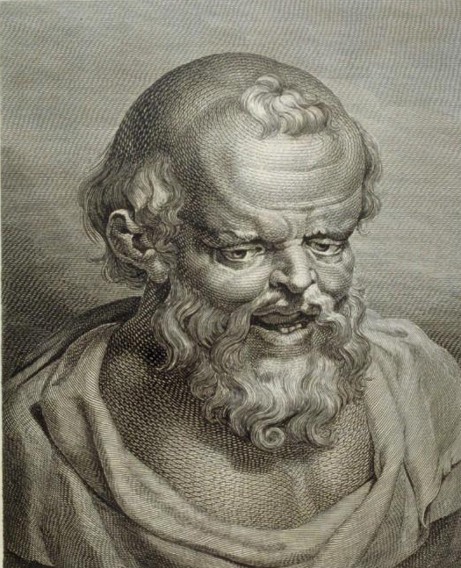
Imagine smashing a rock into tiny bits. Eventually the particles get so small that they are unable to be seen. Can you still break them into smaller pieces or do particles exist that cannot be divided any further? Democritus believed that small particles existed that were unable to be divided any further. He called these particles “Atomos” which is Greek for indivisible or not able to be divided. His ideas were very unpopular because they were different, and for over 2,000 years, his ideas were not even considered.
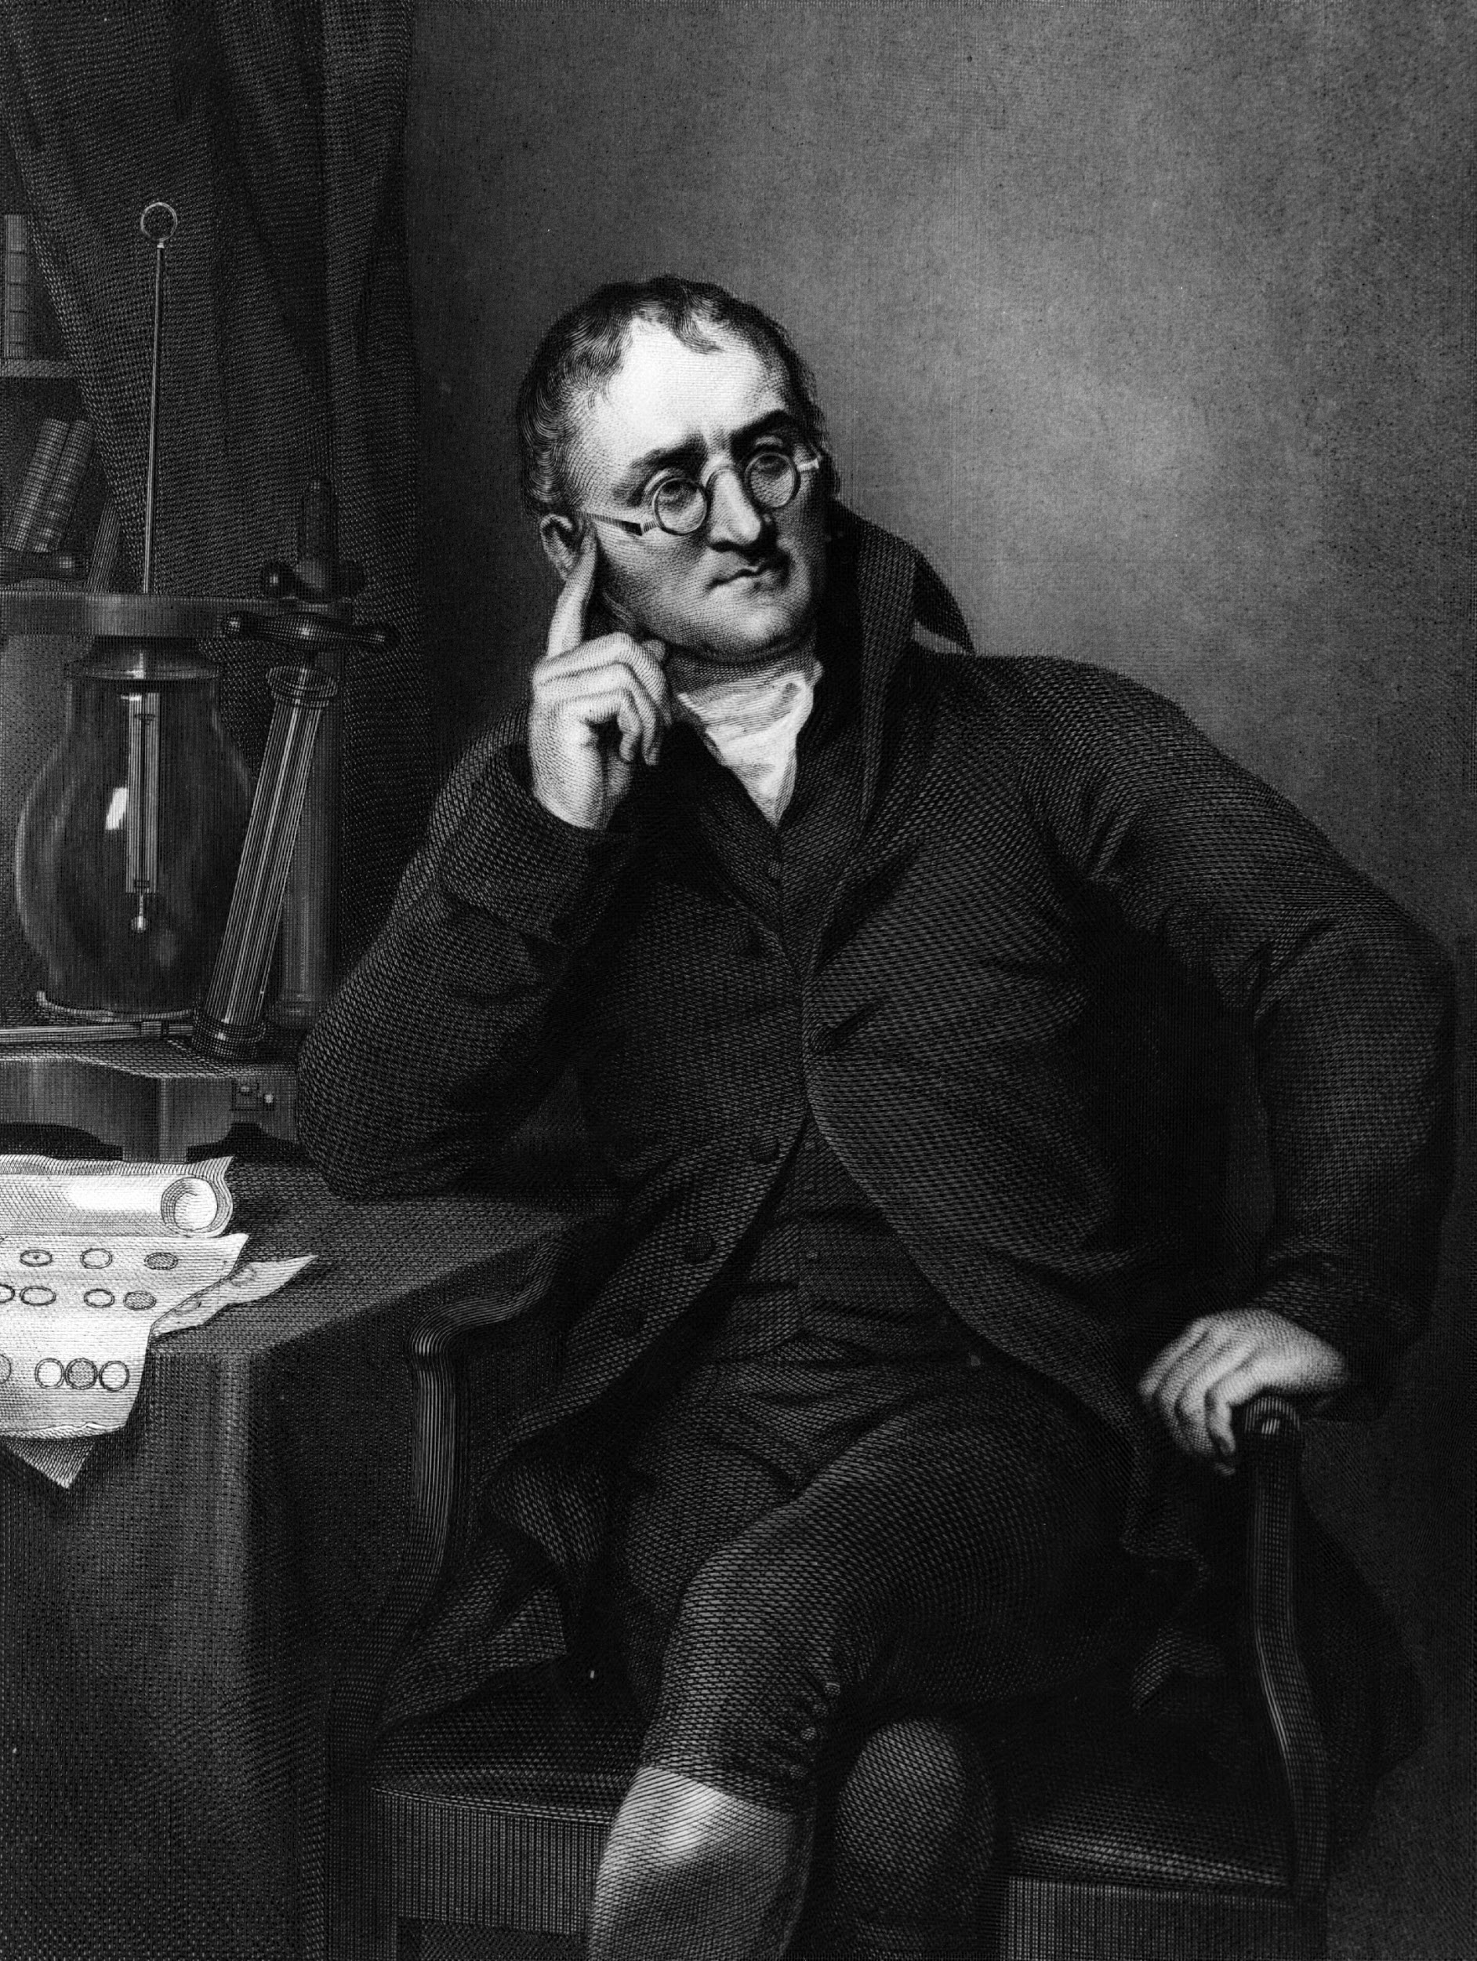
John Dalton proposed the first modern atomic theory in the early 1800s.
Dalton's theory had five major parts:
- All matter is composed of very small particles called atoms.
- All atoms of a given element are identical.
- Atoms cannot be created, destroyed, or subdivided.
- In chemical reactions, atoms combine with or separate from other atoms.
- In chemical reactions, atoms combine with each other in simple, whole-number ratios to form combined atoms.
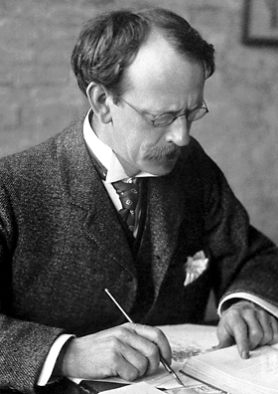
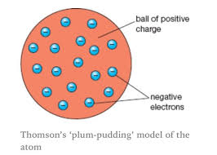
In 1897, English physicist J. J. Thomson discovered that atoms are not indivisible. When introduced to an electrical current, atoms break down into two parts. One of those parts is a tiny particle carrying a negative electrical charge, which we now know as the electron. Thomson suggested a new model of the atom known as the plum-pudding atom. The name comes from a comparison of the atom with a traditional English plum pudding, in which plums are embedded in pudding. In Thomson's atomic model, the "plums" are negatively charged electrons, and the "pudding" is a mass of positive charge. You can think of it as the “chocolate chip cookie dough” model where the chips are the negatively charged electrons and the dough is a mass of positive charge.

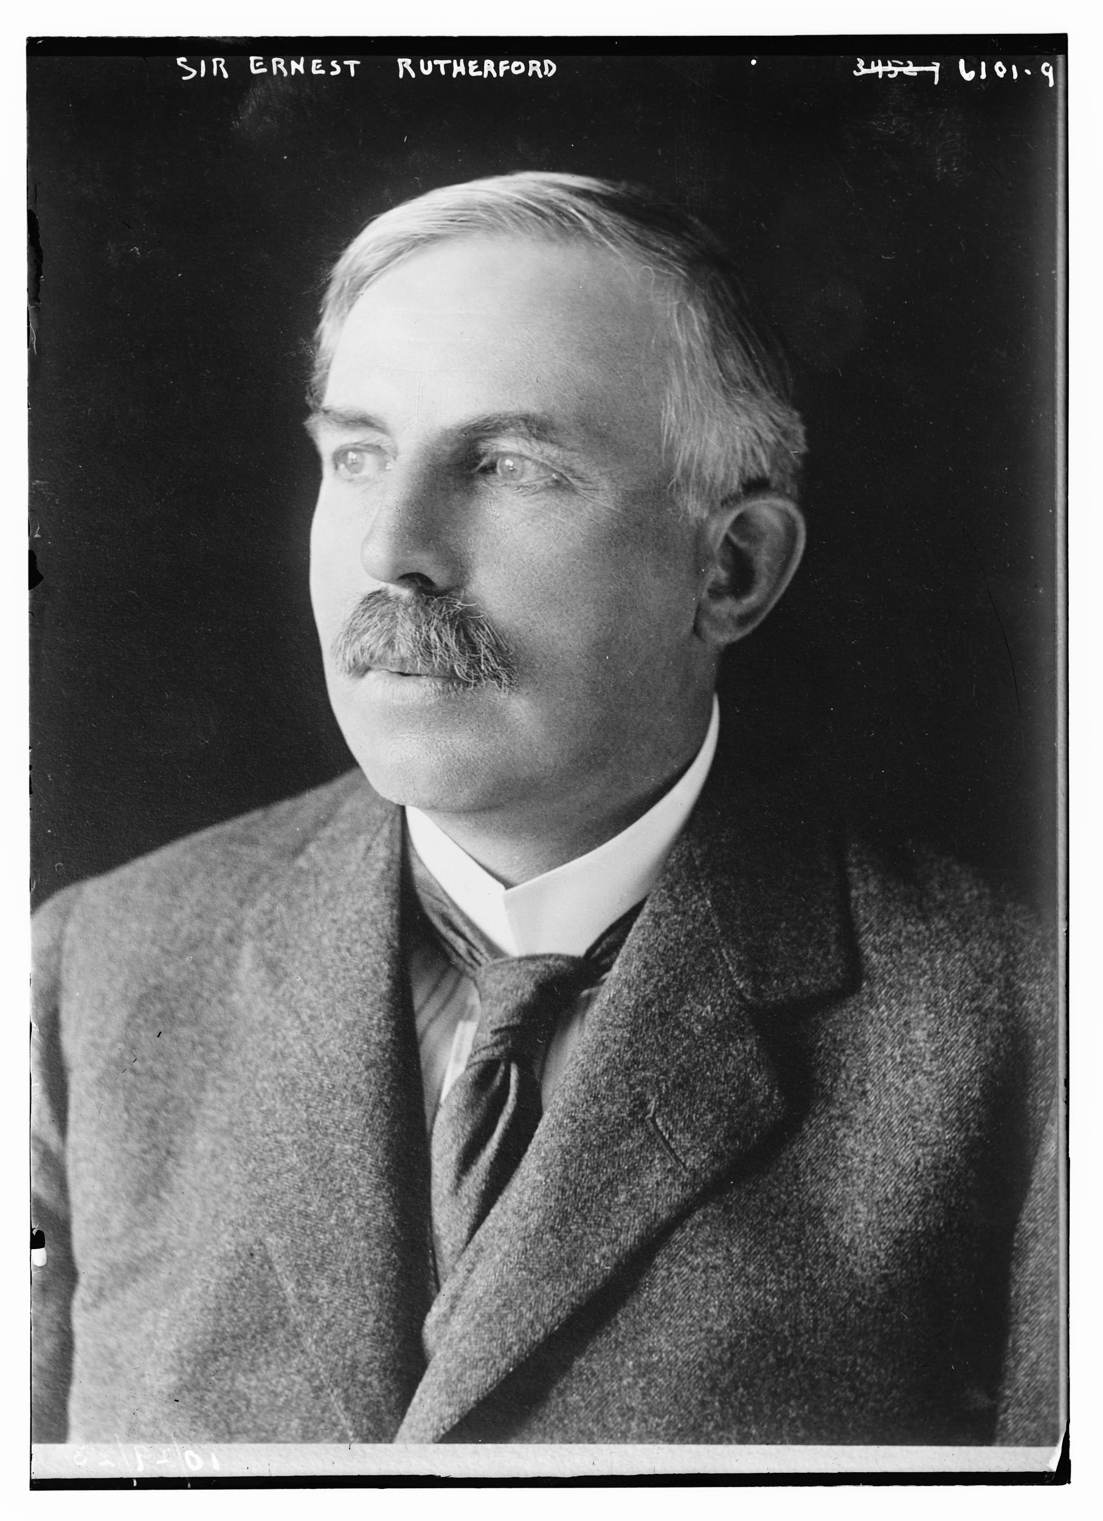
In the early 1900s, English chemist and physicist Ernest Rutherford studied the effects of bombarding thin gold foil with alpha particles. Alpha particles are helium atoms that have lost their electrons, so they are positively charged. Rutherford reasoned that the way alpha particles traveled through the gold foil would give him information about the structure of gold atoms in the foil. Rutherford's experiments provided him with two important pieces of information.
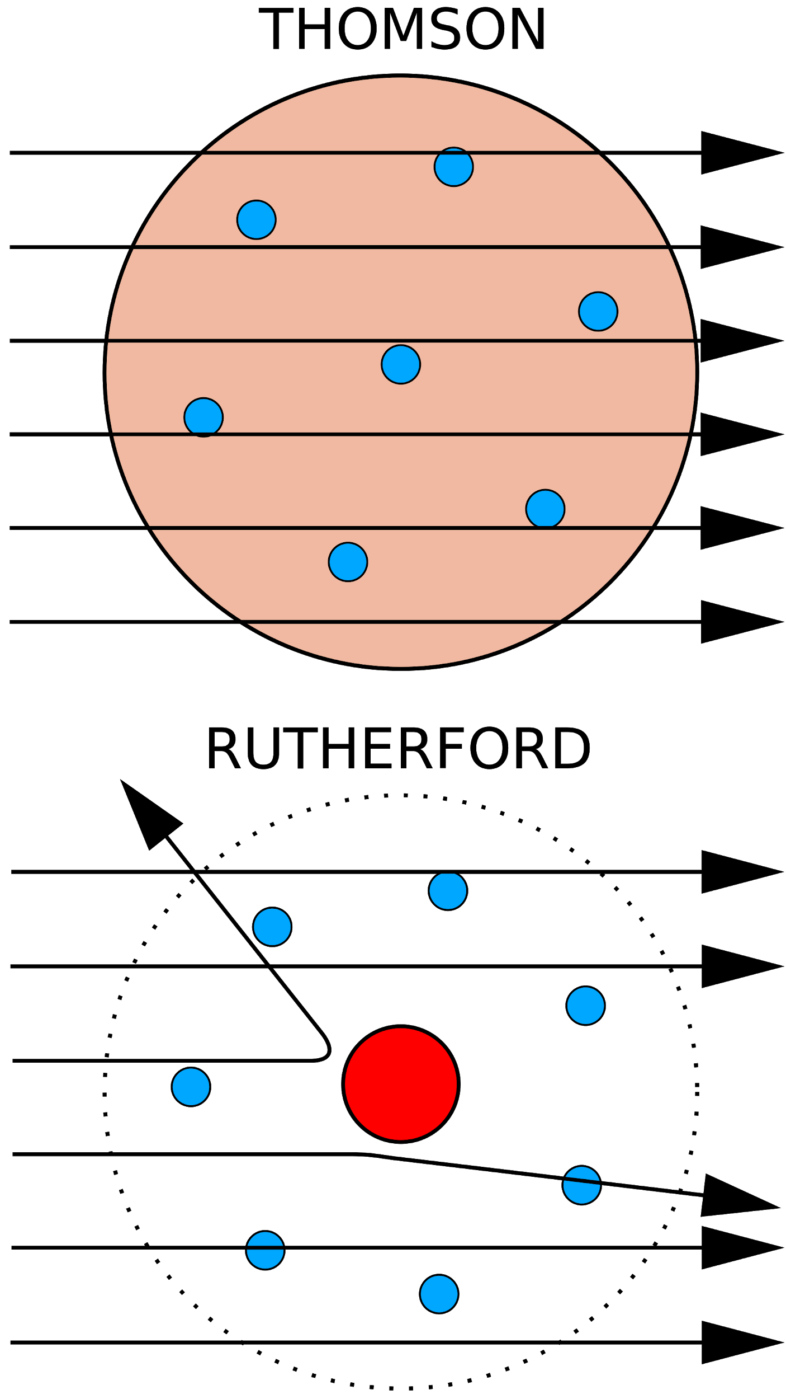
- Most of the alpha particles traveled right through the foil without being deflected at all. Rutherford concluded that atoms consist mostly of empty space.
- A few of the alpha particles were deflected at very sharp angles. In fact, some reflected completely backwards and were detected next to the gun from which they were first produced. Rutherford was enormously surprised. The result, he said, was something like shooting a cannon ball at a piece of tissue paper and having the ball bounce back at you. According to Rutherford, the conclusion to be drawn from this result was that the positive charge in an atom must all be packed together in one small region of the atom. He called that region the nucleus of the atom.
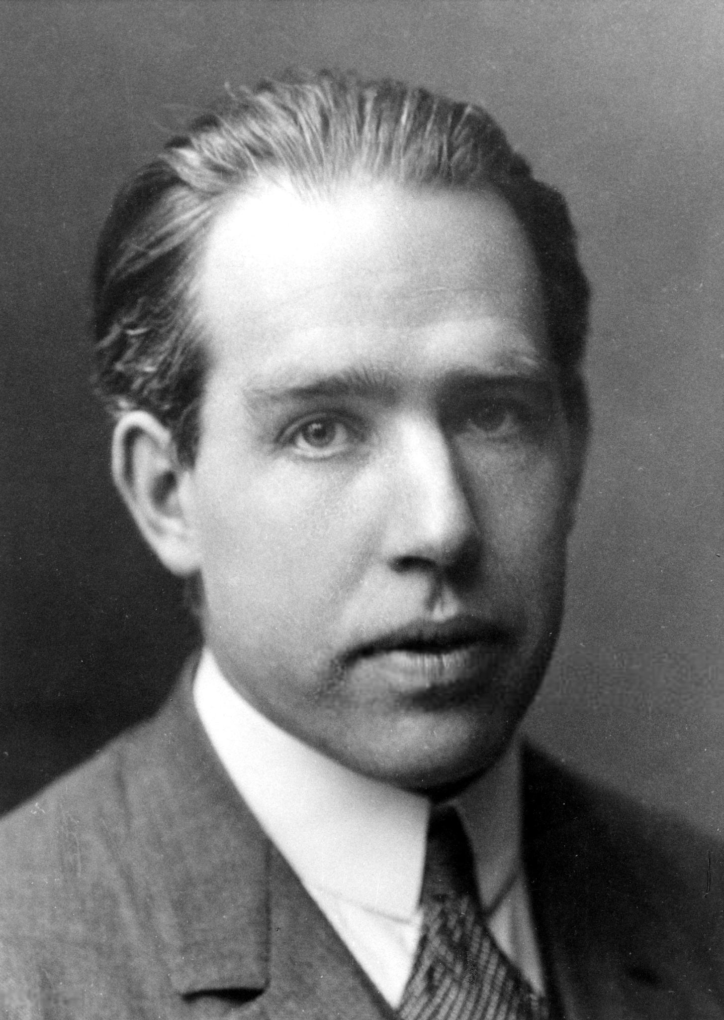
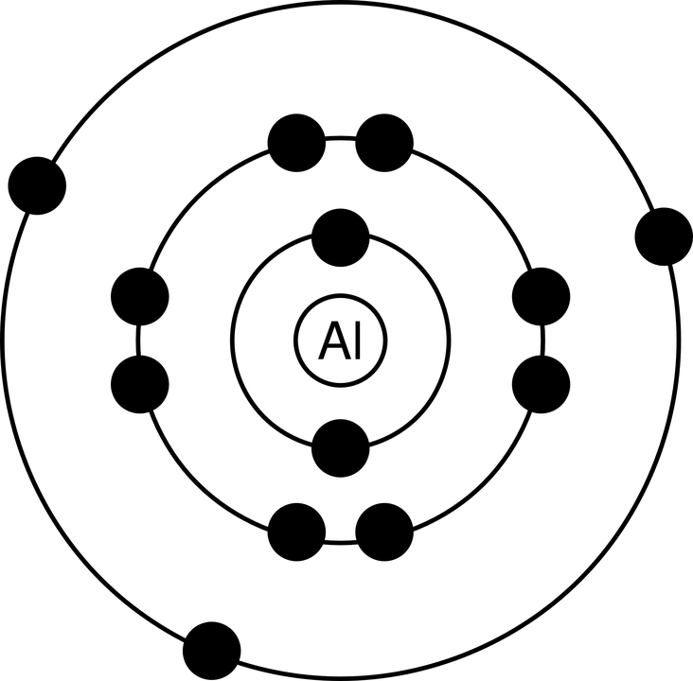
Rutherford’s model was not perfect though because electrons do not remain still as he predicted. Neils Bohr proposed a new atomic theory in 1913. He stated that places exist in the atom where electrons can travel or move around the nucleus, like the orbits that planets travel in their journey around the Sun. By 1930, the accepted model of the atom consisted of two parts, a nucleus whose positive charge was known to be due to tiny particles called protons, and one or more electrons arranged in distinct orbits outside the nucleus.
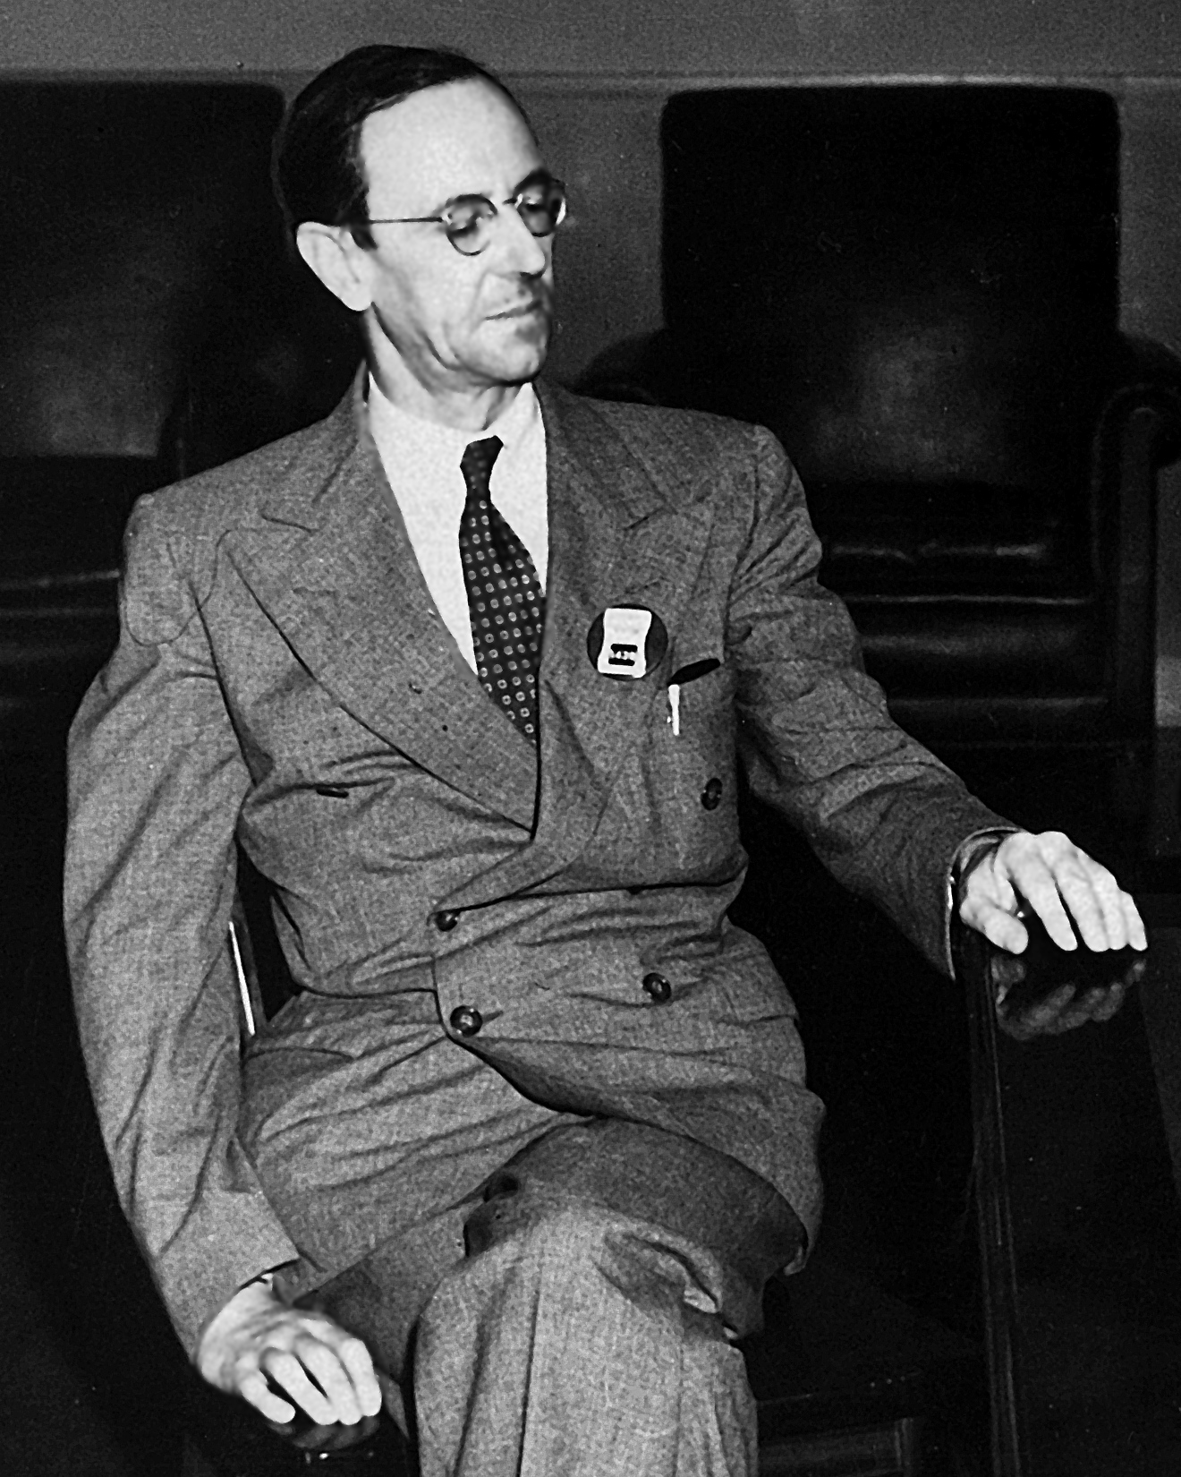
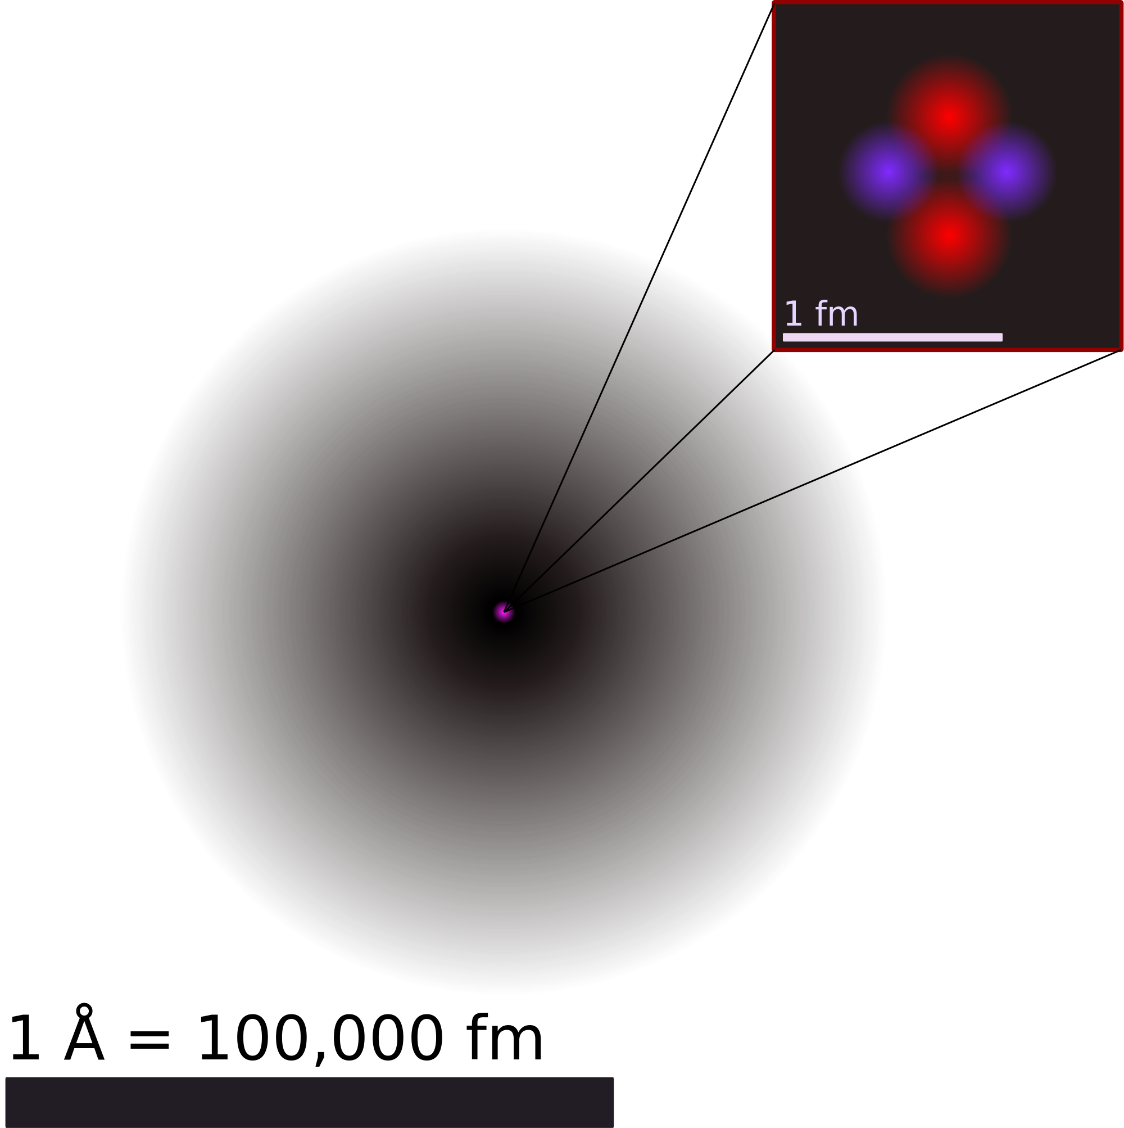
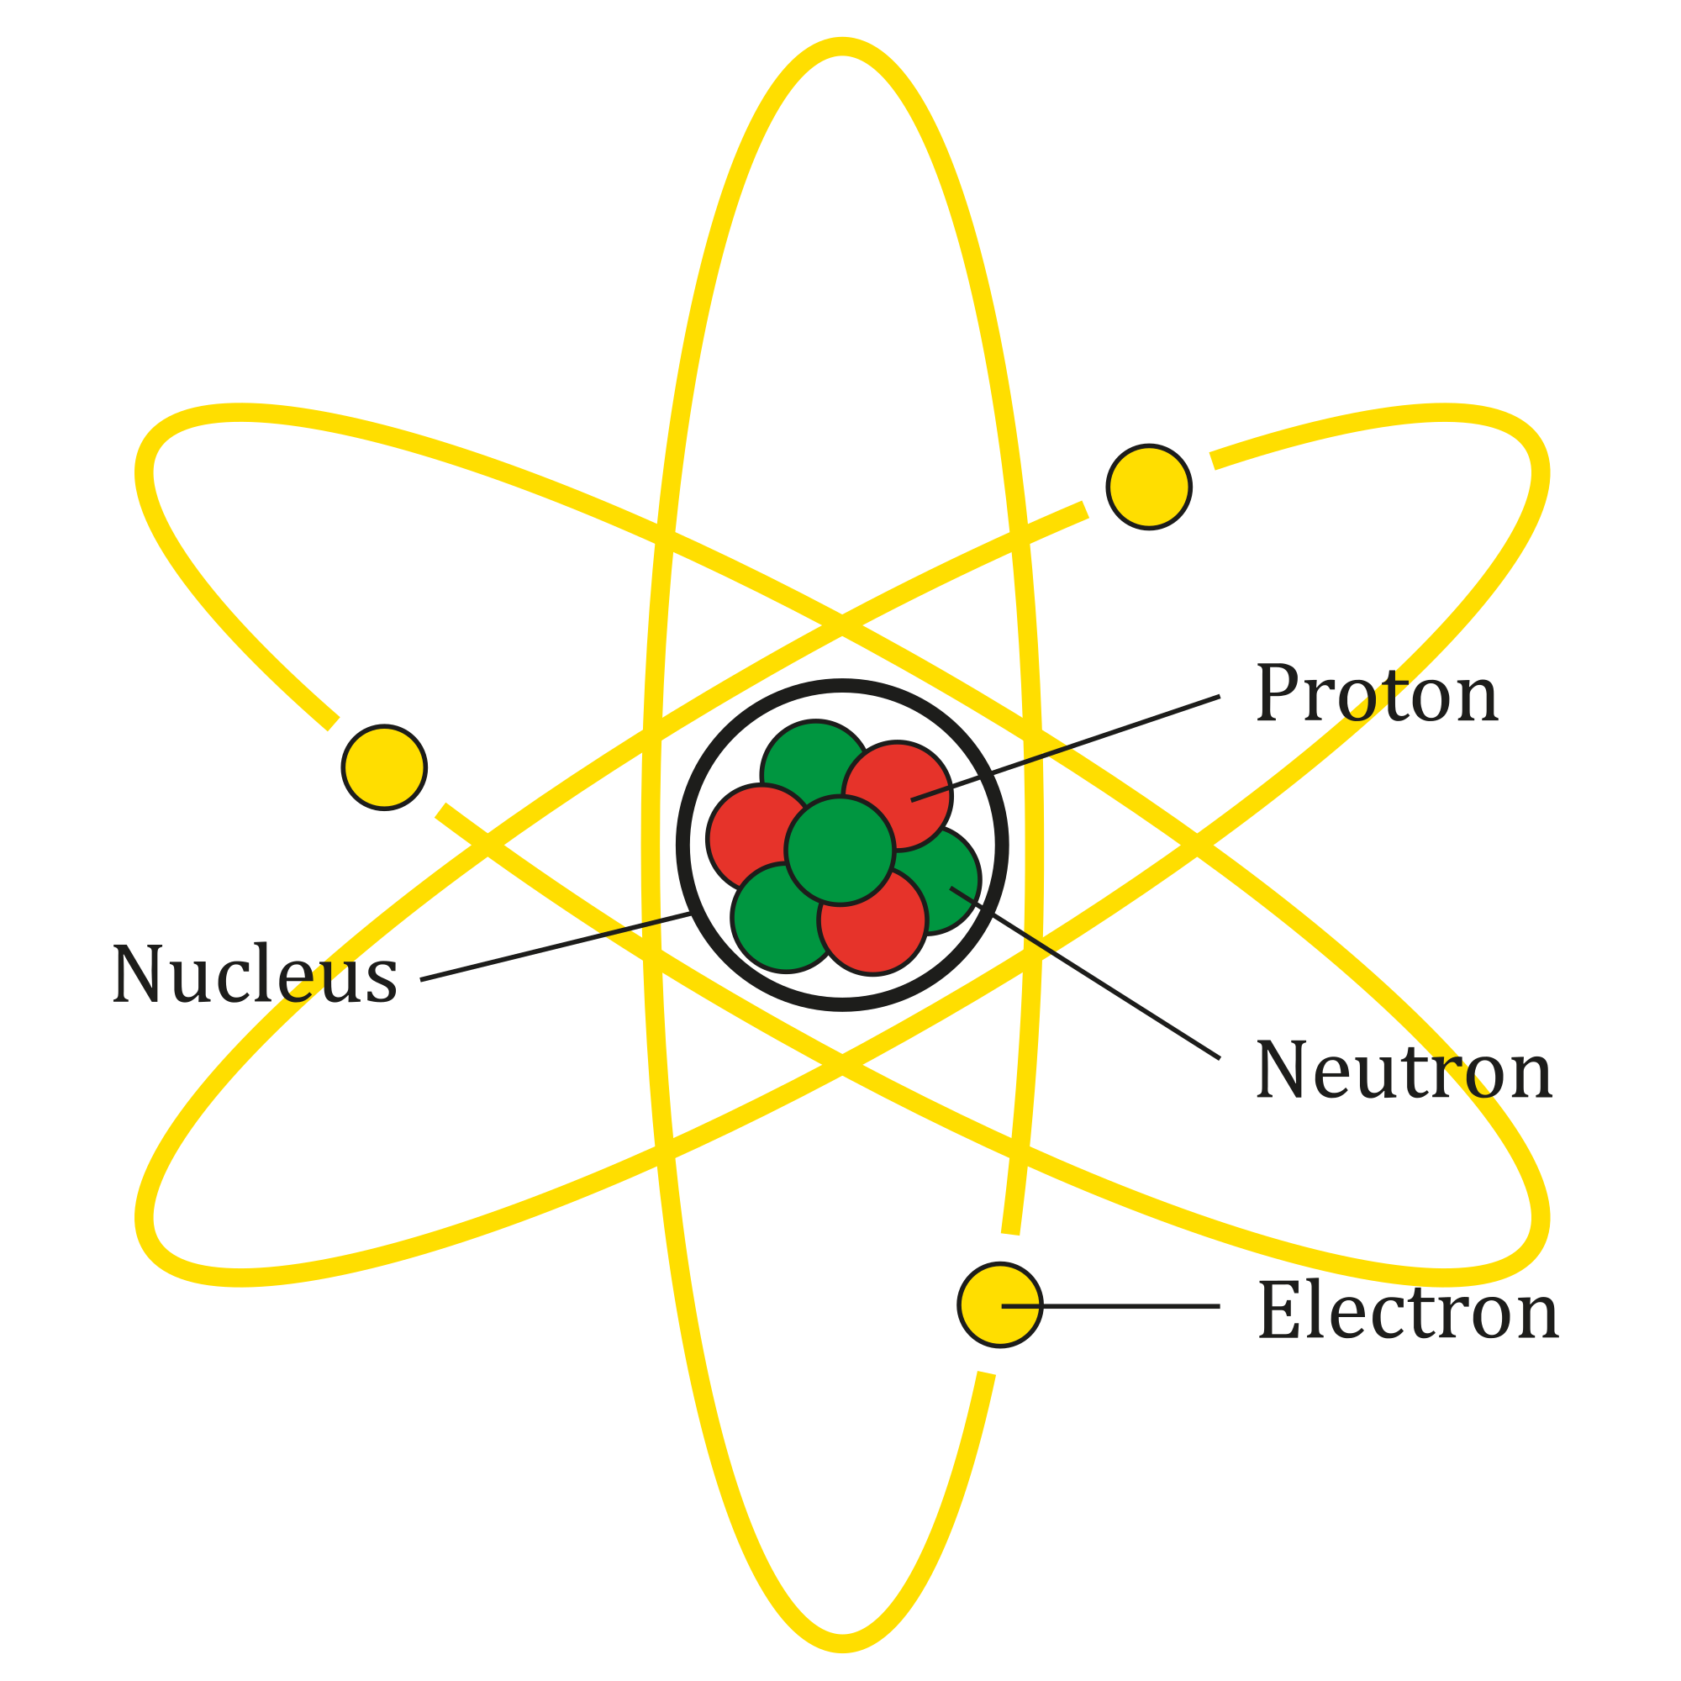
One final problem remained. In the Bohr model, there must be an equal number of protons and electrons. This balance is the only way to be sure that an atom is electrically neutral, which we know to be the case for all atoms. But if you add up the mass (total amount of matter) of all the protons and electrons in an atom, the total comes nowhere near the actual mass of an atom. The solution to this problem was suggested by English physicist James Chadwick in 1932. The reason for mass differences, Chadwick found, was that the nuclei of atoms contain a particle with no electric charge. He called this particle a neutron. Chadwick's discovery resulted in a model where the core of the atom is the atomic nucleus, in which are found one or more protons and neutrons. Outside the nucleus are electrons traveling in orbits.
Bohr’s model of the atom can be used to explain many of the ideas in chemistry in which ordinary people are interested. But the model has not been used by chemists themselves for many decades because revolutionary changes occurred in physics during the 1920s that made scientists reconsider this model. The principle of uncertainty says that it is impossible to describe exactly where an electron is in its path of travel at any moment in time. Therefore, we now consider the atomic model with an electron cloud that shows us not exactly where an electron is, but rather locations that electrons might be at any given time.

NOTE INTERACTIONS: Highlight the main contributions of each scientist or summarize them in your science notebook.
Elements and Isotopes

- Elements
  - Elements are matter constructed of ONE type of atom. Example: Pure gold is made of only gold atoms.
  - Elements are considered to be the simplest pure substances because they have the same composition and same properties throughout. They cannot be broken down into simpler substances.
  - There are currently 118 known elements with about 90 of them naturally occurring. Visit https://ptable.com/ to see all of the elements. These elements have been organized and displayed on a table known as the Periodic Table. https://youtu.be/zGM-wSKFBpo

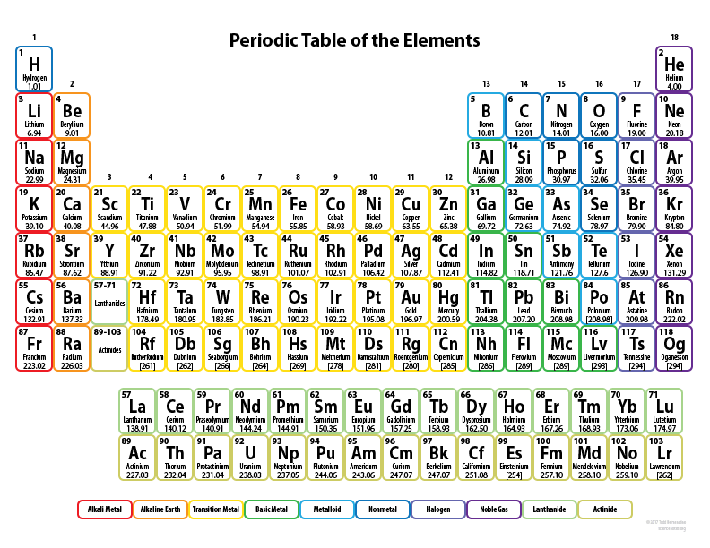

- Reading the Periodic Table
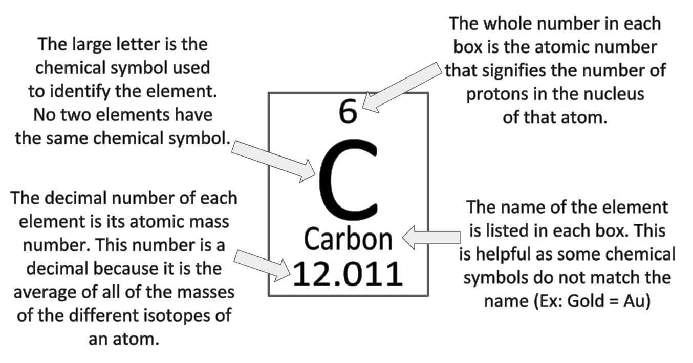

Using the Periodic Table to Figure Out the Number of Protons, Neutrons, and Electrons of an Atom
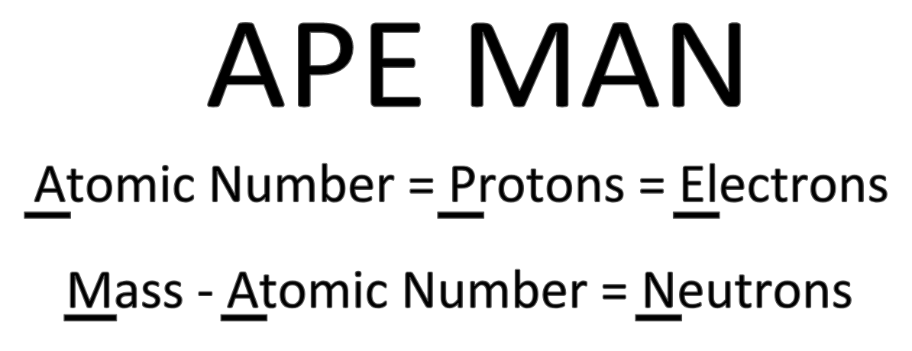
**You will need to round the MASS! The number of neutrons must be a WHOLE NUMBER! **

  - Example: Carbon
    - The atomic number for Carbon is 6. This means that Carbon has 6 protons in its nucleus. Carbon also has 6 electrons orbiting the nucleus.
    - To find the number of neutrons, I first need to round the mass.
      - 12.011 → 12
    - Then, I take the mass and subtract the atomic number to find the number of neutrons
      - 12-6 = 6 Carbon also has 6 neutrons in its nucleus.

- Isotopes
  - Isotopes are atoms that have the same number of protons but different numbers of neutrons.
  - The difference in neutrons changes the atomic mass of the atom. Although both of the atoms shown below are carbon, they are different versions of the same atom because they have different numbers of neutrons.
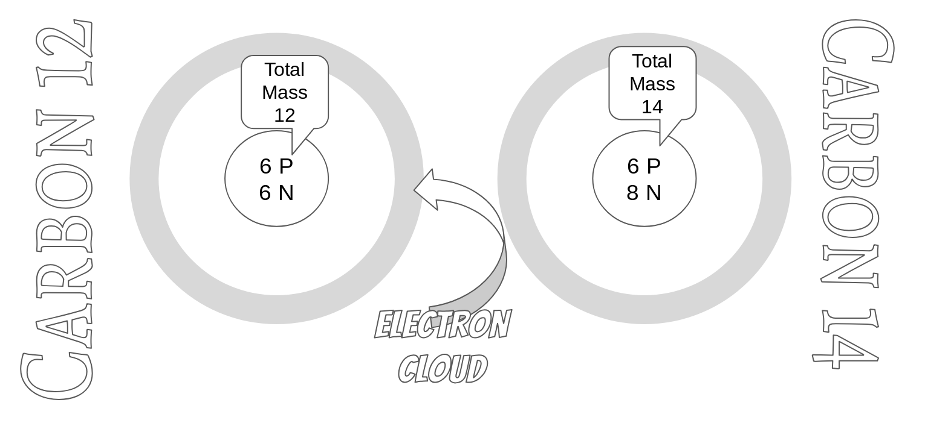

NOTE INTERACTION
Pictured below are elements from the Periodic Table. Create a table in your science notebook to answer the questions for each element pictured.
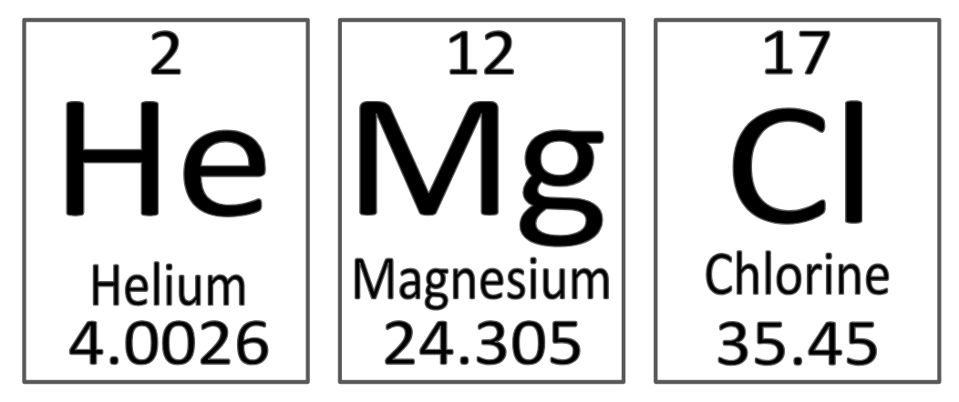
- What is the atomic number of each element?

- What is the atomic mass number of each element?

- How many protons are in the nucleus of each element?

- How many neutrons are in the nucleus of each element?

- How many electrons orbit the nucleus of each element?

Modeling Atoms

- What is a model?
  - A model is a representation of an object, event, or idea that scientists use to help them study or explain complex concepts.
- Types of Models
  - Physical Model: A globe is a physical model of the Earth that can seen and touched.
  - Computer Model: The Doppler radar seen on the news is a computer model that shows the predicted paths of weather events.
  - Idea Models: Einstein’s E=mc² formula is an idea model that helped Einstein explain his ideas to his colleagues.
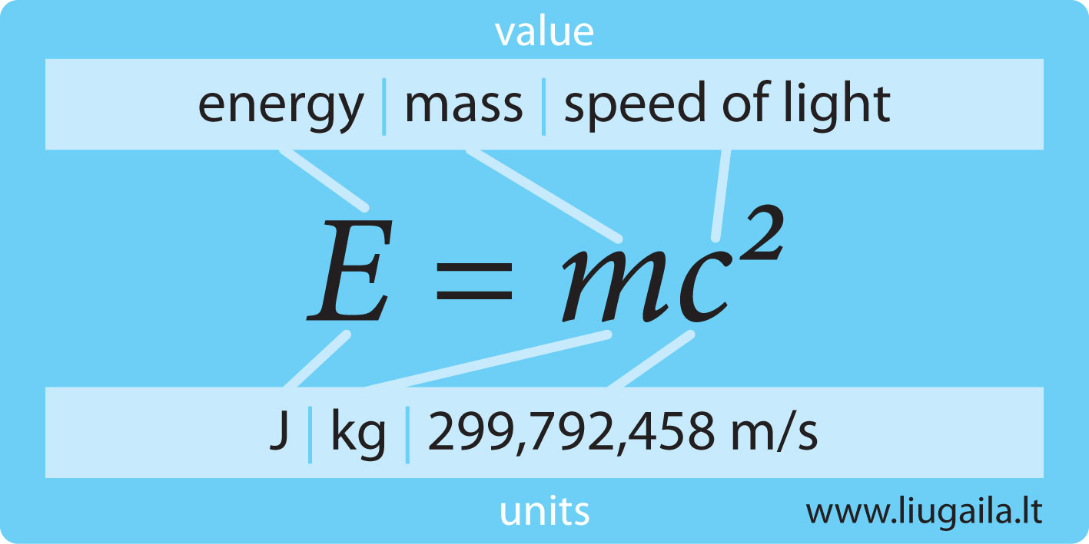
Physical Model Computer Model Idea Model

- Drawing Atomic Models
  - There are many ways to draw physical models of atoms. Remember that atoms are three-dimensional even though we draw them as two dimensional physical models.
  - Begin by using APE MAN to determine the number of protons, neutrons, and electrons for the atom you will draw. We will use Calcium as an example.
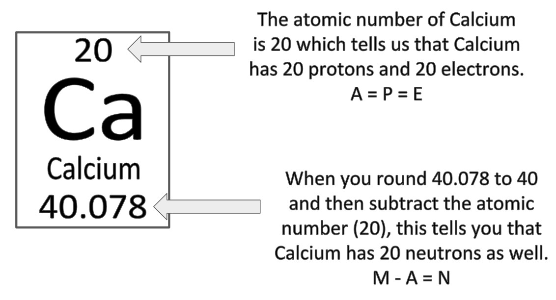
  - In some models of the atom, the nucleus is represented by telling the number of protons and neutrons. In some models, the nucleus is represented as a dot.
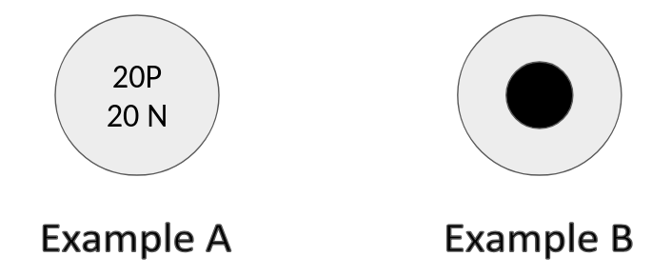

  - The electrons are organized in energy levels outside of the nucleus. Each energy level holds a specific number of electrons.
    - The first energy level is closest to the nucleus and can hold up to 2 electrons.
    - The second energy level can hold up to 8 electrons.
    - The third energy level can hold up to 8 electrons before the next 2 go in the fourth energy level.
    - The first energy level must be full before electrons will begin to fill up the second energy level, and the second energy level must be full before the electrons will begin to fill up the third energy level.
  - In some models, electrons are “paired” and in some models, electrons are not paired. Following the rules above, the 20 electrons for Calcium are placed in the correct energy levels. Both of the examples below show Calcium.
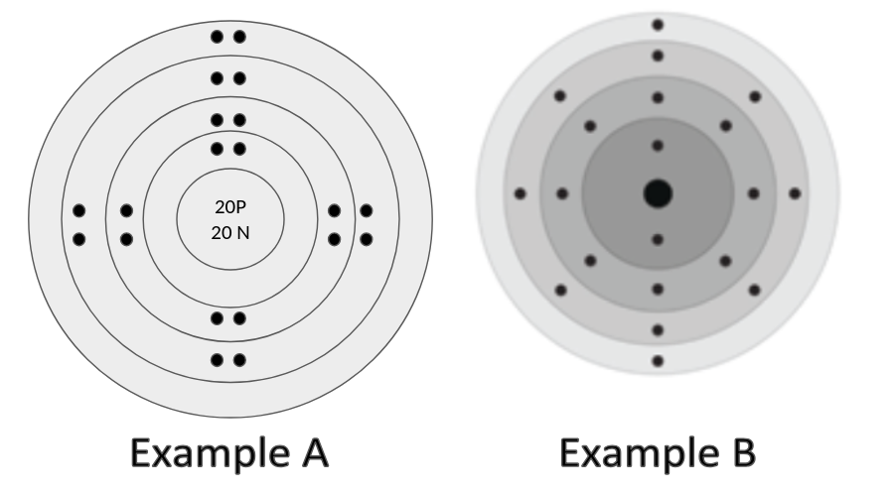
  - Valence Electrons: The electrons in the outermost energy level are given a special name: valence electrons. To determine the number of valence electrons for an atom, only count the electrons in the outermost energy level. In the case of our example above, Calcium has 2 valence electrons.

For step by step instructions on how to create physical models for atoms, please view the following video.
http://bit.ly/drawingatomicmodels

NOTE INTERACTION

Practice creating atomic models for the elements below.

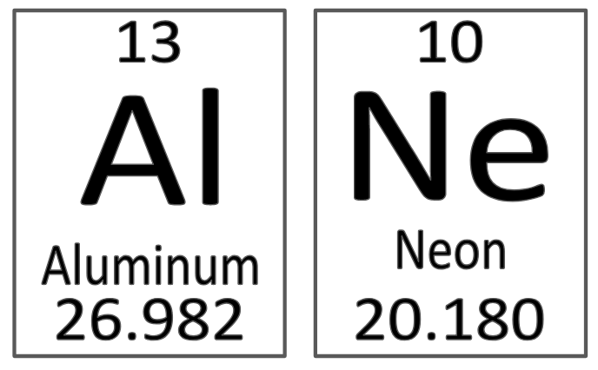

Periodic Table Organization

- The Development of the Periodic Table
  - The Periodic Table of Elements is credited to a Russian Chemist in 1869 named Dmitri Mendeleev who organized the elements into a table. (Video)
  - The word ‘periodic’ means ‘repeating according to some pattern,’ and Mendeleev used this pattern to put the elements in order based on increasing atomic mass. As he became more familiar with the table, Mendeleev was even able to predict elements that had not yet been discovered based on holes in his periodic table.
- Periods and Groups
  - Today the periodic table is arranged by increasing atomic number and similar chemical properties.
  - The horizontal rows (called periods) have elements with the same number of energy levels.
    - Both Hydrogen and Helium are in the first period, and they each have one energy level. Sodium and Phosphorus are in the third period, so they have three energy levels.
  - The vertical columns (called groups) have elements with similar chemical properties. Elements in the same group also have the same number of valence electrons. Valence electrons are the electrons on the outermost energy level and are involved in chemical bonding.
    - Hydrogen, lithium, sodium, and potassium are all in the same group, and they each have 1 valence electron.
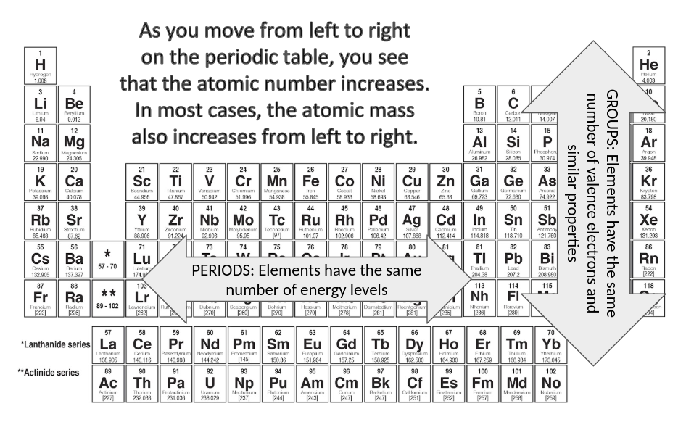

- Metals, Nonmetals, and Metalloids
  - When examining the properties of specific elements, they are grouped into metals, nonmetals, and metalloids on the periodic table.
  - Metals make up the majority of the elements and their properties include shiny luster, good conductors of heat and electricity, solid (except for mercury), malleable (can be pounded into a thin sheet), and ductile (can be stretched into a thin wire).
  - Nonmetals are dull in appearance, not good conductors of heat and electricity, some are gases at room temperature, and brittle.
  - Metalloids have properties of both metals and nonmetals. They can conduct heat and electricity, but not as well as metals. All of them are solids at room temperature.

NOTE INTERACTIONS: Create a chart to summarize the properties of metals, nonmetals, and metalloids.

