Events and Dates to Keep in Mind.
Report Cards: Friday, January 10 Report Cards will go home. Please take time to discuss any concerns you may have with your child.
MLK Holiday: There will be NO school January 20.
100th Day of School: Morningside Elementary will celebrate the 100th Day of School Wednesday, January 22. More information to come.
Valentine Father/Daughter and Mother/Son Dance: Friday, February 7, student council will sponsor a "Love the One You're With" Valentines dance for all students. It will be like the Mother/Son, Daddy/Daughter dances we had a few years ago but it will just be one night. Mothers will come with their sons and dads with their daughters. The cost will be $5.00 and we will sell refreshments.
Coke Sale Begins Monday, February 10 and End Monday, February 24.
PTO Meeting: February 13 at 12:00

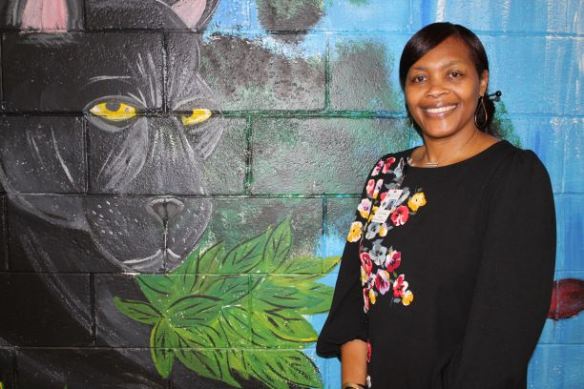
Principal’s Corner
Dear Morningside Elementary Families and Friends,
Morningside is home to the smartest and most talent, gifted students AND teachers in Houston County! We try to equip our students with the skills and knowledge they will need to be successful. Walking the hallways and visiting classrooms each day reminds me how amazing our Morningside Elementary Family is. I hear teachers teaching with passion, using every strategy possible to help their students success. I see students actively engaged in learning and working together with each other to solve difficult problems. I feel the joy in the building because we know we are the gatekeepers of a successful life. Together We Share In the Lives of Great Students! You are our students' first teachers and we proudly take on the responsibility to give your students more than we ever could envision in instruction, love, and accountability. Work with us to prepare our future leaders to be unique citizens!
Nurse’s Notes
During this time of cold and flu season, remember one of the best ways to prevent the spread of germs is to wash your hands. Also, when coughing or sneezing do so in a tissue or bent elbow. On another note, parents of PK -5th grade for your CONVENIENCE please place a change of clothes in your child’s book bag.
Thank you in advance for working with us to keep students and staff healthy and in school.
Mrs. Cross your school nurse

Every day, be on time!
Parents, we need your support with getting students to school on time every day.
- Doors open at 7:45 AM daily.
- Students are marked tardy after 8:30 AM.
- Breakfast is served to all students, free of charge.
- Instruction begins promptly at 8:30 AM.

Visit our Parent Resource Center today!
From 8:00-4:00
Parents we Need Your Help
MSES is looking for some parents to volunteers their time to be our PBIS Prize Patrol. We need a group of parents that will be willing to bag-up PBIS prizes to be given out to students once or twice a month. If this is something you would be interested in, please fill out the flyer pertaining to this information.

Special Thanks,
MSES would like to thank all the parents and students who participated in the canned and dry food drive for Thanksgiving and Christmas. Your donations were great!

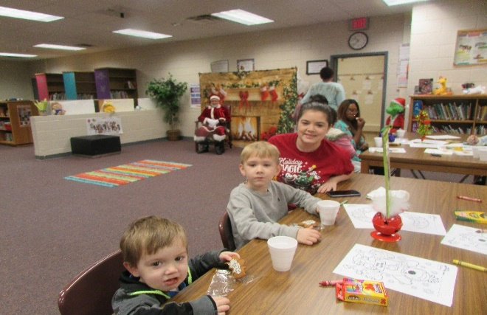

Parents and their Little Ones were invited to school for story time with Santa and the Grinch! Hot Cocoa and Cookies were provided.

Thanks for your support.

Pamelia Harper
Family and Parent Engagement Coordinator

