Psychology AP
Vocabulary Packet

Name ______________________

Chapter Vocabulary
For each chapter, you are responsible to write the definition/explanation for EVERY WORD on the list that I will give you. These will be due the day of the test and must be handed in BEFORE you take your test. (YES, you must complete EVERY word and NO, they will not be accepted at the end of the period or the period following the test or by the end of the day!!!) The list of words may change and you are responsible to know the changes.

To receive 10 points on the Notes:
- Every word must be completed. An incomplete set of words will not be given any credit.
- You do not have to write in complete sentences, but you need complete definitions.
- Your writing should be legible!
- You may use pictures, but they are not required.

Typed notes:
- For consideration to type your notes you must submit a 2 pg research paper explaining the reasons why you need to type your notes (Times 12point font, 1 inch margins) with MLA citations and wait for approval.
- Notes must be typed in this document.
- Prior to the test the notes must be printed.
- Typing notes is a privilege that may be taken away!

UNIT 1: INTRO TO PSYCHOLOGY
- Psychology
(Historical Psychology)
  - Ancient Psychology
    - Socrates
    - Plato
    - Aristotle
  - Empiricism
    - John Locke
  - Monism
  - Dualism
    - Rene Descartes
  - Structuralism
    - Wilhelm Wundt (“father of experimental psychology”)
    - Edward B. Titchener
    - Introspection
  - Functionalism
    - William James
  - Gestalt
    - Max Wertheimer
    - Wolfgang Köhler
    - Kurt Koffka

(Contemporary Psychology)
- Psychoanalysis/Psychodynamic/Psychoanalytic
- Behavioral Psychology
- Neuroscience/Biological/Behavior Genetics
- Evolutionary
- Humanistic
- Cognitive
- Socio-cultural
(Professions)
- Basic Research
- Applied Research
- Industrial/Organizational Psychologists
- Clinical Psychologists
- Psychiatry

UNIT 2: RESEARCH METHODS
- Scientific Method
  - Theory
  - Hypothesis

- Replication
- Selection of who/what to test on:
  - Subject
  - Participant
  - Population
  - Sample
  - Random Sample
  - Sampling error
  - Random Assignment
- Types of Research Methods/Experiments/Studies
  - Case study
  - Survey
  - Naturalistic Observation
  - Correlation –
    - Negative correlation –
    - Positive correlation –
    - Correlation coefficient (r)-
      - Weak correlation
      - Strong correlation
      - Line of best fit
      - Illusory correlation
      - Scatter plots
  - Experiment
    - Laboratory experiments –
    - Field experiments –
    - Experimental condition/Experimental group
    - Control condition/Control group
    - Variable
      - Independent variable
      - Dependent variable
      - Operational definitions (dependent and independent variables)
      - Confounding variable – any difference between the experimental and control group, except for the IV that might affect the dependent variable
    - Single-Blind procedure
    - Double-blind procedure
    - Cross-sectional study –
    - Longitudinal Study
    - Placebo
- Placebo effect

- Problems in Experiments:
  - Experimenter bias – process where the scientists performing the research influence the results, in order to portray a certain outcome
  - Hawthorne effect – reactivity in which individuals modify or improve an aspect of their behavior in response to their awareness of being observed

- Data Analysis:
  - Descriptive statistics
  - Inferential statistics
  - Frequency distribution
  - Frequency polygons
  - Frequency histograms
  - Factor analysis
  - Central tendency
    - Mode
    - Mean
    - Median
    - Range
  - Standard deviation
    - Z score
    - Skewed scores
    - Positive skew
    - Negative skew
    - Measures of variability

- Statistical significance

- Ethics in Human Research
  - Informed consent –
  - Deception –
  - Coercion –
  - Anonymity –
  - Risk –
  - Debriefing –
UNIT 3: NEUROSCIENCE AND BEHAVIOR
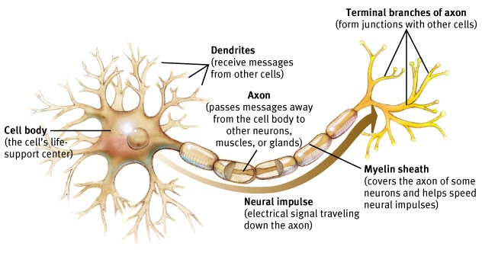
- Phrenology
- Neuron

  - Dendrite
    - Receptor Site
  - Cell body (soma)
  - Axon
  - Myelin Sheath
  - Terminal Branches of axon
    - Terminal Buttons
- Neuron Firing
  - Action Potential
  - Resting Potential
  - Depolarizes
  - Excitatory signal
  - Inhibitory signal
  - Threshold
    - All-or-none response –
- Synapse
  - Reuptake
- Neurotransmitters
  - Acetylcholine
  - Dopamine
  - Serotonin
  - Norepinephrine
  - Endorphins
  - GABA
- Neuron Problems and Interferences:
  - Multiple Sclerosis
  - Agonists
  - Antagonists
- Nerves
  - Sensory neurons (Afferent neurons) –
  - Interneurons
  - Motor neurons (Efferent neurons) –
- Nervous system
  - Central nervous system (CNS)
  - Peripheral nervous system (PNS)
    - Somatic nervous system
    - Autonomic nervous system
        - Sympathetic nervous system
        - Parasympathetic nervous system
- Phineas Gage (1848)
- Lesion
- Types of Scans
  - Electroencephalogram (EEG) –
  - Computer axial tomography scan (CAT)
  - Positron emission tomography scan (PET) -
  - Magnetic resonance imaging (MRI) –
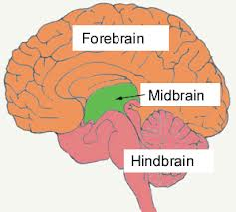
    - fMRI-
- Hindbrain
- Midbrain
- Forebrain
- Brainstem
  - Medulla
  - Pons
  - Reticular formation
- Cerebellum
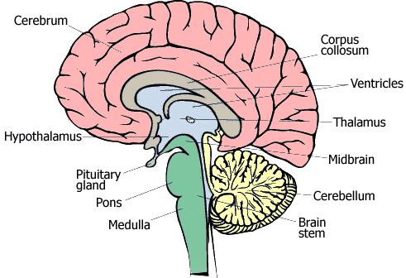
- Thalamus
- Limbic System
  - Amygdala
  - Hypothalamus
  - Hippocampus
- Endocrine system
  - Pituitary Gland
  - Hormones
  - Adrenal glands
- Cerebral Cortex
    - Gyrus (Angular Gyrus)
    - Fissures (Sylvian Fissure) (Longitudinal Fissure)
    - Sulci (Central Sulcus)
    - Gray Matter
    - White Matter
    - Glial cells
  - Hemispheres:
    - Corpus callosum
    - Right Hemisphere
    - Left Hemisphere
    - Split-Brain Studies
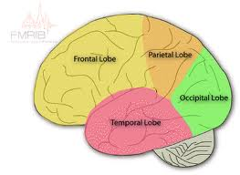
    - Hemispherectomy

  - Lobes
    - Frontal lobes
        - Prefrontal Cortex
        - Broca’s area
        - Motor cortex
    - Parietal lobes
        - Sensory cortex
    - Occipital lobes
        - Visual cortex
    - Temporal lobes
        - Wernicke’s area
        - Auditory cortex
        - Olfactory Cortex
          - Olfactory Bulb
- Association areas
- Aphasia
  - Broca’s Aphasia
  - Wernicke’s Aphasia
- Plasticity (flexible)
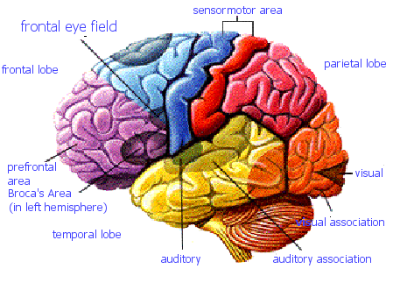
UNIT 4: SENSATION AND PERCEPTION
- Sensation
- Perception
- Using Sensation and Perception together:
  - Bottom-up processing
  - Top-down processing
- Psychophysics
- Stimulation of the Senses:
  - Absolute threshold
  - Difference Threshold (Just Noticeable Difference)
  - Weber’s Law
  - Subliminal Threshold
  - Signal detection theory
  - Sensory adaptation
  - Transduction
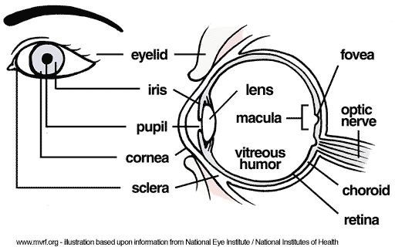
- Parts of the Eye and Brain that aid in vision:
  - Cornea
  - Pupil
  - Iris
  - Lens
  - Retina
    - Rods
    - Cones
  - Fovea
  - Optic Nerve
    - Blind spot
  - Feature detector-
  - Lateral Geniculate nucleaus: (LGN)
- Vision:
  - Acuity
  - Nearsightedness
  - Farsightedness
  - Parallel processing
  - Agnosia
  - Prosopagnosia
- Colors:
  - Wavelength
  - Hue
  - Intensity
  - Young-Helmholtz trichromatic theory
  - Opponent-process theory
    - Afterimage effect
  - Illusory contours
  - Color constancy
  - Color deficient vision
- Audition
  - Frequency –
  - Pitch
  - Decibels
  - Amplitude –
  - Place Theory
  - Frequency Theory
  - Conduction Hearing Loss
  - Sensorineural Hearing loss
- Parts of the Ear
  - Inner Ear
  - Middle Ear
  - Eardrum (Tympanic membrane)
  - Hammer, Anvil, Stirrup
  - Cochlea
- Gustation
  - Papillae
- Olfaction
  - Olfactory bulb –
  - Olfactory Nerve
- Gate-control theory
- Kinesthesis –
- Vestibular sense –
- Interactions of the Senses:
  - Sensory interaction –
  - Selective attention (Cocktail Party Effect)
  - Change Blindness
  - Visual capture
- Gestalt
- Depth Perception
  - Visual Cliff
  - Monocular Cues
    - Figure-ground
    - Relative size
    - Interposition
    - Texture gradient
    - Relative Height
    - Relative motion (motion parallax)
    - Linear Perspective
    - Light and shadow
  - Binocular Cues
    - Retinal disparity
    - Convergence
- Visual Grouping
  - Proximity
  - Similarity
  - Continuity
  - Connectedness
  - Closure
- Phi Phenomenon –
- Perceptual constancy
- Perceptual adaptation
- Perceptual set
- Extrasensory Perception

UNIT 5: STATES OF CONSCIOUSNESS
- Consciousness
- Biological rhythms
- Circadian rhythms
- Sleep
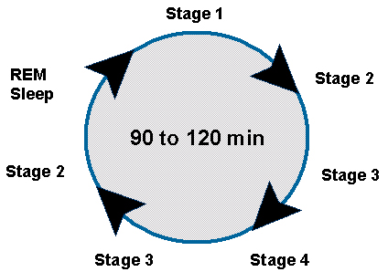
  - Sleep onset
  - Stage 1 Sleep
  - Stage 2 Sleep
  - Stage 3 Sleep
  - Stage 4 Sleep
  - Sleep Cycle
- REM sleep - (Paradoxical sleep)
- Brain Activity During Sleep:
  - Beta waves
  - Alpha waves
  - Theta waves
  - Delta waves
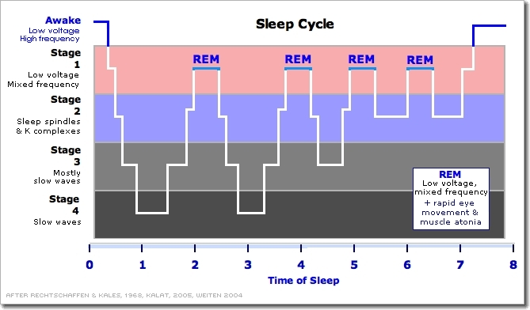
  - REM waves
- Sleep Deprivation
- Sleep Disorders:
  - Insomnia
  - Narcolepsy
  - Sleep apnea
  - Night Terrors
  - Sleep walking –
- Conscious Mind
  - Conscious
  - Preconscious
  - Unconscious
  - Nonconscious
- Dreaming:
  - Manifest Content –
  - Latent content
  - REM rebound
  - Activation-synthesis theory
- Hypnosis
  - Posthypnotic amnesia
  - Posthypnotic suggestions
  - Role theory – (hypnotic suggestibility)
  - Dissociation Theory –
  - Hidden observer
- Psychoactive drugs
  - Tolerance
  - Withdrawal
  - Physical dependence
  - Psychological dependence
  - Hallucinations
  - Types:
    - Depressants
    - Stimulants
    - Hallucinogens
    - Opiates

UNIT 6: LEARNING
- Learning
- Associative learning
- Behaviorism
  - John Watson
    - Little Albert
    - Mary Cover Jones
- Classical conditioning
  - Ivan Pavlov
  - Acquisition
  - Parts of Classical Conditioning:
    - Neutral Stimulus
    - Unconditioned Stimulus
    - Unconditioned Response
    - Conditioned Stimulus
    - Conditioned Response
  - Extinction
    - Spontaneous recovery
  - Generalization
  - Discrimination
  - Aversive conditioning
  - Learned helplessness
- Operant conditioning
  - Edward L. Thorndike
    - Law of effect
  - BF Skinner
    - Skinner box/Operant chamber
- Operant behavior
- Respondent behavior
- Shaping
  - Chaining
- Reinforcement
  - Positive reinforcement
  - Negative reinforcement
- Types of Behavior Reinforcers:
  - Primary reinforcers
  - Conditioned (secondary) reinforcers
- Punishment
  - Positive Punishment
  - Negative Punishment
- Reinforcement Schedules:
  - Continuous reinforcement
  - Partial (intermittent) reinforcement
  - Ratio schedules
    - Fixed-ratio schedule
    - Variable-ratio schedule
  - Interval schedule
    - Fixed-interval schedule
    - Variable-interval schedule
  - Overjustification Effect
- Latent learning
  - Edward Tolman
  - Cognitive map
- Observational learning
  - Albert Bandura
  - Modeling
  - Mirror neurons
  - Prosocial behavior

- Zone of proximal development – Lev Vygotsky
UNIT 7A: Memory
- Memory
- Memory Stages:
  - Sensory Memory
    - Iconic memory
    - Echoic memory
  - Short-term memory
  - Long-term memory
    - Declarative/ Explicit memory
      - Hippocampus
      - Episodic memories
        - Flashbulb memories
      - Semantic memories
    - Procedural/Implicit memories
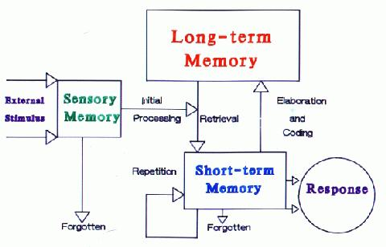
      - Cerebellum
- Memory Processes:
    - Automatic processing
    - Effortful processing
a. Encoding
    - Visual encoding
    - Acoustic encoding
    - Semantic encoding
  - Storage:
    - Spacing Effect
    - Serial position effect -
      - Primacy effect
      - Recency effect
      - Imagery
    - Types of Rehearsal:
      - Elaborative rehearsal
      - Maintenance rehearsal
  - Retrieval
    - Recall
    - Recognition
- Tools for Remembering:
    - Priming
    - Mnemonic devices
    - Chunking
    - Mood-congruent memory
    - State-dependent memory
    - Déjà vu
    - Relearning effect
    - Long-term potentiation –
- Why We Forget:
  - Amnesia
    - Source Amnesia
    - Retrograde amnesia
    - Anterograde amnesia
  - Transience
  - Blocking
  - Proactive interference –
  - Retroactive interference –
  - Repression
  - Misinformation effects
UNIT 7B: Thinking, Problem Solving, Creativity and Language
- Cognition
- Concept
  - Prototype
- Ways to Problem Solve:
  - Algorithm
  - Heuristic
    - Availability heuristic –
    - Representative heuristic –
  - Insight
- Problems with Problem Solving
  - Fixation
  - Functional Fixedness
  - Rigidity –
  - Framing
  - Overconfidence
  - Hindsight Bias
  - Confirmation Bias
  - Belief Bias
    - Belief Perseverance
- Problem Solving Aids:
  - Mental Set
  - Convergent thinking –
  - Divergent thinking –
  - Creativity
- Artificial Intelligence
- Language
  - Acquisition:
    - Linguistic relativity hypothesis – Benjamin Whorf –
    - Nativist theory of language acquisition –
    - Phonemes –
    - Morphemes –
  - Grammar
    - Syntax
  - Semantics
  - Stages:
    - Babbling Stage
    - One-Word Stage
    - Two-Word Stage
      - Telegraphic Speech
  - Animal Language
UNIT 8A: Motivation
- Motivation
- Primary drive – biological needs
- Secondary drive – learned drives
- Drive-reduction theory
  - Homeostasis
- Arousal Theory
  - Yerkes-Dodson law –

- Incentive theory
  - Incentives
- Extrinsic motivation
- Intrinsic motivation
- Abraham Maslow
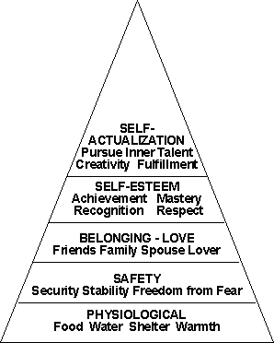
- Hierarchy of Needs

- Physical Motivation:
  - Glucose
  - Insulin
  - Set point
  - Basal metabolic rate
  - Lateral hypothalamus
  - Ventromedial hypothalamus
  - Anorexia nervosa
  - Bulimia nervosa
- Sexual Motivation:
  - Sexual response cycle
    - Initial excitement
    - Plateau phase
    - Orgasm
    - Resolution phase
  - Estrogen
  - Testosterone
  - Sexual orientation
- Work motivation
  - Flow

  - Industrial-organizational psychology
  - Personnel psychology
  - Achievement motivation
  - Theory X
  - Theory Y
- Stressors –
  - Stress reactions
- Hans Seyle’s General adaptation syndrome (GAS)
- Type A Personality
- Type B Personality

UNIT 8B: Emotions, Stress, and Health
- Emotions
  - Primary Affects
- Theories of Emotions
  - James-Lange

  - Cannon-Bard

  - Schactor Two-factor theory
- Lie Detectors/ Polygraphs
- Facial Feedback
- Amygdala
- Catharsis –
- Feel-good, do-good phenomenon
- Subjective well being
- Adaptation-level phenomenon – our tendency to form judgments based on a “neutral” level
- Relative deprivation –

UNIT 9: Developmental Psychology
- Prenatal Development
  - Zygotes
  - Embryo
  - Fetus
- Teratogens
- Fetal alcohol syndrome
- Inborn Reflexes
  - Rooting reflex
  - Sucking reflex
  - Grasping reflex
  - Swallowing reflex
  - Stepping reflex
  - Moro reflex
  - Babinski reflex
- Postpartum depression
- Maturation
- Motor development
- Cognition
- Cognitive development
  - Schemas
  - Assimilate
  - Accommodation
- Jean Piaget
- Cognitive Theory of Development
  - Sensorimotor stage (birth – 2 years)
    - Object permanence
  - Preoperational stage (2 years – 7 years)
    - Conservation
    - Egocentric
    - Theory of mind
  - Concrete operational stage (7 years – 11 years)
  - Formal operational stage (12 years – adulthood)
- Autism
- Critical period
- The Case Study of Genie
- Konrad Lorenz
  - Imprinting
- Stranger anxiety
- Attachment
  - Harry Harlow –
  - Mary Ainsworth –
    - Strange Situation Experiment
    - Secure attachments –
    - Avoidant attachments –
    - Resistant attachments –
    - Disorganized attachment –
- Parenting Styles:
  - Authoritarian Parenting –
  - Permissive Parenting –
  - Authoritative Parenting–
  - Neglective Parenting-
- Self concept
- Adolescence
- Puberty
  - Primary sex characteristics
  - Secondary sex characteristics
  - Menarche
- Moral Development
- Lawrence Kohlberg
  - Preconventional morality
  - Conventional morality
  - Postconventional morality
- Sigmund Freud Psychosexual Theory of Development
  - Oral stage
  - Anal stage
  - Phallic stage
  - Latency stage
  - Genital stage
- Fixation
- Erik Erikson’s stage theory – Psychosocial stage theory
  - Trust vs. Mistrust
  - Autonomy vs. shame and doubt
  - Initiative vs. guilt
  - Industry vs. inferiority
  - Identity vs. role confusion
  - Intimacy vs. isolation
  - Generativity vs. stagnation
  - Integrity vs. despair
- Dementia
- Alzheimer’s Disease
- Crystallized intelligence –
- Fluid intelligence –
- Social clock
- Stages of Dying
  - Denial
  - Bargaining
  - Depression
  - Anger
  - Acceptance
UNIT 10: Personality
- Personality
(Psychoanalytic Perspective)
- Sigmund Freud
- Unconscious
- Id –
  - Pleasure principle
- Ego –
  - Reality principle
- Superego –
  - Morality Principle
- Defense Mechanisms
  - Repression
  - Denial
  - Regression
  - Reaction formation
  - Projection
  - Rationalization
  - Displacement
  - Sublimation
- Projective Tests
  - Thematic Apperception Test (TAT)
  - Rorschach inkblot test
- Neo-Freudians:
  - Alfred Adler
    - Inferiority complex
    - Birth Order
  - Karen Horney
  - Carl Jung
    - Collective Unconscious
      - Archetypes –
(Humanistic Perspective)
- Carl Rogers
- Unconditional positive regard
- Self-concept
(Biological Perspective)
- Body Type Personality – William Sheldon
  - Endomorph
  - Ectomorph
  - Mesomorph
(Trait Perspective)
- Gordon Allport
- Traits
- Isaabel Myers and Kathleen Briggs
- Hans Eysenck and Sybil Eysenck –
  - Introversion and extroversion
  - Stability and instability
- Personality inventories –
  - Objective Tests
  - Minnesota Multiphasic Personality Inventory (MMPI)
- Barnum effect

- The Big Five Factor Theory
  - Openness
  - Conscientiousness
  - Extroversion
  - Agreeableness
  - Neuroticism(Emotional Stability)
(Social-cognitive perspective)
- Reciprocal determinism –
- Personal control
- Julian Rotter – studied and developed the loci of control
  - External locus of control
  - Internal locus of control
  - Learned helplessness
(Exploring the Self)
- Spotlight Effect
- Self-esteem
- Self-serving bias
- Individualism
- Collectivism
UNIT 11: TESTING AND INDIVIDUAL DIFFERENCES
- Intelligence
- Intelligence tests
Single Intelligence
- Mental age
- IQ
- Lewis Terman
- Alfred Binet
- Stanford-Binet Test
- WAIS – (Wechsler Adult Intelligence Scale)
- General intelligence (g) Charles Spearman
  - Factor Analysis
- Mental retardation
  - Savant Syndrome
Multiple Intelligence Theories
- L.L. Thurstone –
- J.P. Guilford –
- Robert Sternberg’s Triarchic Theory of Intelligences:
  - Creative
  - Analytic
  - Practical
- Howard Gardner’s Theory of Multiple Intelligences
  - Linguistic
  - Logical-mathematical
  - Spatial
  - Musical
  - Bodily-kinesthetic
  - Intrapersonal
  - Interpersonal
- Emotional Intelligence (Daniel Goleman)
- Social Intelligence
- Creating Tests:
  - Aptitude tests
  - Achievement tests
  - Standardization
    - Standardized sample
  - Normal Curve
  - Reliability
    - Test-retest reliability –
  - Validity
    - Content validity
    - Predictive validity
- Problems with IQ Tests
  - Stereotype threat
  - Flynn effect

UNIT 12: ABNORMAL PSYCHOLOGY
- Psychological disorder
- Medical model
- Bio-psycho-social perspective
- Behavioral Changes
  - Inappropriate affect
  - Flat affect
- DSM-5
  - Section 1 – Basics
    - Intro, use and cautionary statement
  - Section 2 – Diagnostic Criteria and Codes
    - All of the disorders listed with specific criteria
  - Section 3 – Emerging Measures and Models
    - Assessment measures, cultural formulation, conditions for further study,
- Anxiety Disorders
  - Generalized Anxiety Disorder
  - Separation anxiety
  - Social anxiety disorder
  - Selective Mutism
  - Panic Disorder
  - Agoraphobia
  - Specific phobia
- Obsessive-Compulsive & Related Disorders
  - Obsessive-Compulsive Disorder
    - Obsessions
    - Compulsions
  - Body Dysmorphic Disorder
  - Hoarding Disorder
  - Trichotillomania
- Traumas & Stress-Related Disorders
  - Post-traumatic Stress Disorder
  - Acute Stress Disorder
  - Adjustment Disorder
- Somatic Symptom and Related Disorders
  - Illness Anxiety Disorder (Hypochondriasis)
  - Conversion Disorder
  - Factitious Disorder (formerly Munchausen’s)
- Dissociative Disorders
  - DID
  - Dissociative Amnesia – (With Dissociative Fugue)
  - Depersonalization/Derealization Disorder
- Depressive Disorders
  - Major Depressive Disorder
  - Disruptive Mood Dysregulation Disorder (DMDD)
  - Persistent Depressive Disorder (Dysthymia)
- Bipolar & Related Disorders
  - Bipolar 1
  - Bipolar 2
  - Cyclothymic
- Schizophrenia Disorders
  - Delusional Disorder
  - Schizophrenia
(Positive Symptoms)
    - Delusions
    - Hallucinations
    - Catatonia
    - Disorganized Speech
    - Negative Symptoms
  - Schizoaffective
  - Catatonic disorder
- Personality Disorder
  - Cluster A
    - Paranoid
    - Schizoid
    - Schizotypal
  - Cluster B
    - Antisocial (Conduct Disorder)
    - Borderline
    - Histrionic
    - Narcissistic
  - Cluster C
    - Avoidant
    - Dependent
    - OCPD
- Neurodevelopmental Disorders
  - Intellectual Disability
  - Autism Spectrum Disorder
  - ADHD
  - Tourette Syndrome

UNIT 13: TREATMENT OF PSYCHOLOGICAL DISORDERS
- Psychotherapy
- Deinstitutionalization –
- Eclectic approach
- Psychoanalysis (Freud)
  - Hypnosis
  - Free association
  - Resistance
  - Interpretations
  - Dream analysis
  - Transference
- Humanistic (Carl Rogers)
  - Self-actualization
  - Free will
  - Determinism
  - Client-centered therapy
  - Unconditional positive regard –
  - Active listening
- Behavior therapy
  - Counterconditioning
  - Exposure therapies
  - Systematic desensitization
  - Anxiety hierarchy
  - Aversive Conditioning
  - Token economy
- Cognitive therapies
  - Cognitive-behavior therapy
  - Rational emotive therapy (RET)
  - Cognitive therapy –
- Group Therapy
  - Family therapy
  - Group Therapy
  - Self-Help Groups
- Psychopharmacology
  - Drugs
    - Antipsychotic drugs (Thorazine or Haldol)
    - Antianxiety drugs
    - Barbiturates – (including Xanax & Valium)
    - Antidepressant drugs
    - Tricyclic antidepressants, monoamine oxidase (MAO) inhibitors, serotonin-reuptake-inhibitor - drugs that treat depression by increasing the activity of serotonin in the brain
  - Tardive dyskinesia
  - Electroconvulsive therapy
  - Psychosurgery
    - Lobotomy (prefrontal)
    - Hemispherectomy
    - Lesions
    - Split Brain

UNIT 14: SOCIAL PSYCHOLOGY
1. Social Psychology
- Attribution
  - Fundamental attribution error
- Cognition and Behavior
  - False-consensus effect –
  - Self-serving bias –
  - Attitude
  - Self-fulfilling prophecy
  - Foot-in-the-door phenomenon –
  - Door-in-the-face phenomenon -
  - Role
    - Zimbardo Prison Study
  - Norms
  - Cognitive dissonance theory
  - Conformity
    - Soloman Asch Conformity Study
    - Normative social influence –
    - Information social influence –
- Obedience
  - Milgram Obedience Experiment
- Social Relations:
  - Group polarization
  - Groupthink
  - Ingroup
    - In-group bias
  - Outgroup
    - Out-group homogeneity
  - Prejudice
  - Stereotype
  - Contact theory –
  - Social facilitation
  - Social inhibition
  - Social loafing
  - Deindividuation
  - Scapegoat theory
  - Just-world phenomenon
  - Persuasion
    - Central Route
    - Peripheral Route
- Aggression
  - Frustration-aggression principle
- Conflict
  - Social trap –
  - Aproach-approach conflict:
  - Avoidance-aviodance conflict:
  - Approach-avoidance conflict:
- Liking
  - Mere exposure effect
  - Passionate love
  - Companionate love
  - Self-disclosure –
- Helping Behaviors
  - Altruism
  - Bystander effect
    - Diffusion of responsibility –
  - Social exchange theory
  - Superordinate goals
  - GRIT – Graduated & Reciprocated Initiative in Tension-Reduction

WHO’S WHO IN PSYCHOLOGY!!!
History
- David Buss
- Mary Whiton Calkins
- Charles Darwin
- Dorothea Dix
- G. Stanley Hall
- William James
- John Locke
- Beverly Inez Prosser
- Francis Cecil Sumner
- Edward Titchner
- Margaret Floy Washburn
- Wilhelm Wundt

Biological Bases of Behavior
- Paul Broca
- Charles Darwin
- Michael Gazzaniga
- Roger Sperry
- Carl Wernicke

Sensation and Perception
- Gustav Fechner
- David Hubel
- Ernst Weber
- Torsten Wiesel
- Max Wertheimer

States of Consciousness
- William Dement
- Sigmund Freud
- Ernest Hilgard

Learning
- Albert Bandura
- Mary Carver Jones
- John Garcia
- Ivan Pavlov
- Robert Rescorla
- Martin Seligman
- B.F. Skinner
- Edward Thorndike
- Edward Tolman
- John B. Watson

Cognition
- Noam Chomsky
- Hermann Ebbinghaus
- Wolfgang Kohler
- Elizabeth Loftus
- George A. Miller
- Benjamin Whorf

Motivation and Emotion
- Gary Cannon
- Paul Ekman
- William James
- Alfred Kinsey
- Abraham Maslow
- Stanley Schachter
- Hans Seyle
Developmental Psychology
- Mary Ainsworth
- Albert Bandura
- Diana Baumrind
- Erik Erikson
- Anna Freud
- Sigmund Freud
- Elenor Gibson/Richard Walk
- Carol Gilligan
- Harry Harlow
- Lawrence Kohlberg
- Elizabeth Kubler-Ross
- Konrad Lorenz
- Jean Piaget
- Lev Vygotsky
Personality
- Alfred Adler
- Gordan Allport
- Raymond Cattell
- Paul Costa/Robert McCrae
- Hans & Sybil Eysenck
- Karen Horney
- Sigmund Freud
- Carl Jung
- Abraham Maslow
- Walter Mischel
- Carl Rogers
- Julian Rotter
Testing and Individual Differences
- Alfred Binet
- Francis Galton
- Howard Gardner
- Herbert Simon
- Charles Spearman
- William Stern
- Robert Sternberg
- Lewis Terman
- David Wechsler
Treatment of Abnormal Behavior
- Albert Ellis
- Sigmund Freud
- Mary Cover Jones
- Carl Rogers
- B.F. Skinner
- Joseph Wolpe

Social Psychology
- Solomon Asch
- Leon Festinger
- Kurt Lewin
- Stanley Milgram
- Philip Zimbardo

