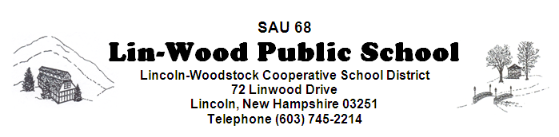

The Policies Committee meets on the 1st meeting of the month at 5:45 pm and the Facilities Committee meets on the 2nd meeting of the month at 5:30 pm in the Elementary MPR unless otherwise revised by the School Board. The Lincoln-Woodstock Cooperative School Board will meet in the Elementary MPR at 6:30 pm on October 9, 2019

**Board members are encouraged to arrive early to sign manifests**

AGENDA

- CALL TO ORDER – Matt Manning, Chairperson
- PUBLIC FORUM/HEARING
The public is invited to meet with Board members to provide community input regarding:
  - Use of monies from the Vehicle Trust Fund for the following:
    - Purchase Van for School
- ADJOURNMENT TO REGULAR SCHEDULED BOARD MEETING
- CALL TO ORDER – Matt Manning, Chairperson
- Educational Focus – Dan Adams
- MINUTES
  - Approval of Minutes of September 25, 2019
  - Approval of Non-Public Minutes of September 25, 2019

- COMMUNICATION
  - CORRESPONDENCE
  - REPORTS
    - Business Administrator’s Report
    - Superintendent’s Report
    - Principal’s Report
    - Committee Reports
- COMMITTEES
  - Policy Committee
FIRST READING: SECOND READING:
DAF-3 Procurement
DAF-4 Procurement – Additional Provisions Pertinent to Food Service Program
DJ – Purchasing
DJB – Purchasing Procedures
EBB/ADD – School Safety
EBBC – Emergency Care and First Aid
EBCA – Crisis Prevention and Emergency Response Plan
EBCB – Fire Drills
JICJ-R – Grade 6-12 Responsible Use Agreement for Personal Electronic Devices
*Please note that Policies are available for your review in the SAU Office and on our school page at www.lin-wood.org
VI. BUSINESS REQUIRING BOARD ACTION
- Staff Nominations, Recommendations and Resignations
VII. NEW BUSINESS

- School Property Disposal – Policy DN

VIII. CONTINUING BUSINESS

- Strategic Plan

IX. RECOGNITION OF VISITORS / PUBLIC PARTICIPATION
- Student
- Staff
- Community – Please state your name and address. This agenda item is intended to give citizens a voice and the Board an opportunity to hear directly from citizens. The total time limit is 15 minutes as per policy BEDH. This time is not intended for Q & A. Questions about programs or practices may be directed to respective administrators during the school day.
X. NON-PUBLIC SESSION (RSA 91-A:3) Discussion of matters that are likely to adversely affect the
reputation of a person other than a member of the school board.
XI. ADJOURNMENT

