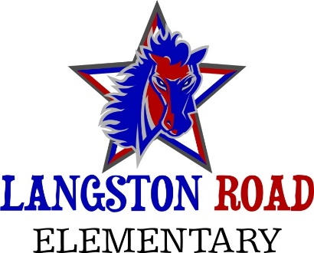
School Council Meeting Agenda
September 22, 2020

Agenda
- Call to order
- Elections
- Roles/Responsibilities
- Routine issues for discussion
- Questions/Concerns
- Adjourn

Next Meeting December 1, 2020
7:30 a.m. via Zoom

