**Grade 4 Mathematics Week of April 6-10 C:\Program Files\Microsoft Office\MEDIA\CAGCAT10\j0304933.wmf**

Dear Students,

I hope you are doing well. I miss seeing all of you at school! I hope you have a wonderful Easter!

From,

Mrs. Pinkerton

Weekly Work:

**Monday, April 6**

Assignment: Problem of the Day and Part One of Geometry Mystery by J. Reynolds

**HAYDEN AND HER BROTHER WERE MAKING A RECTANGULAR PEN FOR THEIR DOG. IT MEASURED 12 FEET LONG BY 8 FEET. EMERSON AND HER BROTHER ALSO MADE A RECTANGULAR PEN FOR THEIR NEW PUPPY. IT MEASURED 10 FEET BY 9 FEET. WHICH PEN HAD THE LARGEST AREA? (Hint: Area=length x width of a rectangle.)**

**__________________________________________________________**

**Next, read the Math Mystery and solve**

**Scroll down to the next page.**

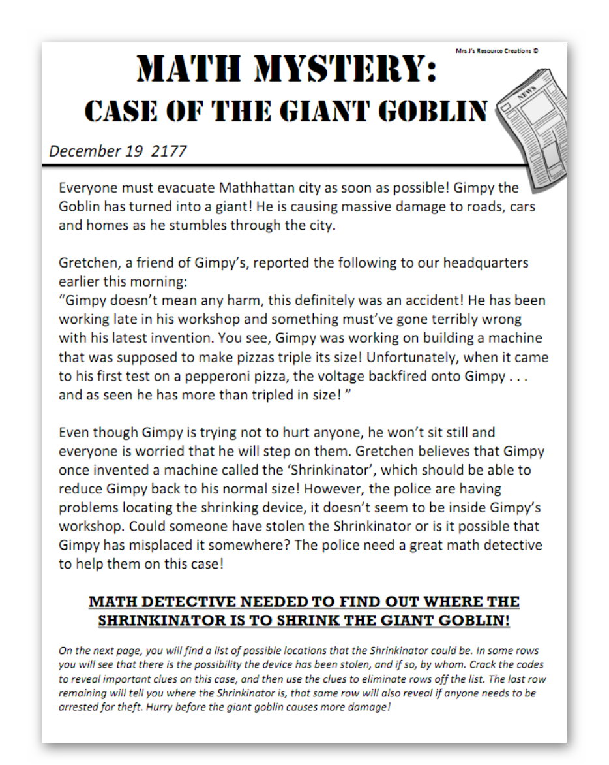

**You may want to also see the video of the story at:**

[**https://www.jjresourcecreations.com/geometry-math.mystery.htm#/**](https://www.jjresourcecreations.com/geometry-math.mystery.htm#/)

There are several locations listed on the next page. Every day as you solve a math mystery, you will find clues about them.

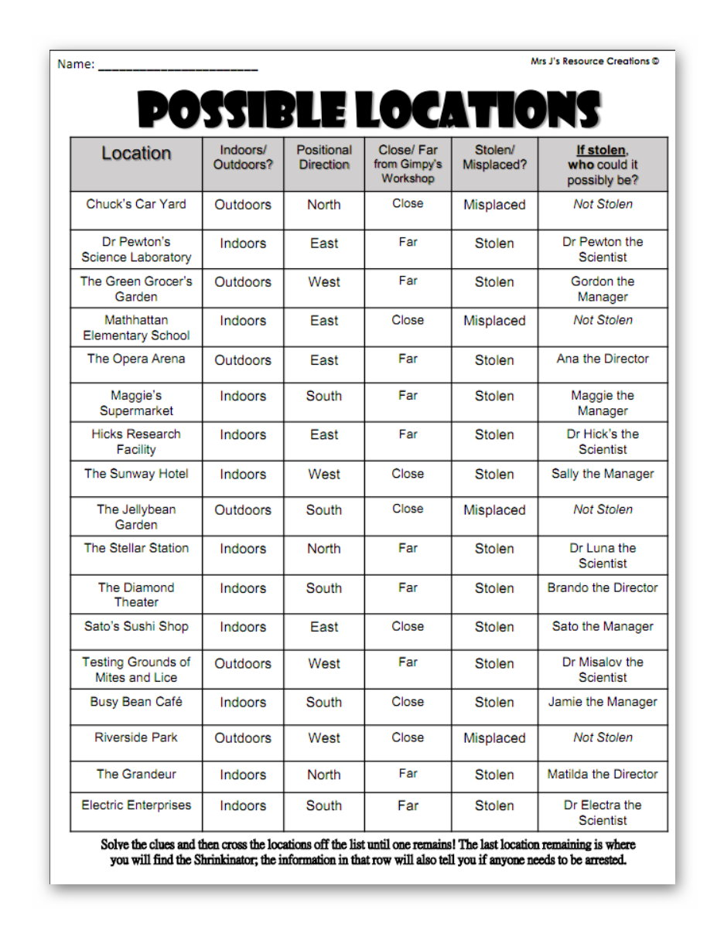

You can return to the possible locations and clues whenever you need to.

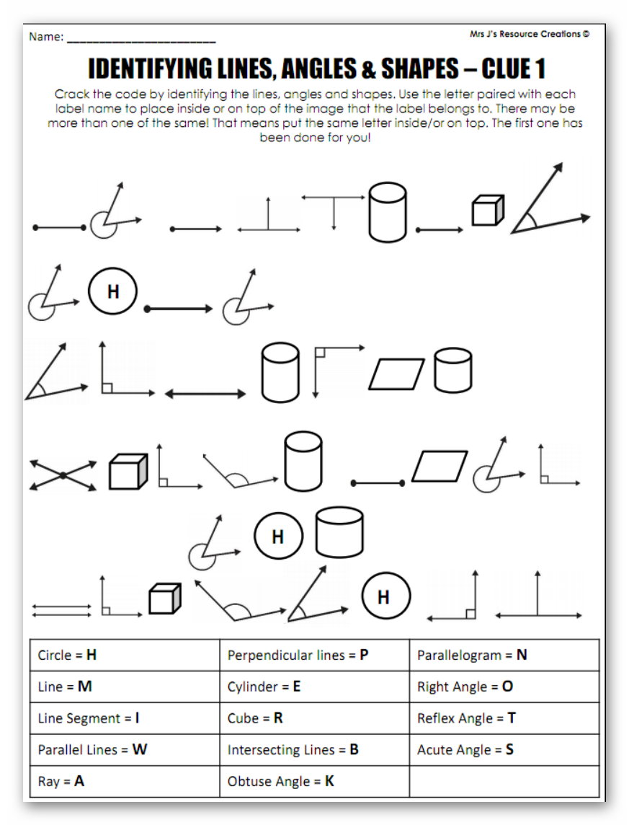

**Tuesday, April 7**

Solve the Problem of the Day and then solve the second page of the mystery.

Problem of the Day

Part A:

Adelaide and her sisters were doing an arts and crafts project. They made a rectangular picture frame that measured 18 inches by 11 inches. They wanted to use glittery ribbon to go all the way around the frame. The ribbon measured 65 inches long. Would there be enough ribbon to go all the way around the perimeter of the picture frame? (Hint: Perimeter means adding all the sides of a shape.)

Show your work:

Go to the next page.

Problem of the Day

Part B:

Savyona was thinking of her friend Serenity. Her mother said she should make a card for Serenity and they would mail it. The rectangular card that Savyona made was 6 inches long and 4 inches wide. What was the perimeter of the card?

Show your work:

Solution____________________________________

Go to the next page.

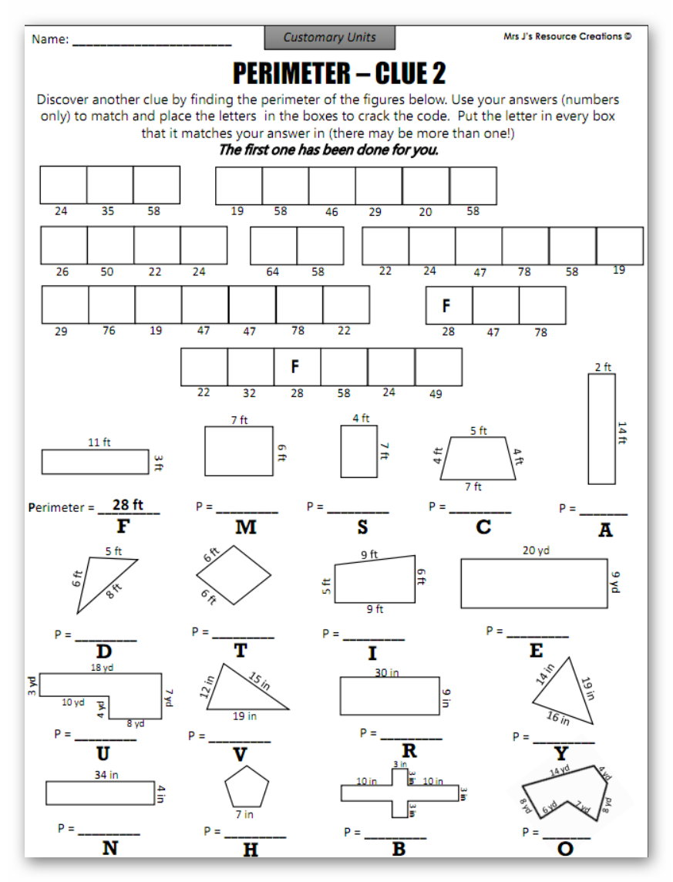

**Wednesday, April 8**

Assignment: Complete the Problem of the Day then solve Math Mystery Page 3.

Problem of the Day

Gavin and his sister had a place to play with Hot Wheels with the area of 72 square inches. It was the shape of a rectangle. The rectangle was 8 feet long. How wide was the place where they played Hot Wheels? (Remember: Length x width = Area)

Show your work:

C:\Program Files\Microsoft Office\MEDIA\CAGCAT10\j0216858.wmf

Now go to the next page for the Math Mystery.

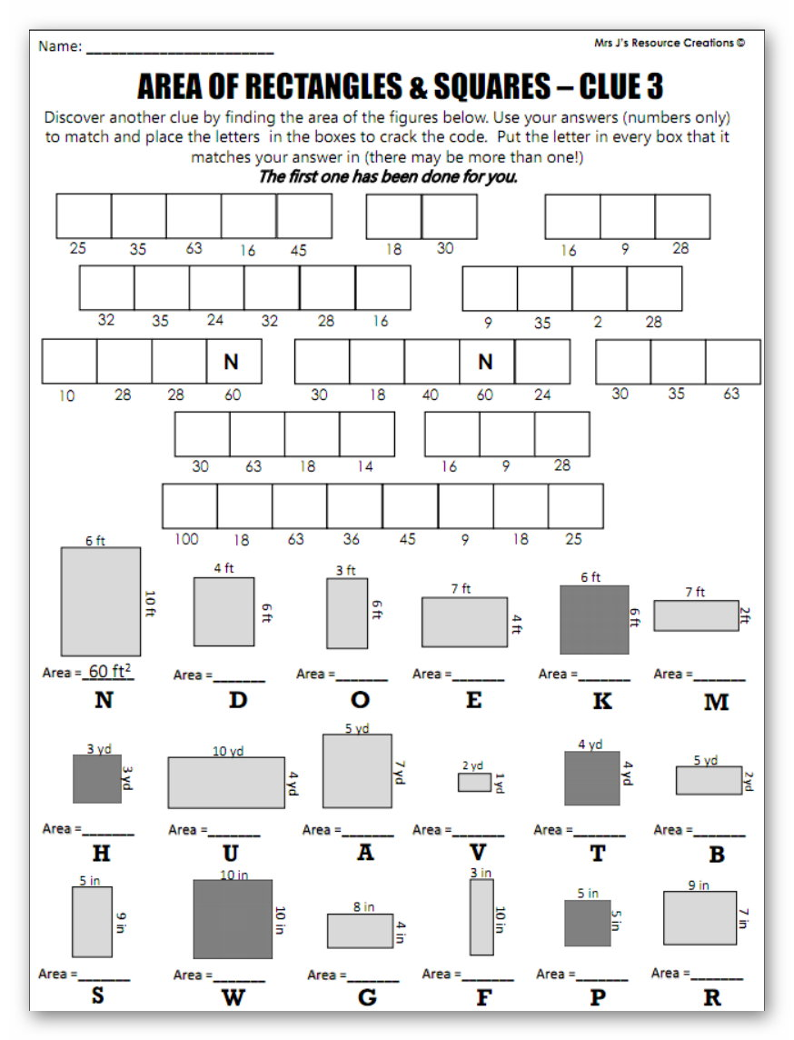

**Thursday, April 9**

Assignment: Complete the Problem of the Day then finish page 4 of the Math Mystery. You should also complete Study Island. The lesson is called “Area and Perimeter Review”. Remember the user name is firstname.lastname@sles. The password is your lunch number.

Problem of the Day

Khloe and Maddie were talking on the phone. Maddie said she was making a picture with geometric angles and it looked like a letter of the alphabet. Khloe asked what it looked like. Maddie said there were 3 parallel red lines going across the paper. She had also drawn a blue line going straight up and down touching the left side of those lines. Khloe said, “I know what letter it is!”

Draw an example of what Maddie’s drawing looked like. (Don’t worry about the colors.)

What letter does it resemble?____________

Was the blue line perpendicular to the red lines? Yes or No

What kind of angle was formed by the blue and red lines?_______

How many degrees do each one have?_____

**Now complete the next page of the math mystery**.

(Remember: acute angles are less than 90 degrees, right angles are 90 degrees and obtuse angles are more than 90 degrees.)

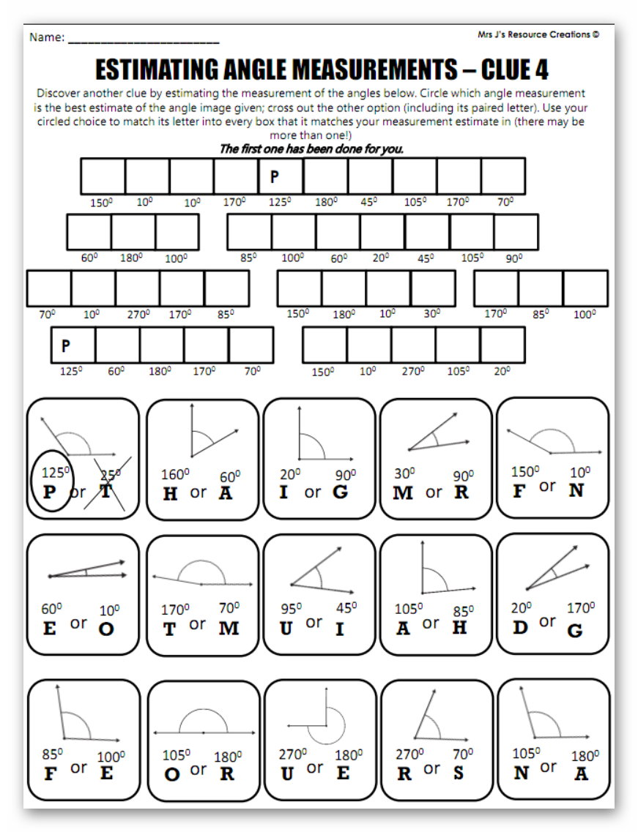

**Friday, April 10**

Assignment: Complete the Problem of the Day and finish the Math Mystery. The possible locations are listed on Monday. You will need to go back and eliminate the wrong choices based on your clues.

Problem of the Day:

Lavayiah was rearranging her bedroom. She wanted to put her bed in a different spot. The spot was 9 feet long. Her bed measured 3 feet wide. The perimeter (all the sides added up) was 23 feet. How long was Lavayiah’s bed?______________

Will her bed fit in the spot she has picked out?__________

(Hint: There are 4 sides to the bed and they add up to 23 feet.)

Show your work.

Now solve the Math Mystery on the next page.

