

Uniform Measurement Guide:

**Name ______________________________ School: ____________________ Squad Name ____________**

### Year of Graduation: (Please circle) 2012 2013 2014 2015 Other ___________

**Home Phone #: ___________________________________________________________**

We are sorry that you are unavailable to attend the actual uniform fitting appointment. We ask that you please be as accurate as possible in your measuring. Also, please have one person do all of your measuring. ***Varsity will NOT be responsible for improper fit due to inaccuracy of measurements***. **If you fall in between sizes, we will automatically go to the next size up. Please follow the tape placement guidelines as instructed:**

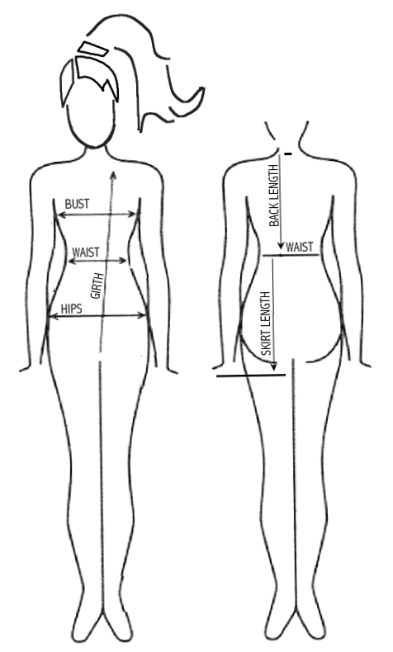BUST – Measure around the body at the fullest part of the bust.

**Bust Measurement** _____________

WAIST – Measure around the body at your ***natural waist line***, usually 1-2” ***above*** your bellybutton.

**Waist Measurement** ____________

HIPS - Measure around the body at fullest part of the hips.

**Hip Measurement** ______________

SKIRT LENGTH – Measure from natural waistline down to desired length of skirt. Then subtract 1” for waistband.

**Skirt Length** _________________

GIRTH – Measure your torso from front right shoulder blade, down between legs and then back up to meet end of tape at shoulder blade.

**Girth Measurement** ______________

INSEAM – Measure from crotch down to bottom of inside foot .

**Inseam Measurement** ______________

SHOE SIZE – Allow room for growth ________________

**Please sign and fax this form to**

**Luanne Parker 423 821-5453**

## 

I agree that these measurements are true and accurate. Varsity will not be responsible for the translation into garment sizes from these measurements and I will be responsible for any alterations if needed.

______________________________________________ ___________________________

Parent Signature Date

