Sports teams hung out a big sign the week of March 9: Closed Until Further Notice.
The National Basketball Association, National Hockey League, the NCAA college basketball championships, Major League Baseball and the Masters golf tournament all canceled or postponed their games because of the threat from the novel coronavirus outbreak.
The danger of spreading the virus makes it too risky to travel or gather in crowds, so playing sports has stopped.
But just because sports are not being played does not mean that sports are finished. Most kids never become professional athletes or play at the college level, so for most kids, sports are important because of the lessons they learn from playing on teams and competing.
Those lessons may be important in the coming weeks and months as everyone tries to cope with this national health emergency. Here are timely lessons:

Pay Attention
There is no way to become good at a sport — or really anything ⁠— if you don't pay attention. Young athletes have to listen to their teachers and coaches and try to do what they say.
Years ago, coach Morgan Wootten of Maryland's DeMatha Catholic High School shared what he looked for in a basketball player. One of the first things Wootten said was, "I look for a player who will listen. If a player doesn't listen, he never gets better."
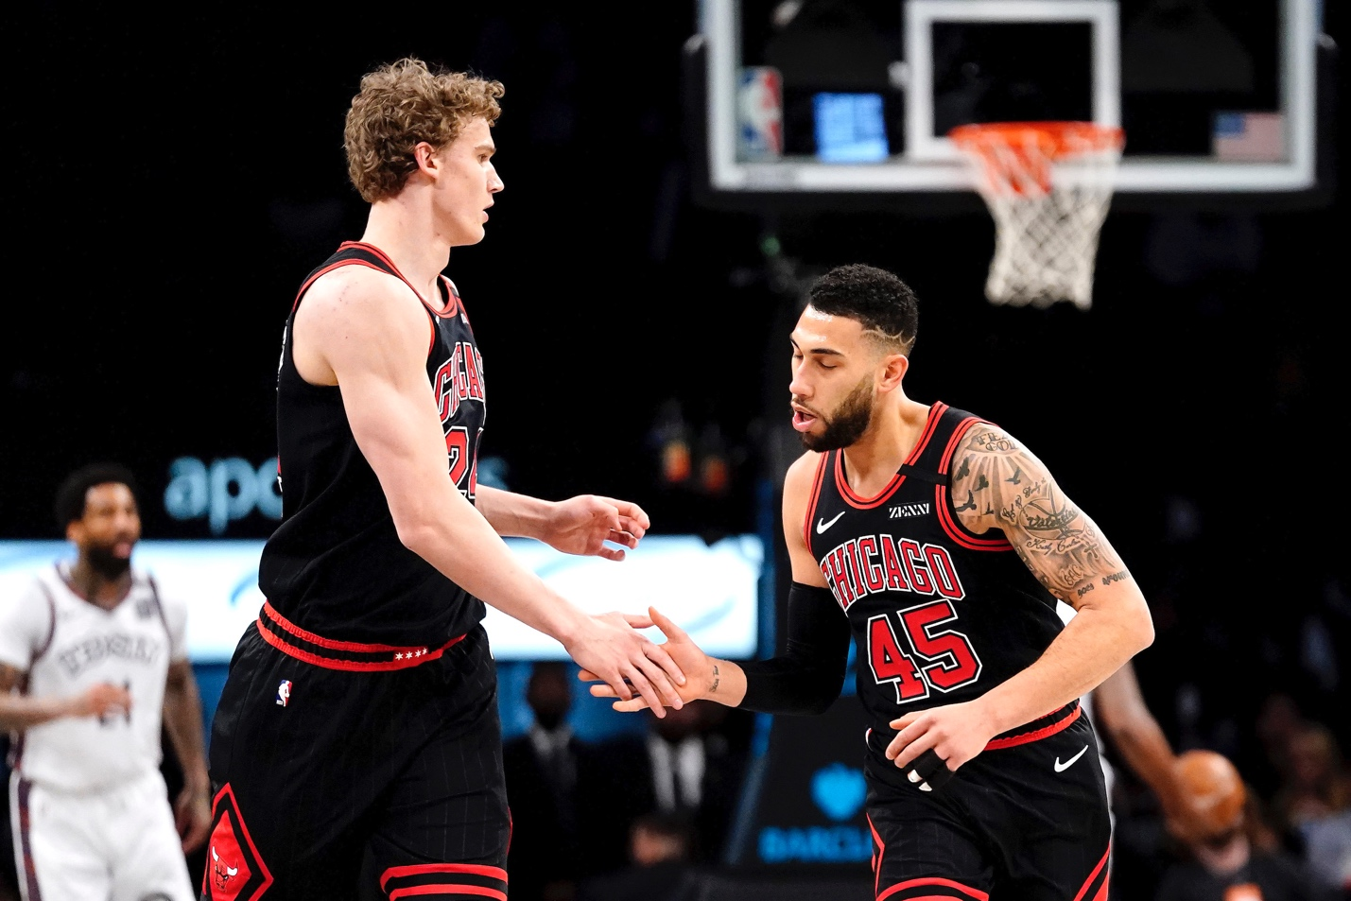Image 2. Chicago Bulls player Denzel Valentine (No. 45) high-fives Lauri Markkanen (No. 24) during a game against the Brooklyn Nets on March 8, 2020, in New York City. The National Basketball League paused the rest of its season on March 11 because of the coronavirus. Photo: Steven Ryan/Getty Images
During this coronavirus crisis, everyone is going to have to listen to government officials and medical experts and follow their instructions carefully on the best ways to remain safe. We all have to pay attention.

Be A Good Teammate
Another lesson kids get from playing sports is how to be part of a team. Good teammates think about the group, not just about how many points or goals they score.
This coronavirus outbreak is going to make things tough for kids' number one team: their families. Many parents will have to work in their house or apartment. Kids will be at home from school. No one will go out as often.
At times like this, it's important for kids to think about how they can help their group or their team. Maybe you can help by cleaning up your bedroom or playing with a younger brother or sister. Think about the team, not just yourself.

Deal With Disappointment
Maybe the biggest lesson kids learn from sports is how to cope with disappointment. Even the best players do not win every game or bat 1.000.
There will be disappointments during the coronavirus crisis. Maybe you were looking forward to your spring soccer or baseball season, and now the games are canceled. Or perhaps a family trip or party had to be postponed.
This may be a time when you realize everything cannot turn out exactly as you wished. Sometimes you have to learn to live with disappointment and make the best of it.
Sports events may be closed, but the lessons we learn from sports are still important. Maybe more important than ever.

