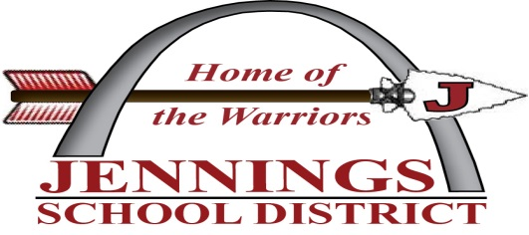
Parents as Teachers
7053 Emma Ave. Jennings, MO 63136
314-653-8084

Parents as Teachers Staff:
Kimberly Wooden, Director
Corey Freeman, Administrative Assistant
Kim Bush, Parent Educator

Parents as Teachers (PAT) is a FREE parent education and family support program serving families throughout pregnancy until your child enters kindergarten (usually age 5). We are here to help you! This is the most important gift you could ever give your child.
Do you worry about:
- the development of your newborn?
- your child developing like other children his/her age?
- finding affordable and quality child care?
- providing age appropriate fun activities at home?
- Your 3-5 year old being prepared for kindergarten?
Call today to schedule a free developmental screening for children 6 months to 5 years of age!
As a PAT family member, you will receive:
*Personal visits-during which your parent educator will share age-appropriate development fun home activities that help you, learn to observe your child, address your concerns and your child’s development.
*Parent Group Meeting-which are opportunities to share information about parent issues and child development. Parents learn and support each other, observe their child with other children and practice parenting skills.
*Resource network: That links your family to other community services.
You may qualify for $200.00 in stipends
CALL TODAY TO ENROLL IN THIS FREE PROGRAM

