Boys Weight Training
Course Syllabus

Instructor: Adam Strakose Room: Weight Rm Email: adam.strakose@hcbe.net

Course Description:
This course is designed to improve the muscular strength/endurance, flexibility and overall conditioning of the female student athlete. We will strive to increase the student’s strength, power, flexibility, and core through a sport specific and individualized program. We will implement the physiological principles of overload, progression, and specificity in our strength and conditioning workouts. Students will develop an understanding of the important role strength, conditioning and proper nutrition plays in athletic excellence and injury prevention. The course will also follow a conceptual approach dealing with the following topics: how strength and conditioning attributes to athletic excellence, safety, diet and weight control.
.*Weight training follows the six GPS performance standards listed on the following link:
www.georgiastandards.org

Class Structure:
The strength and conditioning program will be based on combining sport-specific strength training with core and flexibility exercises. We will work all muscle groups through full range of motion with emphasis on proper technique to insure adequate muscle growth and injury prevention. Workout programs will include cardio circuit, aerobic/anaerobic conditioning, strength, power, core and flexibility.

Class Objectives:
Students will be able to:
-Perform various strength training exercise with proper form.
-Demonstrate correct biomechanical technique while performing all exercises to enhance muscle growth and prevent injury.
-Apply correct safety/spotting techniques in the weight room.
-Demonstrate and apply principles of overload, progression, and specificity in strength training.

Class Expectations:
- RESPECT OTHERS! Pay attention and do not talk while someone else is talking and encourage your classmates/teammates to reach their full potential.
- Follow all normal accepted behavior policies set forth in your student handbook.
- BE ON TIME TO CLASS! The school tardy policy in the student handbook will be followed.
- Be dressed out in clothing appropriate for weight training. (No jewelry on arms/hands or dangling earrings).
- No FOOD or drinks in the weight room/only water.
- No Horseplay. Students that can’t be serious enough to train will be removed from class and conduct will be reported to their respected coaches.
- Athletic shoes MUST be worn. NO FLIP FLOPS, BOOTS, SANDALS. You will not be considered dressed out unless you are wearing proper shoes.
- Students are expected to train DAILY…EVEN ON GAME DAY. Only a note from a PHYSICIAN may excuse a student from participation.
- Students will be given a locker to use daily. They are encouraged to lock up their property during class. The teacher will not be held responsible for lost or stolen items. Students must remove all their items at the end of each period.
- This class is designed to make YOU better….come with the right attitude/no complaining.

Class Schedule:
-Dress out/report to gym/upstairs/Boys weight room

Grading/Course Requirements:
Major Assessments 45%
*Participation Grade
-determined by the daily participation of all activities. This grade will begin at 100 and is reduced by 5 points for each day a student does not participate in daily workouts. Students must bring a doctor’s note to be excused from a workout.

Minor Assessments 20%
*Performance/Progress/Fitnessgram
-student performance and progress will be measured throughout the course by various means including the timed mile and half mile, strength max out, vertical jump increases, etc.

Daily Work 15%
*Dress Grade
-Determined by having the proper shoes/clothing to participate. Grades begin at 100 and are reduced by 5 points for each day not dressed. Dress grades will be assessed weekly.

Final Exam 20%

-This course includes a cumulative exam at the end of the semester. The final exam during the first and second semester is worth 20% of the semester grade.

Google Classroom
To encourage blended learning, online assignments will be posted weekly through Google Classroom. At least one Google Classroom assignment per week will be graded and entered in Infinite Campus. Students should be familiar with how to navigate the online platform, communicate with their teacher, and submit assignments on time. If there are technology limitations, please notify the teacher.

Steps for Google Classroom Log-In:
Step One:
Go to the county’s website and click on SSO Portal.
Or, click on the link below:
https://portal.hcbe.net/_auth/Login.aspx?ru=L3Nzby9wb3J0YWw=

Step Two:
Students should sign in using their school/county username and password. If you have questions on your username and password, please ask your teacher.
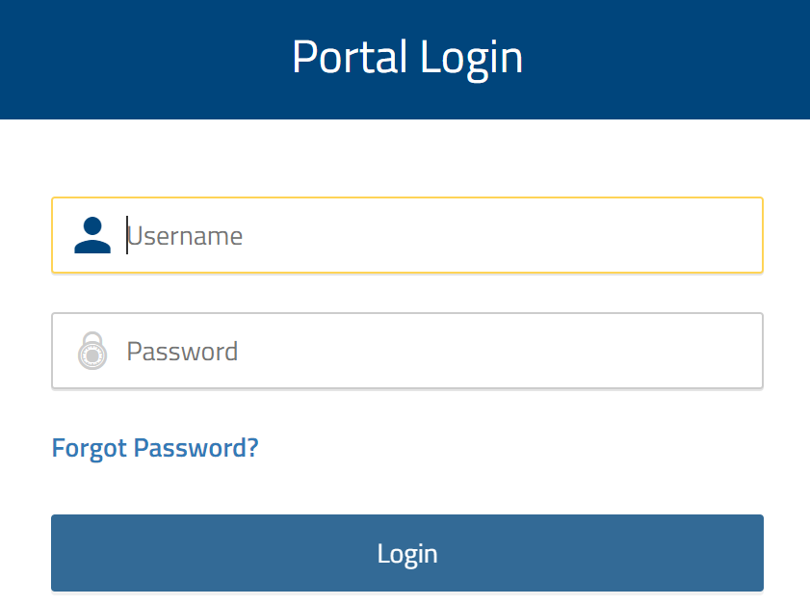

Step Three:
Students should click on the Google Classroom app.
Step Four:
Let’s get to work! When they sign into Google Classroom, they should see several “classrooms’. They simply click on ‘JOIN’ for each class.
Cyberbullying: As defined by Dictionary.com, “the act of harassing someone online by sending or posting mean messages.” Please keep in mind that the Google Classroom communication system is designed to work as an extension of the classroom; therefore, anything done on the site through the access of a school course group code will be treated the same as if it were said aloud in the classroom. Inappropriate comments or use of the site can result in disciplinary action.
**I have read and understand all of the objectives, requirements, and expectations set forth by Coach Simmons for the 2020-21 Weight Training Class.

Student’s Name:___________________________________________
Parent Signature:__________________________________________

**Must be signed by Parent/Guardian and returned no later than Thursday, August 13, 2020.

Medical Information

Parents/Guardians,
If there are any medical concerns that your son or daughter has that I need to be made aware of, please explain on the following lines. Please return alongside the signed syllabus. Remember, students must have a doctor’s note to be excused from any fitness activity. If your student does not have any medical concerns, please write “None”, sign, and return. Thank you.

Student’s Name: ________________________________________
Parent’s Name: _________________________________________

Medical Concerns:

_____________________________________________________

