

Reminders

-**Masks** need to be worn at school.

-Please send a **water bottle** every day.

-Please send in a cheap pair of **head phones** for your child to keep in their backpack each day.

-Donated **treasure box** items are welcomed.

-**Timed test**: multiplication facts 0-12 with 5 division problems (3 minutes)

-**Labor Day** September 7th

September 7th – 11th

Homework

Monday:

* Labor Day!

Tuesday:

* Subtract across zeros worksheet

Wednesday:

* Subtract across zeros worksheet

Thursday:

* Perimeter worksheet

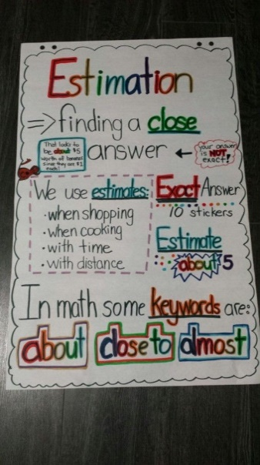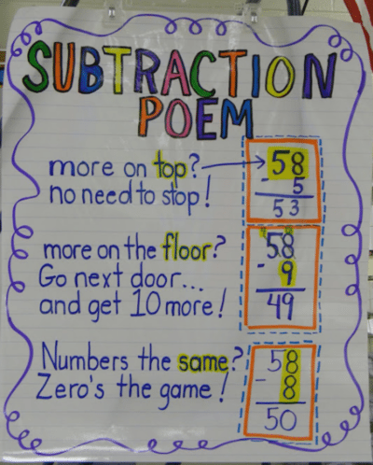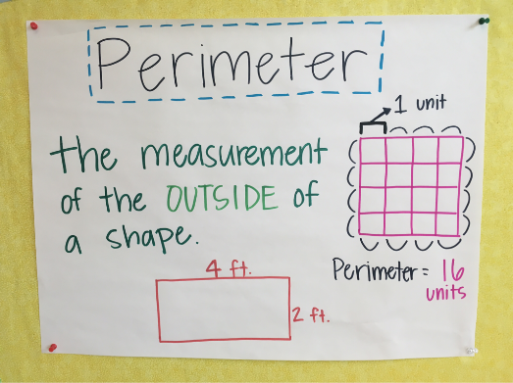

What we are learning…

Tests/Projects

-Timed Test 9/9

- Place Value Quiz 9/10