Students' usernames are constructed using the following formula:
First name, first initial + Last name, first initial + last 6 digits of their lunch number.
Example: If Amy King's lunch number is 1234567, her computer/wifi username is ak234567, and her email address is ak234567@dcsms.org
Students who need their passwords reset or have issues logging in with these accounts should submit a help ticket just as teachers or staff do. Select "Username / Password Issues" from the Help Topic drop-down list and "Email/Office365" as the Account Type.
You must use your full email address (including the @dcsms.org) to log in to Office365 applications including Outlook (email.)
If you have never logged in to Office365, or you have received a password reset, you must first login to Office365 in a web browser and set your own password. Only then can you use your newly set password to access your email in a mail client such as Outlook on a mobile device app.

Students must login and change their email password before they can log in to Teams/Class Notebook.
There are minimum requirements for password complexity which must be met when creating passwords. These are requirements for most systems, including DCS User Account (computer login) and Office365 (email). They are as follows:
- Minimum of 8 characters
Must have 3 of the 4:
Uppercase letters
Lowercase letters
Numerals
Symbols
WITHIN THE FIRST 8 CHARACTERS
For example, Password1 will not work, because the numeral is the ninth character.
- Cannot contain part of your username
- Cannot be any of your previous 3 passwords

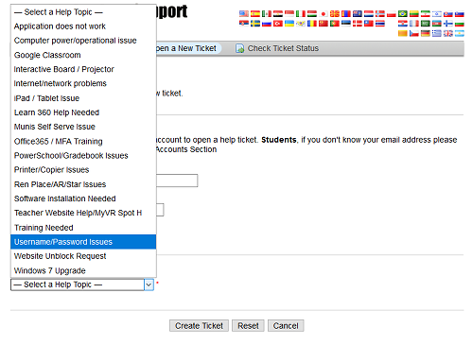
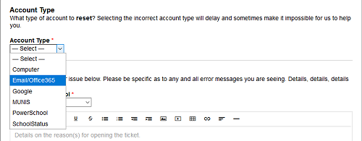
The first time you log in (and every time thereafter until you complete the recovery configuration) you will be prompted to set a recovery cell phone number and / or alternate email address. You cannot reset the password yourself until this is done
