“PULL FOR THE HOUSE”
SUMMER PROJECT

Your pop tabs make a difference!
Help Greenbrook Elementary “Pull for the House!”

Collecting pop tabs is a great way to teach kids about philanthropy and the importance of recycling while raising funds to help ease the hardship of childhood illness on children and their families.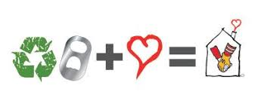
- 1 Pop Tab is approximately 1 inch long
- 1,128 Pop Tabs make 1 pound
- 1 pound of aluminum can be sold for approximately $0.40 - $0.50 per pound
- This program brings in an average of $6,000 each year.
Pop Tab Trivia Did you know...
1 Pop Tab is approximately 1 inch long 1,267 Pop Tabs make 1 pound
1 pound of aluminum can be sold for approximately 45¢ - 60¢ per pound

That little tab that you use to open your soda or any container can make a BIG difference at Ronald McDonald House Charities of Memphis.  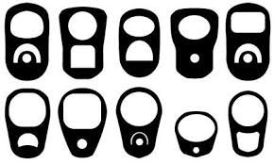 |  | Throughout the school year Greenbrook Elementary School will be collecting tabs for donation. (September-April)
Pop Tabs can be collected in any type of container. We encourage you to create your own collection container(s) using non-glass items such as ice cream buckets, milk containers, coffee cans, cardboard boxes, or any other sturdy container. | 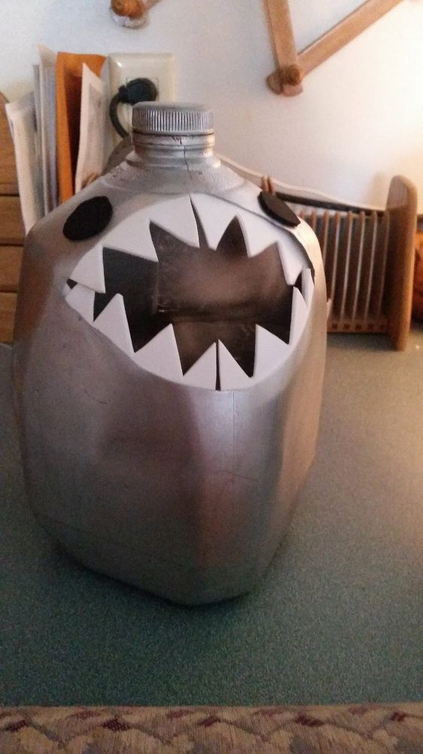 |  | 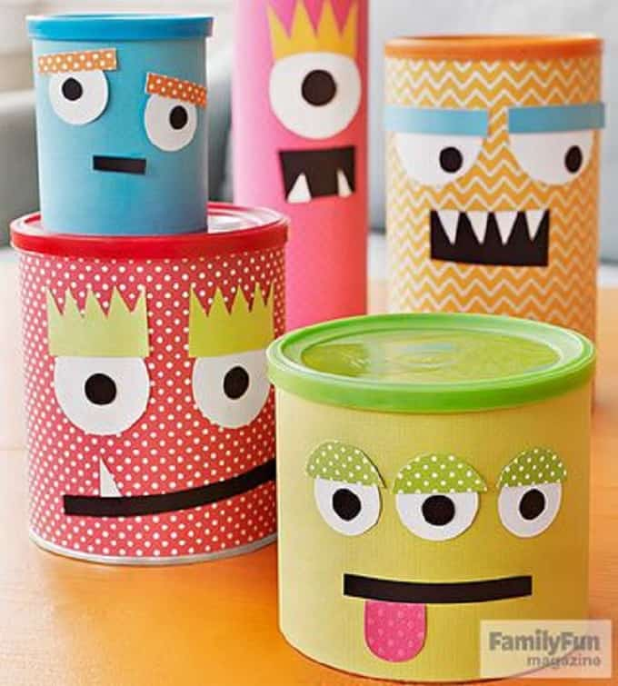 | 