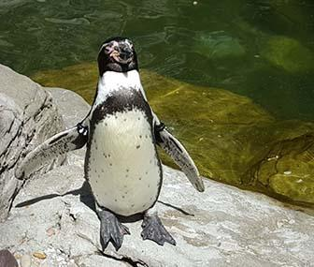
Biome Project
Introduction
You will be given a biome to research in class. The information collected will be used to create a pamphlet, website, or poster that describes the biome. Think about what makes your biome unique and the types of plants and animals that live there as well as dominate weather patterns. As you gather information about the biome, take notes and think about how you can organize this information and put it into your own words. Your final project will need to include references to material you included. Pictures are encouraged to make your presentation interesting to your audience, which is your classmates.
Biomes
- taiga (coniferous forest)
- temperate deciduous forest
- tropical rainforest
- tundra
- desert
- temperate grassland or prairie savannah (also listed as grasslands on some sites)
- freshwater (lakes, rivers, or streams)
- ocean
Projects / Presentations
Use any of the following formats, check with your instructor for additional instructions or information: If you have another idea for your project, check with your instructor.
1. A flyer that you can hand out to the class (ask your teacher to make copies) or use a publisher program to make the pamphlets. Canva.com has tri-fold pamphlet creators.
2. Make a real poster on poster board. Create a self-standing project board that has pictures and information about your biome.
3. Make a presentation using powerpoint, Google Slides or Prezi and present to the class on a digital projector.
Your Biome: ________________________________ Your Project Plan _________________________

Requirements Keep for your teacher to record your grade
1. The name of your biome (title page) which includes a brief introduction to your project.
2. The biome’s characteristics (climate, average temperature, average precipitation amounts, are there seasons) and locations in the world (continents, countries)
3. 4-6 plants that are found in your biome. Describe their niche and interactions they have in the ecosystem. Describe an adaptation they have for surviving in the biome. (Ex) large horizontal roots
4. 4-6 animals that are found in your biome. Describe their niche and interactions they have in the ecosystem. Describe an adaptation they have for surviving in the biome. (Ex) thick fur.
5. Threats to the biome. Give some details to the threats (what are some causes/effects of the threats. (Ex) deforestation-destroying habitats
6. Why would someone want to visit this biome?
7. Pictures to include: a map of the biome location, two plants you described, two animals you described, and one picture of the threat.
8. References - include websites, books or other resources you used to create your project, give credit to images you used.
9. Presentation – one or more members will present to the class. Rehearse your presentation DO NOT JUST READ WHAT YOU WROTE ON THE PROJECT!
Group member Names:________________________________________________________
Rubric: Biomes Project
 | 50 pts | 40 pts | 30 pts | 20 pts 10pts
Title page and introduction
Overall Characteristics (weather, locations, etc.)
Plant Life (information and photos of plants)
Animal Life (information and photos of animals)
Information: Threats to Biome
Information: Why Visit Biome?
Organization: Is the layout, format and photos organized and engaging?
Mechanics: Organization neatness, grammar, turned in on time
References and Citations

Presentation: rehearsed, well spoken,

