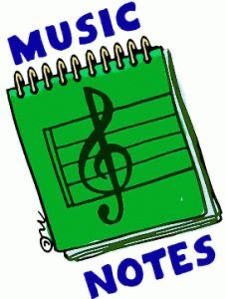
Week of:
May 4 - may 8
5/4: This week see if you can keep the beat with our integrity song of the week, “Star Wars Main Theme” since today is “Star Wars Day”
5/5: Watch “Space Song Rocket Ride” to learn about space
5/6: Let’s use scarves to “The Star Wars Scarf Dance”
5/7: Let’s watch a line rider video to “The Imperial March”. Do you know which Star Wars character this music belongs to?
5/8: Let’s Dance and Sing to our fun song Friday tune, “Wings”

