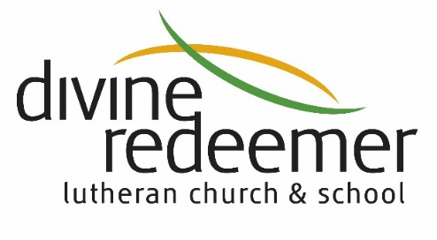
February 28, 2021
On February 14th, 2021, the voter’s assembly of Divine Redeemer Lutheran Church assembled to consider whether or not to extend a divine call to Rev. Dr. Nathan Meador to serve as our next Executive Pastor after Pastor Schubert retires September 1, 2021.
Pastor Meador received a majority of the votes cast at the meeting however the total was just shy of the 60% required in the DRLC by-laws to extend a divine call.
Since the voters meeting, the board of directors and the call committee each met and outlined a process to move forward given this voting outcome. Both the board and call committee desired a process that would address the main concerns and questions expressed at the voter’s meeting. These concerns were:
- More frequent communication to the congregation by the call committee during the search process. This is something that the call committee will do starting with this communication.
2. Increased transparency during the search process including who we are talking with and which pastors are progressing in the process.
The decision of the call committee is to provide the final name(s) of the pastor(s) recommended for the call. This is to maintain the current pastor’s confidentiality as they are currently serving their current congregation and meeting the duties of their current call. The process outlined below changes this process in an effort to increase transparency to the congregation.

3. There were concerns of only one candidate name on the ballot.
This option is in alignment with previous call processes and was reviewed and confirmed by the DRLC board of directors as well as reviewed and confirmed with South Wisconsin District President Rev. John Wille.

To address these concerns and to continue progress toward calling a new Executive Pastor, the board recommended, and the call committee accepted instruction to bring the finalist candidate(s) and their wives to DR for a meet and greet type of visit with both staff and congregants. This will allow our members and staff the opportunity to directly meet and hear from the finalists. This process allows the main concerns outlined above to be satisfied among many of the congregants.
The tentative format for these visits is:
1 PM - Arrival and tour of the school in operation
2 PM - Meeting with church staff
3 PM - One-on-one meetings with Associate Pastors
4 PM - Meeting with school faculty
5 PM - Meeting with members of the Board of Directors and Elders
6:30 PM – Q&A session open to congregant members to observe

These meetings have been scheduled with these pastors and their wives on the following dates:
March 2 – Rev. Dr. Nathan & Jill Meador
March 4 – Rev. Greg & Stephanie Hovland
March 9 – Rev. Seth & Melinda Flick
March 11 – Rev. Jason & Laurel Zobel

As we move forward, please take into consideration the following criteria as we look for the best overall candidate to lead Divine Redeemer.
- Equipped to effectively lead both traditional and contemporary worship
- Equipped to successfully develop staff
- Skilled at administrative tasks
- Supportive of the school and all our missions
- Able to resolve conflict when needed
- Prepared to plan strategically for the future of Divine Redeemer
- Serves the 18- to 28-year-old ministry effectively along with all other ages

Any questions, concerns, or recommendations can be forwarded to the call committee at call.committee@drlc.org.
Thank you – DRLC Board of Directors and the Call Committee

