Procrastinate Much? Manage Your Emotions, Not Your Time.
By Adam Grant
It isn’t about avoiding work; it’s about avoiding negative emotions.
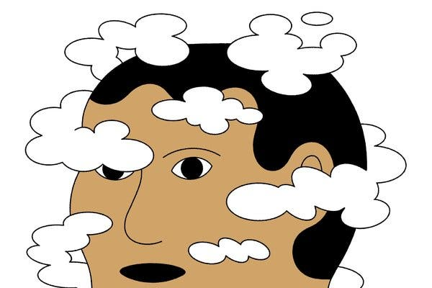
Dominic Kesterton
In the early 1980s, Douglas Adams was struggling to make progress on the fourth installment in his beloved series, “The Hitchhiker’s Guide to the Galaxy.” The great sci-fi humorist had learned from writing the previous books that good ideas usually came to him in the bath, so he would spend his mornings soaking in the tub until he had a eureka moment. Then he would get out to start writing, only to forget the idea while getting dressed, which meant he had no choice but to head right back to the tub.
After many months of failing to make progress, Mr. Adams scheduled a solo writing retreat for several weeks at a country manor. Unfortunately, he ended up befriending the hosts, and he spent most of the trip drinking wine. Just weeks before his manuscript was due, Mr. Adams had produced just 25 pages. “I love deadlines,” Mr. Adams has said. “I like the whooshing sound they make as they go by.”
If there was a world championship of procrastination, some of the top contenders every year would be writers. Margaret Atwood said years ago that her writing routine was to “spend the morning procrastinating and worrying, then plunge into the manuscript in a frenzy of anxiety around 3:00 when it looked as though I might not get anything done.” Yet when I interviewed Ms. Atwood recently on my TED podcast, WorkLife, she said that she had never missed a deadline.
Procrastination is delaying a task even though you expect that delay to come at a cost. Think of the last time you put off a project by watching cat videos on YouTube — and then ended up watching your cat watch cat videos. The question is what causes it and how to overcome it, and Ms. Atwood had an immediate answer: She procrastinates because she’s lazy. With all due respect, I beg to differ.
The psychologists Timothy Pychyl and Fuschia Sirois have discovered that procrastination isn’t about avoiding work; it’s about avoiding negative emotions. We procrastinate when a task stirs up feelings like anxiety, confusion or boredom. And although it makes us feel better today, we end up feeling worse — and falling behind — tomorrow.
This means that if you want to procrastinate less, you don’t have to increase your work ethic or improve your time management. You can instead focus on changing your habits around emotion management.
[Like what you’re reading? Sign up here for the Smarter Living newsletter to get stories like this (and much more!) delivered straight to your inbox every Monday morning.]
One option is to put an end to self-inflicted pain. Mr. Adams suffered from what psychologists call neurotic perfectionism: He was his harshest critic. He would throw pages away as he typed them. Ms. Atwood went further: She hesitated to even put words on a page. For three years, she put off writing “The Handmaid’s Tale.”
“I thought it was just too batty,” she said. Those anxieties finally started to subside when she shifted her focus away from what readers might think and stopped judging her work as she was creating it.
That’s what productive perfectionists do: They aim high based on their own standards, not out of concern about what others will think. When a draft disappoints you, instead of beating yourself up, it can help to try self-compassion: Remind yourself that you’re human, and that everyone procrastinates sometimes. Then start making plans to close the gap between your work and your expectations.
The Solution Is Self-Compassion
Research shows that it can lead to greater achievement than self-criticism would.
A second option is to reconsider when you do the task. Multiple studies suggest that procrastinators tend to be night owls. The work day begins before their minds are most alert — a dull task becomes deflating when you’re only half-awake. If that’s you, shifting tasks that you often put off until later in the day can help. That’s a win-win: If you plan to do the task later because you’ll do it better, you’re not procrastinating.
A third option is to think about who’s doing the task with you. In one study, when people sat next to someone who was twice as productive as average, their own productivity increased by 10 percent. Sometimes, highly productive people make tasks more fun or more meaningful. Other times, they make procrastinating so painful that progress suddenly feels like a more attractive path.
It’s easy to slip into procrastination when you’re working alone on tasks that seem ambiguous and meaningless. But you probably haven’t seen too many surgeons put off medical procedures. I’ve found that we’re more likely to stay on task when we know other people are counting on us. Seeing the person who’s depending on our work can bring focus and meaning … or at least a frenzy of anxiety.
Mr. Adams understood that. With his deadline looming and his bathtub inspiration sessions failing him, his editor came to the rescue. He booked a hotel suite and sat with Mr. Adams, watching him type every day. After a couple of weeks, the manuscript was done.
Procrastination is not a disease that can be permanently cured — it’s a challenge we all have to manage. There will always be undesirable tasks that conjure unwanted emotions. Avoiding those feelings is a habit we can work on breaking. And although Mr. Adams never conquered procrastination, he did get ahead of schedule on writing his own epitaph: “He finally met his deadline.”

1. How does Mr. Grant draw you into the article with the anecdote about Douglas Adams?
2. What role do emotions play in procrastination according to the psychologists Timothy Pychyl and Fuschia Sirois?
3. What are three ways people can manage their emotions to procrastinate less?
4. Think about your own procrastination habits. Which of these three suggestions would be most helpful for you? Why?
5. “Procrastination is not a disease that can be permanently cured — it’s a challenge we all have to manage,” Mr. Grant writes. What does he mean by that?
6. Mr. Grant ends by returning to Mr. Adams’s story. What can we learn about procrastination from this anecdote?

