8th Grade’s August News
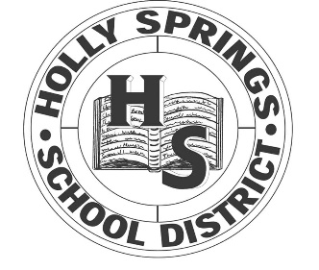HSJH

Upcoming Events

August 8
Student’s first day

September 2
Labor Day Holiday
September 11
Progress Reports sent home

Reminders:
Quick Quizzes are given each Wednesday; test are given each Friday.
Homework is given Monday, Tuesday, and Thursday of each week.
Grades are updated in Powerschool every 3 days.

Dear Parents,
Welcome to 8th grade! We hope you have had a great summer making memories with your student! School is back in session, and we are excited for a fabulous, fun, and exciting year as we wrap up your child’s middle school days. We ask that you send your child to school well rested and ready to learn each and every day. The future is just as bright with more opportunities for growth presenting themselves at every opportunity. Ask your student about clubs and PBIS rewards that have been implemented!
Sincerely,
8th grade faculty

Learning Targets

Math: You will need to purchase your own calculator for this school year. Also, please look for a note coming home with the instructions to add you to the Remind group. Students will need to master 22 skills to have 80% mastery of your standards for 8th grade. Standards 8.NS.1 and NS.2 will be taught for the month.

Reading: 8th Grade is excited to have Mrs. Chataun Bailey and Ms Cynthia Willard. Please look for Class Dojo or Remind letters, all students must have a parent or guardian signed up in the first month of school. This will be our primary form of communication with parents. Standards RL/RI 8.4 and RL/RI 8.1 will be taught for the month

Writing: Students are going to be putting more of a focus on applying the language skills they learned in their writing and also in ALS during their 8th grade year. We are looking forward to enhancing our writing skills throughout this year.

Science: Students will deepen their understanding of scientific principles previously learned, as well as develop an understanding of new 8th grade standards throughout this school year. Looking forward to a new year full of science! Standards L. 8.2.1 and L. 8.2a.2 will be taught for the month

Social Studies: Social studies is spilt into two subjects for 8th graders; these count as credits for high school. MS studies in the Fall Semester = ½ High School Credit. World Geography in the Spring Semester= ½ High School Credit. You MUST PASS this class to graduate from High School. MS Studies standards to be taught are MS.1 and MS.2

ICT: Students will continue to practice their keyboarding skills. Students will be tested on how many correct words per minute they can achieve throughout the year. Students will also create powerpoint presentations on a given topic as assigned by Ms. Tucker.
The mission of Holly Springs Junior High School is to gradually increase academic achievement by providing quality instruction for every student.
The vision of Holly Springs Junior High School is to become an “A” school through academic excellence.
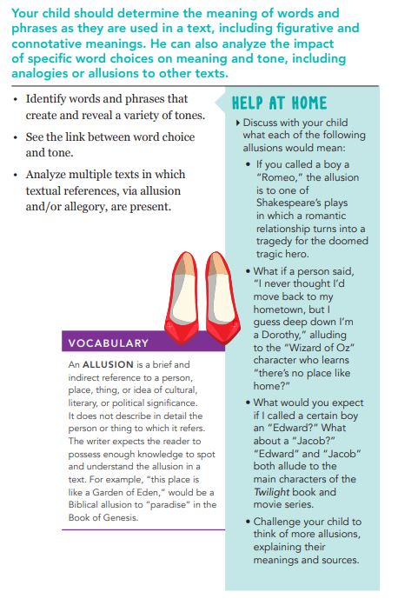
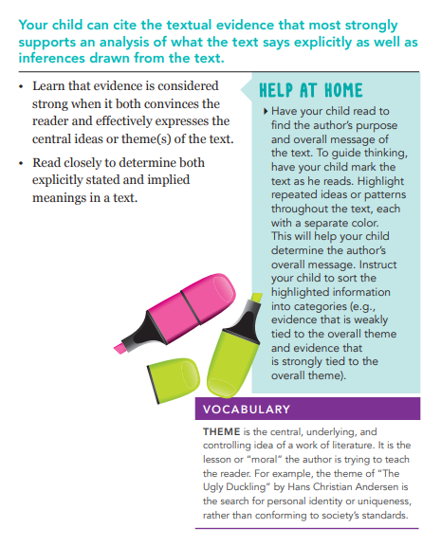
These are ways you can assist your child at home with English for the month of August.
RL 8.4

RL 8.1

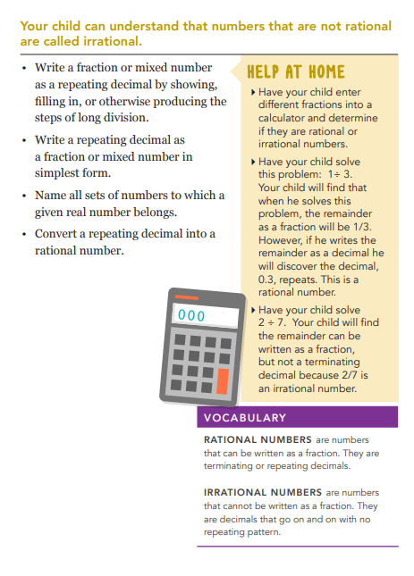
These are ways you can assist your child at home with Math for the month of August.
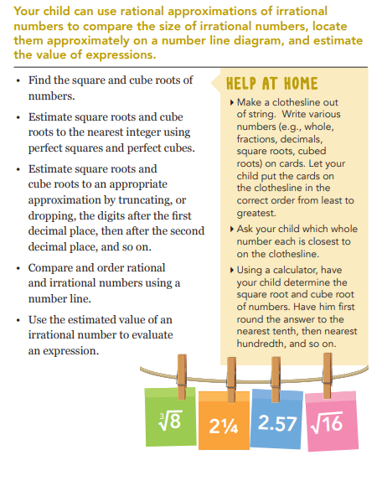
8.NS.2
8.NS.1

There are the performance descriptors of 8th Grade Science for the month of August.
