Spanish 1
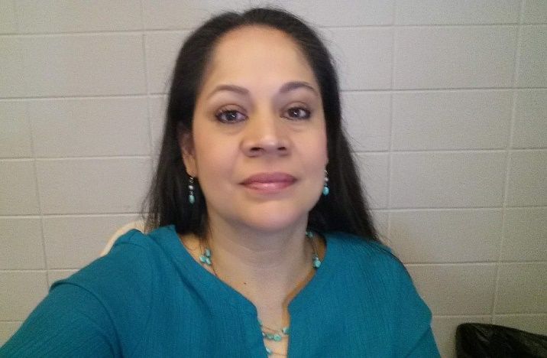

Instructor: Ms. Bea (Jiménez)
Phone: Work: (251) 221-3233 ext. 31734 / Cell: (915) 996-2580
Email: bjimenez@mcpss.com
Office / Tutoring Hours: 9:10 a.m. to 10:10 a.m. and 10:20 to 11:20 with previous arrangement
Communications: will be made through the app Remind101.

Course Description
¡Bienvenidos! This is a course that will introduce you (the student) to the Spanish language and cultures of people who speak it.
This class meets during 1st block every day from 8:00 a.m. to 9:00 a.m.
The focus of this course is to learn about Spanish through the "the 5 C’s":
(1) Communication: To communicate in languages other than English
(2) Culture: To gain knowledge and understanding of other cultures
(3) Connections: To connect with other disciplines and acquire information
(4) Comparisons: To gain insight into the nature of language and culture
(5) Communities: To participate in multilingual communities at home and around the world
In class, we will be engaging in a variety of activities that will include all five of the elements of learning a new language: speaking, writing, listening, reading and writing. Students are expected to practice what they learn outside of class.

Course Objectives
By the end of this introductory course, students are expected to:
- Express greetings, likes and dislikes, give simple descriptions, and talk about their daily routines.
- Follow standards of Spanish grammar such as punctuation, capitalization, adjective and noun agreement, subject and verb agreement, and word order.
- identify cognates (words that are similar to English words) and use reading strategies such as context clues, visuals, and prior knowledge to read short texts.
- Exchange information about themselves, their schedule, their interests, their families and friends, food, clothes, and other various topics in a conversation.
- Understand short dialogs, directions, or videos in Spanish and be able to synthesize the information.
- Write paragraphs, dialogs, and skits in Spanish on a variety of topics.
- Describe cultural activities and perspective of the Spanish culture.
- Be able to compare and contrast their culture with the Spanish culture.

Grading system:

The following scale will be used to grade all assignments:
60-69 = D | 70-79 = C | 80-89 = B | 90-100 = A

MCPSS Absence Policy
This is a full-credit course. Only 3 parent notes (sent via email) and 4 unexcused absences are allowed throughout the semester (two quarters). You cannot receive credit for this course if you reach the limit amount of unexcused absences allowed per term.

