Unit 6: Energy: Conservation of Energy/Energy Transformations
Student Notes

BIG IDEA: Most forms of energy can be transformed into other forms, but never created or destroyed.

ENDURING UNDERSTANDING: Students will understand that energy cannot be created or destroyed. Energy can only be transformed from one type to another.

Energy

I. Energy is defined as the ability to do work.
A. Work (W) is when a force acts on an object to cause displacement of the object, it is said that work was done on the object.
1. Work is caused by three key things: force, displacement, and cause.
a. In order for a force to qualify as having done work, there must be a displacement and the force must have caused the displacement. In other words, to do work, a force has to be in the direction of the motion.
b. The formula for work is W (work)=F (force) x d (distance).
B. Power is calculated using P(power)=W(work) ÷ t(time).
1. Power is measured in watts(w).
C. Energy is measured in Joules (J).
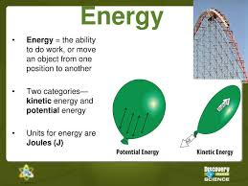
II. There are two main types of energy.
A. Potential Energy (PE) is energy that is stored in an object as a result of its position shape or chemical composition.
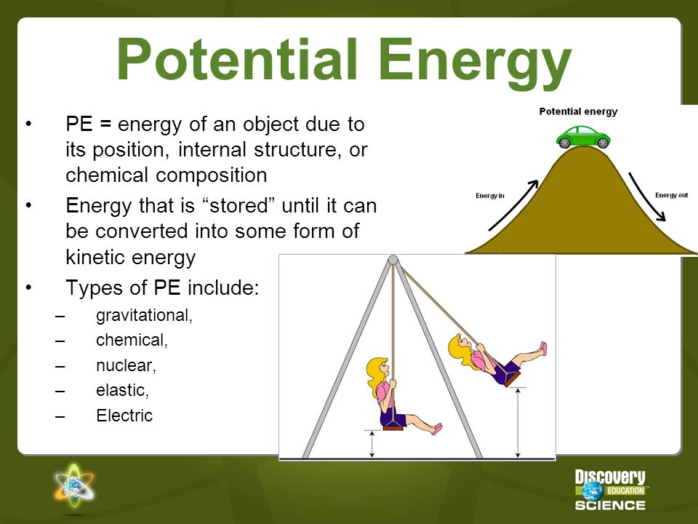
B. Kinetic Energy: Active energy; the energy associated with the movement of objects. Anything that is moving has kinetic energy.
1. Kinetic energy is determined by an object or organism’s mass and velocity (speed).
2. The formula for Kinetic Energy is: KE = 1/2mv².
3. The faster an object moves, the more Kinetic Energy it has.
4. The greater the mass the moving object has, the more Kinetic Energy it has.
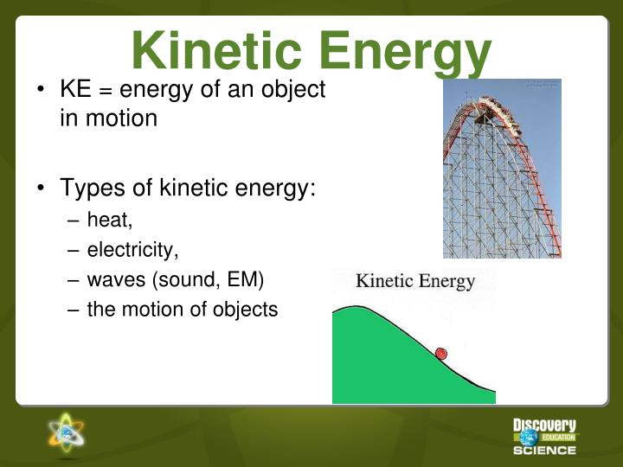

III. Other types of Energy:
A. Light/radiant energy: Any form of light contains energy. (infrared, visible, ultraviolet, etc.)
1. Light energy often gets converted into thermal energy.
2. It is also converted into chemical energy through the process of photosynthesis.
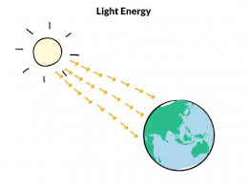
B. Thermal/Heat Energy: A type of mechanical energy contained within a substance due to the movement of molecules.
1. If something feels hot or cold to the touch, you know that you have just experienced the transfer of thermal energy, also known as heat. If an object feels cool or cold, thermal energy is being transferred from your hand to the object.
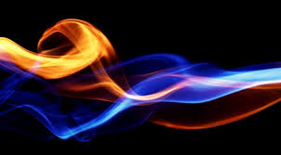
C. Chemical Energy: A type of potential energy associated with the chemical bonds between elements. It is energy that is stored and later released.
1. Food and batteries are good examples of stored chemical energy. 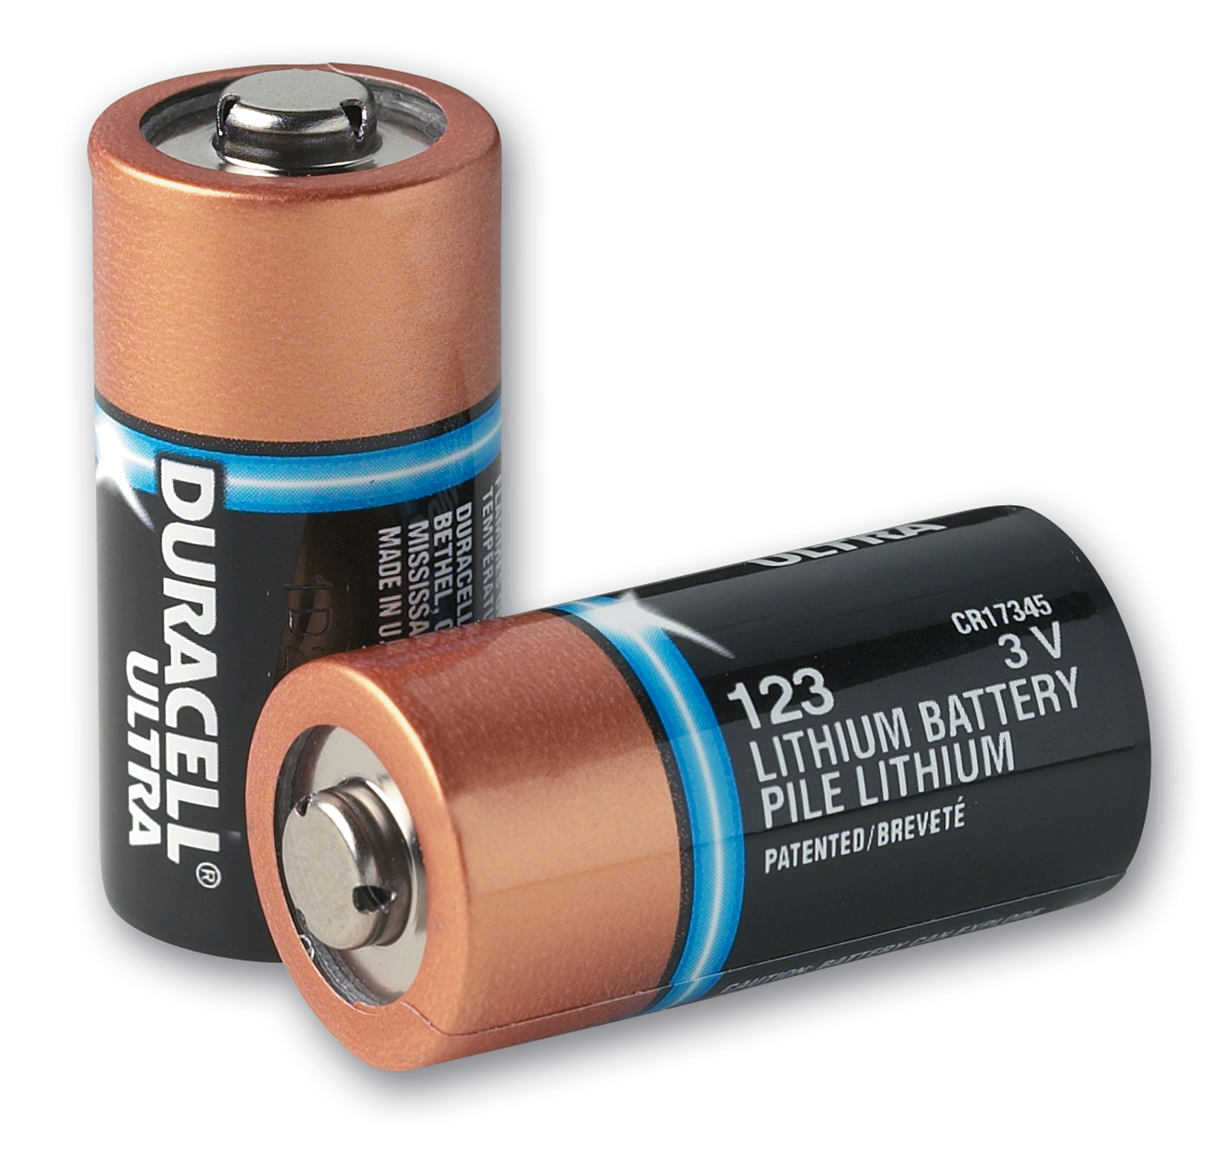
2. Stored chemical energy can be seen or felt when it is converted into thermal energy and sometimes light energy during an exothermic reaction.

D. Sound Energy: Any audible or inaudible sound is sound energy.
1. It is the energy associated with the vibrations of molecules and atoms.
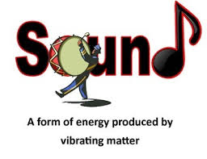
2. Most sound energy is easily detected using our ears (audible).
3. Some sound (inaudible) cannot be heard with our ears.

E. Elastic Potential Energy is the energy stored in elastic materials, such as rubber bands and springs, as the result of their stretching or compressing.
1. The amount of elastic potential energy stored is related to the amount of stretch of the object; the more stretch the more energy.
2. Springs are a special instance of a device that can store elastic potential energy by compressing or stretching.
i. Hooke’s Law: For some springs, the amount of force is directly proportional to the amount of stretch or compression, the constant of proportionality is known as the spring constant (k).
ii. Robert Hooke was a British Physicist (1678).
iii. If a spring is not stretched or compressed it is in equilibrium. Such cases represent 0 potential energy.
iv. The equation used to calculate such energy is PE spring= 0.5●k●x2; x=compression; k =spring constant.

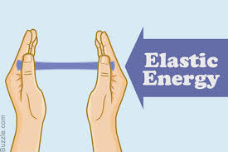

F. Electrical Energy: A type of mechanical energy associated with the movement and separation of charged particles called electrons.
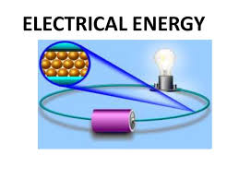
1. Electrical energy can also be associated with the force of attraction or repulsion between positively and negatively charged particles which can do work. This causes “static cling”.
2. Most appliances use electrical energy to function by plugging them into an electrical outlet.
3. Batteries convert chemical energy into electrical energy
G. Mechanical Energy: The energy that is possessed by an object due to its motion or due to its position.
1. Mechanical energy can be either kinetic energy (energy of motion) or potential energy(stored energy of position).
2. Objects have mechanical energy if they are in motion and/or if they are at some position relative to a zero potential energy position (for example, a brick held at a vertical position above the ground or zero height position).
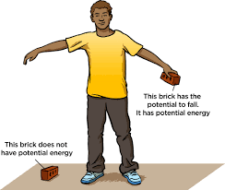
3. A moving car possesses mechanical energy due to its motion (kinetic energy).
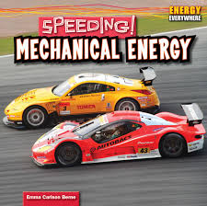
4. A moving baseball possesses mechanical energy due to both its high speed (kinetic energy) and its vertical position above the ground (gravitational potential energy).
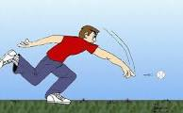
5. A World Civilization book at rest on the top shelf of a cart possesses mechanical energy due to its vertical position above the ground (gravitational potential energy).
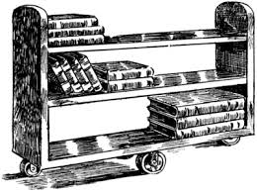
6. A barbell lifted high above a weightlifter's head possesses mechanical energy due to its vertical position above the ground (gravitational potential energy).
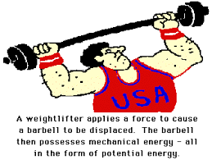
7. A drawn bow possesses mechanical energy due to its stretched position (elastic potential energy).
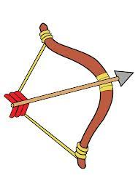
H. Nuclear Energy: the energy held in the nucleus of an atom.
1. There are two types of nuclear energy--fission and fusion.
2. Nuclear fission produces energy through the splitting of atoms, which releases heat that can then generate steam and be used to turn a turbine to produce electricity.
3. Nuclear fusion is a nuclear reaction in which two or more atomic nuclei collide at a very high speed and joining to form a new type of atomic nucleus.

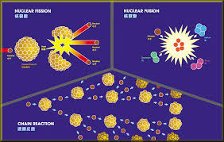
I. Magnetic Energy: The potential energy of a magnetic field.
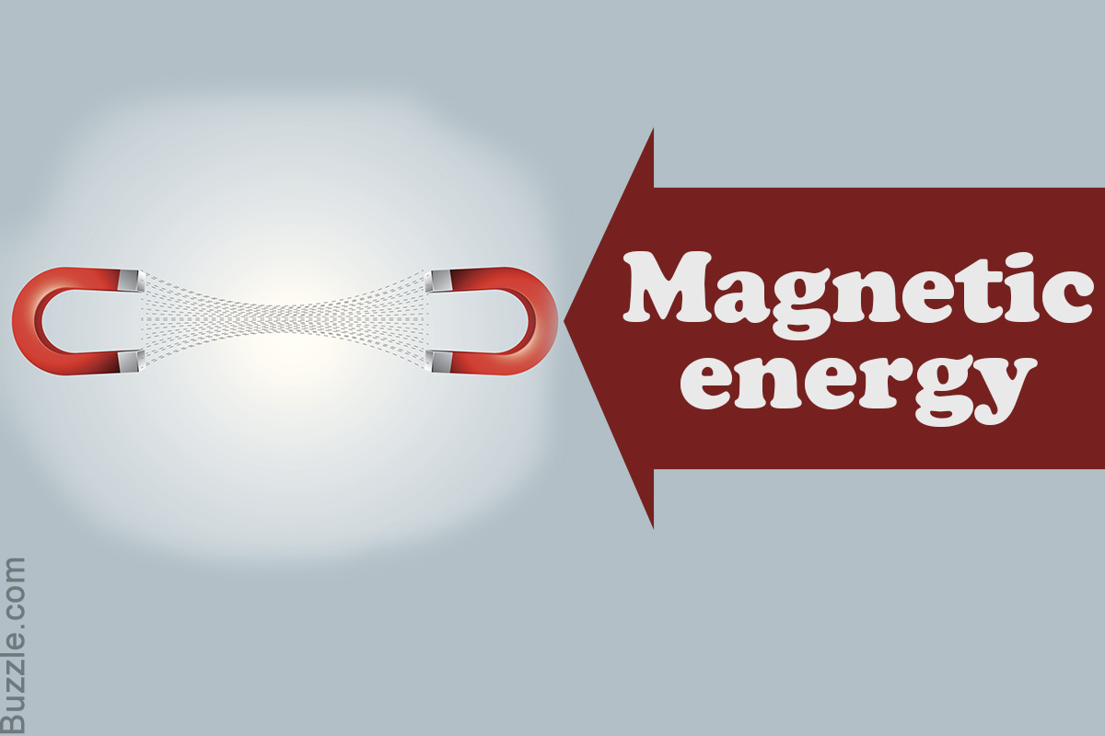
J. Gravitational Potential energy is the energy due to an object’s position above the earth’s surface.
1. There is a direct relation between gravitational potential energy and the mass of an object. The more mass an object has the greater the gravitational potential energy.
2. There is also a direct relation between gravitational potential energy and the height of an object. The higher that an object is elevated, the greater the gravitational potential energy.
3. The formula for Potential Energy is: PE = mgh
i. m = mass; h = height; g = 9.8 m/s² (g is the force of gravity)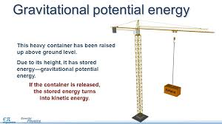

NOTE INTERACTION: Fill out the graphic organizer using what you know about the types of energy.
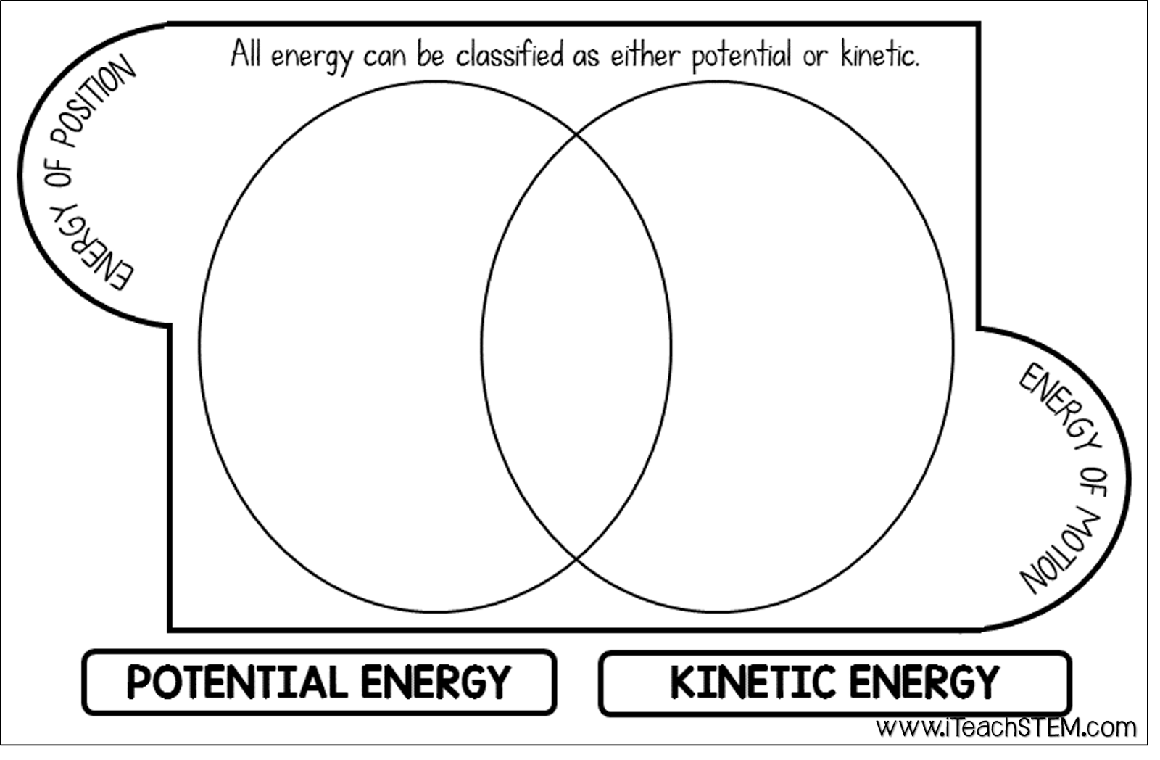

Energy Conservation:

IV. Law of Conservation of Energy
A. The Law of Conservation of Energy states that energy cannot be created or destroyed, only transformed/transferred.
B. The most common energy conversion is the conversion between Potential and Kinetic Energy.
1. In an automobile engine, fuel is burned to convert chemical energy into heat energy. The heat energy is then changed into mechanical energy. The energy transformation would be: Chemical→Heat→Mechanical.
C. Energy conversions may produce unwanted forms of energy, when energy conversions take place the total amount of energy is split between desired (usually some form of work) and undesired energy (usually heat or friction).
1. Heat and friction reduce the ability to perform work.
D. Energy efficiency is the measure of usable energy after a conversion has taken place.
1. Technology can improve the efficiency of energy conversions.
a. LEDS convert almost all electricity to light.
b. Hybrid cars increase the fuel efficiency of cars.
2. The formula for energy efficiency is: Efficiency =Work Output x 100% Work Input.
a. Theoretical Efficiency can reach 100%.
b. Actual Efficiency will never reach 100% due to loss by friction OR heat.
E. Mechanical advantage is the ratio of the force produced by a machine to the force applied to it.

NOTE INTERACTION: Try the following problems using the appropriate formula.

- Sheila applies 55N of force to move her chair 2m, how much work did Sheila do?

2. Two guys lift two 40N rocks up a 5m staircase. Bob does it in 10 seconds. Joe does it in 20 seconds. Compare their work and power.

3. What is the efficiency of a block and tackle if you pull it using 20m of rope with a force of 600N to raise a 200kg piano 5m?

V. Simple Machines
A. Simple Machines are any of the basic mechanical devices for applying a force, such as an inclined plane, wedge, or lever.

View the Simple Machines PowerPoint: https://www.teachengineering.org/content/cub_/lessons/cub_simple/cub_simple_lesson06_presentation.ppt

1. Wheel & Axle - Makes work easier by moving objects across distances. The wheel (or round end) turns with the axle (or cylindrical post) causing movement.
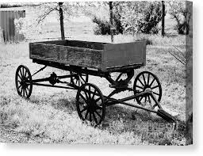
2. Inclined Plane - A flat surface (or plane) that is slanted, or inclined, so it can help move objects across distances. A common inclined plane is a ramp.
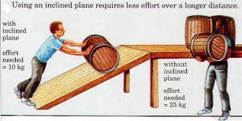
3. Wedge - Instead of using the smooth side of the inclined plane to make work easier, you can also use the pointed edges to do other kinds of work. When you use the edge to push things apart, this movable inclined plane is called a wedge. An ax blade is one example of a wedge.
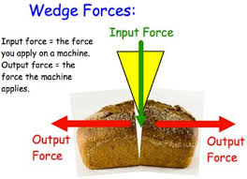
4. Lever - Any tool that pries something loose is a lever. Levers can also lift objects. A lever is an arm that “pivots” (or turns) against a fulcrum (the point or support on which a lever pivots). Think of the claw end of a hammer that you use to pry nails loose; it’s a lever. A see-saw is also a lever.
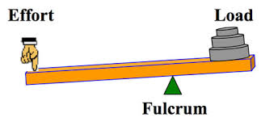
5. Pulley - Instead of an axle, a wheel could also rotate a rope, cord, or belt. This variation of the wheel and axle is the pulley. In a pulley, a cord wraps around a wheel. As the wheel rotates, the cord moves in either direction. Attach a hook to the cord, and now you can use the wheel’s rotation to raise and lower objects, making work easier. On a flagpole, for example, a rope is attached to a pulley to raise and lower the flag more easily.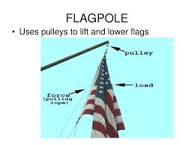
6. Screw - When you wrap an inclined plane around a cylinder, its sharp edge becomes another simple tool: a screw. If you put a metal screw beside a ramp, it may be hard to see similarities, but a screw is actually just another kind of inclined plane. One example of how a screw helps you do work is that it can be easily turned to move itself through a solid space like a block of wood.
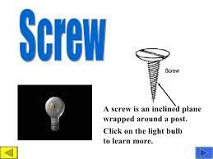
B. Compound Machine is a device that combines two or more simple machines. For example, a wheelbarrow combines the use of a wheel and axle with a lever. Using the six basic simple machines, all sorts of compound machines can be made. There are many simple and compound machines in your home and classroom.
1. Some examples of the compound machines you may find are a can opener (wedge and lever), exercise machines/cranes/tow trucks (levers and pulleys), shovel (lever and wedge), car jack (lever and screw), wheelbarrow (wheel and axle and lever) and bicycle (wheel and axle and pulley).

NOTE INTERACTION: Match the simple machine with its correct definition by writing the corresponding letter in the answer column.

Simple Machine | Answer | Definitions
Inclined Plane |  | A. Something that reduces the friction of moving something.
Wedge |  | B. Something that can hold things together or lift an object
lever |  | C. A ramp
Screw |  | D. Something that uses a rope  and can change the direction of a force
Wheel and Axle |  | E. Something similar to a see-saw that can lift an object.
Pulley |  | F. Something that can split an object apart.

