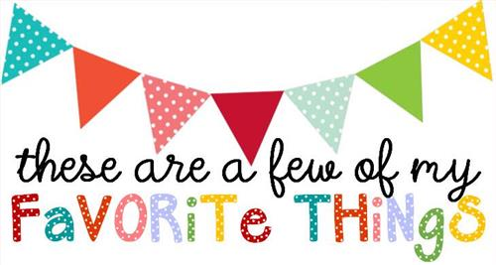

Name: Jennifer Williamson
T-shirt Size: Medium
Birthday: July 2
Monogram: JWC
Favorite Color: Blues: turquoise, aqua, etc.
Favorite Flower: tulips
Favorite Scent: apple cinnamon pumpkin (candles); clean,”beachy” smells for lotions/gels
Favorite Candy: candy corn, Reeses, Snicker
Favorite Drink: Diet Coke with vanilla from Sonic
Favorite Food: shrimp and grits
Favorite Snack: chips and dip (salsa, cheese, spinach/artichoke)
Favorite Fruit: bananas, strawberries, blueberries
Favorite Restaurant: Longhorn’s, The Underground, (Fast Food: Zaxbys, Sonic)
Favorite Places to Shop: Hobby Lobby, Khols, Bunker Boutique
Things I collect: candles, Bath and Body Works soaps, lotions, shower gels :)
Favorite Author/Book Series for my own personal reading: Bible
Wish List for Classroom: individually wrapped candies

