ELMORE COUNTY BOARD OF EDUCATION

100 H.H. Robison Drive | Phone: | 334-567-1200 | Richard E. Dennis, Superintendent
P.O. Box 817  Wetumpka, AL 36092 | Fax: | 334-567-1405 | Jason M. Mann, CSFO

SEHS BAND UNIFORM BID #SEHS-02

PUBLIC NOTICE FOR INVITATION TO BID ON HIGH SCHOOL BAND UNIFORMS FOR
STANHOPE ELMORE HIGH SCHOOL. Sealed bids must be received by the Elmore County Board of Education on the following bid date and time: Wednesday, February 19, 2020 at 9:00AM. The Bid Opening will occur at 10:00am on Wednesday, February 19, 2020. This project shall be bid excluding taxes. The bids must be submitted on company letterhead and the company name, bid number, and proof of insurance are to be posted on the outside of the bid envelope. **This is required for the bid to be accepted and opened** No bid may be withdrawn after scheduled closing for receipt of bids for a period of sixty (60) days. The Owner reserves the right to reject any or all proposals and to waive technical errors if, in the Owners judgment, the best interests of the Owner will thereby be promoted. A separate certified check or Bid Bond payable to The Elmore County Board of Education in an amount not less than five percent (5%) of the amount of the bid, but in no event more than $10,000.00 must accompany the bidder's proposal. Sealed bids will be received by the Elmore County Board of Education, 100 H. H. Robison Drive, Wetumpka, Alabama, 36092, and publicly opened and read aloud for band unifmms in the central office board room.

The project shall be bid excluding taxes. No bid may be withdrawn after scheduled closing for receipt of bids for a period of sixty (60) days. The Owner reserves the right to reject any or all proposals.

Questions may be directed to Jason Mann, CSFO, at 334-567-1200 or jason.mann@elmoreco.com.

Owner:
Elmore County Board of Education 100 H H Robison Drive Wetumpka, AL 36092

Every student empowered. Every student succeeds.

BOARD MEMBERS

Michael Morgan-Chairman Dale Bain-Vice Chairman Leisa Finley Kitty Graham Joey Holley David Jones Wendell Saxon

INVITATION TO BID

Your company is hereby invited to submit a BID QUOTATION ON THE ITEMS AND QUANTITY, AS DESCRIBED FURTHER IN THIS WRITTEN INVITATION. PLEASE RETURN THE bid form
page(s) with your official bid. If you are unable to submit a bid quotation at this time, and if you wish to remain on our list of potential suppliers, simply send us a written explanation.

The deadline for our receipt of your bid is: 9:00 am Wednesday, February 19. 2020.

Whereas considerable time and expense has gone into the preparation of the enclosed specifications, deviations are NOT anticipated. DEVIATIONS MUST BE DOCUMENTED. Unless fully documented, such deviations may DISQUALIFY a bidder at the discretion of the BUYER.

In setting forth these specifications it is the intention of the buyer to offer equal opportunity to all bidders. Styles referred to by number and the company name are for descriptive purposes only and are not restrictive. The buyer feels that specified styles, material, linings and sundry items are equally available to all reputable manufacturers.

Bidder is to furnish itemized quotations showing the cost of each item, the total price per uniform, and the total price of the entire order. Any allowance or cash discount for payment within a certain period before or after delivery is to be indicated on the bid; otherwise, it is presumed that payment is to be made on the basis of net 30 days.

The buyer reserves the right to accept or reject any or all bids in the best interest of the buyer. Factors to be considered when determining the best value for the buyer are to be quality of the gannent, service and responsibility of the company and their representative, as well as price. Low bid is not necessarily to be awarded the contract.

Bidder is to furnish a full time sales representative to handle all details of the order. This includes measuring and servicing, "after the sale". Bidder is to provide name, address and phone number of representative or representatives who are to be responsible for handling the order.

In submitting your bid, specify the time required for delivery of the complete order after receipt of all details.

SAMPLES - Your bid, to be considered, is to be accompanied by a completed sample uniform in accordance to the exact specifications. Each bidder's interest in meeting these specifications is to be reflected in their willingness to manufacture this pilot sample and to make it available at the school prior to the time and date of the official bid opening. Exact samples are also required to insure that the district can expedite this purchase soon after the award. The san1ple uniform provided is to be a male size 38 regular.

The buyer reserves the right to inspect the workmanship of the sample, its inner construction in particular, and for this purpose will open the lining if necessary.

SPECIF/CATIONS

GENERAL
Coats, trousers, blouses and all major parts of the uniform are made to fit the nearest stock size from the information supplied by the company representative. This is done for a better year to year fitting program and allows more fitting flexibility. Exceptions are made on unusual sizes wherein the garment is cut and produced to the measurements taken by the company representative.

LABOR
All garments must be UNION made and shall include the union label. This is to insure consistency and uniform of the manufactured goods. Uniforms made otherwise may have a tendency toward sloppiness and unprofessional tailoring, due to the unskilled cutting and sewing operations.

SHIPPING
Uniforms are to be shipped on wishbone style hangers. Hangers are to be hard plastic, not wood. Wooden hangers have a tendency to pick and pull the basic fabric, and they are not acceptable. The hangers must be bent and rounded at the top to allow the shoulder area of the garment to be spread and hung properly. Each uniform must be delivered in its own clear polyethylene bag to prevent soiling. Uniforms must be delivered in 200 lb. Test cardboard wardrobe containers, opening from the front, and having a metal bar reinforcement at the top with clasp to prevent hangers from disengaging from the metal structure. Each carton will be properly marked on the outside, with identification numbers of the uniforms contained in that specific carton.

IDENTIFICATION
Each major garment item is to have identification numbers sewn into the individual pieces to allow for quick and easy issuing. Coats, trousers, and blouses are to have woven numerals. Trousers are to include inseam and waist information for future reference; coats shall have chest size and length indicated on a linen ticket. The original order is to include a bound booklet with the numbers of each uniform corresponding to the particular size of that uniform, arranged from the smallest to the largest. Size information shall include chest size, height, weight, and inseam for each uniform. Bonnd in the identification record shall be a size chart for use as reference for purchase of future uniforms.

INSPECTION
All garments are to be carefully inspected before final packing and shipment. All thread ends to be picked and cut and specifications, trim and details to be critically checked for each individual garment before shipment. Buttons to be applied and sewn at that time.

VERIFICATION OF FABRIC PROCESSION
Any dacron/wool blend fabric from any vendor must be professional cold water and alcohol sponged, decated, and inspected. Bidder must submit in writing, certification that dacron/wool blend fabric will have undergone this fabric stabilization prior to manufacture of the uniforms. Also, such certification should be submitted in writing by an officer of the bidding company.

The company actually performing the stabilizing process must be indicated, with an individual or officer of said company to contact for verification of processing.

As dacron/wool garments having not undergone such processing can experience significant and excessive shrinkage, bidders not providing such a sponging treatment and certification in this bid will be disqualified.

SUSTAINABLE VERIFICATION CERTIFICATE

Any 14 oz Polyester fabrics must be certified by UTrust Verification Program and must be made from ECO-FRIENDLY textile products, developed from sustainable fibers.

A UTrust Verification Certificate must be attached to this bid or RFP Solicitation. This certificate must be signed by an individual or officer for UTrust.

COAT SPECIFICATIONS

PATTERNS
    - Patterns are to be marked, graded, and cut using a computerized system to insure accuracy.

    - Patterns are to cover a full range of sizes, including male, female, short, regular, long, and extra long from size 26 to 60.

INNERLINING

    - The innerlining shall consist of heavy grade fusing similar to what is found in men's suits in fashion formal wear. The second layer shall consist of a layer of Milliken indestructible fabric.

SHOULDER PADS

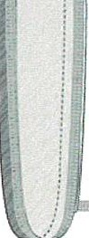SHOULDER PADS

Armhole Seam-

-- Folded Edge

Bar tack - .
i
3/4' Shoulder Seam

Shoulder Pad View

Shoulder pads are high quality, washable, 7 ½" x 4 ½", ¾" thickness, consisting of washable foam materials.

SLEEVEHEAD PAD
    - There is a I 3/4" sleeve head pad composed of a 65/35 Poly/Cotton woven cover sewn into the armhole of the coat assembly.

    - It is reinforced with soft white 100% Polyester needle punch filler.

    - Strips of coat canvas are unacceptable for use as sleeve-head padding.

LINING
    - Coat linings are to be cut from a separate set of patterns designed specifically to fit the particular style of coat. Linings are not to be cut from coat patterns and then cut down.

    - Lining material is to be the highest quality polyester twill; non-toxic, perspiration resistant, color fast, and non-shrinkable. It is to be fully dry-cleanable.

    - Its composition is to be 124 warp x 72 fill and it is to meet government specifications.

    - There is a pleat down the center back in the shoulder area to allow fullness.

    - The lining is COMPLETELY sewn around the armhole, NOT just tacked.

PERSPIRATION SHIELD (see illustration #1)
    - The perspiration shield is secured in the lower part of the armhole and is app roximately 4" square.

    - It is made of an absorbent wool flannel, consisting of 85% wool and 15% nylon material.
It is to be double sponged to prevent shrinkage.

    - The shield is edged all around with a pre-shrunk bias poly/cotton finishing tape and completely sewn into the armhole area. Merely "tacking" the shield to the lining is not acceptable.

    - Shields made of scraps from cutting the outer coat whipcord fabric are not acceptable.

    - Sweatshields will contain Sanogiene Anti-Microbial Protection. Sanogiene is an EPA approved patented technology providing the following properties:

      - Contrals and resists odors
      - Retards the growth and action of bacterial odors
      - Mildew resistant
      - Prevents microbes from degrading uniform construction
      - Long-lasting in excess of one hundred launderings In addition, the staining, degradation and loss of the performance properties of textile fibers are often the result of microbial attack. Sanogiene finish protects the fabrics from microbial contamination and growth. Sanogiene is an EPA registered product and meets requirements for US anti­ microbial registration.

POCKETS (see illustration #2)
    - Any inside pockets are to be cut, sewn, and turned automatically with a double piped lock-stitch machine and reinforced with a non-woven fabric.

    - Pockets are to be constructed with hidden inside bartacks with welts of the same outer fabric as the coat.

    - There is a 1 1/2" whipcord fabric extension down into the pocket, from the opening edges.

    - Pocketing material is to be 70/30 poly/cotton, 50/50 in the warp and I 00% poly in the fill.

    - Pocket is to be "bagged" with no open seams at the bottom.

    - Pockets made of lining or lightweight material are not acceptable.

TAPING
    - Seams which are subject to usual stress, are to be taped with a preshrunk cross-wound cotton tailoring tape.

    - Areas to be taped are down the inside coat front, extending around bottom sides and back, and around the armhole. There must be a 3-4" area at the upper back shoulder area of each sleeve seam, where the cloth tape is omitted. This allows proper "Stretch" across the shoulders during arm lift maneuvers.

SLEEVES
    - The sleeve is to be "felled" into the top of the armhole, using a special felling stitch which allows fullness, evenness, flexibility and strength.

    - The bottom half of the armhole is machine lock-stitched to give the greatest strength in this high stress area.

    - Sleeves are to be cut utilizing a 60/40 pattern per fine tailoring. They will be pitched forward 3-4 degrees in the armhole to allow for the aim-lift associated with playing a musical instrument.

    - The cuff, or hem, is to have a generous 2 1/2" turn-under consisting of fabric and lining secured and constructed to allow easy altering of sleeve length. This is done utilizing an "easy alter" chain stitch.

SHOULDER LOOPS
    - Shoulder loops are to be die-cut to insure uniformity and are cut in two pieces.

    - Shoulder loops are to be reinforced on each layer with heavy Pellon.

    - They are sewn together on the inside, turned, and top-stitched all around the edge for body and durability.

    - All buttons for attachment of shoulder loop and accessory items will be reinforced with backing buttons.

TRIM
    - Coat front trim (braid, welts, appliques, embroidery, etc.) is to be applied only through the outer fabric. That is, it is NOT to be sewn through the chest piece four layer innerlining, nor the polyester twill coat lining. All trim is to be sewn before the lining is joined to the coat.

    - Any trim using 1/4" unfilled tubular braid is to be applied with a FB or FBN com straight 2 needle machine, then it is applied in cloverleafs, turned edges or other circular designs. The benefits of such application provide that the trim (A) lays flat to the fabric surface, and that (B) the stitching is equidistant from each edge along the entire border of the trim. Using a single needle stitch sewn twice is not acceptable. Trim applied with only one single needle stitch in the center is not acceptable.

HARD COLLAR (see illustration #3)
    - The inner core foundation of the standing collar is .014 Mylar.

    - There is a laminated layer of non-woven Pellon PIS on the inboard side of the entire foundation.

    - A stainless steel riveted hook and eye is to be the front closure. The hook and eye are riveted through the Mylar, Pellon and two layers of collar lining material. It is to be placed at the optimum angle to insure proper tension and comfort.

    - A "sewn" hook and eye is not acceptable.

    - The collar lining consists of two layers of Burlington Mills Cramerton fabric, which is 65% polyester and 35% combed cotton, pre-shrunk and non-wicking.

    - Seven male gripper snaps are placed through both layers of the collar lining material. The snaps are supported on the inside by the laininated non-woven Pellon which also serves as a protective layer between the Mylar and the snaps. Female gripper snaps applied to the collar lining are unacceptable.

    - The outboard side of the standing collar is to be covered with a whipcord fabric, as specified by the design specifications.

    - The top edge of the Mylar base is bound with Cramerton fabric and has a finished welted seam on each side. The whipcord fabric is doubled over the top of Mylar base, along with the two layers of collar lining, and stitched along the top edge. This 5-layer construction results in a "beaded" edge and serves as a protection all along the top edge of the liner. This is accomplished with a SINGLE row oflocked stitching through the Mylar base.

    - A single layer of fusing tape or bridle-tape is not sufficient protection in this area and is not acceptable/.

The bottom edge of the standing collar is to be sewn through and through, to attach the double layers of Cramerton linililg to the outer layer of whipcord. This row of stitching is immediately below the bottom edge of the Mylar foundation.

    - Construction of the collar in this manner provides the most dimensionally stable garment, without the additional rows of needle holes.

I. Braid trim, fabric welt, and embroidery are to be applied to the outer fabric of collar before assembly. This prevents sewing the trim "through" the Mylar core with additional rows of needle holes.

  - COLLAR LINER (see illustration #4)

The fabric used in the construction of the washable snap-in, replaceable liners is two layers of VISA treated polyester whipcord. The VISA treatment offers soil release properties in this washable part of the garment.

    - The liner is to be die-cut in a curve to allow it to lie properly against the neck of the wearer.

    - There are seven female gripper snaps evenly spaced and secured through both layers of liner fabric. These are to match up with male gripper snaps on collar lining.

    - The top, bottom and rounded side edges of collar liner is to be bound with a finished binding of non-absorbent Cramerton fabric.

    - There is to be a bartack at each end of the binding.

    - The liner is to be positioned to extend 1/8" above the whipcord collar fabric.

    - Each liner is to be sized to corresponding collar and numbered to match coat size.

  - SOFT COLLAR
    - Soft collars, lapels, and outer pocket flaps are to be hand shaped and cut according to fine quality tailoring practices.

    - Bridle tape is to be placed at the lapel roll, to retain smooth lines and afford a permanent shape.

    - Under-collar felt is to be pre-biased 50% wool/50% Rayon composite.

    - All edges are to be topstitched (with the exception of satin lapels) through and through, from the facing edge through coat front lapels and collar to the opposite edge. Topstitching is to be 1/8" from edge.

  - SEAMS
    - Coat is to be completely machine stitched except in areas where specific tailoring requires other methods.
b, The ends of all seams are to be backstitched not less that 1/4".

c. Coat back is tailored with either a 2-piece back or 4-piece back, if needed, to facilitate insertion of contrasting color panels, trim, etc.

THREAD
    - Threads for seaming are to be 50/3 cotton wrap core thread, 70/2 poly wrap core thread, or 100/2 poly wrap core thread based on the strength requirements of the type of seam.

    - All threads are to be heat resistant, vat dyed, sun-fast, dry-cleanable and moisture proof.

BUTTONS/ BUTTONHOLES
    - High-quality metal buttons are to be used where specified and are to be attached by sewing, ring and washer, or toggle and washer.

    - Buttonholes are to be manufactured using the cut-first method. The hole is to be cut-first, and the edge is to be covered with gimp and twist to cover the fabric and inner canvas edge. The back of the buttonhole is to be closed with a bartack reinforcement.

ZIPPERS
    - Zipper is to be heavy-duty brass with an auto-Jocking pull-slide. Tape is to be 9/16".
    - Zipper is to be bartacked top and bottom and sewn to facing surface, not sandwiched in between shell fabric and facing.

FUSING
    - Certain trim designs call for added reinforcement. This is to be done with Pellon 8557 engineered dot fusible. It is guaranteed against delamination and dry­ cleaning. It is to "tear away" from areas not covered with braid or other trim.

    - Use of Pellon SF134 as reinforcement for trim is unacceptable.

    - The entire coat front outer fabric is to be reinforced, in addition to the "traditional" sewn innerlining, whenever looped braid designs are specified.

    - When sleeve cuff trim is utilized, the lower sleeve is to be reinforced from the cuff bottoms, up as needed.

WASHABLE OPTION

Buyer may opt to change the coat specifications to be a washable item. The coat will have washable shoulder pads and will be fully lined. Front inner foundation, sleeve heads, and underarm shields may be omitted.

Illustra
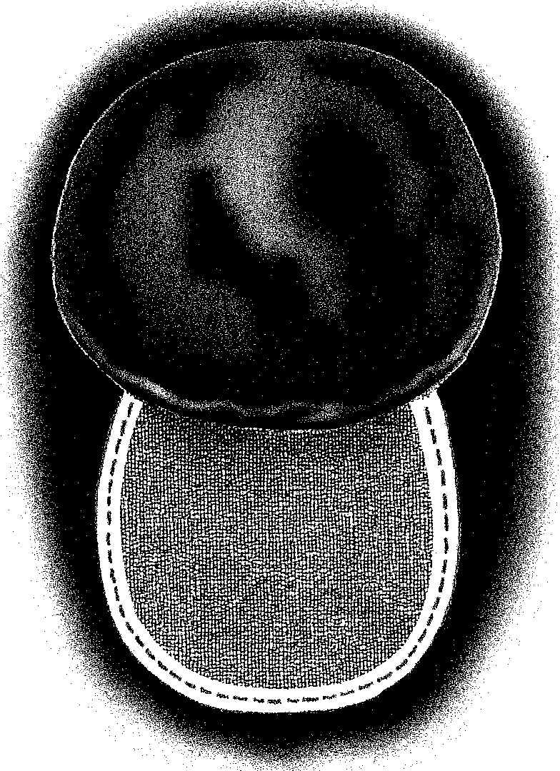

Illustration #2

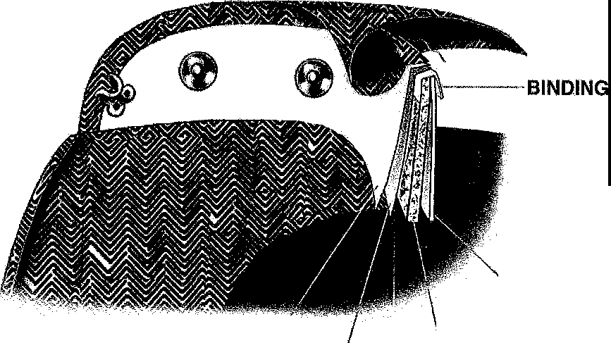
Illustration #3

/'
TWO LAYERS
.0"14 MYLAR PELLON

Illustration #4
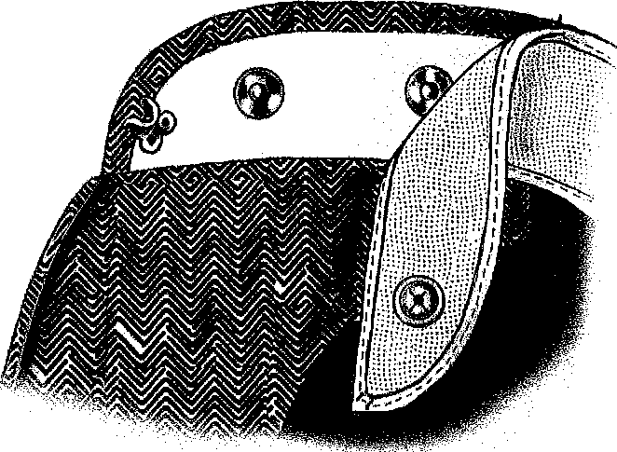

UNIFORM MANAGEMENT SYSTEM

The band uniform order is to be accompanied by a Uniform Management System program with the following features:

Customer information is available via:
Uniform Management System program - Cloud Based Customer Data - Cloud Based

The Uniform Management System will manage student information regarding the assignment of band uniforms and is alterable on a continuing basis as sizing needs change. The program will contain an AUTO-ASSIGN feature which automatically assigns uniform pieces to the students based on their entered measurements. In addition, the student database will include full contact information for student and guardian and will possess the ability to generate address labels and garment bag identification tags. The system will also produce student uniform rental/usage agreements as per needed. The software will be compatible with Microsoft Windows XP, Microsoft Windows Vista, and Apple Mac OS X (PowerPC and Intel). The Uniform Management System must provide ONLINE/TELEPHONE technical support FREE OF CHARGE. Software updates will be available 24 hours a day, 7 days a week via the internet site.

DESIGN & STYLING SPECIFICATIONS
STANI-IOPE-ELMORE HIGH SCHOOL-MILLBROOK, AL BAND:

COAT STYLE: I436CS QUANTITY: 175
COAT FABRIC: Milliken-RejuviTex 14 oz. SHADE: FIRE, COAL BLACK

COAT CLOSURE: Concealed Center Back Brass YKK Zipper FRONT TRIM:
I436CS: Seamless Canopy. Fused front. Inner-lining of lndestructable canvas and fully lined with white coat lining. Taper side 1" and cut 1" shorter than standard. Cut straight across front. Front body of RejuviTex-FIRE with an insert of RejuviTex-COAL BLACK that is 5" from the left shoulder canopy edge and runs the front of the coat in a curve to 6" at the right coat front body at bottom.
Appliqued to the insert are three (3) curved pennant welts. Two outboard welts are dye-subbed with a customized circle pattern. Colors of dye-sub should be CMYK values to match to RejuviTex-ACADEMY GRAY and RejuviTex-PEWTER. Print customized circle pattern on the back side of 212-14. These two curved welts are 2" at the base and run to form a sharp point. The inboard pennant welt is RejuviTex-OPTIC applique, 2.5" at the base. Edge each pennant in 1/8" black satin stitch. Centered in the right of the chest is a white Barudan special emblem that is 2.5" tall by 3.25" wide. Special emblem is a blended treble clef and horse head.

COLLAR TRIM:
Squared Hard collar per construction specifications for such. No collar liner. Line inside of collar with Black. RejuviTex-FIRE, Add heavy duty hook and eye.

SHOULDER LOOP FABRIC: NA SHOULDER TRIM: NA

COAT BACK TRIM:
Plain RejuviTex-COAL BLACK back, cut straight across the bottom.

CUFF:
Left Sleeve of RejuviTex-COAL BLACK and Right Sleeve of RejuviTex-FIRE S-8
Sleeve trim with modern trim package. S-8 plaques are opposite the color of the sleeve (Red Sleeve- Black and Black Sleeve-Red). Set superimposed on the plaque is a 1" curved applique of RejuviTex-OPTIC that taper to a point.

SPECIAL FEATURE: Adjust-a-Hem™. Each coat shall include Sanogiene­ technology sweat protection.

DEVIATION FORM

In the event that the undersigned Bidder intends to deviate from the specifications by utilizing any materials, items, treatments, finishes, inner construction, tailoring details, etc., contrary to those listed as standards in the specifications, the bidder is to fully document and list each deviation in complete detail including reasons for the deviation. General statements are not acceptable, Furthermore, these deviations are to be approved in writing.

If no deviations are submitted, the bidder assures the buyer of full compliance with the specifications and conditions, and assures the buyer that samples accompanying bid meet all construction specifications.

If deviations are found on said sample, and not listed, the bidder is to be disqualified!

Company _ Date---------

Signed Title

