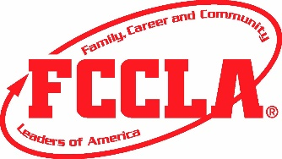 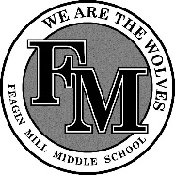 WHY FCCLA? FCCLA IS

the only in school student organization with the family as it's central focus.

a vocational education student organization that functions as an integral part of the family and consumer science education curriculum and operates within the school system.

FCCLA provides opportunities for active student participation at local, state, and national levels.

Keep This Page

FCCLA - The Facts
FCCLA - Family, Career, Community Leaders of America, founded in 1945, is a dynamic and effective national student organization that helps young men and women become leaders and address important personal, family, work, and societal issues through family and consumer science education.
Chapter projects focus on a variety of youth concerns including parenting, family relationships, substance abuse, peer pressure, environment, nutrition and fitness, inter-generational communication and career education.
Involvement in FCCLA offers members the opportunity to expand their leadership potential and develop skills for life - planning, goal setting, problem solving, decision making, and interpersonal communication - necessary in the home and workplace.

Leadership- An executive director leads the organization and heads a national staff that gives direction to and carries out programs, communications, membership services and financial management.

Governance-Ten national officers (students) are elected by the voting delegates at the National Leadership meeting and together make up the National Executive Council.
The National Board of Directors is composed of adult representatives from education and business and four youth representatives.
State associations and local chapters elect their own youth officers. State programs come under the supervision of vocational family and consumer education staff. Chapter advisors are family and consumer science teachers.
Perry Middle School FCCLA Calendar At A Glance
*** Dates and times are subject to change
***Additional meetings will be held for special committees working on individual or group projects
Aug. 10th Discover training registration due
Aug. 11th back to school social 3-4pm
Sept 1st monthly chapter meeting 3-4pm fall leadership registration due
Sept 14th fall leadership paid to attend only meeting 3-4pm
Sept 30-Oct. 3rd fair booth setup
Oct 20th monthly chapter meeting 3-4pm
Nov 3rd monthly chapter meeting 3-4pm
Nov TBA Basic Training Camp John Hope day trip
Dec 3rd monthly chapter meeting 3-4pm
Dec TBA Party For Cause
Jan 13th monthly chapter meeting 3-4pm
Feb 4th monthly chapter meeting 3-4pm
Feb 8-12 National FCCLA Week
March 3rd monthly chapter meeting 3-4pm
April 5th monthly chapter meeting 3-4pm
May TBA end of year party

Membership- FCCLA has a national membership of nearly 230,000 young men and women. There are 53 state associations including the District of Columbia, Puerto Rico, and the Virgin Islands. There are 10,000 local chapters.
Since its founding in 1945, FCCLA has involved over nine million youth. Former members are eligible to become members of Alumni & Associates.

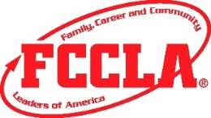 Keep this page
FCCLA Schedule for 1st Semester
These are tenative dates and subject to change.
Also, some meetings/competitions may be in a virtual format, so stay up to date via social media (below) and google classroom group. Mrs. Duke will give you the google classroom code to join when you turn in your paperwork and dues.

August:
August 11th-3:00-4:00 Officer Induction and meeting (If you are interested in being an officer, see Mrs. Duke to see if any spots are available before this date.
August 13th-FCCLA Informational Meeting 3:00-3:30- Anyone interested in joinging FCCLA can attend. This will be virtual, see or email Mrs. Duke (lisa.duke@hcbe.net) for link to meeting.

September:
September 1st- Discover Officer Training deadline to sign up and turn in money ($25)
September 14 - October 2 Discover Virtual Officer Training exact date TBD (officers only)
September 17-FCCLA meeting 3:00-4:00, and deadline to sign up/pay for Fall Rally ($25 registration fee and optional pre-purchased t-shirt: $10)

October:
October 8th- FCCLA meeting 3:00-4:00 and deadline/money due for Fall Leadership Conference ($90)
October 14th-Fall Rally
October 22nd-Officer Meeting

November:
November 10th-12th- Fall Leadership Conference
November 13th-Deadline to sign up and turn in money for Culinary Boot Camp (cost TBD)

December:
December 3rd-5th- Middle School Culinary Boot Camp
December 10th- FCCLA Christmas Party (3:00-4:00)

Stay connected with our local chapter on social media

Facebook Page-Feagin Mill Middle FCCLA and FACS
https://www.facebook.com/fmmsfccla/?modal=admin_todo_tour

Instagram- Feagin Mill FCCLA and FACS
https://www.instagram.com/feaginmill_fccla_facs/

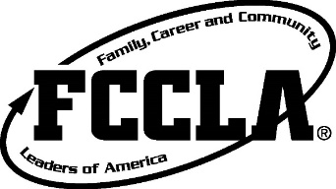
Dues: $20 dues (non-refundable)
To be completed by teacher for record keeping purposes:
Student paid $_______Check#_______ or Cash: _______
T-shirt ordered: ________ T-shirt received: _______
Size ordered: _________
FCCLA Membership Application
and $15 for a comfort colors member T-shirt.
When: Join as soon as possible to gain the benefits of all member activities, competitions, and trips.
FMMS FCCLA Member Information (PRINT NEATLY PLEASE!)

First Name: ______________________Middle Name: _________Last Name: ___________________________
Gender: ______ Grade: ____ Birthdate: ___________Student Email Address: ___________________________
Physical Address: __________________________________Student Cell#: _____________________________
Parent/s Name: ____________________________________________________________________________
Parent/s Email: _______________________________________ Parent/s Cell #: ________________________
Recruited by: ____________________________________________T-shirt Size_________________________
Student’s Schedule
Period | Course | Teacher
1
2
3
4
5
- I give permission for my child to be photographed during FCCLA events and for pictures to be published on social media sites and other media outlets for the purpose to promote FCCLA.
- I understand after 2 times of being late to pick up FCCLA member, he or she will no longer be allowed to participate in afterschool FCCLA activities.
- I understand my child must remain in good academic standing and free from disciplinary referrals to attend any trip with FCCLA.
- I understand all funds paid to Feagin Mill Middle School FCCLA are non-refundable despite the situation or circumstance.
- I agree to the terms of FCCLA membership and allow my child to participate in FCCLA.

Student signature__________________________________________Date_____________________

Parent signature____________________________________________Date____________________

