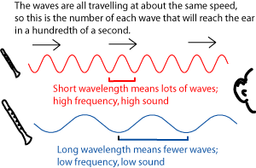

**Vocabulary:**

Vibration vacuum

Pitch hertz decibel *ultrasound*  intensity resonance **acoustics**

Doppler effect *amplification*  echolocation sonar

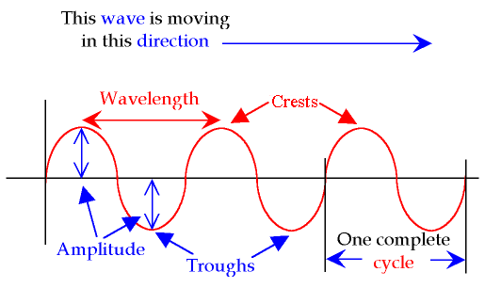

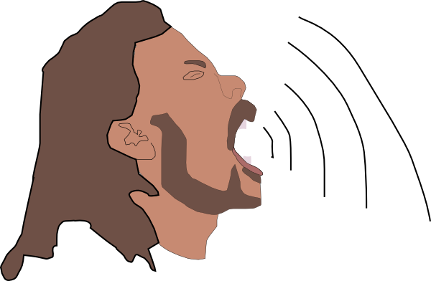

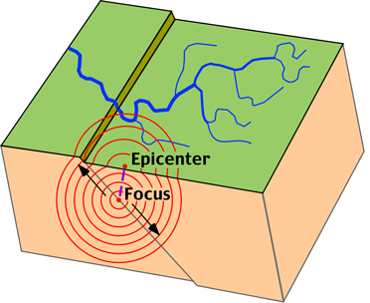



**A wave is a disturbance transferring energy from one place to another.**

**Mechanical waves** need a medium in which to travel. Sound waves travel by “bumping” or vibrating the atoms between the source of the sound and the receptor of the sound. Sound waves vibrate the molecules between the too. Examples:

RoPe WaVe WaTeR WaVe EaRtHqUaKe WaVe SoUnD WaVe

Electromagnetic waves are made of vibrating electric and magnetic fields. EM waves travel at the speed of light through a vacuum. EM waves transfer energy and can interact with matter. EM waves have many common daily uses and medical uses. **Roy G. Biv** is the mnemonic device used to remember colors in the visible light range.

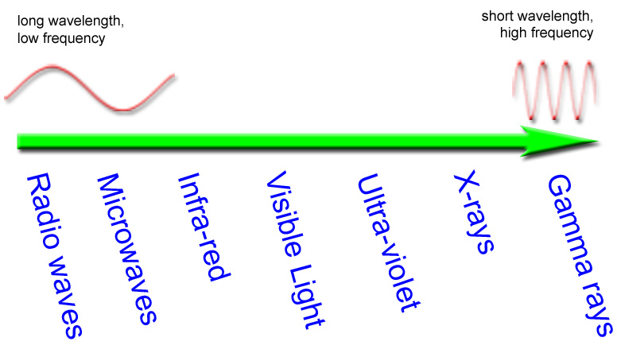

**WAVES: The students will understand that…**

1. energy is neither created nor destroyed; it can only be transformed from one form to another.

2. waves transfer energy; not matter.

3. mechanical waves are disturbances that transmit energy from one place to another and are created when a source of energy causes a medium to vibrate.

4. the characteristics of waves are affected by the type of medium through which they are traveling.

5. the energy of the wave changes as it travels from one medium to another.

6. waves can be classified based on how they move (transverse or longitudinal).

7. electromagnetic and mechanical waves have similar characteristics, but differ in that electromagnetic waves do not require a medium to travel through.

8. waves share common properties and are characterized by their frequency and their wavelength.

9. energy changes affect frequency and wavelength.

10. the higher the frequency of a wave, the higher its energy.

11. waves travel at different speeds.

12. wavelength is measured differently for transverse (up and down) and compressional (longitudinal) waves.

13. the speed (distance per second), frequency (waves per second), and wavelength (distance) of a wave are related to each other by a

mathematical formula: speed = wavelength x frequency (Hertz).

14. waves carry energy that can be transferred or transformed during interactions with matter or other waves.

15. sound waves carry energy by vibrating particles

16. the energy of a sound wave changes as it travels from one medium to another.

17. the characteristics of sound waves are affected by the type of medium

18. sound can travel through different mediums: solids, liquids, and gases.

19. frequency determines the pitch of sound.

20. the pitch of a sound wave is related to its frequency and its intensity (loudness) (decibels) is related to its amplitude.

21. unique properties allow sound to be used in medical, meteorological and sonar technology.

Longgggggggg wavelength = low frequency, low pitch

sHort wavelength = high frequency, high pitch