Mrs. Cook’s Messages
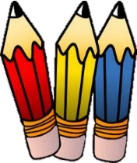
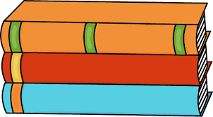
May 10-14, 2021
Grammar (prepositions and prepositional phrases) and
Reading Skills (draw conclusions) Tests: Thursday
Vocabulary and Spelling (final syllable: -tion, -ture) Tests: Friday
May Events |  | 12th | Vision Research Screenings
 |  | 14th | Spirit Day/Special Snack
 |  | 24th | Field Day/End of Year Celebration (25th if it rains on the 24th)
 |  | 28th | 2nd grade Awards Day – each child receives 3 tickets for 3 parents
 |  |  | or grandparents to attend. More info. will be sent home soon.

Story:  “A Birthday Basket for Tia” by Pat Mora  Phonics/Fluency:  final syllables –  -tion, -ture  Text-Based Comprehension:  draw conclusions;  questioning  Grammar:  prepositions and prepositional phrases | Selection Vocabulary Words (Students will be tested on these):  - aunt – your father’s sister, your mother’s sister, or your uncle’s wife  - bank – a place where people keep their money  - basket – something to carry or store things in  - collects – brings things together  - favorite – the thing liked better than others  - present – something given  Amazing Words  celebration, tradition, inspect,  brilliant, custom, create, angle, snapshot
Topic 12: Geometry  Lesson 1: Flat Surfaces, Vertices, and  Edges  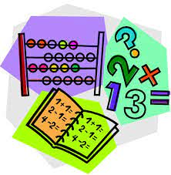  Lesson 2: Relating Plane Shapes to Solid  Figures  Lesson 3: Polygons and Angles |  | Social Studies/Science  Our topic this week is scientists,  artists, and inventors. We will  learn about people from various  backgrounds and cultures who  made important contributions  to our country.
Spelling Words:
- mixture  - nation  - section | - future  - picture  - action |  | - caution  - station  - fixture | - motion  - nature  - feature

